Huda Okab 1193133

Business Chapter 5 (Notes)

* The management process
* Management

I

process of planning, organizing, leading, and controlling an organization’s resources (Financial, physical, human, information) to achieve its goals.

* Who takes over management?

The person responsible for management is referred to as a manager.

I

What is a manager’s job?

* Analyzing their competitive environments, planning, organizing, directing, controlling day-to-day operations of their business.
* They are responsible for the performance and effectiveness of the teams, divisions, or companies they head.
* What are the processes of management?
* Planning: determining what an organization needs to do and how best to get it done.

I

What is the process of planning?

1. The manager determines the firm’s goals
2. they create a comprehensive methodology for accomplishing the goals.
3. Operational plans are done to get to the strategy

* Organizing: determining how best to arrange an organization’s resources and activities into a coherent structure.
* Leading: guiding and motivating employees to meet an organization’s objectives.

I

it involves more complex activities than giving orders and demanding results.

Best managers had the capacity to unite their employees in a clear and targeted manner and motivate them to work in the best interests of their employer with trust, and mutual benefit and with clear channels of communication.

* Controlling: monitoring an organization’s performance to ensure that it is meeting its goals.

I

What do they monitor?

* Costs and performance.
* Numerous performance indicators that should be measured and adjusted.
* Customer satisfaction and customer complaints.
* Control can show where performance is running better than expected.
* A basis for providing rewards or reducing costs.



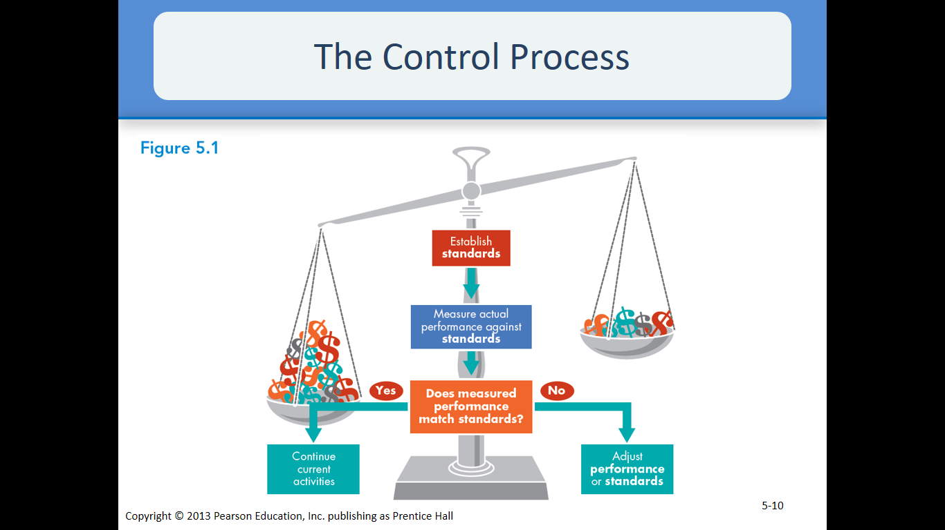

* The science and art of management.
* Science of management:

I

Many administration issues can be drawn nearer in ways that are levelheaded, consistent, objective, and precise. They can utilize quantitative models and choice making procedures to reach to adjust decisions They utilize logical approach to illuminate issues particularly when managing with schedule and clear issues. Technical, symptomatic and choice making aptitudes are imperative when utilizing logical perspective.

* Art of management:

I

Managers as a rule make choices and solve issues on the premise of instinct, encounter, intuitive, and individual insights. They depend on conceptual, communication, interpersonal, and time administration aptitudes.

Note that; Managers must blend an element of intuition and personal insights with hard data and objective facts.

* What are the qualifications to become a manager?
* Education: college degree, Diplomas, MBA, Executive MBA, Trainings, online courses etc... (it doesn’t just stop at college they have to keep their knowledge updated)
* Experience: Day-to-day pressures, training indoor, variety of jobs, exposure to major aspects etc…
* What are the 3 types of managers?
* Top Manager (guides the fortune)

I

responsible for a firm’s overall performance and effectiveness (President, vice president, CEO)

* Middle Manager (considerable autonomy and importance)

I

responsible for implementing the strategies and working toward the goals set by top managers (Plant manager, division manager, regional sales manager)

* First line manager

I

responsible for supervising the work of employees (supervisor, group leader, sales manager)

* 5 areas of management
* Human resources management
* Operation managers
* Marketing managers
* Information managers
* Financial managers
* 3 managerial roles
* Interpersonal roles: covers the relationship that a manager has to have with others
* Includes: figure head, leader, and liaison.

(Coordinator or links among groups, people, & organizations)

* Informational roles: flow naturally from impersonal roles
* Includes: monitor, disseminator, spokes person

(transmitting relevant information to people in the workplace)

* Decisional roles: informational roles lead to it
* Includes: entrepreneur, disturbance handler, resource allocator, negotiator
* Five basic management skills

1. Technical skills: skills needed to perform specialized tasks, developed through education & experience, Importance for first line managers, Managers spend time helping employees solve problems, training in more efficient procedures and monitoring performance.
2. Human skills relation: getting along with people, middle managers, good communication skills, and maintain good relations.
3. Conceptual skills: analyze, diagnose, and see beyond situations. (mostly top managers) helps oversee future problems. Threats
4. Decision making skills: skills in defining problems and selecting the best courses of action Gathering facts, identifying solutions, evaluating alternatives, implementing the chosen alternatives Following up and evaluating the effectiveness of the choice Identify effective strategies Poor decision making skills can lead to failure.
5. Time skills management: skills associated with productive use of time.

* Leading causes of waste of time
* Paperwork: Some managers spend too much time deciding what to do with letters and reports. Most documents of this sort are routine and can be handled quickly. Managers must learn to recognize those documents that require more attention
* Telephone calls: Experts estimate that managers get interrupted by the telephone every five minutes. To manage this time more effectively, they suggest having an assistant screen all calls and setting aside a certain block of time each day to return the important ones. Unfortunately, the explosive use of cell phones seems to be making this problem even worse for many managers.
* Meetings: Many managers spend as much as four hours a day in meetings. To help keep this time productive, the person handling the meeting should specify a clear agenda, start on time, keep everyone focused on the agenda, and end on time.
* E-mail: Increasingly, managers are relying heavily on e-mail and other forms of electronic communication. Time is wasted when managers have to sort through spam and a variety of electronic folders, in-boxes, and archives.
* What are the two types of management skills for the twenty 1st century?
* Global management skills: managers have to understand foreign markets, cultures, and practices of a culture. They also need how to make collaborations with other people worldwide. They have to understand international operations.
* Management and technology skills: managers must be able to work with new technology since it is updating by day. It relates to communication and makes the job end faster.
* What is the difference between strategic management and strategy and how do they relate?
* Strategic management: the process of helping an organization maintain an effective alignment with its environment. Examples: competition, globalization. (to be competitive, to put a mark on the world)
* Strategy: organizational plans to work on to achieve a future goal. (can’t be a problem to problem basis)
* Strategy and strategic management relate by both have a mission to set a goal.
* What does it mean to set business goals? How can setting goals be done?
* Goals: an organization and their managers measure (in their eyes) success or failure at every level (whether big or small in is taken into consideration)
* Questions asked:
* What is the purpose of this company?
* What actions will help receive our goals?
* What are the objectives that we plan to achieve?
* What is the purpose of setting goals?
* Where the company is headed
* Where to allocate new or more resources (new projects)
* Innovation, creative environment, tolerance for future mistakes
* Reward those who excel and getting rid of those who do not.
* What are the 4 kinds of goals?
* Mission statement: organization’s statement of how it will achieve its purpose in the environment in which it conducts its business.
* Reason of Being (raison d’etre).
* Mission statement might be revised.
* Long-term goals: goals extended for the future, typical time 5 years
* Short-term goals: goals set for a very close future for example a month
* Intermediate goals: goals set for one to five years of the future (basically in the middle of short and long term goals)
* What are the three types of business strategy?
* Corporate strategy: is to determine what business or businesses a company will own and operate example, to own and operate a single business or to grow by increasing its activities or investments or to retrench by reducing them or to buy or operate multiple businesses in compatible industries.

I

Three types of corporate strategy:

* Related diversification: occurs when a firm moves into a new industry that has important similarities with the firm's existing industry or business lines. Example KFC, PIZZA HUT
* Unrelated diversification: involves entering an entirely new industry that lacks any important similarities with the firm's existing industry or industries, and is often accomplished through a merger or acquisition. Example SAMSUNG
* E-partnering: A partnership relying on electronic (information) technologies to communicate and interact amongst partners. It is mostly associated with e-commerce or e-business partnerships. Example buying shares of small companies that can provide technology.
* Business competitive strategy: strategy, at the business-unit or product-line level, focusing on improving a firm’s competitive position. Example Pepsi and Cola
* Functional strategy: managers in specific areas decide how best to achieve corporate goals through productivity. Managers in different areas (marketing, finance, operations) should decide how to achieve corporate goals by performing their functional activities most effectively.
* How to formulate a strategy?
* Strategy formulation: Creation of a broad program for defining and meeting an organization's goals A strategy outlines how the business intends to meet its goals It includes the organization responsiveness to new challenges and new needs. A well formulated strategy is so vital to a business’s success.

I

Steps to formulate a strategy:

Step 1: Setting Strategic Goals

Goal derived directly from a firm’s mission statement.

Step 2: Analyzing the Organization and the Environment: SWOT Analysis

Identify and analyze the org. strengths, weaknesses, opportunities, threats.

Step 3: Matching the Organization and Its Environment

Process of matching the environmental threats and opportunities against corporate strengths and weaknesses.

* Explanation of steps:
* Strategy formulation: Creation of a broad program for defining and meeting an organization's goals A strategy outlines how the business intends to meet its goals It includes the organization responsiveness to new challenges and new needs. A well formulated strategy is so vital to a business’s success.
* Environmental analysis: process of scanning the business environment for threats and opportunities, change in consumer taste government regulations, new products, updates.
* Organizational analysis: process of analyzing a firm’s strengths and weaknesses. Surplus cash, work forces, managerial talents.
* A hierarchy of plans
* Strategic plan: Strategy formulation: Creation of a broad program for defining and meeting an organization's goals A strategy outlines how the business intends to meet its goals It includes the organization responsiveness to new challenges and new needs. A well formulated strategy is so vital to a business’s success.
* Tactical plan: a short term plan concerned with implementing certain aspects of a company’s strategic plan. Involves upper and middle management.
* Operational plan: planning short term targets or goals for daily, weekly, monthly performance. Mostly done by mid-level and lower level managers.
* What is the difference between contingency planning and crisis management?
* Contingency planning: stating what if… thinking of things that might change the work environment.
* Crisis management: how to deal with emergencies.

(planning for the un predicated future)

* What is corporate culture and how is it related to management?
* Corporate culture: the shared experiences, stories, beliefs, and norms that characterize an organization.
* helps define the work and business climate that exists in an organization Just as every individual has a unique personality, ever company has a unique identity or a corporate culture
* Communicating the Culture and Managing Change
* Managers themselves must have a clear understanding of the culture
* Must transmit the culture to others in the organization
* Training and orientation for new comers.
* Clear and meaningful mission statement.
* Should maintain the culture by rewarding and promoting those who understand it and work toward maintaining it.
* What are the three ways of managing changes?
* At the highest level, analysis of the company’s environment highlights extensive change as the most effective response to its problems. This period is typically characterized by conflict and resistance.
* Top management begins to formulate a vision of a new company. Whatever that vision, it must include renewed focus on the activities of competitors and the needs of customers.
* The firm sets up new systems for appraising and compensating employees who enforce the firm’s new values. The purpose is to give the new culture solid shape from within the firm.