Huda Okab 1193133

Business Chapter 6 (Notes)

* Organizational structure
* specification of the jobs to be done within an organization and the ways in which they relate to one another.
* What is one key decision that managers must address?
* how best to structure the organization.
* What is an organization chart?
* An organization chart is a diagram showing a company’s structure and where the employees fit in to it operation. Solid lines define the chain of command.

I

reporting relationships within a company from the highest level in the org. to the lowest.

* What does the organization chart in large firms consist of?
* Far more complex
* Include individuals at many more levels
* Size prevents many large firms from even having charts that include their managers.
* They usually create chart showing overall corporate structure (consists of various departments that contribute to the company’s overall mission or goal)
* Separate charts for each division
* More charts for individual departments or units.

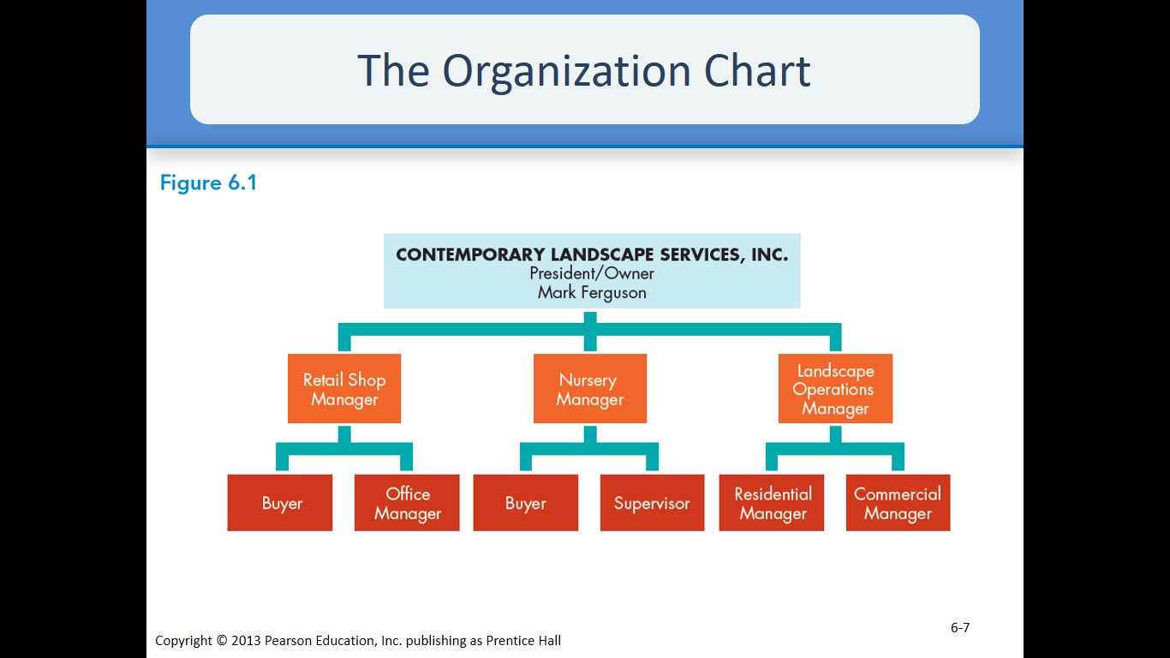

* What are the determinants of organizational structure?

Many factors play a part in determining an organization’s optimal structure. Chief among them are the organization’s mission and strategy. Size of the company and aspects of the organization’s environment also affect organizational structure. Organizing must be conducted with an equal awareness of both a firm’s external and internal environments.

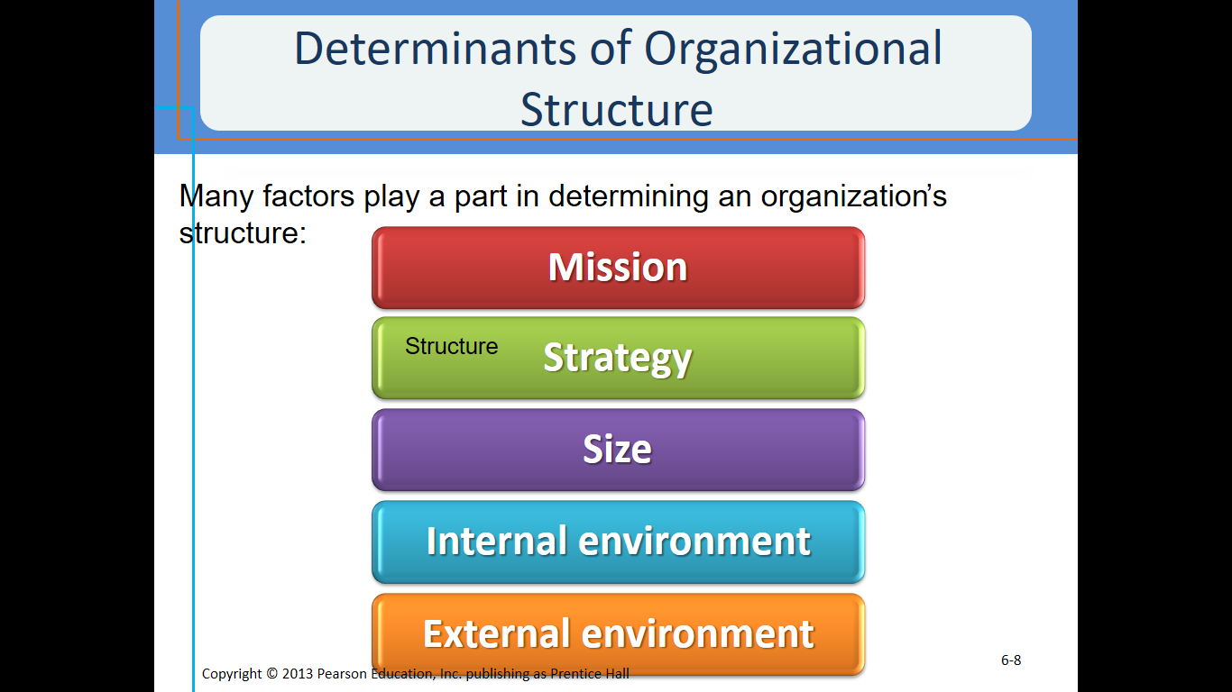

* What are the 3 building blocks of organizational structure?
* Specialization: determining who will do what (like picking chores)
* Departmentalization: determining how people performing certain tasks can best be grouped together. (basically putting like with like, like in math we add up the like terms)
* Establishment of a Decision-Making Hierarchy: deciding who will be empowered to make which decisions and who will have authority over others (Basically choosing the boss)
* What is the one type of specialization?
* Job specialization: the process of identifying the specific jobs that need to be done and designating the people who will perform them. (This is similar to house chore choosing ☺ ) Bigger organization needs more specialized jobs.
* What are the advantages of specialized jobs? specialized jobs are learned more easily and can be performed more efficiently, also, easier to replace people who leave job. In a small organization the owner may perform all the jobs.
* What are the 5 types of departmentalization?
* Product Departmentalization: dividing an organization according to specific products or services being created.
* Process Departmentalization: dividing an organization according to production processes used to create a good or service.
* Functional Departmentalization: dividing an organization according to groups’ functions or activities. Most new startups use this Departments may be further subdivided e.g. marketing. Dept.
* Customer departmentalization: dividing an organization to offer products and meet needs for identifiable customer groups. Example, women’s department, children.
* Geographic departmentalization: dividing an organization according to the areas of the country or the world served by a business.

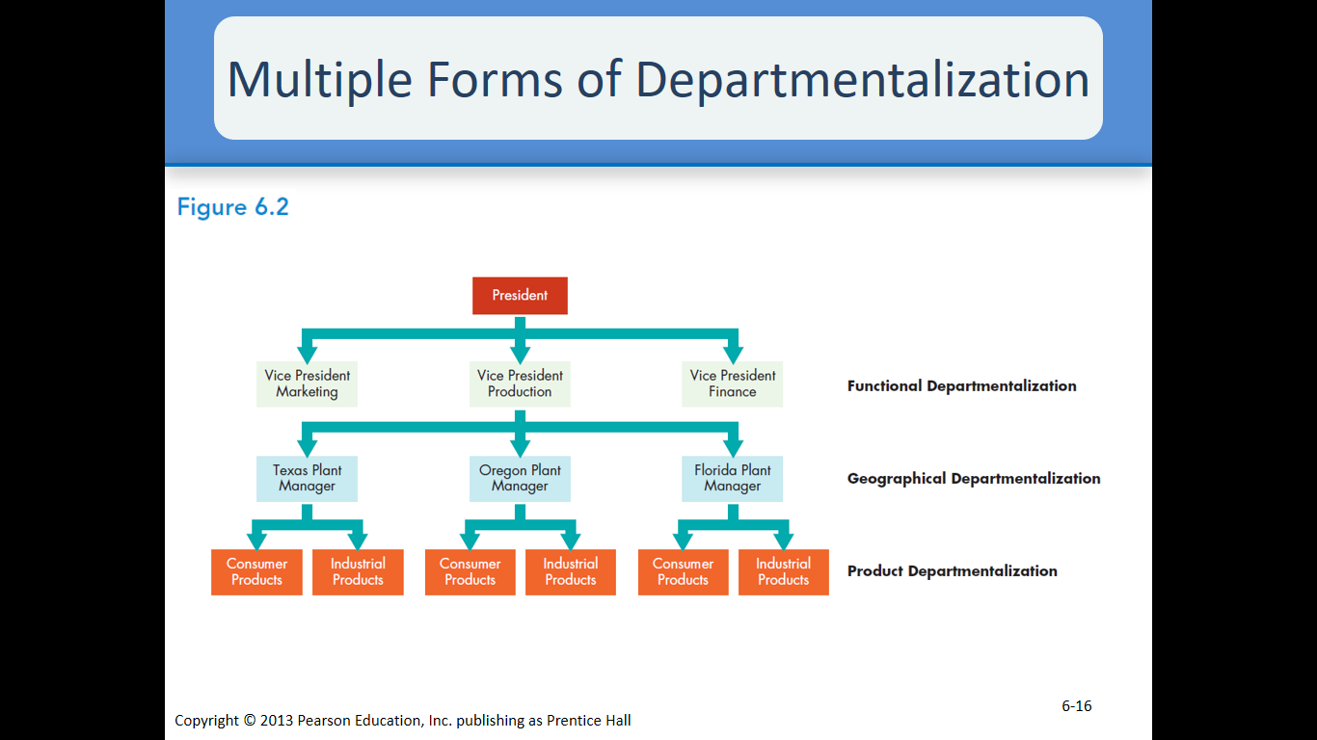

functional departmentalization at the top level. At the middle level, production is divided along geographic lines. At a lower level, marketing is departmentalized by product group.

* Establishment of a Decision-Making Hierarchy: The third major building block of Org. structure. This is done by formalizing reporting relationships. When the focus is on the reporting relationships among managers and the people who report to them, it is referred to as DELEGATION.
* What is centralized organization?
* organization in which most decision-making authority is held by upper-level management.
* It is needed to maintain standardization especially in restaurants. (with chains)
* It is most commonly found in companies that face relatively stable and predictable environments and in small businesses.
* Centralized firms typically require multiple layers of management and thus tall organizational structures, as in the U.S. Army
* What is decentralized organization?
* Organization in which a great deal of decision-making authority is delegated to levels of management at points below the top
* It makes the company more responsive by allowing managers take quick decisions.
* It is Typical in firms that have complex and dynamic environmental conditions also, in businesses specialized in customer service.
* Decentralized firms tend to have relatively fewer layers of management, resulting in a flat organizational structure like that of the hypothetical law firm.
* What is a flat organization?
* It is a characteristic of decentralized companies with relatively few layers of management.

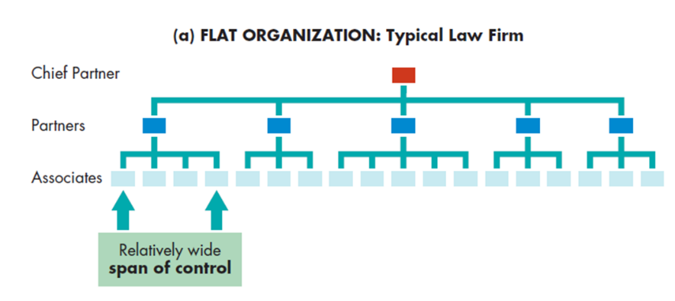

* What is a tall organizational structure?
* characteristic of centralized companies with multiple layers of management
* They are likely to delays in information flow.
* Bigger org. normally becomes taller

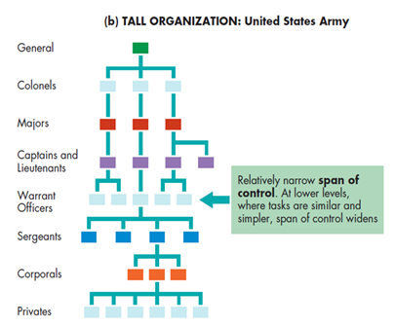

* What does centralized and decentralized structures have in common?
* Too few layers can create chaos and inefficiency
* Too many layers can create rigidity and bureaucracy.
* The distribution of authority in an organization also affects the number of people who work for any individual manager.
* Over all status: They must look out for their usage
* What is span of control?
* Number of people supervised by one manager (basically the area of activity and number of functions, people, or things for which an individual or organization is responsible.)
* In a flat org. structure, the number of people directly managed by one supervisor is usually wide.
* In a tall org. span of control tends to be narrower.
* What influences how wide or narrow the span of control is?
* Employees abilities.
* Supervisor’s managerial skills.
* Similarity and simplicity of tasks.
* The extent to which tasks are interrelated.
* More diversified jobs or prone to change, narrow Span of Control
* What is the delegation process?
* Assignment of authority over another person
* What does the delegation process include?
* Assigning responsibility: the duty to perform an assigned task. (doing what’s told)
* Granting authority: the power to make the decisions necessary to complete the task. (set goals and work according to them)
* Creating accountability: the obligation employees have for the successful completion of the task. (The restrictions and limits)

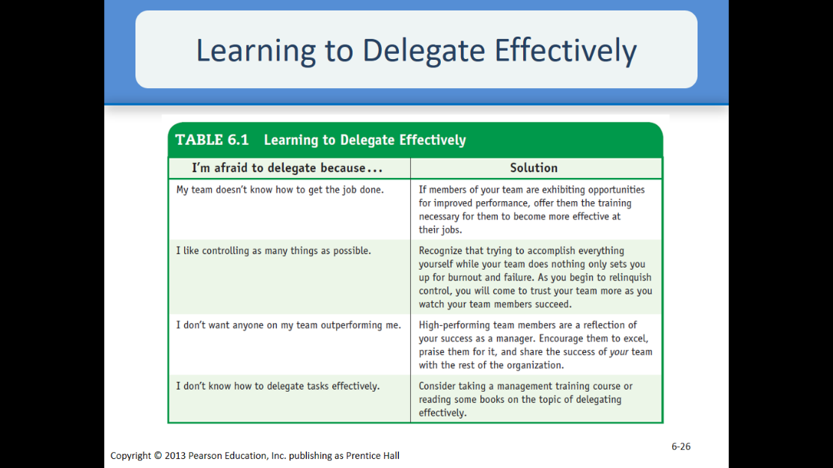

\*From this chart we can sense the lack of trust and low self-esteem that the boss has. \*

* What are the 4 forms of authority?
* Line authority: organizational structure in which authority flows in a direct chain of command from the top of the company to the bottom. (basically moving in a line form)
* Staff authority: authority based on skill that usually involves counseling and advising line managers. (work based on skill and take advice from line)
* Committee and Team Authority: Authority (decision making body) granted to committees or teams (beyond the individual authority possessed by each member) involved in a firm’s daily operations
* Work Team: Groups of operating employees who are empowered to plan and organize their own work and to perform that work with a minimum of supervision. (basically plan and are supervised by a small amount of people)

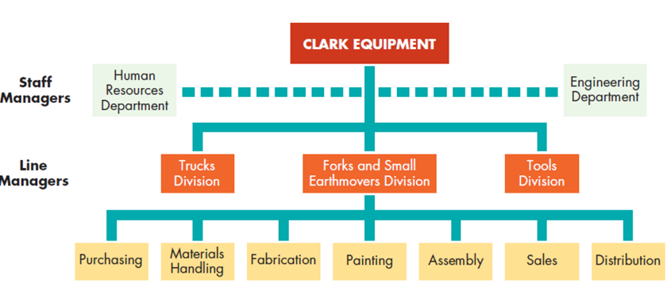

\*Typically, the separation between line authority and staff responsibility is clearly delineated and is usually indicated in organization charts by solid lines (line authority) and dotted lines (staff responsibility). \*

* What are the four types of organizational structures?
* Functional structure
* organization structure in which authority is determined by the relationships between group functions and activities

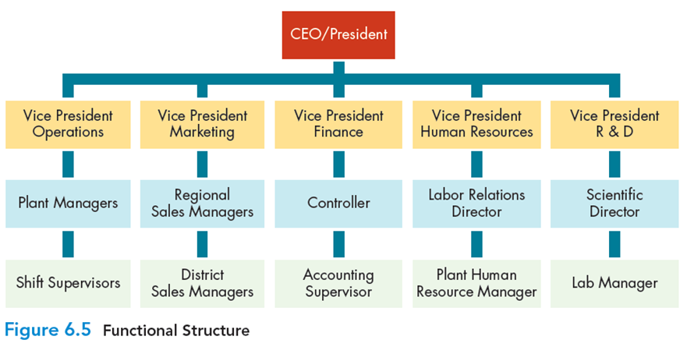

* Division structure
* organizational structure in which corporate divisions operate as autonomous businesses under the larger corporate umbrella
* Division: dept. that resembles a separate business in that it produces and markets its own products.

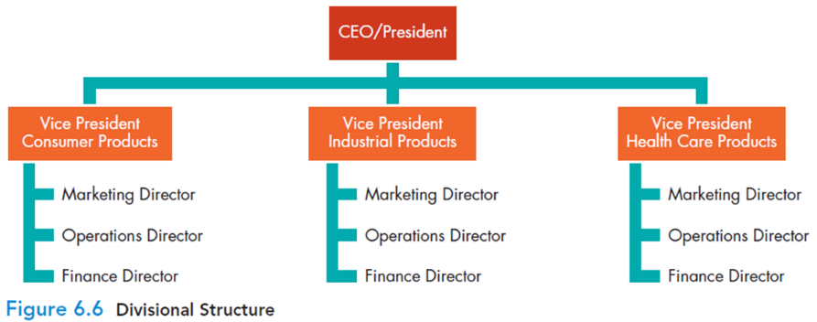

* Matrix structure
* organizational structure created by superimposing one form of structure onto another
* In some companies, the matrix organization is a temporary measure installed to complete a specific project and affecting only one part of the firm.
* In some cases, the matrix org. is a semi-permanent fixture.

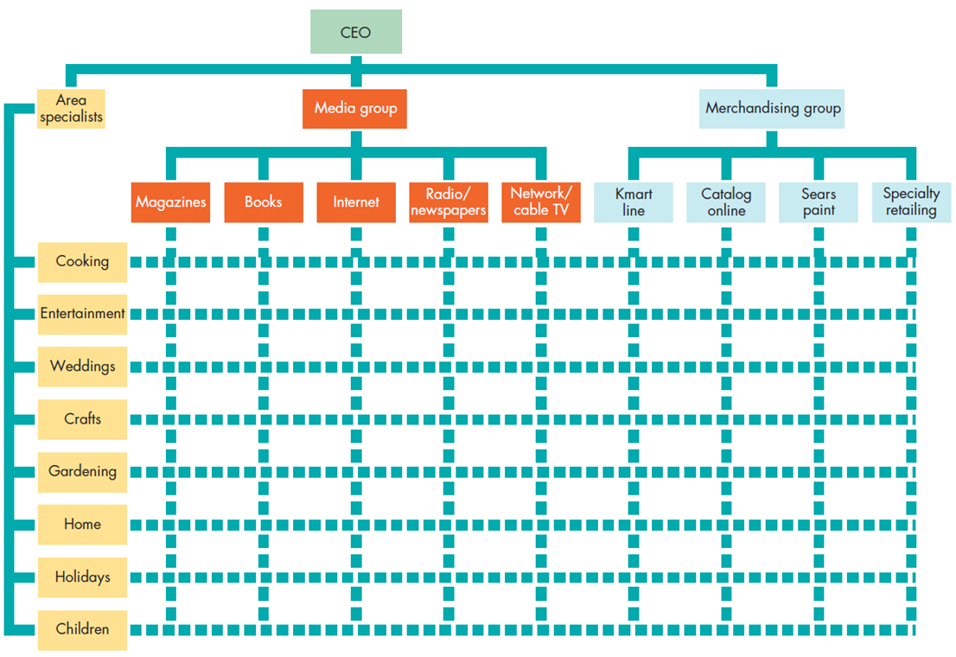

* International Organizational Structures
* Approaches to organizational structure developed in response to the need to manufacture, purchase, and sell in global markets.

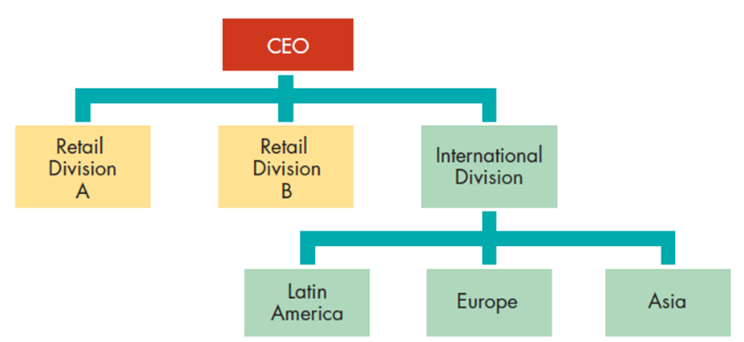

* 3 Organizational Design for the Twenty-first Century
* Team organization: relies almost exclusively on project-type teams, with little or no underlying functional hierarchy.
* Learning organization: works to facilitate the lifelong learning and personal development of all of its employees while continually transforming itself to respond to changing demands and needs (constantly upgrade employee talent, skill and knowledge)
* Goals: superior quality, continuous improvement, performance measurement.
* Virtual organization: has little or no formal structure has only a handful of permanent employees, a very small staff, and a modest administrative facility.

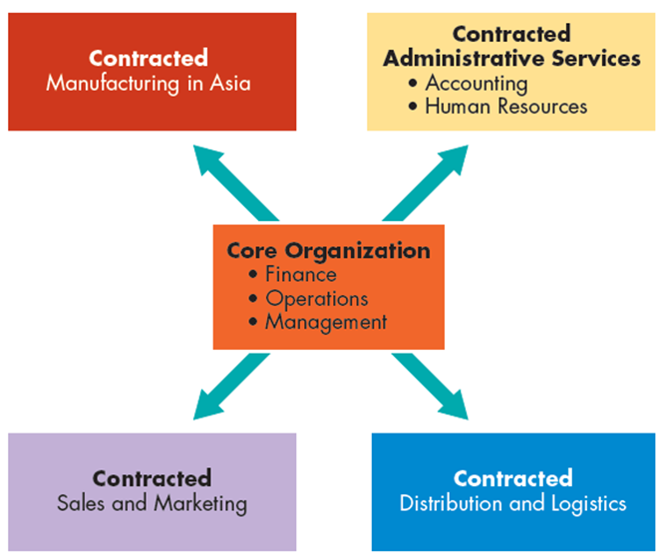

* What is an informal organization?
* network, unrelated to the firm’s formal authority structure, of everyday social interactions among company employees.
* Informal groups: groups of people who decide to interact among themselves.
* What is an Organizational Grapevine?
* informal communication network that runs through an organization (Rumors, gossip chains, cluster chain).
* By maintaining open channels of communication and responding vigorously to inaccurate information, managers can minimize the damage the grapevine can cause.
* What is Intrapreneuring?
* process of creating and maintaining the innovation and flexibility of a small-business environment within the confines of a large organization. (basically is the act of behaving like an entrepreneur while working within a large organization.)
* What are 3 intrapreneurial roles in large org.?
* The inventor: the person who conceives of and develops the new idea
* The product champion: middle manager who learns about the project and becomes committed to it
* A sponsor: top level manager who approves of and supports a project.