Huda okab 1193133

Business notes (chapter 8)

* What is employee behavior?
* the pattern of actions by the members of an organization that directly or indirectly influences the organization’s effectiveness.
* What are the three forms of employee behavior?

1. Performance Behaviors: the total set of work-related behaviors that the organization expects employees to display. (a measurable connection is made between result and the behavior that is required to achieve that result.)
2. Organizational Citizenship: positive behaviors that do not directly contribute to the bottom line. An employee might be a good performer but not a good org. citizen. Number of factors play role in promoting or minimizing org. CB such as Individual (personality and attitudes, needs), social, work groups, corporate culture (appreciation, recognition, reward system)
3. Counterproductive Behaviors: behaviors that detract from organizational performance rather than contribute to it. (basically behaviors as stealing it harms the organization rather than help it)



* Types of counterproductive behaviors
* Absenteeism: When an employee does not show up for work. Sometimes a substitute must be hired to do the job.
* Turnover: Annual percentage of an org. workforce that leaves and must be replaced. Org. incurs cost in replacing workers, lost productivity, training etc... And the reason might be personal, job related, org. related, family aspects etc… and in general poor person job fit is a major cause.
* Theft and sabotage: they result in direct financial costs for an org.
* Sexual and racial harassment: they cost an org. both indirectly (by lowering morale, producing fear, driving off valuable employees) and directly (through financial liability if the org. responds inappropriately)
* Workplace aggression and violence: such as bullying.
* What is the personality that a person should have at work?
* Every individual is unique and different fin their own shape or form.
* Individual differences are personal attributes that vary from one person to another.
* Individual differences may be physical, psychological, emotional.
* Basic categories of individual differences include personality and attitudes.
* What is personality?
* the relatively stable set of psychological attributes that distinguish one person from another.

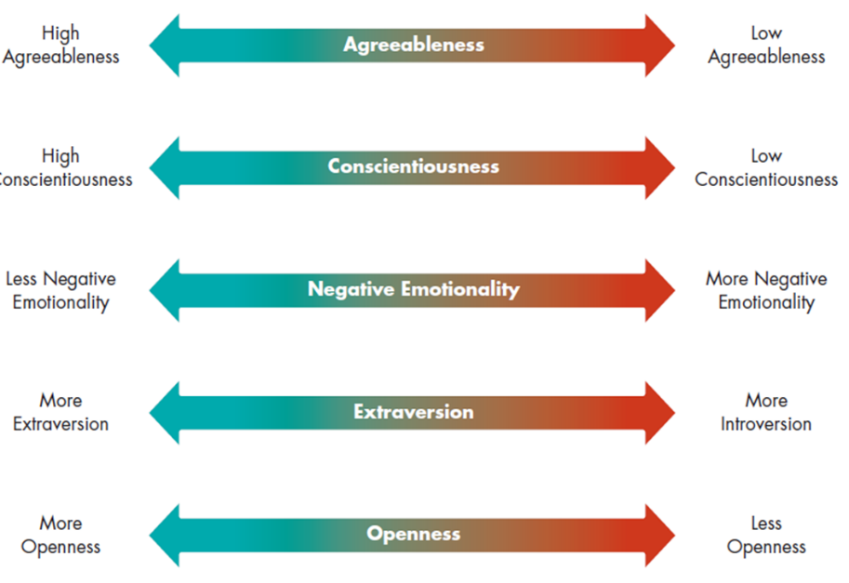

* What are the big five personality traits?
* Agreeableness: A person’s ability to get along with others. (basically treat other people right)
* What is the effects of high and low level agreeableness?
* High level of agreeableness is gentle, cooperative, forgiving, understanding and good natured in dealing with others. These are better at developing good working relationships with coworkers.
* Low level of agreeableness is irritable, short tempered, uncooperative, antagonistic toward other people.
* Conscientiousness: a reflection of the number of things a person tries to accomplish. It refers to the individual’s persistence, dependableness, orderliness
* High conscientious people tend to focus on relatively few tasks at one time, they are more organized, systematic, careful, thorough, responsible and self-disciplined.
* Emotionality: the degree to which people tend to be positive or negative in their outlook and behaviors toward others. (people like to be around positive people and tend to stay away from negative ones)
* People with positive emotionality are relatively poised, calm, resilient, and secure. They might be expected to better handle job stress, pressure and tension. They are more reliable.
* People with negative emotionality are more excitable, insecure, reactive and subject to mood swings
* Extraversion: a person’s comfort level with relationships. (how comfortable a person is)
* Extraverts are sociable, talkative, assertive, and open to establishing new relationships. They tend to be higher overall job performers and more likely to be attracted to jobs based on personal relationships such as sales and marketing positions.
* Introverts are much less sociable, talkative and assertive and more reluctant to begin new relationships.
* Openness: reflects how open or rigid a person is in terms of his or her beliefs (basically how open minded they are)
* People with high levels of openness are curious and willing to listen to new ideas and to change their own ideas, beliefs and attitudes in response to new information. They are often better performers because of their flexibility.
* People with low levels of openness tend to be less receptive to new ideas and less willing to change their minds.
* What is emotional intelligence?
* Emotional intelligence AKA Emotional Quotient: the extent to which people are self-aware, can manage their emotions, can motivate themselves, express empathy for others, and possess social skills. (basically people managing the way they feel)
* Research suggests that people with high EQ may perform better than other especially with jobs that require high degree of interpersonal interaction.
* EQ can be developed.
* These various dimensions can be described next.
* What are the five qualities of emotional intelligence?
* Self-awareness: a person’s capacity for being aware of how they are feeling (More self-awareness allows people to more effectively guide their own lives and behaviors.)
* Managing emotions: a person’s capacities to balance anxiety, fear, and anger so that they do not overly interfere with getting things accomplished
* Motivating oneself: a person’s ability to remain optimistic and to continue striving in the face of setbacks, barriers, and failure
* Empathy: a person’s ability to understand how others are feeling even without being explicitly told
* Social skills: a person’s ability to get along with others and to establish positive relationships
* What are some other personality traits at work?
* Locus of control: The extent to which people believe that their behavior has a real effect on what happens to them. (basically blaming their behavior on their life issues) (HAVING A POSITIVE BEHAVIOR YOU SUCCEED/VISE VERSA)
* What are the two types of locus of control?
* internal locus of control: People who believe that individuals are in control of their lives
* external locus of control: People who think that forces beyond their control dictate what happens to them
* Self-efficacy: A person’s belief about his or her capabilities to perform a task. (high self-efficacy you will do well; low self-efficacy you will do horrible)
* Some people are more self-confident that others. High self-efficacy results in better performance and better focus.
* Authoritarianism: (comes from the word authority) the extent to which a person believes that power and status differences are appropriate within hierarchical social systems such as organizations.
* A highly authoritarian person, accept orders directly from “the boss”, but less authoritarian person, might express disagreement or objections. (واحد بناقش و واحد برد بدون نقاش)
* A highly authoritarian manager may be autocratic and demanding.
* Less authoritarian manager may allow subordinates a bigger role in making decisions.
* Machiavellianism: Used to describe behavior directed at gaining power and controlling the behavior of others.
* More Machiavellian individuals tend to be rational and none emotional, maybe willing to lie to attain personal goals, put little emphasis on loyalty and friendship and enjoy manipulating others’ behavior.
* Less Machiavellian people are more emotional, less willing to lie to succeed, value loyalty and friendship.
* Self- esteem: The extent to which a person believes that he or she is a worthwhile and deserving individual (like confidence)
* A person with high self-esteem is more likely to seek higher status jobs, be more confident in his ability to achieve higher levels of performance and derive greater intrinsic satisfaction from his accomplishment
* A person with low self-esteem is more content with lower level jobs, less confident with his ability, focus more on extrinsic rewards. (tangible and observable)
* Widely studied in other countries (يعني كثير بدرسوا بهاي الموضوع برا)
* Risk propensity: The degree to which a person is willing to take chances and make risky decisions. (يعني يكون جريء)
* A manager with high RP might experiment new ideas and gamble on new products. This manager might be a catalyst for innovation or if the risky decisions prove to be bad, might risk the wellbeing of the organization.
* A manager with low RP might lead an org. to stagnation and excessive conservatism or might help the org. successfully in unpredictable times by maintaining stability and calm.
* البيئة بلعب دور إذا رح ينجح المخاطرة او لا Consequences depends on the org. environment
* What is an attitude?
* Attitude: a person’s beliefs and feelings about specific ideas, situations, or people. They are formed by a variety of forces including personal values, our experiences and our personalities.
* What are some key words related to attitudes at work?
* Job Satisfaction: degree of enjoyment that people derive from performing their jobs, i.e. the extent to which people have positive attitudes toward their jobs. (some people use the word morale instead of job satisfaction.) (basically they love their job and the environment) Job satisfaction is not necessarily related to productivity
* Organizational Commitment: an individual’s identification with the organization and its mission.
* Highly committed person will probably see himself a true member of the firm, overlook minor sources of dissatisfaction, see himself a member of the org., refers to the org. in personal terms such as “we make quality products”
* Less committed person is more likely to see himself as an outsider, referring to the org. in less personal terms such as “They don’t pay well”
* What can a manager do in order to gain employees satisfaction and commitment?

1. Few critical things managers can do to promote satisfaction and commitment:
2. Treat employees fairly and provide reasonable rewards and job security
3. Allow employees to have a say in how things are done
4. Designing new jobs.
5. Understanding and respecting the psychological contracts.

* What is psychological contract?
* set of expectations held by an employee concerning what he or she will contribute to an organization (referred to as contributions) and what the organization will in return provide the employee (referred to as inducements) (basically represents the mutual beliefs, perceptions and informal obligations between an employer and an employee)
* Unlike a business contract, it is not written on paper, nor its terms explicitly negotiated

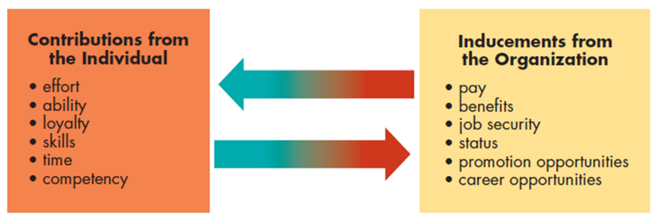

* What is a person job fit?
* the extent to which a person’s contributions and the organization’s inducements match one another (basically getting what is earned)
* A good person-job fit is one in which the employee’s contributions match the inducements that are offered by the org. and it can result in higher performance and more positive attitude.
* A perfect person-job fit when the org. takes perfect advantage of behaviors and abilities, and exactly fulfill needs of employees.
* What is motivation and what are the types of basic motivation theory?
* Motivation: the set of forces that cause people to behave in certain ways. (Mostly positive, like positive energy)
* Managers must understand differences in behavior and reasons for them.
* Over the years, a steady progression of theories and studies has attempted to address these issues.
* The book focuses on three approaches to human relations in workplace: The classical theory and scientific management, Early behavioral theory, and the contemporary motivational theories.
* Classical Theory of Motivation: theory holding that workers are motivated solely by money
* Frederick Taylor approach is known as the scientific management
* He proposed a way for both companies and workers to benefit.
* IF workers are motivated by money, paying them more would prompt them to produce more.
* Meanwhile, the firm that analyzed jobs and find better ways to perform them and would produce goods more cheaply, make higher profits and pay workers higher than competitors
* What is the Hawthorne effect?
* Tendency for productivity to increase when workers believe they are receiving special attention from management (when workers feel as though the mangers are giving extra attention to them)
* Managers and researchers focused more attention on the importance of good human relations in motivating employee performance.
* The major motivation theories are human resources model, the hierarchy of needs model and the two-factor theory.
* What is the X and Y theory?
* Theory X: theory of motivation holding that people are naturally lazy and uncooperative and must be punished or rewarded to be make productive.
* Theory Y: theory of motivation holding that people are naturally energetic, growth-oriented, self-motivated, and interested in being productive Managers are more likely to have satisfied and motivated employees.

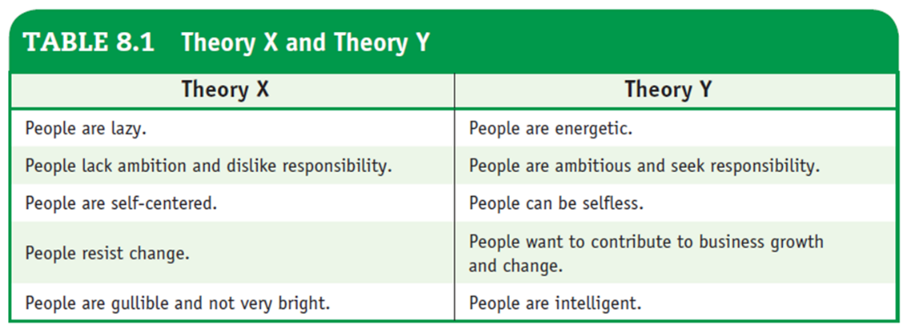

* What is Maslow’s Hierarchy of Needs Model?
* theory of motivation describing five levels of human needs and arguing that basic needs must be fulfilled before people work to satisfy higher-level needs

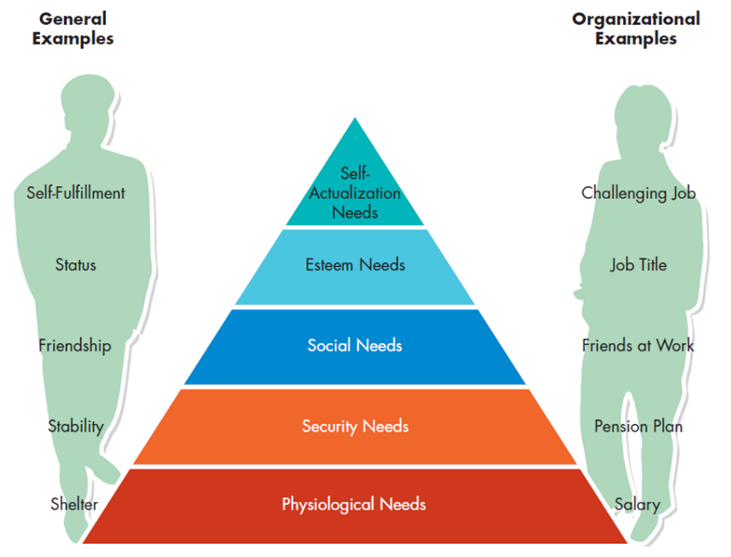

Psychologist Abraham Maslow’s hierarchy of human needs model proposed that people have several different needs that they attempt to satisfy in their work. Maslow classified these needs into five basic types and suggested that they be arranged in the hierarchy of importance. According to Maslow, needs are hierarchical because lower-level needs must be met before a person will try to satisfy higher-level needs.

* What is the two factor theory?
* theory of motivation holding that job satisfaction depends on two factors, hygiene factors (such as working conditions) and motivation factors (such as recognition for a job well done)
* Hygiene factors affect motivation and satisfaction only if they are absent or fail to meet expectations. (environment)
* Motivation factors are related directly to the work that employees perform.
* Two step approach: They must ensure hygiene factors are acceptable, then offer motivation factors.

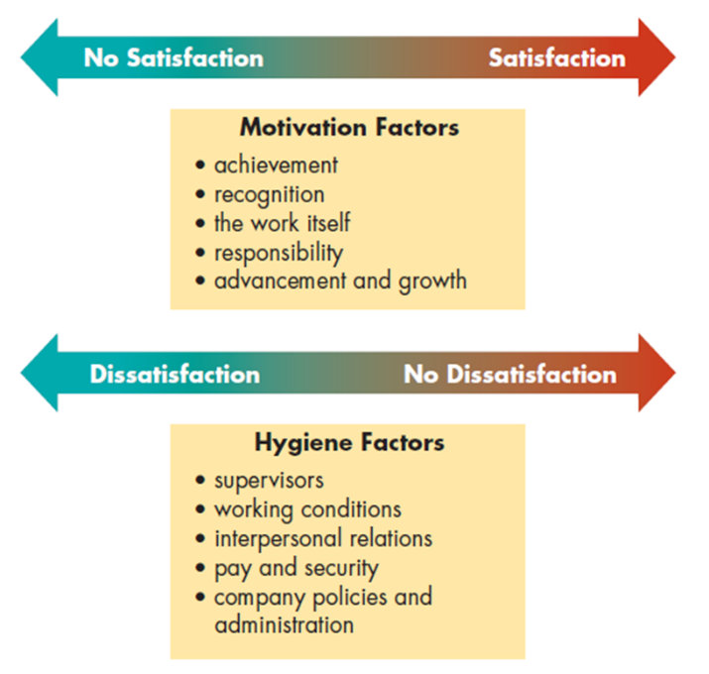

\*Note that motivation factors lie along a continuum from satisfaction to no satisfaction. \*

* What are other important needs?
* Need for achievement: An individual’s desire to accomplish a goal or task as effectively as possible.
* Individuals who have high need for achievement tend to set moderately difficult goals to make moderately risky decisions.
* High need achievers want immediate and specific feedback on their performance. That’s why they take jobs in sales to get immediate feedback from customers, and they avoid jobs like R&D.
* Workaholic
* They assume personal responsibility and find it so difficult to delegate to others, they don’t need assistance.
* Need for affiliation: An individual’s desire for human companionship.
* People with high need for affiliation tend to want reassurance and approval from others and usually are genuinely concerned about others’ feelings.
* They act and think as they believe others want them to
* They work with a lot of personal contact such as sales and teaching.
* Need for power: The desire to control one’s environment, including financial, material, informational, and human resources
* Some people desire power and others avoid it
* People with high need for power can be successful managers when 3 conditions are met:
* They must seek power for the betterment of the org. rather for own interest.
* They must have a fairly low need for affiliation.
* They need plenty of self-control to curb their desire for power when it threatens the org. or interpersonal relationships.
* What is Contemporary Motivation Theory?
* Expectancy Theory: theory of motivation holding that people are motivated to work toward rewards that they want and that they believe they have a reasonable chance (expectancy) of obtaining.
* It explains why people do not work as hard as they can when their salaries are based purely on seniority.

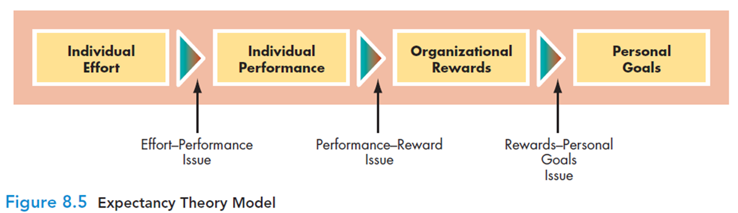expectancy theory in terms of issues that are likely to be considered by an individual employee.

* Equity Theory: theory of motivation holding that people evaluate their treatment by the organization relative to the treatment of others. Similar to the psychological contract When treated inequitably, some do constructive actions and some not so constructive.

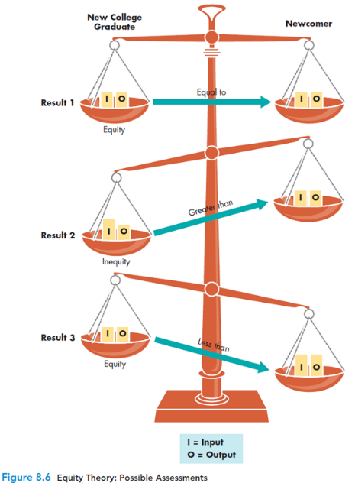When employees compare their own ratios with those of other employees, they ask whether their ratios are equal to, greater than, or less than those of the people with whom they are comparing themselves. Depending on their assessments, they experience feelings of equity or inequity. illustrates the three possible results of such an assessment.

* Strategies and techneiques for enchancing motivations
* One part of manager’s job is to know what motivates workers, the other part is to apply that knowledge.
* Managers try to influence workers’ behavior through systematic rewards and punishments.
* They want to encourage specific behaviors and they want to eliminate others.
* What are some reinforcement and behavior modifications?
* Positive Reinforcement: reward that follows desired behaviors. A manager wants to encourage desired behaviors such as working hard, helping others.
* Punishment: unpleasant consequences of an undesirable behavior It is designed to change behavior
* Social Learning: Learning that occurs when people observe the behaviors of others, recognize their consequences and alter their own behavior as a result.
* Using goals to motivate behavior
* Performance goals are commonly used to direct and motivate behavior, the most frequently used method is MBO
* What is MBO?
* Management by Objectives (MBO)
* set of procedures involving both managers and subordinates in setting goals and evaluating progress Collaborative goal setting, extends from top of org. to bottom. Motivational impact is the biggest advantage of MBO.
* What is Participative Management and Empowerment?
* method of increasing job satisfaction by giving employees a voice in the management of their jobs and the company They become empowered to take greater responsibility for their own performance. This also makes employees feel more committed to org. goals they have helped to shape. It can be used in large or small firms. Such program doesn’t fit everyone, some people feel may be frustrated or dissatisfied her especially when participation is symbolic and not substantive.
* What are team structures?
* Using teams in org. increase motivation and enhance and enhance job satisfaction
* They are less effective in traditional and rigidly structured bureaucratic org.
* They help smaller, more flexible org. makes decisions more quickly and effectively, enhance communication, encourage org. citizenship.
* However, teams are not for everyone.
* What is job enrichment and redesign?
* Job Enrichment: method of increasing job satisfaction by adding one or more motivating factors to job activities E.g. job rotation, they gain new skills and broader overview of their work and their org. OR increasing responsibility or recognition.
* Job Redesign: method of increasing job satisfaction by designing a more satisfactory fit between workers and their jobs Different people want different things from their jobs. It motivates individuals with strong needs for career growth or achievements.
* What are some job redesign programs?
* Combining Tasks: involves enlarging jobs and increasing their variety to make employees feel that their work is more meaningful
* Forming Natural Work Groups: help employees see the importance of their jobs in the total structure of the firm
* Establishing Client Relationships: letting employees interact with customers
* What are some modified work schedules?
* Work Sharing (Job Sharing): method of increasing job satisfaction by allowing two or more people to share a single full-time job
* Flextime Programs: method of increasing job satisfaction by allowing workers to adjust work schedules on a daily or weekly basis
* Alternative workplaces: Teleworking or telecommuting
* Telecommuting: form of flextime that allows people to perform some or all of a job away from standard office settings
* Advantages and Disadvantages of Modified Schedules and Alternative Workplaces
* Advantages
* more satisfied, committed employees
* More freedom in personal and professional lives.
* reduced stress
* improved productivity
* Less traffic congestion
* No lost work time.
* Higher level of commitment and job satisfaction
* Disadvantages
* challenging to coordinate and manage
* poor fit for some workers
* lack of network and coworker contact
* lack of management belief