

**Business Administration Department**

**BUSA2301 – Course Project**

**Project: Online Shopping System**

|  |  |
| --- | --- |
| **Student Name** | **Student Number** |
| Majd Khasib | 1162331 |
| Ihab Abdelkarim | 1150477 |
| Bader Anini | 1150691 |
| Hamed Hijazi | 1151849 |
| Motaz Shelleh | 1160834 |
| Mohammad Abed | 1162016 |

**Supervised by: Dr. Sahar El Jallad**

**3 December 2019**

## 

## Executive Summary

Online trading is starting to take over a large portion of the market these days. As opposed to traditional trading, buying and selling products online could save a huge amount of expenses while offering new products with unmatched diversity and availability. In this project, we want to build a fully online system that enables users with ease to browse and order products available through the platform and for sellers to offer whatever they want to sell stock or used.

In general, products are to be delivered from the seller to warehouses where they get stored, and from there to the buyer who ordered it through the system.

We propose "Smart Online Shopping", an e-commerce platform to serve a wide variety of customers worldwide, we aim to deliver top-notch products from our partnering brands, merchants and sellers to customers efficiently and reliably.

This project can create many job opportunities and have the opportunity to enhance the overall trading experience for people in Palestine and can take advantage and lead the online shopping as there are no general-purpose online shopping systems in this country and all the existing ones are specialized in few genres of products.

Table of Contents

1. Defining the Project 1

1.1 Project Scope 1

1.1.1 Project objectives 1

1.1.2 Deliverables 2

1.1.3 Milestones 3

1.1.4 Technical Requirements 4

1.1.5 Limits, and exclusions 5

1.2 Project Priorities 7

1.3 Work Breakdown Structure 9

1.4 Coding the WBS 10

2.Estimating Project Times and Costs 11

3. Developing a Project Plan 12

3.1 Resource Allocation 12

3.1.1 Merchants and Shop Owners 12

3.1.2 Platform Customers 13

3.1.3 Technological Resources 14

3.2 Organizational Hierarchy 15

# 

# 1. Defining the Project

## Project Scope

### Project objectives

The overall objective of this project is to develop a new and convenient way of selling and trading to overcome the limitations of traditional shopping while offering full logistic support from storing delivery and tracking. Specific objectives are:

* To facilitate the operation of buying goods for the customers, meaning that they can at any time browse offered products and order whatever they want online, thus getting rid of time and place limitations forced by traditional shopping.
* To connect sellers and buyers easily through the system without the need for any physical interaction. This includes automated payment process and private messaging between customer and seller, anywhere and anytime.
* To give people a chance to sell used items through the system by opening a seller account and offering these items with the prices they choose and with a declared current state of the product.
* Increasing the availability and variety of products among customers. Users will have more options with higher quantities and different qualities since the products offered are from sellers from all over the country and are stored in localized warehouses.
* To create a good number of jobs for people in the country. These jobs include operations, loading and receiving in warehouses as well as delivery and customer support.
* To attract local shops to move fully or partially online through our system, and attract new shops to quickly start their business online as this helps both in avoiding rent and maintenance costs and makes their job much easier.
* To provide an automated recommendation system to customers that gives them suggestions of products to buy based on their history and on the rating of the product and seller. Buyers can rate the products when they buy it which helps other customers know the overall quality of the offered products.

### Deliverables

In general, the overall deliverable of the project is an online system that is used to browse and order products to be delivered, as well as selling products through the platform. The specific deliverables are:

* An online platform that shows the products available for buying along with their details including descriptive pictures or videos of the actual product, different options of it, prices, specifications and manuals for devices, as well as other important product information. The platform also shows the quantity available of each product, and seller information including contact details and the list of the products he offers.

Users of the platform will be able to search, sort and filter products through the platform and choose one or more products with the quantity they want to order and confirm it and choose a location of delivery and payment option.

The platform is to be designed for both web and mobile.

* A way for anyone who wants to sell a product online to open seller account through the platform and fill in his info and start offering his list of products with their details and availability and prices. The storage of the offered product can be taken care of using localized warehouses throughout the country.
* A way for the already existing local shops to offer their products online through the platform, thus reaching many more customers so that both can benefit from this high availability and variety of the products offered.
* A delivery system that takes care of receiving the products from sellers and moving it to the desired warehouses according to the target region, the delivery system also takes care of delivering the products from warehouses to the location chosen by the buyer when ho ordered through the platform. This delivery system is provided by an advanced tracking system that reports the state and location of the order through its delivery timeline as well as the expected arrival time.
* A way for selling or exchanging used/secondhand items through the platform such that sellers find a way of offering these used items to a large number of customers who may be interested in it and offers cheaper options to all users. Such items or products can be stored in customs warehouses for used products and be delivered to buyers through the delivery system.

### Milestones

**Milestone 1:** Finishing the feasibility study and making precise time and resource estimations for the Project along with assigning roles to several personnel. Where project plans have a specific start date, corresponding to the start of the first task, and specific end date, corresponding to the end of the last task.

**Milestone 2:** Pitching the idea to local stores and merchants to obtain their approval to join and contribute to the online shopping platform.

**Milestone 3:** Reserving warehouse locations and having them arranged to be used for product storage: Inventory management is a difficult and complex process, especially when the number of products offered in the store is high. Sales and shipment to the customer, including inventory control for each product and accompanying alerts.

**Milestone 4:** Developing a web-based application, which provides the main services, and objectives that we wish to provide through our project using the formal transformation model with.

**Milestone 5:** Introduce the application to the involved stores and merchants while moving their products to the warehouse for distribution to customers.

**Milestone 6:** Advertising the platform through social media, posters and public meetings and talks. Some paid advertisements can also be made to publish this application.

**Milestone 7:** Extending the online platform to a mobile application, giving users a seamless selling, and buying experience within the palms of their hands, thus the application can be accessed by phone making it easier for users.

### Technical Requirements

* Nowadays many people use e-commerce and online shopping. Therefore, the application that we do must be for such functions of high quality and excellent performance because it is very much linked to the number of sales of this application, and the fact that the application must do a lot of things with high performance in order to facilitate the user to make the purchase, and the most important of these things is the speed of application That's where the studies described it "A One-second Improvement Equals a Two-percent Conversion Rate Boost".
* The application should include the largest number of languages so people can use it in all regions of the world in order to provide self-service support in the languages spoken by your customers. This can be done in a number of ways, including the help center for the application, to work in multiple languages and determine the languages to be supported such as Arabic and English, then all your groups, sections and articles will have the option to add a translated version for each language It is easy to manage, and easy for visitors to navigate, whatever language they use.
* When your customers run into a problem with your product, they contact your support team. Whether the problem is a “user” error, a bug or technical issue, it doesn’t matter to them, they just want it solved so they can continue their work. For example, such sentences are placed:

- If you cannot log in to your product? Contact technical support.

- Feature or unit does not work as you normally do? Contact technical support.

If you don’t have a tech support team in place to answer these questions, then customers will eventually stop using your product. And this leads to higher churn rates.

Put simply, if you run a product-based business, and then technical support is crucial to your overall success.

* The site must support the refund policy in case the products did not reach their owners or arrival of goods is damaged or the goods are not as in the description, in this case, the application gives the user several options, namely the refund of money (if not arrived) or the recovery of goods (if arrived Unsatisfactory) or an agreement between the seller and the customer on a discount given by the seller to the buyer
* Be sure to provide a fast and permanent connection to the Internet before starting any step of shopping, and this contributes to the completion of the shopping process in a successful manner.

### 1.1.5 Limits, and exclusions

In reality, there are some limitations when considering an online shopping system, but all of them can be overcome with good planning and management. These limits are:

* Online shopping has strong local and global competition: it is undebatable that there are many well-known global online shopping systems like Amazon and eBay that are huge and offer variety of options with very good prices, users still have to pay import fees when shopping globally but the prices sometimes can still be competing and the offered products there may not be available here. For the local online shopping systems, there are some available which will form a competition. The variety and the price of the products, as well as the convenience of the system and the delivery, are the things online systems compete for.
* The ability to convince stores and merchants to extend their business to the platform: it is not always possible to make owners of the local stores move online. It may be more convenient for them and even cheaper but they will not trust that kind of work, they may also be not interested in delivery or in keeping their products in warehouses for some reason, or they simply prefer to keep their working business as is without changes.
* Obstacles in reserving warehouses for storage with the desired sizes and locations: for efficient delivery and storage, warehouses are needed to be as planned or things may go wrong, unfortunately, this is not always the case. Finding and reserving places for warehouses that are in the location and size needed may cost more money than planned or may not even be available.
* Handling multiple simultaneous orders with limited delivery resources: this case can happen at any time during the actual operation of the project. The number of concurrent users at any moment can be predicted up to a certain extent and could be underestimated if this happened the resources allocated will only be enough to satisfy the underestimated number thus causing delays in some deliveries or cancelation of another.
* Obtaining the required funding and investment for the project: this could happen if the investors for some reason were not convinced by the plan if there is anything not clear to them or may not like the advertisement campaigns. This could lead to failure of the project or waiting for an extended time to look for other investments or work on the development of the planning or advertising.
* Dealing with spam reviews and false payment information and scamming attempts: this problem may be the most occurring in the online shopping systems. Scammers who offer fake products by putting forged or unoriginal photos or wrong description or high price may be able to deceive customers who will not be satisfied after the process. The fake review also plays an important role in deceiving customers and giving a positive picture of a product that is not that good.

## Project Priorities

The main part of any project management is to set the priorities that we need to consider. These priorities can be divided into four groups: urgent and important, not urgent but important, urgent but not important and not urgent and not important.

In our project, the urgent and important part is to find the appropriate warehouses in terms of the size, location, and price, this activity is considered important because we need a place to store the goods before displaying it on the platform. Also creating our platform is required to be finished as fast as possible, the faster the website is finished the faster the business start making income. We also need to build a development team to develop the website.

Another important activity but less urgent is to convince merchants and storeowners to use our platform for their businesses, this activity is very important because it’s a major part of the income, but it can be delayed if needed until the platform is finished. Also, the addition of a mobile platform is important but can be focused on after finishing the main website. Another activity that is important is the advertisement part we must advertise our platform but we cannot do it before finishing other parts first.

Some activities are considerednot important and not urgent like getting the storeowners and merchant feedback for the platform, this activity can be neglected if the resources and the budget cannot afford it.

Urgent but not important activities are the ones that don’t affect the business goals but is needed to be done like responding to emails and calls from stakeholders and listening to their suggestions, also providing progress reports for the interested people in this project.

## **Work Breakdown Structure**

The following Figure shows the WBS structure of the system:

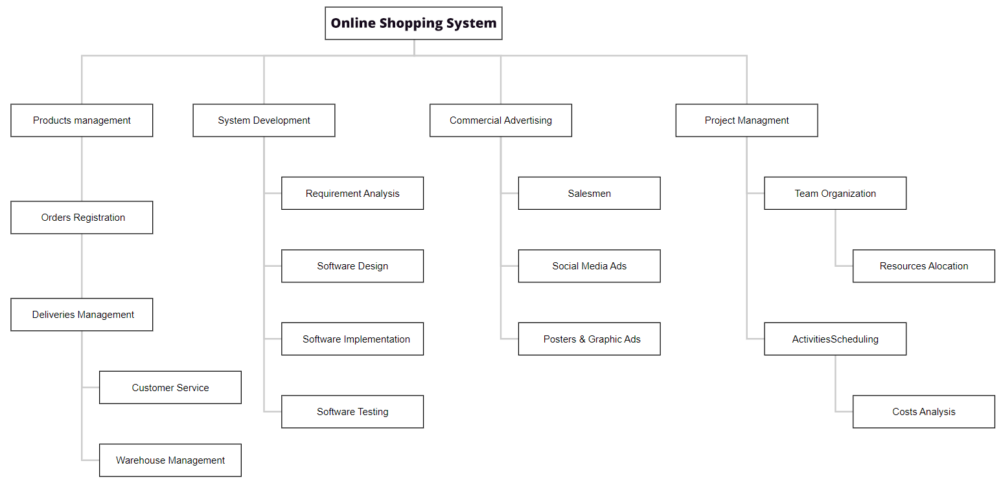

**Figure 1.3:Work Breakdown Structure of the Project.**

## Coding the WBS

The outline of the project will start with the management of the project, where it starts with activities and teams management, and ends with the integration of the final software application of the system

1. **Project Management**
   1. **Team Organization**
      1. **Resources Allocation**
   2. **Activities Scheduling**
      1. **Cost Analysis**
2. **Commercial Advertising**
   1. **Salesmen**
   2. **Social Media Ads**
   3. **Posters & Graphic Ads**
3. **System Development**
   1. **Requirement Analysis**
   2. **Software Design**
   3. **Software Implementation**
   4. **Software Testing & Integration**
4. **Products management**
   1. **Orders Registration**
      1. **Deliveries Management**
         1. **Customer Service**
         2. **Warehouse Management**

# 2.Estimating Project Times and Costs:

The following table shows the estimated costs (in shekel ₪) and duration of each task in (days) of the project Major tasks and corresponding activates.

|  |  |  |  |
| --- | --- | --- | --- |
| Task Number | Task Title | Duration | Cost |
| O-4 | **Products management** | **63** | **153455 ₪** |
| O-4.1 | **Orders Registration** | **10** | **24358 ₪** |
| O-4.1.1 | **Deliveries Management** | **8** | **19486 ₪** |
| O-4.1.1.1 | **Customer Service** | **15** | **36537 ₪** |
| O-4.1.1.2 | **Warehouse Management** | **30** | **73074 ₪** |
| D-1 | **System Development** | **165** | **401907 ₪** |
| D-1.3 | **Requirement Analysis** | **60** | **146148 ₪** |
| D-1.1 | **Software Design** | **40** | **97432 ₪** |
| D-1.2 | **Software Implementation** | **40** | **97432 ₪** |
| D-1.4 | **Software Testing** | **25** | **60895 ₪** |
| T-2 | **Commercial advertising** | **36** | **87688 ₪** |
| T-2.6 | **Salesmen** | **16** | **38972 ₪** |
| T-2.4 | **Social Media Ads** | **10** | **24358 ₪** |
| T-2.5 | **Posters & Graphic Ads** | **10** | **24358 ₪** |
| O-3 | **Project Management** | **21** | **51150 ₪** |
| O-3.1 | **Team Organization** | **5** | **12179 ₪** |
| O-3.1.1 | **Resources Allocation** | **3** | **7307 ₪** |
| O-3.2 | **Activities Scheduling** | **7** | **17050 ₪** |
| O-3.2.1 | **Costs Analysis** | **6** | **14614 ₪** |
| Total |  | **285** | **694200 ₪** |

# 3. Developing a Project Plan

After defining the specific work breakdown structure along with setting the exact deliverables of the project, project planning comes in order to layout the **resource allocation** and **organizational hierarchy** to achieve our goals. While other elements of project planning have been implicitly covered in previous sections, in this section, we’ll focus on the three mentioned aspects of project planning to demonstrate our desired strategy in fulfilling the project’s goals and objectives.

## 3.1 Resource Allocation

As previously mentioned, the proposed online shopping platform concerns many stakeholders who require a variety of resources to be available in order to successfully carry out their needs. Resource allocation can be discussed in terms of stakeholders' needs, in which it can be divided into allocation regarding **merchants and shop owners, platform customers (buyers and sellers),** and finally **physical storage and technological resources**.

### 3.1.1 Merchants and Shop Owners

Merchants and shop owners shall be our most valuable asset, as they form the main source of supplies that flow into our platform’s warehouses, which are then sold to customers all around. For these stakeholders, the required resources which are to be available before approaching any advanced stage of the project could be:

* An initial budget for the acquisition of the shop's products
* Vehicles to facilitate the operation of moving their products to our warehouses
* Lifting and material handling workers (3 – 5 per shop)
* Transportation personnel and operations management to assure the success of product transfer

Obtaining the approval of the shop owners to join the platform is one of the initial milestones of the project. Consequently, making sure that the above resources are available as soon as possible is a crucial part of the project plan.

### 3.1.2 Platform Customers

### Customers logging into our platform are the main individuals responsible for performing the required transactions which keep the business running. While planning the project, it is important to allocate the required resources which guarantee customer satisfaction from the beginning, whether it be buyers trying to purchase items or sellers looking to sell second-hand goods. Consequently, the resources needed to satisfy such customers are as follows:

* Transportation-related resources to collect and deliver items from and to customers
* Customer service employees and operators

### 3.1.3 Technological Resources

There is no doubt that our platform is to deliver an online web-based application that allows customers to seamlessly buy and sell products. As mentioned, the products are collected in various ways and stored in multiple warehouses up until they are ordered for distribution. The project plan also requires the reservation of data storage centers and hosting platforms in which we are able to store all the data related to our application. The resources needed here mainly are:

* Warehouses for product storage
* Data storage resources such as local servers and cloud platforms
* Devices and equipment needed for the development of the application
* The initial budget for software engineers

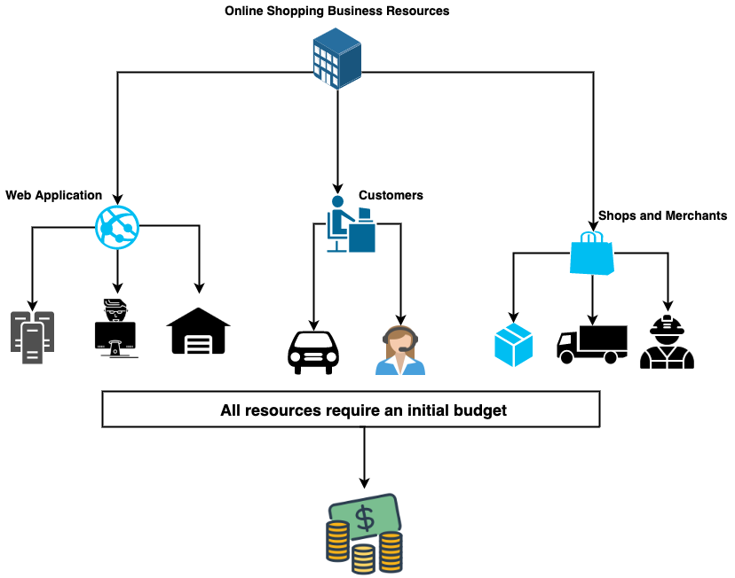

**Figure3.1.3: Resources allocation for the online shop.**

## 3.2 Organizational Hierarchy

The remaining aspect of project planning is formalizing a valid organizational hierarchy which in turn divides roles among the business’s employees. In our case, the hierarchy of roles is thoroughly depicted in the following Figure:

­

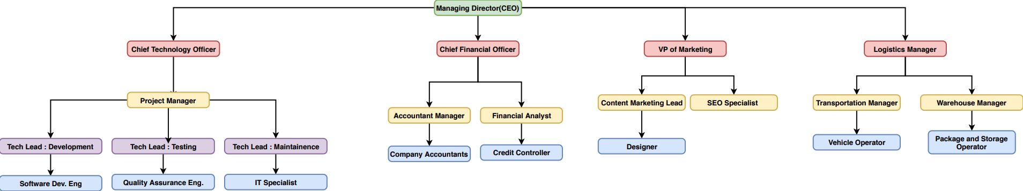

**Figure3.2: Organizational Hierarchy of the online shop.**