**Financial Reports**

every company is required to submit a **financial report** every year to the government, potential investors, and shareholders to report the financial health of the company and its potential to grow in the future. This section will describe all about a balance sheet, a profit and loss account and some key numbers that you can use to assess a company situation.

**Balance Sheet**

A balance sheet is a legal document showing the quantity of a company’s assets and liabilities and it is usually **issued at the end of a company’s financial year**. However, companies in the stock markets are required to send their balance sheets to the public every quarter. This may depend on the existing regulations of particular countries in which the companies operate.

In a balance sheet, a company’s assets are equal to the summation of a company’s liability and a company’s equity.

**Asset = Liabilities + Equity**

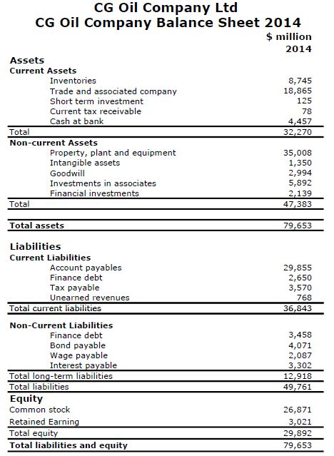

**Figure 1**– Example of Balance Sheet

According to Figure 1, Total assets in 2014 are 79,653 million $ equates to the summation of liabilities (49,761 million $) and equity (29,892 million $).

Please be reminded that the balance sheet is a capture of a company’s financial status at a reporting time and it may change dramatically due to several factors. It is the risk of investors to evaluate and estimate a company’s future monetary health based on this document alone.

**Assets**

Assets are divided into two types, which are non-current assets and current assets.

**Current assets:**They are assets of a company that can reasonably be expected to be converted into cash within one year from a date shown in a balance sheet. The current assets of CG Oil Company in 2014 are 32,270 million $.

**Non-current assets:**They are assets of a company that are not likely to turn into cash within one year from a balance sheet date. It can be known as “long-term assets.”  The non-current assets of CG Oil Company in 2014 are 47,383 million $.

Total assets (79,653 million $) = Current assets (32,270 million $) + Non-current assets (47,383 million $)

**Liability**

A liability means a company’s legal debts or obligations occurred when the company does its business. Two types of liabilities are current liabilities and non-current liabilities.

**Current liabilities:** They are debts payable within one year. The current liabilities of CG Oil Company in 2014 are 36,843 million $.

**Non-current liabilities:**They are debts payable in a longer period than one year. The non-current liabilities of CG Oil Company in 2014 are 12,918 million $.

Total liabilities (49,761 million $)) = Current liabilities (36,843 million $) + Non-current liabilities (12,918 million $)

**Equity**

Equity is the value of assets after paying all liabilities of a company. It has a relationship like this:

**Equity = Assets – Liabilities**

From this example, CG Oil Company has a total equity of 29,892 million $.

All of the figures that you see from a balance sheet may not represent how healthy a company is. The best way to verify a financial situation of a company is to use some accounting factors. We will describe this in a later article.

**Profit and Loss Account**

A profit and loss account is a financial statement that summarizes revenues, costs and expenses occurred during a specific period of time. The profit and loss account is more dynamic than the balance sheet because it shows where the money comes and goes in a company during a given period. Figure 2 shows the profit and loss account of CG Oil Company in 2014.

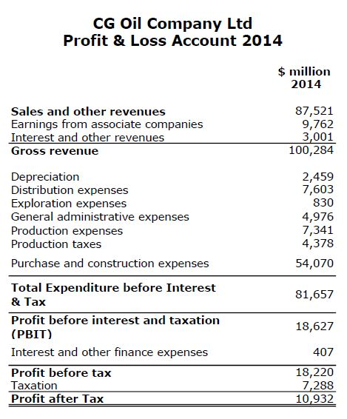

**Figure 2** – Profit and Loss Account

**Refere**

* ***0***

*Shares*

Tagged [account](http://www.drillingformulas.com/tag/account/), [Balance Sheet](http://www.drillingformulas.com/tag/balance-sheet/), [Financial Statement](http://www.drillingformulas.com/tag/financial-statement/), [loss](http://www.drillingformulas.com/tag/loss/), [profit](http://www.drillingformulas.com/tag/profit/). Bookmark the [permalink](http://www.drillingformulas.com/basic-knowledge-of-financial-statement-balance-sheet-and-profit-and-loss-account/).