Chapter Seven. Process Design.

Discussion Questions
1. Process strategy is the organization’s approach to transforming resources into goods and services.
2.
Product | Likely Process
(a) Beer | Product Focused/Continuous
(b) Wedding invitations | Process Focused/Job Shop
(c) Automobiles | Modular/Repetitive
(d) Paper | Product Focused/Continuous
(e) “Big Mac” | Modular/Repetitive
(f) Custom Homes | Job Shop with components made  in Product Focused and Modular  facilities
(g) Motorcycles | Modular/Repetitive
3. Service blueprinting is a process analysis technique that focuses on the provider’s interaction with the customer.
4. Process redesign reengineering is the rethinking and radical design of business processes to bring about dramatic improvements in performance.
5. Techniques for improving service productivity include separation, self-service, postponement, focus, modules, automation, scheduling, and training.
6. The four quadrants are:
(1) Mass service (low interaction/customization; high labor intensity)
(2) Professional service (high interaction/customization; high labor intensity)
(3) Service factory (low interaction/customization; low labor intensity)
(4) Service shop (high interaction/customization; low labor intensity)
7. CIM (computer-integrated manufacturing) in its ideal but seldom realized form, ties together computer-aided design (CAD), computer-aided manufacturing, flexible manufacturing systems (FMS), the necessary automated storage and retrieval systems (ASRS) and movement of materials (automated transfer machines or automated guided vehicles [AGVs]) to make it all work.
8. In process-control systems sensors collect data; analog devices read data on a periodic basis; measurements are digitized and transmitted to a computer; data are analyzed; and output is presented in various signals, charts, diagrams, messages, etc.
9. Manufacturing firms in each of the process models:
- Process focus, your local print shop, Kinko’s.
- Repetitive focus, Harley-Davidson
- Product focus, Frito-Lay
- Mass customization, Dell Computer
10. Competitive advantage of manufacturing firms in each of the process models:
- Process focus, differentiation, and expertise in each process area (Kinko’s)
- Repetitive focus, rapid response, and efficiency (Harley-Davidson)
- Product focus, very low variable cost (Frito-Lay)
- Mass customization, low cost, rapid response to unique customer demands (Dell Computer)
11. Students may find Figure 7.1 and Figure 7.8 and the related discussions helpful with this question. Service firms in each of the process models:
- Process: Your local general-purpose hospital; also most construction firms, such as Bechtel
- Repetitive: Fast-food restaurants
- Product: Shouldice Hospital
- Mass customization: Cafeterias and online stockbrokers, such as Schwab
12. Competitive advantage of service firms in each process model:
- Process focus for a general-purpose hospital: specialization of expertise in each hospital discipline, x-ray, physical therapy, blood lab, etc., by both the technician and supervision.
- Repetitive focus: High-quality modules as in most fast-food (very limited menu) restaurants, and law clinics—with the low cost of the uncontested divorce.
- Product focus: Southwest Airlines and online stockbrokers may be good examples of low-cost advantage.
- Mass customization: Per the text, McDonald’s is trying this in a limited way. Charles Schwab seems to be effective at this in the financial services areas. They seek competitive advantage via low cost and high customization.
13. Numerically controlled machinery means the equipment is computer controlled via programming languages. As an added note, machinery with its own programmable computer is sometimes called computer numerically controlled (CNC), implying that there is computer memory at the machine. Machines that are wired to a central machine are called direct numerically controlled (DNC) machines.
14. In an automatic identification system (AIS), bar codes, radio frequency (RF) signals, and optical signals improve both accuracy and speed of data entry contributing to productivity. For instance, costs are reduced because clerks spend less time keying in prices and quantities and do so with fewer errors. New services are being developed as these systems collect more information about customer behavior.
15. Technological advances include numeric control, process control, vision systems, robots, automated storage and retrieval systems, automated guided vehicles, flexible manufacturing systems, and computer-integrated manufacturing (CIM).
16. A flexible manufacturing system (FMS) usually refers to the manufacturing element (a subsystem) within a larger computer-integrated manufacturing (CIM) system. A CIM includes elements of computer-aided design, computer-aided engineering, computer-aided drafting, production, inventory control, etc., as well as flexible manufacturing systems.
17. CAD data generates design data, but can also generate instructions for NC machines. If the NC machines are connected (integrated) with other NC machines and material handling equipment such as AGVs or conveyors or other transfer machines, the entire system is considered a flexible manufacturing system.
Ethical Dilemma
For a nice class discussion exercise, all you need is an animal rights advocate to really get things going. Most students will agree that this is not a nice way to treat animals.
However, to get things in perspective, you might point out that much egg production is also handled this way with chickens in small cages, and although we do not put steers in cages, we do confine them to feedlots, and most bulls become steers. The advantage to society is that food (pork in this example) is prepared very economically, bringing lower-cost food and some protein to those who might not otherwise be able to afford it. (Lack of protein is acontributor to limited mental development.) The violence reaped upon animals in the food chain is not confined to what homo sapiens do to hogs. Animals reap violence on others in their food chain.
Virtually all of those cows grazing peacefully in pastures and chickens looking quaint in farmyards will come to a violent end. That violent end is often why the investment is made in them.
The alternatives are expensive; we don’t even take very good care of many animals in zoos.
Active Model Exercise
ACTIVE MODEL 7.1: Crossover Chart
1. Suppose Kleber Enterprises wants to lower the point of indifference between Software A and Software B to 2,000 units. What would the Fixed costs need to be for Software B?
$270,000
2. Examine the graph. If the expected volume is 1,500 reports, which process should be used?
Software A
3. Examine the graph. If the expected volume is 15,000 reports, which process should be used?
Software C
4. As the fixed costs for developing Software B drop, what happens to the graph?
The cost line for B drops and the area between the break-even points for B widens. There is a wider range of volume over which Software B is the best choice.
End-of-Chapter Problems
7.1 | (a) A fun topic, as students will add a lot of waiting. Flow is, of course, dependent upon the school but usually includes the following:  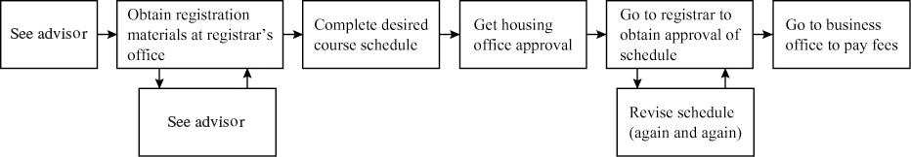  (b) Flow diagram for a car wash:  (c) Flow diagram for a shoe shine (customer perspective, a very different diagram would be prepared for the operator):
7.2 | 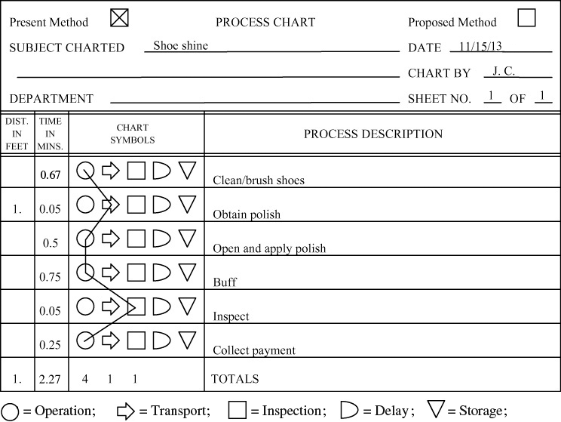
7.3 | A service blueprint for ashoe shine. (For a discussion of thisparticular application, see G.L. Shostack “Designing Services thatDeliver,” Harvard Business Review 62, no. 1, (Jan.–Feb. 1984):133–139.)  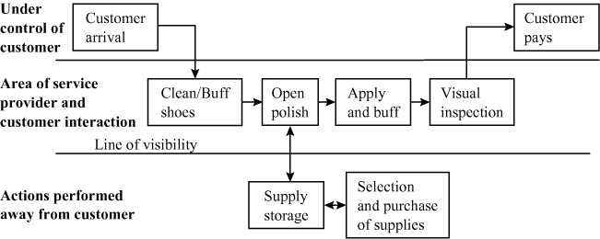
7.4 | Time function map of a shoe shine:  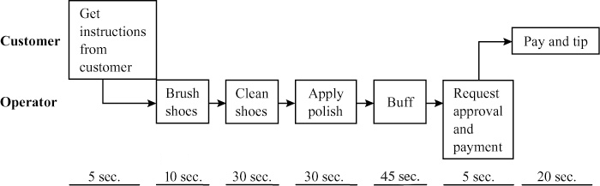
7.5 | GPE’s total cost = $3,100,000 = [($15 × 200,000)  + $100,000]  FMS’s total cost = $3,000,000 = [($14 × 200,000)  + $200,000]  DM’s total cost = $3,100,000 = [($13 × 200,000)  + $500,000]  The total cost for the flexible manufacturing system is lowest
7.6 | 15x + 100,000 = 14x + 200,000. Therefore,  x = 100,000  14x + 200,000 = 13x + 500,000. Therefore,  x = 300,000  GPE is best below 100,000.  FMS is best between 100,000 and 300,000.  DM is best over 300,000.
7.7 | The optimum process will change at 100,000 units and 300,000 units, as shown in Problem 7.6. If total units are 600,000 (3 years × 200,000), then DM has the lowest cost.
7.8 | Based on the solution to Problem 7.6,  at 75,000 units, use GPE  at 275,000 units, use FMS  at 375,000 units, use DM
7.9 | (a) Values to aid in plotting the graph below:  (b) At 6,881 gears, either choice would have the same cost (indifference point)  4x = 15,000 + 1.82x  4x – 1.82x = 15,000  2.18x = 15,000  x = 6,881 = the exact quantity at the crossover point
  Units | Stan’s Costs | Salt Lake Supply Costs
  0 | 15,000 | 0
  10,000 | 18,200 + 15,000 | 40,000
7.10 | (a)  (b) At 3,000 boards, costs are:  Plan A: 800 + (1.10)(3,000) = $4,100  Plan B: 1,100 + (.70)(3,000) = $3,200  Plan C: 1,800 + (.40)(3,000) = $3,000  So, at 3,000 board, plan C is the low-cost plan.  (c) Crossover points:  First, 800 + 1.10x = 1,100 + .70x  .40x = 300  x = 750  Second, 1,100 + .70x = 1,800 + .40x  .30x = 700  x = 2,333  So, between 1,000 and 2,000 boards, plan B is best.
   | Units | At 0 Units | At 4,000 Units  (arbitrary  number)
  (A) | Y = 800 + 1.10x | 800 | $5,200 | Refurbish
  (B) | Y = 1,100 + 0.70x | 1,100 | $3,900 | Modify
  (C) | Y = 1,800 + 0.4x | 1,800 | $3,400 | New
7.11 | CAD software decision.  (5)($3,000) + $200x = (6)($2,000) + $240x  $15,000 + $200x = $12,000 + $240x  3,000 = 40x  75 = x = crossover in no. of drawings  Since the projected volume of 80 is above the crossover point, he should rent the HP software.
7.12 | Expected rooms rented: 50 × 365 = 18,250.  Current: Fixed cost = $61,000  Variable cost = $12.50  Outsourcing: Fixed cost = $25,000  Variable cost = $18.50  61,000 + (12.50)x = $25,000 + (18.50)x  36,000 = 6x  6,000 = x = crossover point in room  nights  Since Tim expects to rent 18,250 rooms, he should not outsource the cleanup.
7.13 | (a) Find break-even points, X.  Mass customization: 1,260,000 + 60X = 120X → X = 21,000  Intermittent: 1,000,000 + 70X = 120X → X = 20,000  Repetitive: 1,625,000 + 55X = 120X → X = 25,000  Continuous: 1,960,000 + 50X = 120X → X = 28,000  Find least-cost process at X = 24,000 units.  Fixed cost VC Units  Mass customization: 1,260,000 + 60(24,000) = 2,700,000  Intermittent: 1,000,000 + 70(24,000) = 2,680,000  Repetitive: 1,625,000 + 55(24,000) = 2,945,000  Continuous: 1,960,000 + 50(24,000) = 3,160,000  Least-cost process: Intermittent process  (b) Annual profit using intermittent process:  $[120(24,000) – 2,680,000] = $200,000  The intermittent process will maximize profit.  Annual profit: $200,000
7.14 | Using the value stream map, Figure 7.6, as a starting point, analyze the opportunity for improvement and develop an improved process.  Remove inventory, improve throughput by reducing setup, reduce lot sizes, use pull techniques, and focus on only activities the customer is willing to pay for. Possible improvements include  (1) driving the lot size down to 500 and trying to lower it even more if the supplier and shipping can do so efficiently; (2) getting more frequent shipments from supplier, perhaps twice a week or even each day; (3) shipping smaller lots; and (4) implementing a work cell that performs the machine, component mount, assemble, test, and pack function on a one-piece-flow basis.
Case Study
ROCHESTER MANUFACTURING’S PROCESS
DECISION
1. As a production manager for RMC, what do you recommend? Why?
As production manager, you believe that the inherent advantages of an FMS should tilt the scales in favor of FMS. Your management task should be easier and therefore better. Your task will be easier and better because those parts of your workday that are related to scheduling, manpower, maintenance, and housekeeping should require less direction and be easier to control. You would be inclined to ask the “numbers people” to be sure they included all of these relatively minor shop floor issues in the decision.
2. Prepare a case by a conservative plant manager for main-taining the status quo until the returns are more obvious.
A conservative plant manager may well be the individual in the decision-making process who is asked about the return on investment. ROI may be largely the plant manager’s responsibility. If the numbers do not support change, then don’t do it. Additionally, the trauma of change in layout, training, and acceptance by workers contains numerous hidden costs. Consequently, the plant manager may have a strong case for the status quo.
3. Prepare the case for an optimistic sales manager who suggests that you should move ahead with the FMS now.
The optimistic sales manager’s case is that improved delivery time (i.e., improved throughput) and improved quality may well yield a higher market share, which, if the company is already above break even, is great for profitability, and hence ROI will be higher than projected (sales growth is not typically included in ROI computations). Additionally, the management task is easier (i.e., fewer machines to maintain, fewer people to supervise), and additional floor space will be available when needed.
Video Case Studies
1
PROCESS ANALYSIS AT ARNOLD PALMER HOSPITAL
The video, filmed specifically for our text, is available from Pearson at www.myomlab.com and is designed to supplement this case.

1. As Diane’s new assistant, you need to flowchart this process. Explain how the process might be improved once you have completed the chart.
Managers (and students) have a variety of options at their disposal for preparing flowcharts. These include:
- Traditional flowcharts, which show a process with annotated boxes and interconnected lines. (See the Harley-Davidson flowchart in the Global Company Profile that opens Chapter 7 in the text.)
- Value stream mapping, similar to traditional flowcharting but adds customers and suppliers (Figure 7.6 in text).
- Time-function mapping, a flow diagram with time added on the horizontal axis (Figure 7.5 in text).
- Process charts, which use symbols to map the flow of people or materials (Figure 7.7 in text).
- Service blueprinting, which focuses on the customer and interaction with the customer (Figure 7.8 in text).
The chart on the next page is a version of a traditional flow chart for the flow of maternity patients.:
2. If the mother is scheduled for a Caesarean-section birth (i.e., the baby is removed from the womb surgically), how would this flowchart change?
See Step 7 of flowchart for Question 1, on next page.
3. If all mothers were electronically (or manually) pre-registered, how would the flowchart change? Redraw the chart to show your changes.
Dispense with Step 2b.
4. Describe in detail a process that the hospital could analyze besides the one mentioned in this case.
Many options are available to the student including the hundreds of processes charted by hospital staff such as: forms needed under various situations, vacated room turnaround, admissions, inventory, delivery of foodservice, and information requirements (for the patient and information from the patient). See the chart on page 100 for an example of how to document information requirements.

PROCESS STRATEGY AT WHEELED COACH
3
The video, filmed specifically for the text, is available from Pearson at www.myomlab.com and is designed to supplement this case.
1. The major auto companies are not in the custom design business, and ambulance volume is small compared with the volume of the big three U.S. auto manufacturers.
2. The traditional way to build specialized custom products such as autos was for the work to stand still and to bring the material and parts to the workstation.
3. It is more efficient to prepare work modules and then deliver them to the assembly line than it would be to produce the components on the line because of all of the advantages of work cells. Work cells can be designed around the modules (upholstery, wiring, or cabinetry work) with the necessary supplies, talents, and machinery located in that particular “module.” Then the employees become experienced in those modules and the customized modules can be delivered to the line as needed.
4. Management sets high expectations for quality and provides an extensive in-house training program to ensure the proper talent is available. Because custom products require unique labor standards, they are set for each module and assembly area to ensure that the work at each station can be accomplished in the time allocated. Absentees, tardiness, and special talents can play havoc with such a system.
2
Flowchart for Arnold Palmer case study.
Additional Case Study*
MATTHEW YACHTS, INC.
This is an excellent case to address the characteristics of process-oriented vs. repetitive vs. product-oriented production.
1. Matthew Yachts is profitable, thanks to its custom-designed yachts. Its management experience appears to have yielded a competitive advantage in custom-designed yachts, hence the higher profit margins. However, since the demand for the “fixed” design is growing, expansion into this area, with its repetitive-oriented layout and procedures (see Table 7.2 and Figure 7.1 in text), may be warranted.
2. Establishing a separate facility with its own labor force, costing, and procedures may be a good move. Particularly if this can be done at a low production level that will allow maintenance of production even in periods of recession (or high federal luxury taxes).

*This is the solution to a case that appears on our Web sites, www.pearsonglobaeditins.com/heizer and www.myomlab.com

