Module A. Decision Modeling.

Discussion Questions
1. The 6 steps of the decision–making process are:
1. Clearly define the problem and the factors that influence it.
2. Develop specific and measurable objectives.
3. Develop a model.
4. Evaluate each alternative solution.
5. Select the best alternative.
6. Implement the solution.
2. The purpose of this question is to make students use a personal experience to distinguish between good and bad decisions. A “good” decision is one that is based on logic and all available information.
A “bad” decision is one that is not based on logic and all available information. It is possible for an unfortunate or undesired outcome to result from a “good” decision (witness a patient expiring after open-heart surgery). It is also possible to have a favorable or desirable outcome result from a “bad” decision (you win at Blackjack, even though you drew a card when you already held an “18”).
3. The equally likely model selects the alternative with the highest average value; it assumes each state of nature is equally likely to occur.
4. The basic difference between decision making under certainty, risk, or uncertainty is based on the nature and amount of chance or risk that is involved in making the decision. Decision making under certainty assumes that we know with complete confidence the outcomes that result from our choice of each alternative. Decision making under risk implies that we do not know the specific outcome that will result from our choice of a particular alternative, but that we do know the set of possible outcomes, and that we are able to objectively measure or estimate the probability of occurrence of each of the outcomes in the set. Decision making under uncertainty implies that we do not know the specific outcome that will result from our choice of a particular alternative; we know only the set of possible outcomes and are unable to objectively measure or estimate the probability of occurrence of any of the outcomes in the set.
5. A decision tree is a graphic display of the decision process that indicates decision alternatives, states of nature and their respective probabilities, and payoffs for each combination of alternative and states of nature.
6. Decision trees can be used to aid decision making in such areas as capacity planning (Supplement 7), new product analysis (Chapter 5), location analysis (Chapter 8), scheduling (Chapter 15), and maintenance (Chapter 17).
7. EVPI is the difference between payoff under certainty and maximum EMV under risk.
8. Expected value with perfect information is the expected return if we have perfect information about the states of nature before a decision has to be made.
9. Decision tree steps:
1. Define the problem
2. Structure or draw the decision tree
3. Assign probabilities to the states of nature
4. Estimate payoffs for each possible combination of alternatives and states of nature
5. Solve the problem by computing the EMV for each state of nature node.
10. Maximax considers only the best outcomes, while maximin considers only worst-case scenarios.
11. Expected values is useful for repeated decisions because it is an averaging process. However, it averages out the extreme outcomes. A rational decision maker is concerned with these extreme outcomes and will incorporate them into the decision-making process.
12. Decision trees are most useful for sequences of decisions under risk.

End-of-Module Problems
A.1 | (a) EMV (assembly line) = (0.4)($10,000) + (0.6)($40,000)  = $28,000  EMV (plant) = (0.4)(– $100,000) + (0.6)($600,000) = $320,000  EMV (nothing) = 0  Select the new plant option.  (b) EVPI = $364,000 − 320,000 = $44,000
A.2 | (a) EMV (Alt. 1) = (0.4)(10,000) + (0.6)(30,000)  = $22,000  EMV (Alt. 2) = (0.4)(5,000) + (0.6)(40,000) = $26,000  EMV (Alt. 3) = (0.4)(−2,000) + (0.6)(50,000)  = $29,200  So the Max EMV is Alternative 3.  (b) Expected value with perfect information = (0.4)(10,000)  + (0.6)(50,000)  = $34,000  (c) EVPI = $34,000 − $29,200 = $4,800.
A.3 | 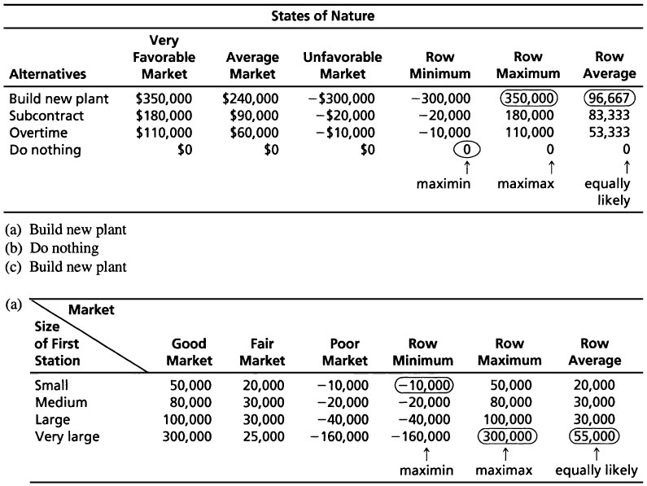
A.4 | (b) Maximax decision: very large station  (c) Maximin decision: small station  (d) Equally likely decision: very large station  (e)  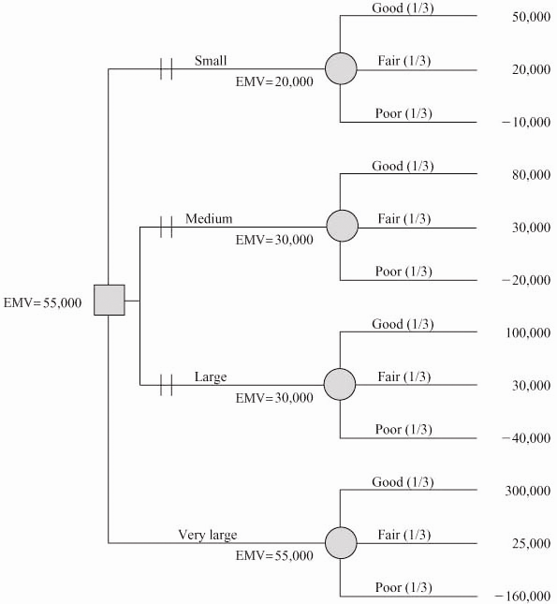  The first station should be very large, with EMV = $55,000
A.5 | Note: In the text, the states of nature appeared in the left column and the decision alternative across the top row. This is to let students know that data are sometimes presented in alternative formats.  (a)  (b) using the maximin criterion; No floor space (N).
A.6 | Using equally likely, “Buying equipment” is the best option.
   |  | Row Average
   | Increasing capacity | $700,000
   | Using overtime | $700,000
   | Buying equipment | $733,333 ←
A.7 | (a) EMV (large stock) = 0.3(22) + 0.5(12) + 0.2(–2) = 12.2  EMV (average stock) = 0.3(14) + 0.5(10) + 0.2(6) = 10.4  EMV (small stock) = 0.3(9) + 0.5(8) + 0.2(4) = 7.5  Maximum EMV is large inventory = $12,200  (b) EVPI = $13,800 – 12,200 = $1,600  where: $13,800 = 0.3(22) + 0.5(12) + 0.2(6)
A.8 | Note: All dollar values in $1,000s.  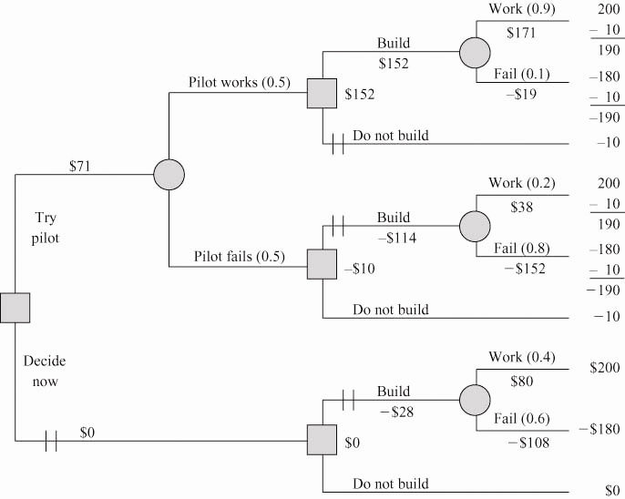  The recommended strategy (EMV = 71) is  - Try pilot  - If pilot is success: build plant  If pilot is failure: do not build plant  Note: All costs/revenues have been entered at the end of the branches of the tree.
A.9 | (a) Expected cost of hiring full-timer = 0.2(300) + 0.5(500) + 0.3(700)  = $60 + 250 + 210  = $520  Expected cost of part-timers = 0.2(0) + 0.5(350)  + 0.3(1,000)  = $0 + 175 + 300  = $475  Thus, use part-time nurses.  (B)  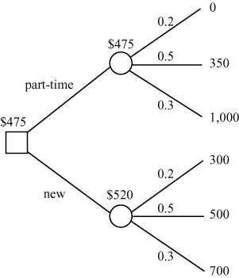
A.10 | (a) The primary challenge in this problem is constructing the payoff table. Each book stocked and sold results in a $30 profit. That’s $2,100 for the combination 70–70. Each book stocked but not sold results in a $46 loss. Demand that cannot be satisfied results in no loss of revenue or profit. Profit from each book sold = $112 – 82 = $30. Loss from each book bought but not sold = $82 – 36 = $45. Thus the payoff table is:  (b)  The largest EMV is associated with the action: Stock 75 books.
   | Demand
   | 70 | 75 | 80 | 85 | 90
  Stock | p = 0.15 | p = 0.30 | p = 0.30 | p = 0.20 | p = 0.05
  70 | 2,100 | 2,100 | 2,100 | 2,100 | 2,100
  75 | 1,870 | 2,250 | 2,250 | 2,250 | 2,250
  80 | 1,640 | 2,020 | 2,400 | 2,400 | 2,400
  85 | 1,410 | 1,790 | 2,170 | 2,550 | 2,550
  90 | 1,180 | 1,560 | 1,940 | 2,320 | 2,700
   | EMV
  Stock 70 | 2,100
  Stock 75 | 2,193
  Stock 80 | 2,172
  Stock 85 | 2,037
  Stock 90 | 1,826
  Best EMV = 2,193
A.11 | (a) Under conditions of risk, the company should choose batch processing, with an expectation of $1,000,000, which is twice as high as the next best choice.  (b) EVPI is $170,000.  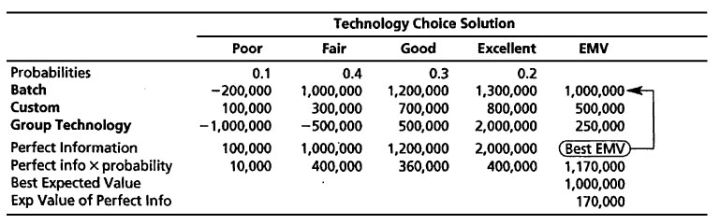
A.12 | Profit from each case sold: $95 – $45 = $50. Loss from each case produced but not sold: $45.  She should manufacture eight cases per month.
  Demand (Cases)
  Production  (Cases) | 6  p = 0.1 |  |  |  | 7  p = 0.3 |  |  | 8  p = 0.5 |  |  | 9  p = 0.1 | EMV
  6 | 300 |  |  |  | 300 |  |  | 300 |  |  | 300 | $300.00
  7 | 300 |  |  |  | 350 |  |  | 350 |  |  | 350 | $340.50
   | –45
   |  |  | 255
  8 | 300 |  |  |  | 350 |  |  | 400 |  |  | 400 | $352.50
   | –90 |  |  |  | –45
   |  |  | 210 |  |  | 305
  9 | 300 |  |  |  | 350 |  |  | 400 |  |  | 450 | $317.00
   | –135 |  |  |  | –90 |  |  | –45
   |  | 165 |  |  |  | 260 |  |  | 355
A.13 | Note: All dollar values are in 1,000s.  (a)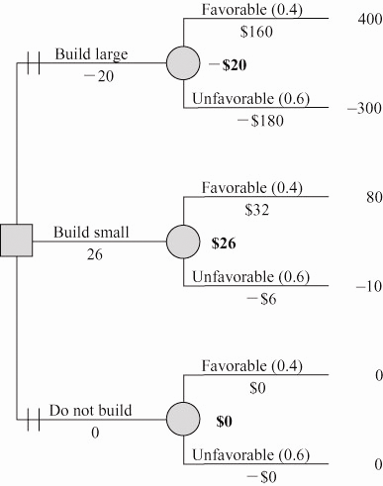  (b) Based on the expected monetary value criterion, Dwayne should elect to build a small plant.  (c) We can find the EVPI from the following:  - Expected value under certainty = (0.4)(400,000)  + 0.6(0)  = $160,000  - Maximum EMV = $26,000  - EVPI = $160,000 – $26,000 = $134,000
A.14
A.15 | More than one decision is involved, and the problem is under risk, so use a decision tree approach:  Note: Payoffs and expected payoffs are in $1,000s.  (a) Build the large facility. If demand proves to be low, then advertise to stimulate demand. If demand proves to be high, no advertising is needed (so don’t advertise).  (b) Expected payoff: $544,000.
A.16 | (a) Analysis of the decision tree finds that Resort has a higher EMV ($76) than Home:  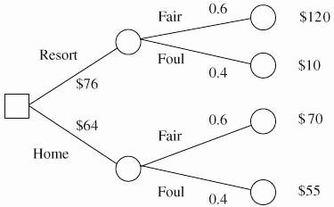  (b) EMV (Resort) = 0.6(120) + 0.4(10) = $76  EMV (Home) = 0.6(70) + 0.4(55) = $64  Choose Resort.
A.17 | 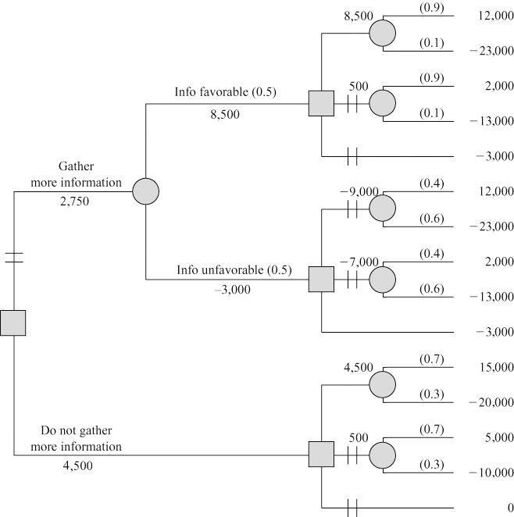  Your advice should be to not gather additional information and to build a large video section.
A.18 | (a)  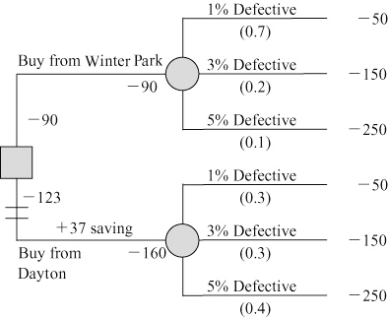  (b) Tests should be purchased from Winter Park Technologies.
A.19 | 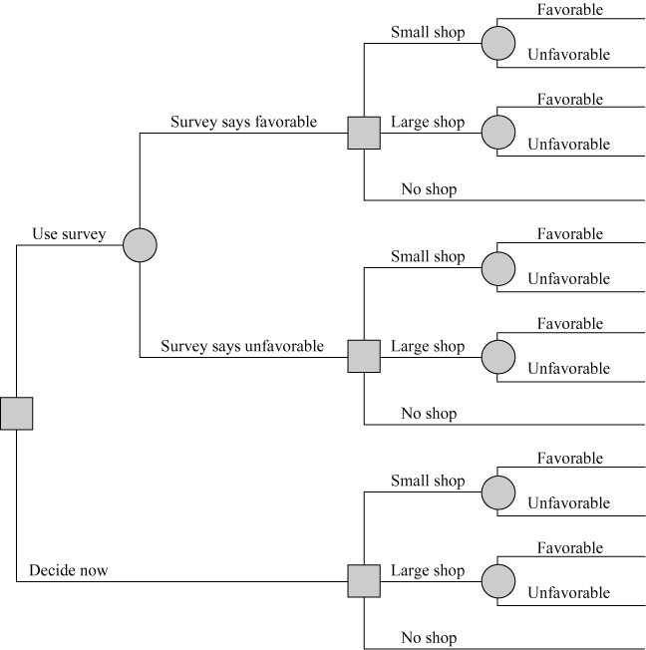
A.20 | (a)  .25 (b) EMV (X) = .45(18) + .55(–18) = –1.8  EMV (Y) = .45(−9) + .55(15) = 4.2 ← Best  EMV (X&Y) = .45(9) + .55(−3) = 2.4  EMV (Nothing) = 0  Y is best choice
  ADecision | At X |  |  | At Y |  |  |  | At X |  |  | At Y
  X | 45–27 |  |  | 9–27 |  |  |  | 18 |  |  | –18
  Y | 6–15 |  |  | 30–15 |  |  |  | –9 |  |  | 15
  X&Y | (45 + 6)–(27 + 15) |  |  | (30 + 9)–(27 + 15) |  |  |  | 9 |  |  | –3
  Nothing | 0 |  |  | 0 |  |  |  | 0 |  |  | 0
  Probability |  | .45 |  |  | .55 |  |  |  | .45 |  |  | .55
A.21 | (a) Maximum EMV = $11,700 [= .3(15) + .5(12) + .2(6)]  (b) EV with PI = .3(20) + .5(12) + .2(6) = 13,200  EVPI = 13,200 – 11,700 = 1,500
A.22 | The EMV of this game is $0.59, as illustrated in the diagram below:  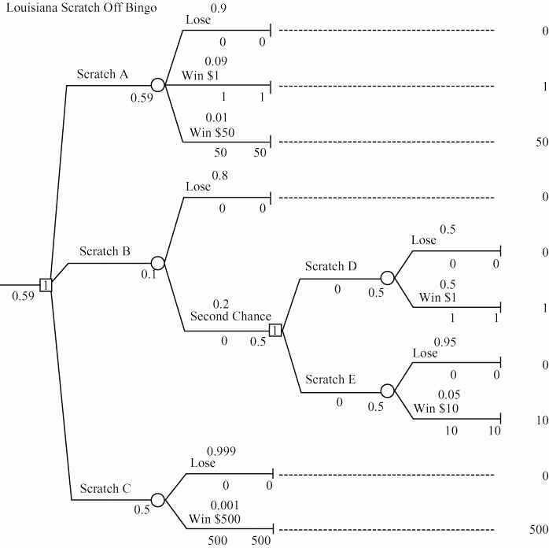
A.23 | Solution approach: Decision tree, since problem is under risk and has more than one decision:  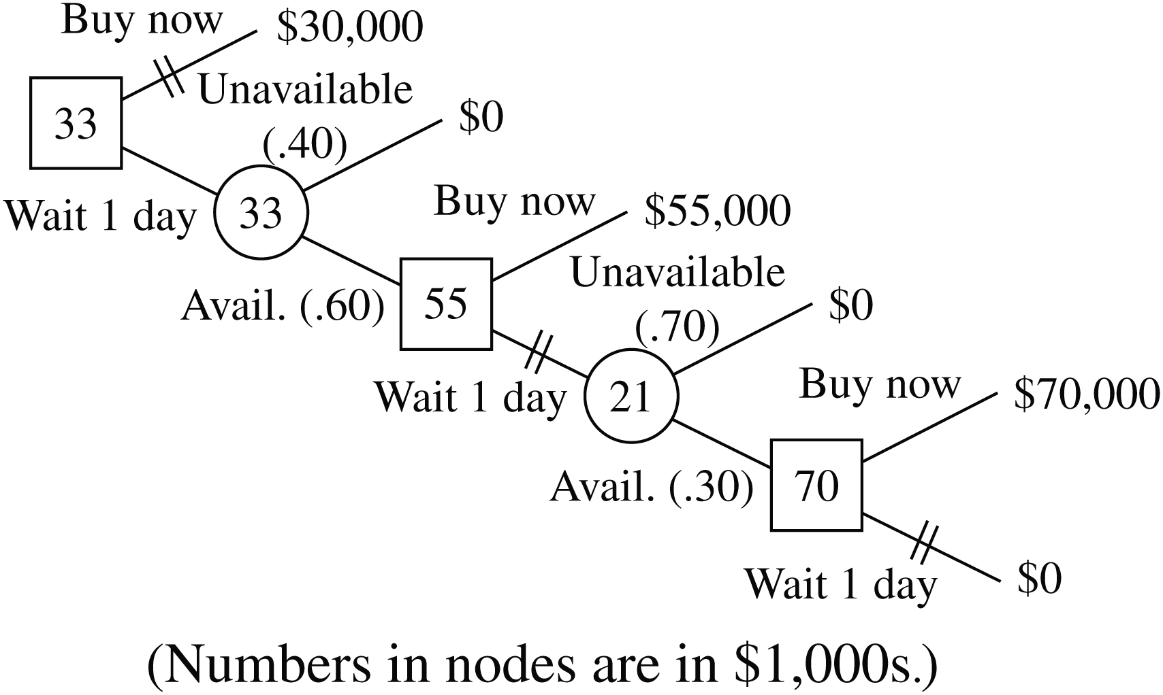  Maximum expected profit: $33,000. Michael should wait 1 day. Then, if an R386 is available, he should buy it. Otherwise, he should stop pursuing an R386 on the wholesale market.
A.24 | 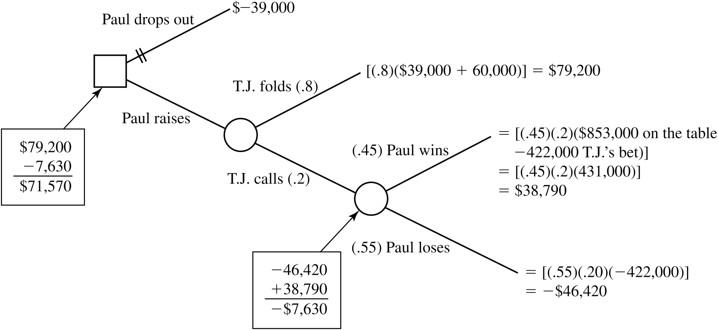

Additional Homework Problems
Here are solutions to the additional homework problems that appear on www.myomlab.com and www.pearsonglobaleditions.com/heizer.
A.25 | 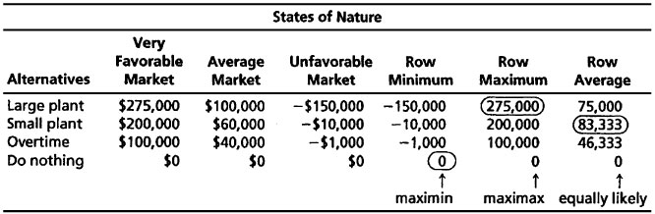  (a) Large plant  (b) Do nothing  (c) Small plant
A.26 | (a) EMV (Alt. 1) = (0.4)(80) + 0.3(120) + 0.3(140)  = 32 + 36 + 42 = 110 = max. EMV  EMV (Alt. 2) = (0.4)(90) + 0.3(90) + 0.3(90)  = 36 + 27 + 27 = 90  EMV (Alt. 3) = (0.4)(50) + 0.3(70) + 0.3(150)  = 20 + 21 + 45 = 86  (b) EVPI = 117 − 110 = 7
A.27 | Large has EMV = $75,000; small has EMV = $83,333; overtime EMV = $46,333; and do nothing = $0.
A.28 | (a)  The recommended course of action, based on the expected monetary value criterion, is to stock 11 cases.
   | Demand  11 Cases  P = 0.45 |  |  | Demand  12 Cases  P = 0.35 |  |  | Demand  13 Cases  P = 0.20 | EMV
  Stock 11 cases | 385 |  |  | 385 |  |  | 385 | $385.00
  Stock 12 cases | 385 |  |  | 420 |  |  | 420 | $379.05
   | −56
   |  | 329
  Stock 13 cases | 385 |  |  | 420 |  |  | 455 | $341.25
   | −112 |  |  | −56
   |  | 273 |  |  | 364

Case Study
WAREHOUSE TENTING AT THE PORT OF MIAMI*
1. According to the timeline of events for this problem, the first thing that happens is the decision of whether to hire ProGuard, followed by the possibility of being burglarized. Because of the assumptions stated in the problem, if the warehouse is burglarized, CCI will have to pay $25,000, and it costs $150 × 48 = $7,200 to hire security. These events and expenses can be depicted in a decision tree as follows:
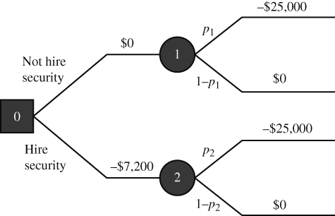
In node 0, we make one of two decisions: choose not to hire security (payoff of $0) or choose to hire security (payoff = –$7,200, i.e., a cost). For each of those decisions (braches of the tree), we create event nodes (1 and 2) to take into account the possibility of being burglarized. At the top branch of the tree (node 1), the warehouse will be burglarized with probability p₁, in which case an additional expense of $25,000 is incurred, or it will be safe with probability (1 – p₁), in which case no extra cost is incurred. Therefore, the expected monetary value of not hiring security, which we will call EMV₁, is to spend $25,000 with probability p₁ and spend nothing with probability (1 – p₁). In our case, p₁ = 30%, which yields EMV₁ = –$0 – $25,000 (0.30) – $0(0.70) = – $7,500. Through a similar analysis of the bottom branch of the tree (node 2), and using the fact that the probability of begin burglarized while under surveillance is p₂ = 3%, we calculate that the expected monetary value of hiring security is EMV₂ = – $7,200 – $25,000(0.03) – $0(0.97) = –$7,950. The EMV rule says that the best course of action is the one with the greatest EMV. Because EMV₁ > EMV₂, it is better not to hire ProGuard.
2. If we look at the calculations in Question 1 and replace d for $25,000, c for $7,200, p₁ for 30%, and p₂ for 3%, we conclude that EMV₂ will be greater than EMV₁ when the following expression holds: – c – dp₂ > – dp₁, which, after some algebraic manipulations, becomes p₁ – p₂ > c/d. Therefore, unless the difference between burglary probabilities is greater than the cost of security divided by the deductible, you should not hire security. In our numerical example, p₁ – p₂ = 27%, which is smaller than 7,200/25,000 ≈ 28.8%. Interestingly, if p₁ were already below 28.8% to begin with, even if the security company were perfect (i.e., p₂ = 0%), it would still be better not to hire them given the projected expenses.
3. As usual, good decisions do not guarantee good outcomes. It may still be the case that CCI’s warehouse will get burglarized, requiring CCI to spend $25,000. However, given the circumstances and risks CCI is facing, not hiring security is still the best decision to make.

*Case author is Professor Tallys Yunes, University of Miami.

Additional Case Studies*
ARCTIC, INC.
1
No probabilities have been included in this case study. As an initial analysis, we expect students to input the data and run Excel OM or POM for Windows.
Student analysis would be to determine something about maximax, maximin, equally likely, and the expected values. Because the probabilities are not known, a first try might be to assign equal probabilities—say, 0.1666. The best expected value is given by “building new,” with a value of nearly 2. However, note that this value is not that much greater than the value for “expanding” the plant. “Purchasing” has a terrible expected value of (0.35) and can be eliminated. “Sole sourcing” also has a low expected value and can possibly be eliminated from consideration. The question that remains is this: How sensitive are the results to the scenario probabilities? This is where the power of a computer comes in handy. Students can try many different probability combinations and look at the expected values. We are primarily concerned with expanding, building new, subcontracting, and expanding and subcontracting.
As “drop” is the worst scenario, try probabilities of 0.125, 0.125, and 0.25 for grow, stable, and drop, respectively. In this case, “expand” or “expand and subcontract” are better options. To determine the effects of growth, reverse the probabilities. This brings “building new” to the forefront. It is impossible to give an exact answer on what option to choose. The analysis shows that building a new plant can be very profitable, but this strategy can also be very risky. It might be more prudent to focus on the two expansion strategies.

SKI RIGHT CORP.
2

1. Bob can solve this case using decision analysis. As you can see, the best decision is to have Leadville Barts make the helmets and have Progressive Products do the rest with an expected value of $2,600 per month. The final option of not using Progressive, however, was very close with an expected value of $2,500 per month

 | Poor ($) | Average ($) | Good ($) | Excellent ($) | Expected  Value |  |  | Row  Minimum |  |  | Row  Maximum
Probabilities | 0.1 | 0.3 | 0.4 | 0.2
Option 1—PP | −5,000 | −2,000 | 2,000 | 5,000 | 700 |  |  | −5,000 |  |  | 5,000
Option 2—LB | −10,000 | −4,000 | 6,000 | 12,000 | 2,600 |  |  | −10,000 |  |  | 12,000
and PP
Option 3—TR | −15,000 | −10,000 | 7,000 | 13,000 | 900 |  |  | −15,000 |  |  | 13,000
and PP
Option 4—CC | −30,000 | −20,000 | 10,000 | 30,000 | 1,000 |  |  | −30,000 |  |  | 30,000
and PP
Option 5—LB, | −60,000 | −35,000 | 20,000 | 55,000 | 2,500 |  |  | −60,000 |  |  | 55,000
CC, and TR
Column Best |  |  |  |  | 2,600 |  |  | −5,000 |  |  | 55,000
The maximum expected monetary value is $2,600 per month
given by Option 2—LB and PP.

2. The expected value of perfect information is presented below.
The EVPI is $15,300.
Perfect Information
 | Poor Market | Average | Good | Excellent
Probabilities | 0.1 | 0.3 | 0.4 | 0.2
Option 1—PP | –5,000 | –2,000 | 2,000 | 5,000
Option 2—LB and PP | –10,000 | –4,000 | 6,000 | 12,000
Option 3—TR and PP | –15,000 | –10,000 | 7,000 | 13,000
Option 4—CC and PP | –30,000 | –20,000 | 10,000 | 30,000
Option 5—LB, CC, and TR | –60,000 | –35,000 | 20,000 | 55,000
Perfect Information | –5,000 | –2,000 | 20,000 | 55,000
Perfect info × Probability | –500 | –600 | 8,000 | 11,000
The expected value with certainty = 17,900
The expected value = 2,600
The expected value of perfect information = 15,300

3. There are a number of options that Bob did not consider. See if students can list one or more of these options.

TOM TUCKER’S LIVER TRANSPLANT
3
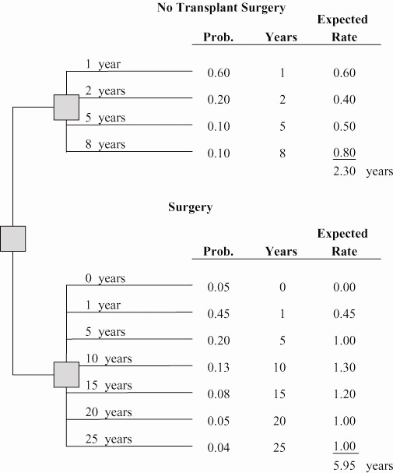

Expected survival rate with surgery (5.95 years) exceeds the nonsurgical survival rate of 2.30 years. Surgery is favorable.
Other factors might include the particular doctor and hospital used and care received.

