Part 5
Long-Term Investment Decisions
Chapters in This Part

Chapter 10 Capital Budgeting Techniques

Chapter 11 Capital Budgeting Cash Flows

Chapter 12 Risk and Refinements in Capital Budgeting

Integrative Case 5: Lasting Impressions Company

Chapter 10
Capital Budgeting Techniques

■ Instructor’s Resources

Overview
This chapter is the first of three that deal with long-term investment decisions. This chapter covers capital budgeting techniques, Chapter 11 deals with the basic principles of determining relevant cash flows, and Chapter 12 considers risk and refinements in capital budgeting. Both the sophisticated [net present value (NPV) and the internal rate of return (IRR)] and unsophisticated (average rate of return and payback period) capital budgeting techniques are presented here. Discussion centers on the calculation and evaluation of the NPV and IRR in investment decisions, with and without a capital rationing constraint. Several illustrations exist explaining why capital budgeting techniques will be useful to students in their professional and personal lives.

■ Suggested Answers to Opener-in-Review Questions

a. The chapter opener reported that the project had an NPV of $66 million and an internal rate of return of 20%. From those two facts alone, what can you conclude about Seafield’s cost of capital? (Hint: Is it more or less than 20%?)

The cost of capital must be less than 20% because at 20% the NPV is zero (by definition of the IRR being 20%). Because the NPV is positive, Seafield must be discounting cash flows at a rate less than 20%.

b. Given the information above about the project’s initial cost and subsequent cash flows, as well as the information from part (a), can you estimate Seafield’s cost of capital?

Using the trial-and-error approach, the discount rate that equates the present value of the project’s cash flows to $66 million, the project’s NPV, can be found. Thus, the cost of capital can be found to be 7%. Using equation 10.1, we have:

66 = −83.6 + 18.8/(1 + r)¹ + 18.8/(1 + r)² + …. + 18.8/(1 + r)^{1/2}
Rearranging the equation, 0 = −149.6 + 18.8/(1 + r)¹ + 18.8/(1 + r)² + …. + 18.8/(1 + r)^{1/2}

Notice that this expression has the same form as equation 10.3, except that the discount rate here is the firm’s cost of capital, not the project’s IRR. Therefore, we can calculate Seafield’s cost of capital as 7%.

■ Answers to Review Questions

1. Once the relevant cash flows have been developed, they must be analyzed to determine whether the projects are acceptable or to rank the projects in terms of acceptability in meeting the firm’s goal. Managers reach their goal of maximizing shareholder wealth when they undertake all investments wherein the present value of the cash inflows exceeds the present value of cash outflows.

2. The payback period is the exact time it takes to recover a firm’s initial investment in a project. In case of a mixed stream, the cash inflows are added until their sum equals the initial investment in the project. In case of an annuity, the payback is calculated by dividing the initial investment by the annual cash inflow.

3. The weaknesses of using the payback period are (1) no explicit consideration of shareholders’ wealth, (2) failure to take fully into account the time value of money, and (3) failure to consider returns beyond the payback period and hence overall profitability of projects. (Note: If you discount each cash flow at the time value of money and subtract that from the original expenditure, you end up with a revised payback period, usually called the discounted payback period. However, this technique still does not consider all of the cash flows.)

4. NPV computes the present value of all relevant cash flows associated with a project. For conventional cash flow, NPV takes the present value of all cash inflows over years 1 through n and subtracts from that sum the initial investment at time zero. The formula for the NPV of a project with conventional cash flows is:

NPV = present value of cash inflows − initial investment

5. Acceptance criterion for the NPV method is if NPV > 0, accept; if NPV < 0, reject. If the firm undertakes projects with a positive NPV, the market value of the firm should increase by the amount of the NPV.

6. NPV, PI, and EVA are all based on the same underlying idea, that investments should earn a rate of return high enough to meet investors’ expectations. The PI differs from NPV in that it is expressed as a rate of return. That is, it measures the present value of an investment’s cash inflows relative to the up-front cash outflow. EVA calculates a “cost of capital” charge, which is deducted each year from a project’s cash flows. To calculate the overall project EVA, you take the annual EVA figures and discount them at the cost of capital. In general, NPV, PI, and EVA will always agree on whether a project is worth investing in or not.

7. Answers will vary for question because values are algorithmically generated in MyFinanceLab.

8. The IRR on an investment is the discount rate that would cause the investment to have a NPV of zero. It is found by solving the NPV equation given below for the value of k that equates the present value of cash inflows with the initial investment.

9. If a project’s IRR is greater than the firm’s cost of capital, the project should be accepted; otherwise, the project should be rejected. If the project has an acceptable IRR, the value of the firm should increase. Unlike the NPV, the amount of the expected value increase is not known.

10. The NPV and IRR always provide consistent accept/reject decisions. These measures, however, may not agree with respect to ranking the projects. The NPV may conflict with the IRR due to different cash flow characteristics of the projects. The greater the difference between timing and magnitude of cash inflows, the more likely it is that rankings will conflict.

11. An NPV is a graphic representation of the NPV of a project at various discount rates. The NPV profile may be used when conflicting rankings of projects exist by depicting each project as a line on the profile and determining the point of intersection. If the intersection occurs at a positive discount rate, any discount rate below the intersection will cause conflicting rankings, whereas any discount rates above the intersection will provide consistent rankings. Conflicts in project rankings using NPV and IRR result from differences in the magnitude and timing of cash flows. Projects with similar-sized investments having low early-year cash inflows tend to be preferred at lower discount rates. At high discount rates, projects with the higher early-year cash inflows are favored, as later-year cash inflows tend to be severely penalized in present value terms.

12. The reinvestment rate assumption refers to the rate at which reinvestment of intermediate cash flows theoretically may be achieved under the NPV or the IRR methods. The NPV method assumes the intermediate cash flows are reinvested at the discount rate, whereas the IRR method assumes intermediate cash flows are reinvested at the IRR. On a purely theoretical basis, the NPV’s reinvestment rate assumption is superior because it provides a more realistic rate, the firm’s cost of capital, for reinvestment. The cost of capital is generally a reasonable estimate of the rate at which a firm could reinvest these cash inflows. The IRR, especially one well exceeding the cost of capital, may assume a reinvestment rate the firm cannot achieve. In practice, the IRR is preferred due to the general disposition of business people toward rates of return rather than pure dollar returns.

■ Suggested Answer to Focus on Practice Box:
Limits on Payback Analysis
In your view, if the payback period method is used in conjunction with the NPV method, should it be used before or after the NPV evaluation?
While the payback method is simple to use and can be used to initially screen projects, the major disadvantage is that a very rewarding project may be overlooked if it does not meet the arbitrary payback period. For example, if all projects that do not make a specified payback period—say, 3 years—are rejected, the company might forgo a very rewarding project whose payback is justified at, say, 3.5 years.
The projects most likely rejected by the payback analysis that could be acceptable using the NPV method are those that are slow to provide a return cash flow in early years but that provide a significant cash flow in outlying years. However, the further out the cash flows are, the more uncertain they become.
Therefore, if there is an abundance of projects to evaluate, it may make sense to use a simple method such as the payback period analysis to winnow down the projects before applying a more sophisticated method, such as the NPV method, to the survivors. If there is not an abundance of projects or if time allows, it makes sense to apply more than one method of analysis to all of the projects before making a final decision.
Another variation is to extend the payback period an extra year on the initial screen so that those projects just beyond the preferred payback horizon are given a second chance.

■ Suggested Answer to Focus on Ethics Box: Nonfinancial Considerations for Project Selection
What are the potential risks to a company of unethical behaviors by employees? What are potential risks to the public and to stakeholders?
The consequences to the company may include prosecution, fines, and other penalties for the improper conduct of its employees. Legal sanctions bring unwanted publicity that can result in loss of business or damage to the company’s good name, trade and customer relations, and even future business opportunities. Consequences for the employee can include prosecution, fines, and imprisonment. Other penalties for improper conduct can include loss of incentive pay and annual increases and other forms of disciplinary action as determined by the company. Serious unethical behavior will almost certainly lead to termination of employment, not to mention damage to the employee’s personal reputation.
Employees’ unethical behavior could cost the company customers, suppliers, and sources of capital. Consequences for the public, depending upon the types of products the firm produces, may include compromised product safety, an increased environmental risk, and a loss of faith in the company. Risks to the public include health risks and risks to their livelihoods (consider, for example, the oil spill in the Gulf of Mexico). Stakeholders’ (e.g., shareholders, creditors, employees) risks include the possibility that the unethical behavior damages the firm’s business to the extent that the firm defaults on its obligations and/or does not survive as a going concern. This would have a devastating impact on the firm’s investment value.

■ Answers to Warm-Up Exercises

E10-1. Payback period

Answer: The payback period for Project Hydrogen is 4.29 years. The payback period for Project Helium is 5.75 years. Both projects are acceptable because their payback periods are less than Elysian Fields’ maximum payback period criterion of 6 years.

E10-2. NPV

Answer:
Year | Cash Inflow | Present Value
1 | $850,000 | $ 772,727.27
2 | 768,000 | 634,710.74
3 | 643,000 | 483,095.42
4 | 565,000 | 385,902.60
5 | 400,000 | 248,368.53
 | Total | $2,524,804.56
NPV = $2,524,804.56 − $2,520,000 = $4,804.56
Sweet Potato should acquire the new cooking machine.

E10-3: NPV comparison of two projects

Answer: Project Kelvin
Present value of expenses –$45,000
Present value of cash inflows 51,542 (PMT = $20,000, N = 3, I = 8, Solve for PV)
NPV $ 6,542
Project Thompson
Present value of expenses −$275,000
Present value of cash inflows 277,373 (PMT = $60,000, N = 6, I = 8, Solve for PV)
NPV $ 2,373
Based on NPV analysis, Axis Corporation should choose an overhaul of the existing system.

E10-4: IRR

Answer: You may use a financial calculator to determine the IRR of each project. Choose the project with the higher IRR.
Project T-Shirt
PV = −15,000, N = 4, PMT = 8,000
Solve for I
IRR = 39.08%
Project Board Shorts
PV = −25,000, N = 5, PMT = 12,000
Solve for I
IRR = 38.62%
Based on IRR analysis, Billabong Tech should choose project T-Shirt.

E10-5: NPV

Answer: Note: The IRR for Project Terra is 10.68% while that of Project Firma is 10.21%. Furthermore, when the discount rate is zero, the sum of Project Terra’s cash flows exceed that of Project Firma. Hence, at any discount rate that produces a positive NPV, Project Terra provides the higher net present value.
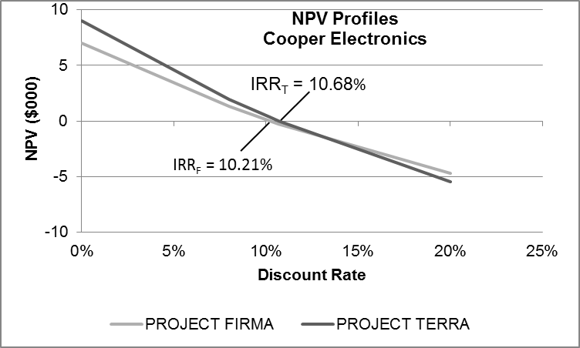

■ Solutions to Problems
Note to instructor: In most problems involving the IRR calculation, a financial calculator has been used. Answers to NPV-based questions in the first 10 problems provide detailed analysis of the present value of individual cash flows. Thereafter, financial calculator worksheet keystrokes are provided. Most students will probably employ calculator functionality to facilitate their problem solution in this chapter and throughout the course.

P10-1. Payback period

LG 2; Basic

a. $84,000 ÷ $7,000 =12 years

b. The company should not accept the project, since payback period of 12 years exceeds the entity’s maximum acceptable one.

P10-2. Payback comparisons

LG 2; Intermediate

a. Machine 1: $25,000 ÷ $6,500 =3.85 years

Machine 2: $75,000 ÷ $9,500 =7.89 years

b. Only Machine 1 has a payback faster than 5 years and is acceptable.

c. The firm will accept the first machine because the payback period of 3.85 years is
less than the 5-year maximum payback required by Colorado Cleaning.

d. Machine 2 has returns that last 20 years while Machine 1 has only 8 years of returns. Payback cannot consider this difference; it ignores all cash inflows beyond the payback period.

P10-3. Choosing between two projects with acceptable payback periods

LG 2; Intermediate

a.
 | Project A |  |  |  | Project B
Year | Cash  Inflows | Investment  Balance |  | Year | Cash  Inflows | Investment  Balance
0 |  | −$100,000 |  | 0 |  | −$100,000
1 | $10,000 | −90,000 |  | 1 | 40,000 | −60,000
2 | 20,000 | −70,000 |  | 2 | 30,000 | −30,000
3 | 30,000 | −40,000 |  | 3 | 20,000 | −10,000
4 | 40,000 | 0 |  | 4 | 10,000 | 0
5 | 20,000 |  |  | 5 | 20,000

Both Project A and Project B have payback periods of exactly 4 years.

b. Based on the minimum payback acceptance criteria of 4 years set by John Shell, both projects should be accepted. However, because they are mutually exclusive projects, John should accept Project B.

c. Project B is preferred over A because the larger cash flows are in the early years of the project. The quicker cash inflows occur, the greater their value.

P10-4. Personal finance: Long-term investment decisions, payback period

LG 4

a. and b.
 | Project A |  | Project B
Year | Annual Cash Flow | Cumulative Cash Flow | Annual Cash Flow | Cumulative  Cash Flow
0 | $(9,000) | $(9,000) | $(9,000) | $(9,000)
1 | 2,200 | (6,800) | 1,500 | (7,500)
2 | 2,500 | (4,300) | 1,500 | (6,000)
3 | 2,500 | (1,800) | 1,500 | (4,500)
4 | 2,000 |  | 3,500 | (1,000)
5 | 1,800 |  | 4,000
Total Cash Flow | 11,000 |  | 12,000
Payback Period | 3 + 1,800/2,000 = 3.9 years |  | 4 + 1,000/4,000 = 4.25 years

c. The payback method would select Project A because its payback of 3.9 years is lower than Project B’s payback of 4.25 years.

d. One weakness of the payback method is that it disregards expected future cash flows as in the case of Project B.

P10-5. NPV

LG 3; Basic

NPV = PV_{n} − Initial investment

a. N = 15, I = 9%, PMT = $150,000

Solve for PV = $1,209,103.26

NPV = $1,209,103.26 − $1,000,000

NPV = $209,103

NPV = $209,103.26, which means that the project is acceptable.

b. N = 15, I = 9%, PMT = $320,000

Solve for PV = 2,579,420.30

NPV = $2,579,420.30 − $2,500,000

NPV = $79,420.30

NPV = $79,420.30, which means that the project is acceptable.

c. N = 15, I = 9%, PMT = $365,000

Solve for PV = $2,942,151.28

NPV = $2,942,151.28 − $3,000,000

NPV = −$57,848.72

NPV = −$57,848.72, which means that the project is unacceptable.

P10-6. NPV for varying cost of capital

LG 3; Basic

a. 8%

N =5, I =8%, PMT = $65,000

Solve for PV = $259,526.15

NPV =PV_{n}− Initial investment

NPV = $259,526.15− $235,000

NPV = $24,526.15

Accept; positive NPV

b. 10%

N =5, I = 10%, PMT = $65,000

Solve for PV = $246,401.14

NPV =PV_{n}− Initial investment

NPV = $246,401.14− $235,000

NPV = $11,401.14

Accept; positive NPV

c. 15%

N =5, I = 15%, PMT = $65,000

Solve for PV = $217,890.08

NPV =PV_{n}− Initial investment

NPV = $217,890.08− $235,000

NPV = -$17,109.92

Reject; negative NPV

P10-7. NPV—independent projects

LG 3; Intermediate

Project A

N = 10, I = 14%, PMT = $4,000

Solve for PV = $20,864.46

NPV = $20,864.46 − $26,000

NPV = −$5,135.54

Reject

Project B—PV of Cash Inflows

CF₀ = −$500,000; CF₁ = $100,000; CF₂ = $120,000; CF₃ = $140,000; CF₄ = $160,000;

CF₅ = $180,000; CF⁶ = $200,000

Set I = 14%

Solve for NPV = $53,887.93

Accept

Project C—PV of Cash Inflows

CF₀ = −$170,000; CF₁ = $20,000; CF₂ = $19,000; CF₃ = $18,000; CF₄ = $17,000;

CF₅ = $16,000; CF₆ = $15,000; CF₇ = $14,000; CF₈ = $13,000; CF₉ = $12,000;
CF₁₀ = $11,000,

Set I = 14%

Solve for NPV = −$83,668.24

Reject

Project D

N = 8, I = 14%, PMT = $230,000

Solve for PV = $1,066,938.70

NPV = PV_{n} − Initial investment

NPV = $1,066,939 − $950,000

NPV = $116,938.70

Accept

Project E—PV of Cash Inflows

CF₀ = −$80,000; CF₁ = $0; CF₂ = $0; CF₃ = $0; CF₄ = $20,000; CF₅ = $30,000; CF₆ = $0;
CF₇ = $50,000; CF₈ = $60,000; CF₉ = $70,000

Set I = 14%

Solve for NPV = $9,963.63

Accept

P10-8. NPV

LG 3; Challenge

a. N = 5, I = 9%, PMT = $385,000

Solve for PV = $1,497,515.74

The immediate payment of $1,500,000 is not preferred because it has a higher present value than does the annuity.

b. N = 5, I = 9%, PV = −$1,500,000

Solve for PMT = $385,638.69

c. Present value_{Annuity Due} = PV_{ordinary annuity} × (1 + discount rate)

$1,497,515.74 (1.09) = $1,632,292

Calculator solution: $1,632,292

Changing the annuity to a beginning-of-the-period annuity due would cause Simes Innovations to prefer to make a $1,500,000 one-time payment because the present value of the annuity due is greater than the $1,500,000 lump-sum option.

d. No, the cash flows from the project will not influence the decision on how to fund the project. The investment and financing decisions are separate.

P10-9. NPV and maximum return

LG 3; Challenge

a. N =5, I = 15%, PMT = $68,500

Solve for PV = $229,622.62

NPV = PV − Initial investment

NPV = $229,622.62− $245,000

NPV = –$15,377.38

Reject this project due to its negative NPV.

b. N =5, PV= -$245,000, PMT = $68,500

Solve for IRR=12.317%

12% is the maximum required return that the firm could have for the project to be acceptable. Since the firm’s required return is 15% the cost of capital is greater than the expected return and the project is rejected.

P10-10. NPV—mutually exclusive projects

LG 3; Intermediate

a. and b.

Press A

CF₀ = −$85,000; CF₁ = $18,000; F1 = 8

Set I = 15%

Solve for NPV = −$4,228.21

Reject

Press B

CF₀ = −$60,000; CF₁ = $12,000; CF₂ = $14,000; CF₃ = $16,000; CF₄ = $18,000;

CF₅ = $20,000; CF₆ = $25,000

Set I = 15%

Solve for NPV = $2,584.34

Accept

Press C

CF₀ = −$130,000; CF₁ = $50,000; CF₂ = $30,000; CF₃ = $20,000; CF₄ = $20,000;

CF₅ = $20,000; CF₆ = $30,000; CF₇ = $40,000; CF₈ = $50,000

Set I = 15%

Solve for NPV = −$15,043.89

Accept

c. Ranking—using NPV as criterion
Rank | Press | NPV
1 | C | $15,043.89
2 | B | 2,584.34
3 | A | −4,228.21

d. Profitability Indexes

Profitability Index = Σ Present Value Cash Inflows ÷ Investment

Press A: $80,771.79 ÷ $85,000 = 0.95

Press B: $62,584.34 ÷ $60,000 = 1.04

Press C: $145,043.89 ÷ $130,000 = 1.12

e. The profitability index measure indicates that Press C is the best, then Press B, then Press A (which is unacceptable). This is the same ranking as was generated by the NPV rule.

P10-11. Personal finance: Long-term investment decisions, NPV method

LG 3

Key information:

Cost of EMBA program $153,000

Annual incremental benefit $ 48,000

Time frame (years) 40

Opportunity cost 5.0%

Calculator Worksheet Keystrokes:

CF₀ = −153,000

CF₁ = 48,000

F₁ = 40

Set I = 5%

Solve for NPV = −153,000 + [48,000 / (1.05) ^40]

= −153,000 + 6818.19 = −146,181

The financial benefits do not outweigh the cost of the EMBA program as the NPV is negative.

P10-12. Payback and NPV

LG 2, 3; Intermediate

a.
Project | Payback Period
A | $40,000 ÷ $13,000 = 3.08 years
B | 3 + ($10,000 ÷ $16,000) = 3.63 years
C | 2 + ($5,000 ÷ $13,000) = 2.38 years

Project C, with the shortest payback period, is preferred.

b. Worksheet keystrokes
Year | Project A | Project B | Project C
0 | −$40,000 | −$40,000 | −$40,000
1 | 13,000 | 7,000 | 19,000
2 | 13,000 | 10,000 | 16,000
3 | 13,000 | 13,000 | 13,000
4 | 13,000 | 16,000 | 10,000
5 | 13,000 | 19,000 | 7,000
Solve for NPV | $2,565.82 | −$322.53 | $5,454.17
 | Accept | Reject | Accept

Project C is preferred using the NPV as a decision criterion.

c. At a cost of 16%, Project C has the highest NPV. Because of Project C’s cash flow characteristics, high early-year cash inflows, it has the lowest payback period and the
highest NPV.

P10-13. NPV and EVA

LG 3; Intermediate

a. NPV = −$860,000 + $320,000 ÷ 0.12 = $1,806,667

b. Annual EVA = $320,000 – ($860,000 x 0.12) = $216,800

c. Overall EVA = $216,800 ÷ 0.12 = $1,806,667

In this case, NPV and EVA give exactly the same answer.

P10-14. IRR—Mutually exclusive projects

LG 4; Intermediate

IRR is found by solving:

Most financial calculators have an “IRR” key, allowing easy computation of the internal rate of return. The numerical inputs are described below for each project.

Project A

CF₀ = −$90,000; CF₁ = $20,000; CF₂ = $25,000; CF₃ = $30,000; CF₄ = $35,000; CF₅ = $40,000

Solve for IRR = 17.43%

If the firm’s cost of capital is below 17%, the project would be acceptable.

Project B

CF₀ = −$490,000; CF₁ = $150,000; CF₂ = $150,000; CF₃ = $150,000; CF₄ = $150,000

[or, CF₀ = −$490,000; CF₁ = $150,000, F₁= 4]

Solve for IRR = 8.62%

The firm’s maximum cost of capital for project acceptability would be 8.62%.

Project C

CF₀ = −$20,000; CF₁ = $7500; CF₂ = $7500; CF₃ = $7500; CF₄ = $7500; CF₅ = $7500

[or, CF₀ = −$20,000; CF₁ = $7500; F₁ = 5]

Solve for IRR = 25.41%

The firm’s maximum cost of capital for project acceptability would be 25.41%.

Project D

CF₀ = −$240,000; CF₁ = $120,000; CF₂ = $100,000; CF₃ = $80,000; CF₄ = $60,000

Solve for IRR = 21.16%

The firm’s maximum cost of capital for project acceptability would be 21% (21.16%).

P10-15. IRR

LG 4; Intermediate

The IRR of the project is 4%. Because the IRR is lower than the firm’s cost of capital, the firm should reject the project. However, note that in this case, the project’s cash flows have the opposite sign from what we typically see. That is, in this project, there is an upfront inflow (not an outflow) followed by outflows (not inflows) in the latter years. In a sense, the firm is borrowing money from its customers, receiving $200 up front and paying back $106 in each of the next two years. In a project like this, the IRR decision rule is the opposite of the normal case. Because inflows come first followed by outflows, the firm should accept this project precisely because its IRR is low relative to the cost of capital (borrowing at a low rate is a good thing). To see this more clearly, calculate the project NPV, and you will see that it is positive:

The NPV is positive, so the project is acceptable.

P10-16. IRR—Mutually exclusive projects

LG 4; Intermediate

IRR is the rate of return at which NPV equals zero

IRR is found by solving:

The numerical inputs are described below for project X and Y.

a. and b.

Project X

CF₀ = –$980,000; CF₁ = $150,000; CF₂ = $170,000; CF₃ = 220,000; CF₄ = $270,000

CF₅ = $340,000

Solve for IRR = 4.8588; since IRR > cost of capital (4%), accept.

Project Y

CF₀ = −$363,000; CF₁ = $110,000; CF₂ = $98,000; CF₃ = $93,000; CF₄ = $82,000

CF₅ = $67,000

Solve for IRR = 8.2906%; since IRR > cost of capital (4%), accept.

c. Project Y, with the higher IRR, is preferred, although both are acceptable.

P10-17. Personal Finance: Long-term investment decisions, IRR method

LG 4; Intermediate

IRR is the rate of return at which NPV equals zero

Computer inputs and output:

N = 5, PV = $33,000, PMT = $8,300

Solve for IRR =8.16%

Required rate of return: 7%

Decision: Accept the investment opportunity

P10-18. IRR, investment life, and cash inflows

LG 4; Challenge

a. N = 10, PV = −$61,450, PMT = $10,000

Solve for I = 10.0%

The IRR < cost of capital; reject the project.

b. I = 15%, PV = −$61,450, PMT = $10,000

Solve for N = 18.23 years

The project would have to run a little more than 8 more years to make the project acceptable with the 15% cost of capital.

c. N = 10, I = 15%, PV = $61,450

Solve for PMT = $12,244.04

P10-19. NPV and IRR

LG 3, 4; Intermediate

a. N = 5, I = 8%, PMT = 65,000

Solve for PV = $259,526.15

NPV = PV − Initial investment

NPV = $259,526.15 − $248,250

NPV = $11,276.15

b. N =5, PV = $248,250, PMT = $65,000

Solve for I = 9.71%

c. The project should be accepted since the NPV > 0 and the IRR > the cost of capital.

P10-20. NPV, with rankings

LG 3, 4; Intermediate

a. NPV_{A} = $45,665.50 (N = 3, I = 15, PMT = $20,000) − $50,000

NPV_{A} = −$4,335.50

Or, using NPV keystrokes

CF₀ = −$50,000; CF₁ = $20,000; CF₂ = $20,000; CF₃ = $20,000

Set I = 15%

NPV_{A} = −$4,335.50

Reject

NPV_{B} Key strokes

CF₀ = −$100,000; CF₁ = $35,000; CF₂ = $50,000; CF₃ = $50,000

Set I = 15%

Solve for NPV = $1,117.78

Accept

NPV_{C} Key strokes

CF₀ = −$80,000; CF₁ = $20,000; CF₂ = $40,000; CF₃ = $60,000

Set I = 15%

Solve for NPV = $7,088.02

Accept

NPV_{D} Key strokes

CF₀ = −$180,000; CF₁ = $100,000; CF₂ = $80,000; CF₃ = $60,000

Set I = 15%

Solve for NPV = $6,898.99

Accept

b.
Rank | Press | NPV
1 | C | $7,088.02
2 | D | 6,898.99
3 | B | 1,117.78
4 | A | −4335.50

c. Using the calculator, the IRRs of the projects are:
Project | IRR
A | 9.70%
B | 15.63%
C | 19.44%
D | 17.51%

Because the lowest IRR is 9.7%, all of the projects would be acceptable if the cost of capital was 9.7%.

Note: Because Project A was the only rejected project from the four projects, all that was needed to find the minimum acceptable cost of capital was to find the IRR of A.

P10-21. All techniques, conflicting rankings

LG 2, 3, 4: Intermediate

a.
Project A |  |  |  | Project B
Year | Cash Inflows | Investment  Balance |  | Year | Cash Inflows | Investment  Balance
0 |  | −$150,000 |  | 0 |  | −$150,000
1 | $45,000 | −105,000 |  | 1 | $75,000 | −75,000
2 | 45,000 | −60,000 |  | 2 | 60,000 | −15,000
3 | 45,000 | −15,000 |  | 3 | 30,000 | +15,000
4 | 45,000 | +30,000 |  | 4 | 30,000 | 0
5 | 45,000 |  |  |  | 30,000
6 | 45,000 |  |  |  | 30,000

b. At a discount rate of zero, dollars have the same value through time and all that is needed is a summation of the cash flows across time.

NPV_{A} = ($45,000 × 6) − $150,000 = $270,000 − $150,000 = $120,000

NPV_{B} = $75,000 + $60,000 + $120,000 − $150,000 = $105,000

c. NPV_{A}:

CF₀ = −$150,000; CF₁ = $45,000; F₁ = 6

Set I = 9%

Solve for NPV_{A} = $51,866.34

NPV_{B}:

CF₀ = −$150,000; CF₁ = $75,000; CF₂ = $60,000; CF₃ = $120,000

Set I = 9%

Solve for NPV = $51,112.36

d. IRR_{A}:

CF₀ = −$150,000; CF₁ = $45,000; F₁ = 6

Solve for IRR = 19.91%

IRR_{B}:

CF₀ = −$150,000; CF₁ = $75,000; CF₂ = $60,000; CF₃ = $120,000

Solve for IRR = 22.71%

e.
 | Rank
Project | Payback | NPV | IRR
A | 2 | 1 | 2
B | 1 | 2 | 1

The project that should be selected is A. The conflict between NPV and IRR is due partially to the reinvestment rate assumption. The assumed reinvestment rate of Project B is 22.71%, the project’s IRR. The reinvestment rate assumption of A is 9%, the firm’s cost of capital. On a practical level, Project B may be selected due to management’s preference for making decisions based on percentage returns and their desire to receive a return of cash quickly.

f. NPV_{A}:

CF₀ = −$150,000; CF₁ = $45,000; F₁ = 6

Set I = 12%

Solve for NPV_{A} = $35,013

NPV_{B}:

CF₀ = −$150,000; CF₁ = $75,000; CF₂ = $60,000; CF₃ = $30,000; F01 = 4

Set I = 12%

Solve for NPV = $37,436

At a cost of capital of 12%, the NPV of Project A is $35,013, and the NPV of Project B is $37,436. In this case, Project B appears to be the better project, in contrast to the previous NVP-based rankings, which showed Project A to be superior. Notice that Project B pays most of its cash in the early years. This makes its NPV less sensitive to the cost of capital. The NPVs of both projects fall as the cost of capital rises, but the NPV of Project A falls more rapidly.

P10-22. Payback, NPV, and IRR

LG 2, 3, 4; Intermediate

a. Payback period

Balance after 3 years: $95,000 − $20,000 − $25,000 − $30,000 = $20,000

3 + ($20,000 ÷ $35,000) = 3.57 years

b. NPV computation

CF₀ = −$95,000; CF₁ = $20,000; CF₂ = $25,000; CF₃ = $30,000; CF₄ = $35,000

CF₅ = $40,000

Set I = 12%

Solve for NPV = $9,080.60

c.

CF₀ = −$95,000; CF₁ = $20,000; CF₂ = $25,000; CF₃ = $30,000; CF₄ = $35,000

CF₅ = $40,000

Solve for IRR = 15.36%

d. NPV = $9,080; because NPV > 0, accept

IRR = 15%; because IRR > 12% cost of capital, accept

The project should be implemented because it meets the decision criteria for both NPV and IRR.

P10-23. NPV, IRR, and NPV profiles

LG 3, 4, 5; Challenge

a. and b.

Project A

CF₀ = −$130,000; CF₁ = $25,000; CF₂ = $35,000; CF₃ = $45,000

CF₄ = $50,000; CF₅ = $55,000

Set I = 12%

NPV_{A} = $15,237.71

Based on the NPV, the project is acceptable because the NPV is greater than zero.

Solve for IRR_{A} = 16.06%

Based on the IRR, the project is acceptable because the IRR of 16% is greater than the 12% cost of capital.

Project B

CF₀ = −$85,000; CF₁ = $40,000; CF₂ = $35,000; CF₃ = $30,000

CF₄ = $10,000; CF₅ = $5,000

Set I = 12%

NPV_{B} = $9,161.79

Based on the NPV, the project is acceptable because the NPV is greater than zero.

Solve for IRR_{B} = 17.75%

Based on the IRR, the project is acceptable because the IRR of 17.75% is greater than the 12% cost of capital.

c.

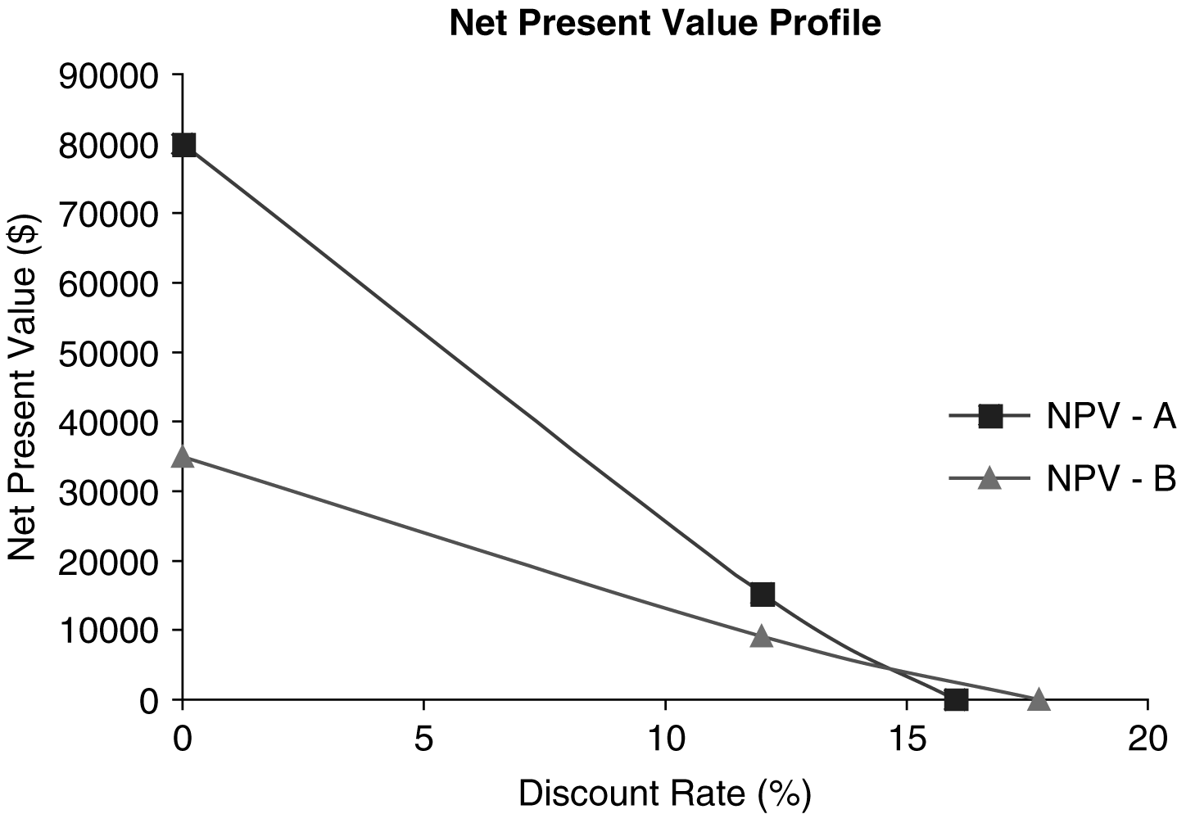

Data for NPV Profiles
 |  | NPV
Discount Rate |  | A | B
0% |  | $80,000 | $35,000
12% |  | $15,238 | $9,161
15% |  | — | $ 4,177
16% |  | 0 | —
18% |  | — | 0

d. The net present value profile indicates that there are conflicting rankings at a discount rate less than the intersection point of the two profiles (approximately 15%). The conflict in rankings is caused by the relative cash flow pattern of the two projects. At discount rates greater than approximately 15%, Project B is preferable; less than approximately 15%, Project A is better. Based on Thomas Company’s 12% cost of capital, Project A should be chosen.

e. Project A has an increasing cash flow from Year 1 through Year 5, whereas Project B has a decreasing cash flow from Year 1 through Year 5. Cash flows moving in opposite directions often cause conflicting rankings. The IRR method reinvests Project B’s larger early cash flows at the higher IRR rate, not the 12% cost of capital.

P10-24. All techniques—decision among mutually exclusive investments

LG 2, 3, 4, 5, 6; Challenge
 | Project
 | A | B | C
Cash inflows (years 1−5) | $20,000 | $ 31,500 | $ 32,500
a. Payback* | 3 years | 3.2 years | 3.4 years
b. NPV* | $10,345 | $ 10,793 | $ 4,310
c. IRR* | 19.86% | 17.33% | 14.59%
*Supporting calculations shown below:

a. Payback Period: Project A: $60,000 ÷ $20,000 = 3 years

Project B: $100,000 ÷ $31,500 = 3.2 years

Project C: $110,000 ÷ $32,500 = 3.4 years

b. NPV

Project A

CF₀ = −$60,000; CF₁ = $20,000; F₁ = 5

Set I = 13%

Solve for NPV_{A} = $10,344.63

Project B

CF₀ = −$100,000; CF₁ = $31,500; F₁ = 5

Set I = 13%

Solve for NPV_{B} = $10,792.78

Project C

CF₀ = −$110,000; CF₁ = $32,500; F₁ = 5

Set I = 13%

Solve for NPV_{C} = $4,310.02

c. IRR

Project A

CF₀ = −$60,000; CF₁ = $20,000; F₁ = 5

Solve for IRR_{A} = 19.86%

Project B

CF₀ = −$100,000; CF₁ = $31,500; F₁ = 5

Solve for IRR_{B} = 17.34%

Project C

CF₀ = −$110,000; CF₁ = $32,500; F₁ = 5

Solve for IRR_{C} = 14.59%

d.

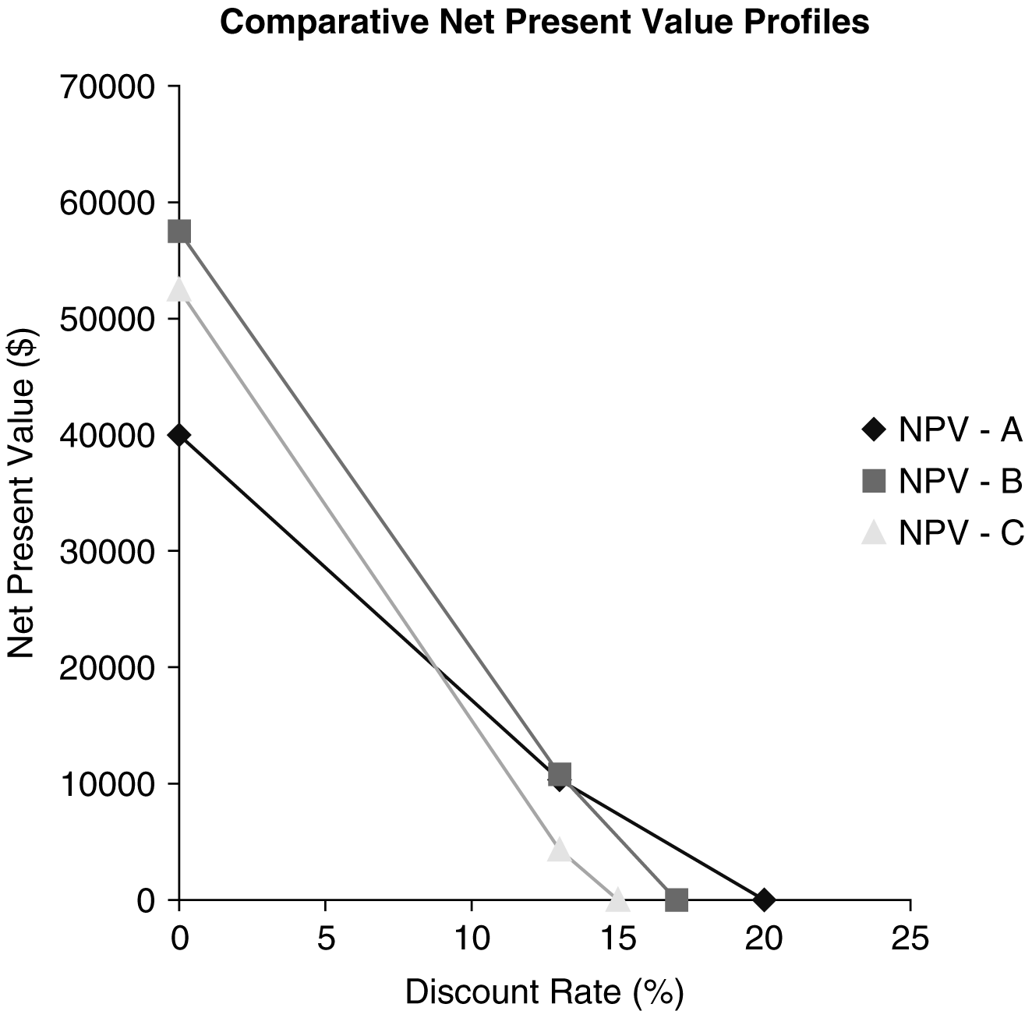

Data for NPV Profiles
 | NPV
Discount Rate | A | B | C
0% | $40,000 | $57,500 | $52,500
13% | $10,345 | 10,793 | 4,310
15% | 7,043 | 5,593 | 0
17% | 3,987 | 0 | —
20% | 0 | — | —

The difference in the magnitude of the cash flow for each project causes the NPV to compare favorably or unfavorably, depending on the discount rate.

e. Even though A ranks higher in Payback and IRR, financial theorists would argue that B is superior because it has the highest NPV. Adopting B adds $448.15 more to the value of the firm than does adopting A.

P10-25. All techniques with NPV profile—mutually exclusive projects

LG 2, 3, 4, 5, 6; Challenge

a. Project A

Payback period

Year 1 + Year 2 + Year 3 = $60,000

Year 4 = $20,000

Initial investment = $80,000

Payback = 3 years + ($20,000 ÷ 30,000)

Payback = 3.67 years

Project B

Payback period

$50,000 ÷ $15,000 = 3.33 years

b. Project A

CF₀ = −$80,000; CF₁ = $15,000; CF₂ = $20,000; CF₃ = $25,000; CF₄ = $30,000;

CF₅ = $35,000

Set I = 13%

Solve for NPV_{A} = $3,659.68

Project B

CF₀ = −$50,000; CF₁ = $15,000; F₁ = 5

Set I = 13%

Solve for NPV_{B} = $2,758.47

c. Project A

CF₀ = −$80,000; CF₁ = $15,000; CF₂ = $20,000; CF₃ = $25,000; CF₄ = $30,000;

CF₅ = $35,000

Solve for IRR_{A} = 14.61%

Project B

CF₀ = −$50,000; CF₁ = $15,000; F₁ = 5

Solve for IRR_{B} = 15.24%

d.

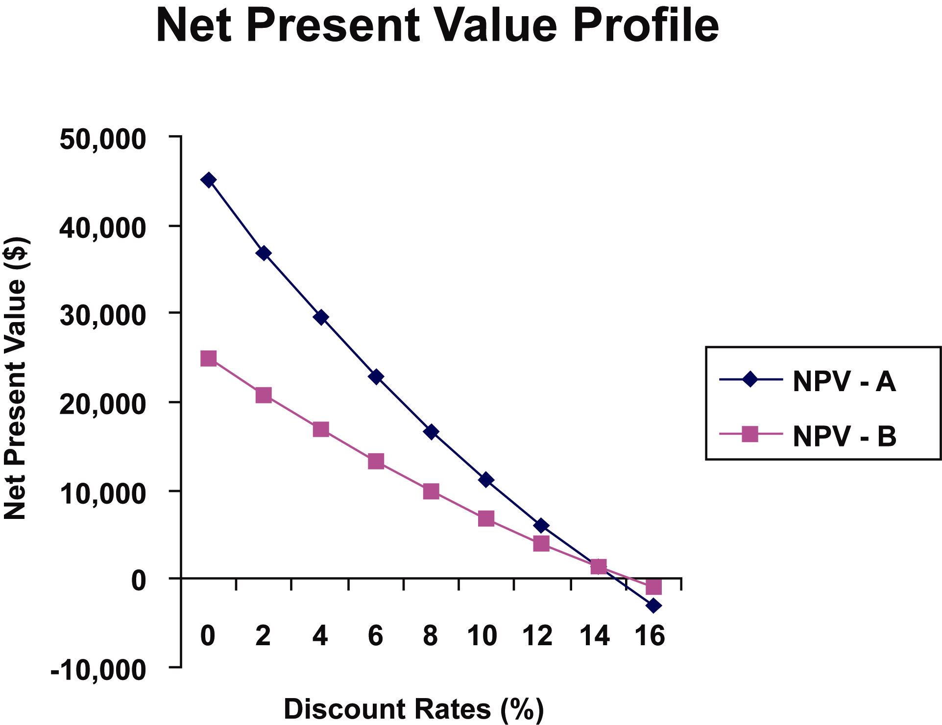

Data for NPV Profiles
 | NPV
Discount Rate | A | B
0% | $45,000 | $25,000
13% | $3,655 | 2,755
14.6% | 0 | —
15.2% | — | 0

Intersection—approximately 14%

If cost of capital is above 14%, conflicting rankings occur.

The calculator solution is 13.87%.

e. Both projects are acceptable. Both have similar payback periods, positive NPVs, and equivalent IRRs that are greater than the cost of capital. Although Project B has a slightly higher IRR, the rates are very close. Because Project A has a higher NPV, accept Project A.

P10-26. Integrative—Multiple IRRs

LG 6; Basic

a. First the project does not have an initial cash outflow. It has an inflow, so the payback is immediate. However, there are cash outflows in later years. After 2 years, the project’s outflows are greater than its inflows, but that reverses in year 3. The oscillating cash flows (positive-negative-positive-negative-positive) make it difficult to even think about how the payback period should be defined.

b. CF₀ = $200,000, CF₁ = −920,000, CF₂ = $1,582,000, CF₃ = −$1,205,200, CF₄ = $343,200

Set I = 0%; Solve for NPV = $0.00

Set I = 5%; Solve for NPV = −$15.43

Set I = 10%; Solve for NPV = $0.00

Set I = 15%; Solve for NPV = $6.43

Set I = 20%; Solve for NPV = $0.00

Set I = 25%; Solve for NPV = −$7.68

Set I = 30%; Solve for NPV = $0.00

Set I = 35%, Solve for NPV = $39.51

c. There are multiple IRRs because there are several discount rates at which the NPV is zero.

d. It would be difficult to use the IRR approach to answer this question because it is not clear which IRR should be compared to each cost of capital. For example, at 5%, the NPV is negative, so the project would be rejected. However, at a higher 15% discount rate, the NPV is positive, and the project would be accepted.

e. It is best simply to use NPV in a case where there are multiple IRRs due to the changing signs of the cash flows.

P10-27. Integrative—Conflicting Rankings

LG 3, 4, 5; Intermediate

a. Plant Expansion

CF₀ = −$3,500,000, CF₁ = 1,500,000, CF₂ = $2,000,000, CF₃ = $2,500,000,
CF₄ = $2,750,000

Set I = 20%; Solve for NPV = $1,911,844.14

Solve for IRR = 43.70%

CF₁ = 1,500,000, CF₂ = $2,000,000, CF₃ = $2,500,000, CF₄ = $2,750,000

Set I = 20%; Solve for NPV = $5,411,844.14 (This is the PV of the cash inflows.)

PI = $5,411,844.14 ÷ $3,500,000 = 1.55

Product Introduction

CF₀ = −$500,000, CF₁ = 250,000, CF₂ = $350,000, CF₃ = $375,000, CF₄ = $425,000

Set I = 20%; Solve for NPV = $373,360.34

Solve for IRR = 52.33%

CF₁ = 250,000, CF₂ = $350,000, CF₃ = $375,000, CF₄ = $425,000

Set I = 20%; Solve for NPV = $873,360.34 (This is the PV of the cash inflows.)

PI = $873,360.34 ÷ $500,000 = 1.75

b.
 | Rank
Project | NPV | IRR | PI
Plant Expansion | 1 | 2 | 2
Product Introduction | 2 | 1 | 1

c. The NPV is higher for the plant expansion, but both the IRR and the PI are higher for the product introduction project. The rankings do not agree because the plant expansion has a much larger scale. The NPV recognizes that it is better to accept a lower return on a larger project here. The IRR and PI methods simply measure the rate of return on the project and not its scale (and therefore not how much money in total the firm makes from each project).

d. Because the NPV of the plant expansion project is higher, the firm’s shareholders would be better off if the firm pursued that project, even though it has a lower rate of return.

P10-28. Ethics problem

LG 1, 6; Intermediate
Year | LED Project | Solar Project
0 | –$4,200,000 | –$500,000
1 | 700,000 | 60,000
2 | 700,000 | 60,000
3 | 700,000 | 60,000
4 | 700,000 | 60,000
5 | 1,000,000 | 60,000
6 | 700,000 | 60,000
7 | 700,000 | 60,000
8 | 700,000 | 60,000
9 | 700,000 | 60,000
10 | 700,000 | 60,000
- LED project

CF₀ = −$4,200,000; C0₁ = $700,000; F01 = 4; C0₂ = $1,000,000; C0₃ = $700,000; F02 = 5

I = 10

Solve for NPV_{LED} = $287,473.37

SOLAR project

CF₀ = −$500,000; C0₁ = $60,000; F01 = 10

I = 10

Solve for NPV_{Solar} = −$131,325.97

Because the NPV of LED project is positive, the company should undertake LED project.
- Combined project

NPV_{Combined} = NPV_{LED} + NPV_{Solar}

= $287,473.37 + (−$131,325.97)

= $156,147.40

Even though NPV of the combined project is positive, the company should not take the combined project. NPV of the LED project is $287,473.37. If the company undertakes combined project, NPV decreases by −$131,325.97 (NPV of the Solar project.) Hence, it should undertake only the LED project and not the combined project.

c) If Diane agrees to combining the two projects into a single proposal, the company would not be maximizing its NPV; on the other hand, if she does not agree to combining the projects, then David would not be able to curry favor with his boss. It would not be ethical for Diane to accept David’s proposal of rolling two projects into one as this leads to reduction in the overall NPV of the company. The company would be better off by accepting only the LED project and rejecting the Solar project. which has a negative NPV.

■ Case
Case studies are available on MyFinanceLab.

Making Norwich Tool’s Lathe Investment Decision
The student is faced with a typical capital budgeting situation in Chapter 10’s case. Norwich Tool must select one of two lathes that have different initial investments and cash inflow patterns. After calculating both unsophisticated and sophisticated capital budgeting techniques, the student must reevaluate the decision by taking into account the higher risk of one lathe.

a. Payback period

Lathe A:

Years 1−4 = $644,000

Payback = 4 years + ($16,000 ÷ $450,000) = 4.04 years

Lathe B:

Years 1−3 = $304,000

Payback = 3 years + ($56,000 ÷ $86,000) = 3.65 years

Lathe A will be rejected because the payback is longer than the 4-year maximum accepted, and Lathe B is accepted because the project payback period is less than the 4-year payback cutoff.

b. 1. NPV
Year | Discount Rate | Lathe A  Cash Flow | PV | Lathe B  Cash Flow | PV
0 | 13% | −$660,000 | $58,132.88 | −$360,000 | $43,483.24
1 |  | 128,000 |  | $88,000
2 |  | 182,000 |  | 120,000
3 |  | 166,000 |  | 96,000
4 |  | 168,000 |  | 86,000
5 |  | 450,000 |  | 207,000

2. IRR

Lathe A

IRR = 15.95%

Lathe B

IRR = 17.34%

Under the NPV rule, both lathes are acceptable because the NPVs for A and B are greater than 0. Lathe A ranks ahead of B because it has a larger NPV. The same accept decision applies to both projects with the IRR because both IRRs are greater than the 13% cost of capital. However, the ranking reverses with the 17.34% IRR for B being greater than the 15.95% IRR for Lathe A.

c. Summary
 | Lathe A | Lathe B
Payback period | 4.04 years | 3.65 years
NPV | $58,133 | $43,483
IRR | 15.95% | 17.34%

Both projects have positive NPVs and IRRs above the firm’s cost of capital. Lathe A, however, exceeds the maximum payback period requirement. Because it is so close to the 4-year maximum
and this is an unsophisticated capital budgeting technique, Lathe A should not be eliminated from consideration on this basis alone, particularly because it has a much higher NPV.

If the firm has unlimited funds, it should choose all projects with positive NPVs in order to maximize shareholder value. If the firm is subject to capital rationing, Lathe B, with its shorter payback period and higher IRR, should be chosen. The IRR considers the relative size of the investment, which is important in a capital rationing situation.

d. To create an NPV profile, it is best to have at least three NPV data points. To create the third point an 8% discount rate was arbitrarily chosen. With the 8% rate, the NPV for Lathe A is $176,078, and the NPV for Lathe B is $104,663.

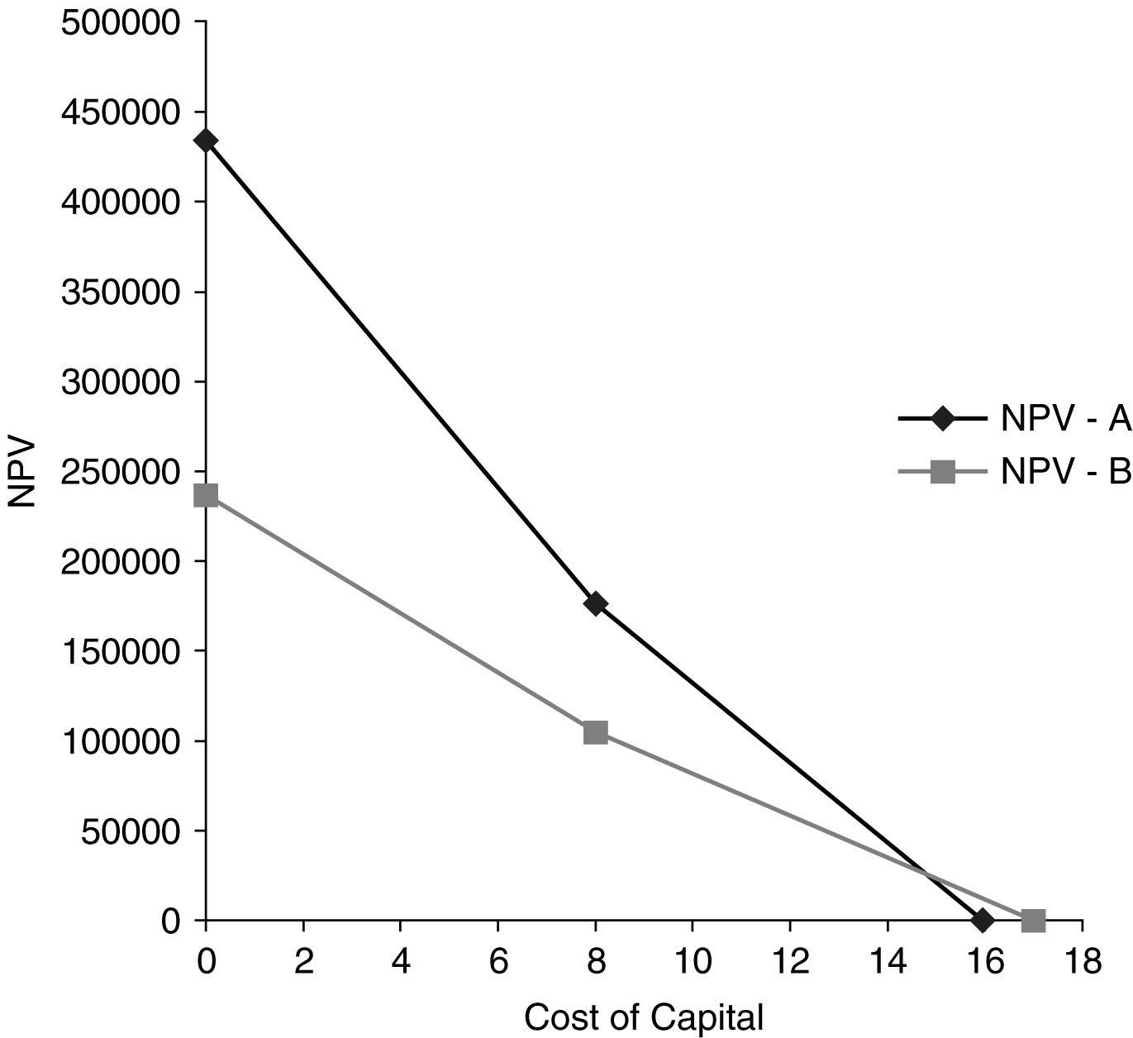

Lathe B is preferred over Lathe A based on the IRR. However, as can be seen in the NPV profile,
to the left of the crossover point of the two lines Lathe A is preferred. The underlying cause of this conflict in rankings arises from the reinvestment assumption of NPV versus IRR. NPV assumes the intermediate cash flows are reinvested at the cost of capital, while the IRR has cash flows being reinvested at the IRR. The difference in these two rates and the timing of the cash flows will determine the crossover point.

e. On a theoretical basis, Lathe A should be preferred because of its higher NPV and thus its known impact on shareholder wealth. From a practical perspective, Lathe B may be selected due to its higher IRR and its faster payback. This difference results from managers’ preferences for evaluating decisions based on percent returns rather than dollar returns and on the desire to get a return of cash flows as quickly as possible.

■ Spreadsheet Exercise
The answer to Chapter 10’s Drillago Company spreadsheet problem is located on the Instructor’s Resource Center at www.pearsonglobaleditions.com/gitman under the Instructor’s Manual.

■ Group Exercise
Group exercises are available on MyFinanceLab.
This assignment continues the long-term investment projects designed in the previous chapter. Students were required to make estimates of relevant cash flows before reading this chapter. This means that some of their numbers may have to be altered to allow each project to have a positive payback period. Allowing students to revisit their previous estimates should make their numbers more realistic and better to work with.
The first task is to calculate the payback periods for each of the projects. The NPV is then calculated for each project, where the NPVs should both be greater than 0. The crucial part of this step is the estimate of the discount rate used to calculate the NPVs. Each group must defend their chosen rate of discount. The final calculation is the IRR for each project.
Given the calculations regarding the payback period, NPV, and IRR of each project, the groups are asked to choose the more desirable project. This choosing process should be detailed, giving the reader a sense of the reasons for choosing between the projects. A summary of each method and a defense for the interpretation of these results should be included in each group’s write-up. Giving groups an example of a variety of potential projects will help students stay focused on the capital budgeting techniques presented in this chapter.

