Part 3
Valuation of Securities
Chapters in This Part

Chapter 6 Interest Rates and Bond Valuation

Chapter 7 Stock Valuation

Integrative Case 3: Encore International

Chapter 6
Interest Rates and Bond Valuation

■ Instructor’s Resources

Overview
This chapter begins with a thorough discussion of interest rates, yield curves, and their relationship to required returns. Features of the major types of bond issues are presented along with their legal issues, risk characteristics, and indenture convents. The chapter then introduces students to the important concept of valuation and demonstrates the impact of cash flows, timing, and risk on value. It explains models for valuing bonds and the calculation of yield-to-maturity using either an approximate yield formula or calculator. Students learn how interest rates may affect their ability to borrow and expand business operations or assets under personal control.

■ Suggested Answers to Opener-in-Review Questions
a. With short-term interest rates near 0 percent in 2013, suppose the Treasury decided to replace maturing notes and bonds by issuing new Treasury bills, thus shortening the average maturity of U.S. debt outstanding. Discuss the pros and cons of this strategy.
The U.S. Treasury would face many of the same considerations as those faced by a company that is considering revision of its average debt maturity. Short-term rates are normally lower, reducing total financing costs. However, if the U.S. Treasury relies on short-term rates and short-term rates rise, the cost of financing the federal debt could end up being higher. Even more serious is the risk that the U.S. Treasury may not be able to find buyers of new Treasury bills when old Treasury bills mature. According to market segmentation theory, there is a limited amount of demand for short-term securities. Excessive short-term demand might push up the cost of seasonal business loans higher, hindering business and tax revenues.
Another concern that the U.S. Treasury would have to face is whether the financing adjustment would diminish the high regard with which Treasury bills are held. Currently, Treasury bills are as close as we can get to a risk-free rate in the real world. If the amount of short-term financing becomes excessive, the ability of the federal government to make good on its short-term repayment promises may come into question, no longer make it a “risk-free” surrogate, and increase Treasury bill rates.
b. The average maturity of outstanding U.S. Treasury debt is a little more than 5 years. Suppose a newly issued 5-year Treasury note has a coupon rate of 2 percent and sells for par. What happens to the value of this bond if the inflation rate rises 1 percentage point, causing the yield-to-maturity on the 5-year note to jump to 3 percent shortly after it is issued?
Debt priced at par provides a coupon payment sufficient to pay the required rate of return. Hence, if the required rate of return is 2 percent, it must be paying $20 annually. If the discount rate increases, the coupon payment is no longer sufficient. Hence, the price would drop to create a one percent capital gain per year, leading up to $1,000 at maturity. The price would be
N = 5, I = 3%, PMT = $20, FV = 1,000
Solve for PV = 954.20
The price of the Treasury would drop $45.80, or 4.58 percent, to $954.20.
c. Assume that the “average” Treasury security outstanding has the features described in part b. If total U.S. debt is $16 trillion and an increase in inflation causes yields on Treasury securities to increase by 1 percentage point, by how much would the market value of outstanding debt fall? What does this suggest about the incentives of government policy makers to pursue policies that could lead to higher inflation?
Based on the information provided in the Opener, a few calculations can lead us to an approximation for this complex and complicated question. We are informed that $360 billion is the 2012 interest expense and that the national debt was about $15.8 trillion in 2012 (i.e., $16.8 trillion less, more than $1 trillion accrued in 2012). Division of the interest payment by the total debt results in an interest rate of 2.28 percent (i.e., $360 billion ÷ $15.8 trillion). Assuming the Treasuries are priced at par, one ends up with $22.80 per thousand being the annual payment needed to result in Treasuries being priced at par.
If interest rates rise by 1 percent to 3.28 percent, the price of the federal debt would fall to $954.57, as computed below.
N = 5, I = 3.28, PMT = 22.80, and FV = $1,000
Solve for PV = $954.57
The drop in Treasury values would be about 4.5 percent. This would decrease the size of the federal debt by $756 billion (0.045 × $16.8 trillion). Hence, if one considers the size of the current federal budget deficit in isolation, there is an incentive for the government to pursue policies which will lead to higher inflation. However, higher prices will lead to higher future costs for goods and services purchased by the government and an increase in the cost of entitlements, making proper use of interest rates to properly manage the federal budget difficult, complicated, and, alas, political.

■ Answers to Review Questions

1. The real rate of interest is the rate that creates an equilibrium between the supply of savings and demand for investment funds. The nominal rate of interest is the actual rate of interest charged by the supplier of funds and paid by the demander. The nominal rate of interest differs from the real rate of interest due to two factors: (1) a premium due to inflationary expectations (IP) and (2) a premium due to issuer and issue characteristic risks (RP). The nominal rate of interest for a security can be defined as r₁ = r* + IP + RP. For a 3-month U.S. Treasury bill, the nominal rate of interest can be stated as r₁ = r* + IP. The default risk premium, RP, is assumed to be zero because the security is backed by the U.S. government; this security is commonly considered the risk-free asset.

2. The term structure of interest rates is the relationship of the rate of return to the time to maturity for any class of similar-risk securities. The graphic presentation of this relationship is the yield curve.

3. For a given class of securities, the slope of the curve reflects an expectation about the movement of interest rates over time. The most commonly used class of securities is U.S. Treasury securities.

a. Downward sloping: Long-term borrowing costs are lower than short-term borrowing costs.

b. Upward sloping: Short-term borrowing costs are lower than long-term borrowing costs.

c. Flat: Borrowing costs are relatively similar for short- and long-term loans.

The upward-sloping yield curve has been the most prevalent historically.

4. a. According to the expectations theory, the yield curve reflects investor expectations about future interest rates, with the differences based on inflation expectations. The curve can take any of the three forms. An upward-sloping curve is the result of increasing inflationary expectations, and vice versa.

b. The liquidity preference theory is an explanation for the upward-sloping yield curve. This theory states that long-term rates are generally higher than short-term rates due to the desire of investors for greater liquidity, and thus a premium must be offered to attract adequate long-term investment.

c. The market segmentation theory is another theory that can explain any of the three curve shapes. Because the market for loans can be segmented based on maturity, sources of supply and demand for loans within each segment determine the prevailing interest rate. If supply is greater than demand for short-term funds at a time when demand for long-term loans is higher than the supply of funding, the yield curve would be upward sloping. Obviously, the reverse also holds true.

5. In the Fisher equation, r = r* + IP + RP, the risk premium, RP, consists of the following issuer- and issue-related components:

• Default risk: The possibility that the issuer will not pay the contractual interest or principal as scheduled.

• Maturity (interest rate) risk: The possibility that changes in the interest rates on similar securities will cause the value of the security to change by a greater amount the longer its maturity, and vice versa.

• Liquidity risk: The ease with which securities can be converted to cash without a loss in value.

• Contractual provisions: Covenants included in a debt agreement or stock issue defining the rights and restrictions of the issuer and the purchaser. These can increase or reduce the risk of a security.

• Tax risk: Certain securities issued by agencies of state and local governments are exempt from federal, and in some cases state and local taxes, thereby reducing the nominal rate of interest by an amount that brings the return into line with the after-tax return on a taxable issue of similar risk.

The risks that are debt specific are default, maturity, and contractual provisions.

6. Most corporate bonds are issued in denominations of $1,000 with maturities of 10 to 30 years. The stated interest rate on a bond represents the percentage of the bond’s par value that will be paid out annually, although the actual payments may be divided up and made quarterly or semiannually.

Both bond indentures and trustees are means of protecting the bondholders. The bond indenture is a complex and lengthy legal document stating the conditions under which a bond is issued. The trustee may be a paid individual, corporation, or commercial bank trust department that acts as a third-party “watch dog” on behalf of the bondholders to ensure that the issuer does not default on its contractual commitment to the bondholders.

7. Long-term lenders include restrictive covenants in loan agreements in order to place certain operating and/or financial constraints on the borrower. These constraints are intended to assure the lender that the borrowing firm will maintain a specified financial condition and managerial structure during the term of the loan. Because the lender is committing funds for a long period of time, he seeks to protect himself against adverse financial developments that may affect the borrower. The restrictive provisions (also called negative covenants) differ from the so-called standard debt provisions in that they place certain constraints on the firm’s operations, whereas the standard provisions (also called affirmative covenants) require the firm to operate in a respectable and businesslike manner. Standard provisions include such requirements as providing audited financial statements on a regular schedule, paying taxes and liabilities when due, maintaining all facilities in good working order, and keeping accounting records in accordance with generally accepted accounting procedures (GAAP).

Violation of any of the standard or restrictive loan provisions gives the lender the right to demand immediate repayment of both accrued interest and principal of the loan. However, the lender does not normally demand immediate repayment but instead evaluates the situation in order to determine if the violation is serious enough to jeopardize the loan. The lender’s options are: Waive the violation, waive the violation and renegotiate terms of the original agreement, or demand repayment.

8. Short-term borrowing is normally less expensive than long-term borrowing due to the greater uncertainty associated with longer maturity loans. The major factors affecting the cost of long-term debt (or the interest rate), in addition to loan maturity, are loan size, borrower risk, and the basic cost of money.

9. If a bond has a conversion feature, the bondholders have the option of converting the bond into a certain number of shares of stock within a certain period of time. A call feature gives the issuer the opportunity to repurchase, or call, bonds at a stated price prior to maturity. It provides extra compensation to bondholders for the potential opportunity losses that would result if the bond were called due to declining interest rates. This feature allows the issuer to retire outstanding debt prior to maturity and, in the case of convertibles, to force conversion. Stock purchase warrants, which are sometimes included as part of a bond issue, give the holder the right to purchase a certain number of shares of common stock at a specified price.

10. Current yields are calculated by dividing the annual interest payment by the current price. Bonds are quoted in percentage of par terms, to the thousandths place. Hence, corporate bond prices are effectively quoted in dollars and cents. A quote of 98.621 means the bond is priced at 98.621 percent of par, or $986.21.

Bonds are rated by independent rating agencies such as Moody’s and Standard & Poor’s with respect to their overall quality, as measured by the safety of repayment of principal and interest. Ratings are the result of detailed financial ratio and cash flow analyses of the issuing firm. The bond rating affects the rate of return on the bond. The higher the rating, the lower the risk and the lower the yield.

11. Eurobonds are bonds issued by an international borrower and sold to investors in countries with currencies other than that in which the bond is denominated. For example, a dollar-denominated Eurobond issued by an American corporation can be sold to French, German, Swiss, or Japanese investors. A foreign bond, on the other hand, is issued by a foreign borrower in a host country’s capital market and denominated in the host currency. An example is a pound-denominated bond issued in Great Britain by a French company.

12. A financial manager must understand the valuation process in order to judge the value of benefits received from stocks, bonds, and other assets in view of their risk, return, and combined impact on share value.

13. Three key inputs to the valuation process are

a. Cash flows—the cash generated from ownership of the asset;

b. Timing—the time period(s) in which cash flows are received; and

c. Required return—the interest rate used to discount the future cash flows to a PV. The selection of the required return allows the level of risk to be adjusted; the higher the risk, the higher the required return (discount rate).

14. The valuation process applies to assets that provide an intermittent cash flow or even a single cash flow over any time period.

15. The value of any asset is the PV of future cash flows expected from the asset over the relevant time period. The three key inputs in the valuation process are cash flows, the required rate of return, and the timing of cash flows. The equation for value is:

where:
V₀ = value of the asset at time zero
CFt = cash flow expected at the end of year t
r = appropriate required return (discount rate)
n = relevant time period

16. The basic bond valuation equation for a bond that pays annual interest is:

where:
V₀ = value of a bond that pays annual interest
I = interest
n = years to maturity
M = dollar par value
r_{d} = required return on the bond

To find the value of bonds paying interest semiannually, the basic bond valuation equation is adjusted as follows to account for the more frequent payment of interest:

a. The annual interest must be converted to semiannual interest by dividing by two.

b. The number of years to maturity must be multiplied by two.

c. The required return must be converted to a semiannual rate by dividing it by two.

17. A bond sells at a discount when the required return exceeds the coupon rate. A bond sells at a premium when the required return is less than the coupon rate. A bond sells at par value when the required return equals the coupon rate. The coupon rate is generally a fixed rate of interest, whereas the required return fluctuates with shifts in the cost of long-term funds due to economic conditions and/or risk of the issuing firm. The disparity between the required rate and the coupon rate will cause the bond to be sold at a discount or premium.

18. If the required return on a bond is constant until maturity and different from the coupon interest rate, the bond’s value approaches its $1,000 par value as the time to maturity declines.

19. To protect against the impact of rising interest rates, a risk-averse investor would prefer bonds with short periods until maturity. The responsiveness of the bond’s market value to interest rate fluctuations is an increasing function of the time to maturity.

20. The yield-to-maturity (YTM) on a bond is the rate investors earn if they buy the bond at a specific price and hold it until maturity. The YTM can be found precisely by using a hand-held financial calculator and using the time value functions. Enter the B₀ as the PV, and the I as the annual payment, and the N as the number of periods until maturity. Have the calculator solve for the interest rate. This interest value is the YTM. Many calculators are already programmed to solve for the internal rate of return (IRR). Using this feature will also obtain the YTM because the YTM and IRR are determined the same way. Spreadsheets include a formula for computing the yield to maturity.

21. Answers will vary for question because values are algorithmically generated in MyFinanceLab.

22. Answers will vary for question because values are algorithmically generated in MyFinanceLab.

23. Answers will vary for question because values are algorithmically generated in MyFinanceLab.

■ Suggested Answer to Focus on Practice Box:
I-Bonds Adjust for Inflation
What effect do you think the inflation-adjusted interest rate has on the cost of an I-bond in comparison with similar bonds with no allowance for inflation?
The cost of the I-bond when issued is the face value ($25 or more). Because the bond has an inflation protection feature, the Treasury Department can issue the I-bond at slightly lower interest rates than comparable bonds.

■ Suggested Answer to Focus on Ethics Box:
Can We Trust the Bond Raters?
What ethical issues may arise because the companies that issue bonds pay the rating agencies
to rate their bonds?
The rating agencies have an incentive to keep their customers (i.e., the issuers) happy in order to secure future business. Some suggest that the relationship between the agencies’ and the issuers is one of the factors that contributed to the subprime crisis. The concern is that rating agencies might hesitate to give low ratings, fearing that bond issues would no longer pay to have their bonds rated.

■ Answers to Warm-Up Exercises

E6-1. Finding the real rate of interest
Answer: Nominal rate = real rate + inflation rate = 7.4%

E6-2. Yield curve

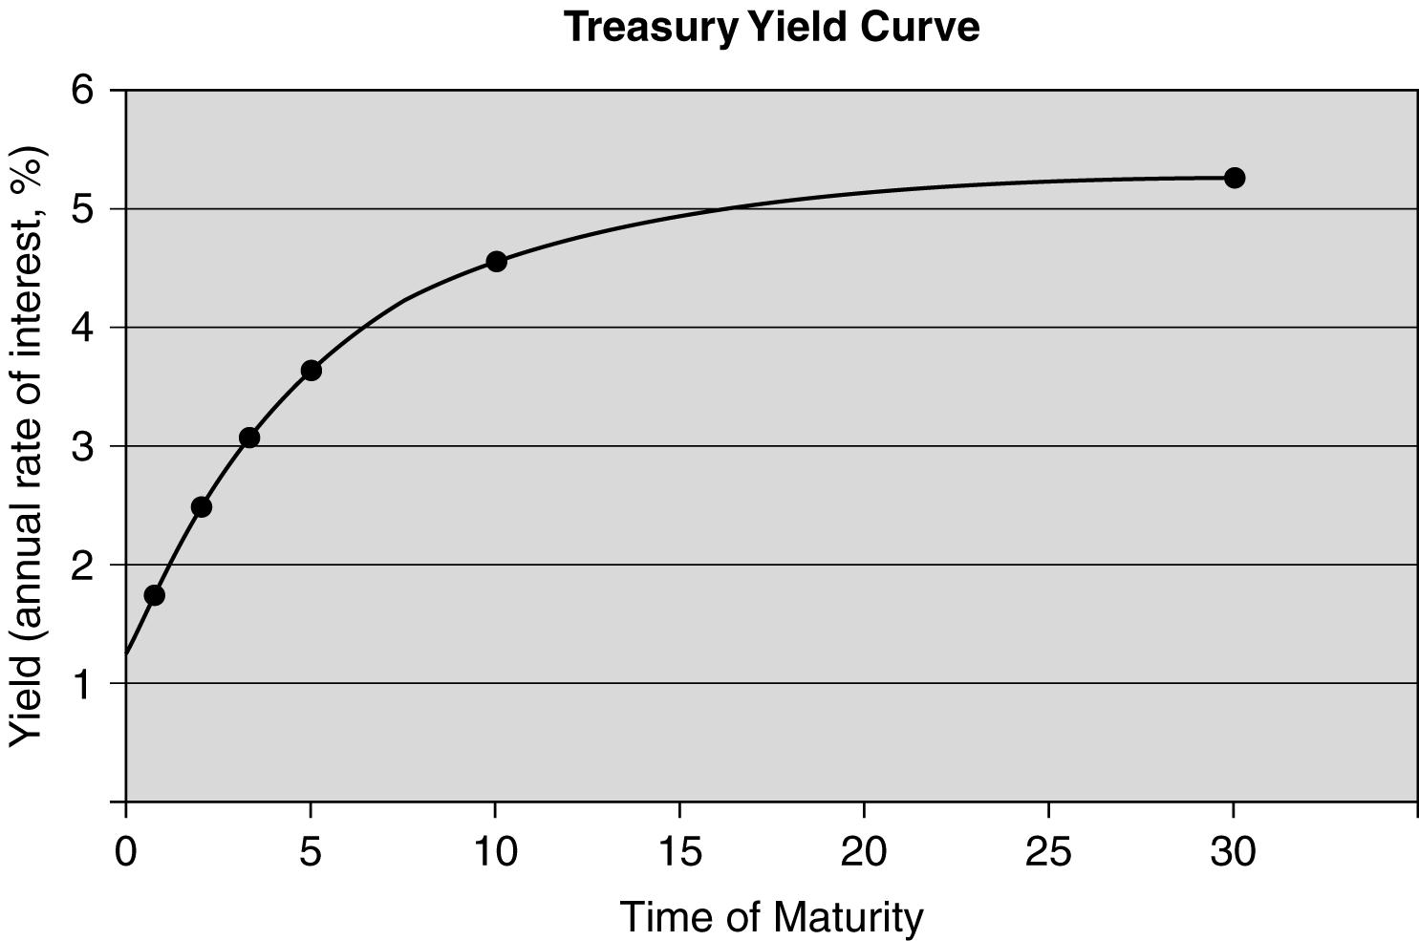

b. {(4.51% × 10) − (3.7% × 5)} ÷ 5

= {45.1% − 18.5%} ÷ 5

= 26.6% ÷ 5 = 5.32%

c. (3.01% × 3) − (2.68% × 2) = 9.03% − 5.36% = 3.67%

d. Yield curves may slope up for many reasons beyond expectations of rising interest rates. According to liquidity preference theory, long-term interest rates tend to be higher than short-term rates because longer-term debt has lower liquidity, higher responsiveness to general interest rate movements, and borrower’s willingness to pay a higher interest rate to lock in money for a longer period of time. In addition to the expectations theory and the liquidity preference theory, the market segmentation theory allows for additional increase in interest rate arising from either limited availability of funds or greater demand for funds at longer maturities.

E6-3. Calculating inflation expectation

Answer: The inflation expectation for a specific maturity is the difference between the yield and the real interest rate at that maturity.
Maturity | Yield | Real Rate of Interest | Inflation Expectation
3 months | 1.41% | 0.80% | 0.61%
6 months | 1.71 | 0.80 | 0.91
2 years | 2.68 | 0.80 | 1.88
3 years | 3.01 | 0.80 | 2.21
5 years | 3.70 | 0.80 | 2.90
10 years | 4.51 | 0.80 | 3.71
30 years | 5.25 | 0.80 | 4.45

E6-4. Real returns

Answer: A T-bill can experience a negative real return if its interest rate is less than the inflation rate as measured by the CPI. The real return would be zero if the T-bill rate was 3.3% exactly matching the CPI rate. To obtain a minimum 2% real return, the T-bill rate would have to be at least 5.3%.

E6-5. Calculating risk premium

Answer: We calculate the risk premium of other securities by subtracting the risk-free rate, 4.51%, from each nominal interest rate.
Security | Nominal interest rate | Risk premium
AAA | 5.12% | 5.12% − 4.51% = 0.61%
BBB | 5.78 | 5.78% − 4.51% = 1.27%
B | 7.82 | 7.82% − 4.51% = 3.31%

E6-6. The basic valuation model

Answer: Find the PV of the cash flow stream for each asset by discounting the expected cash flows using the respective required return.

Asset 1: PV = $500 ÷ 0.15 = $3,333.33

Asset 2:

E6-7. Calculating the PV of a bond when the required return exceeds the coupon rate

Answer: The PV of a bond is the PV of its future cash flows. In the case of the 5-year bond, the expected cash flows are $1,200 at the end of each year for 5 years, plus the face value of the bond that will be received at the maturity of the bond (end of year 5). You may use the bond valuation formula found in your text or you may use a financial calculator. The solution presented below is derived using a financial calculator. Set the calculator on 1 period/year.
PV of interest: PMT = −1,200
I = 8%/year
N = 5 periods
Solve for PV = $4,791.25
PV of the bond’s face value: FV = $20,000
N = 5 periods
I = 8%/year
Solve for PV = $13,611.66

The PV of this bond is $4,791.25 + $13,611.66 = $18,402.91.

This answer is consistent with the knowledge that when interest rates rise, the values of previously issued bonds fall. The present value is a cash outflow or cost to investor.

E6-8. Bond valuations using required rates of return

Answer: a. Student answers will vary but any required rate of return above the coupon rate will cause the bond to sell at a discount, while at a required return of 4.5%, the bond will sell at par. Any required rate of return below the coupon rate will cause the bond to sell at a premium.

b. Student answers will vary but should be consistent with their answers to part a.

■ Solutions to Problems

P6-1. Interest rate fundamentals: The real rate of return

LG1; Basic
Nominal return = risk free rate + risk premium = 6% + 5% = 11%

P6-2. Real rate of interest

LG 1; Intermediate

a.

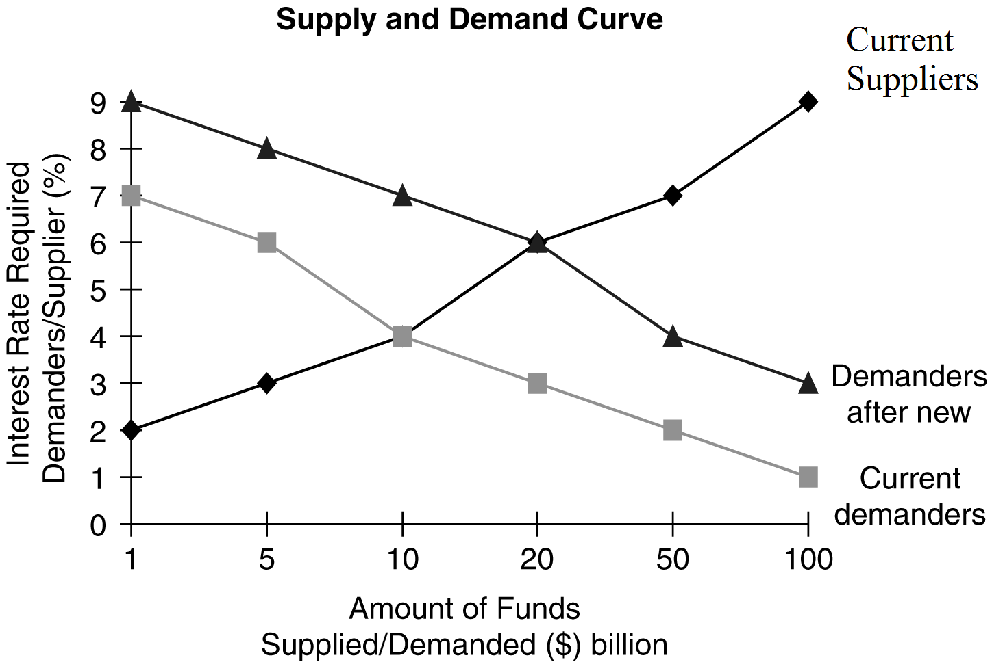

b. The real rate of interest creates an equilibrium between the supply of savings and the demand for funds, which is shown on the graph as the intersection of lines for current suppliers and current demanders; r = 4%.

c. See graph.

d. A change in the tax law causes an upward shift in the demand curve, causing the equilibrium point between the supply curve and the demand curve (the real rate of interest) to rise from r₀ = 4% to
r₀ = 6% (intersection of lines for current suppliers and demanders after new law).

P6-3. Personal finance: Real and nominal rates of interest

LG 1; Intermediate

a. Four shirts

b. $100 + ($100 × 0.09) = $109

c. $25 + ($25 × 0.05) = $26.25

d. The number of polo shirts in one year = $109 ÷ $26.25 = 4.1524. He can buy 3.8% more shirts (4.1524 ÷ 4 = 0.0381).

e. The real rate of return is 9% − 5% = 4%. The change in the number of shirts that can be purchased is determined by the real rate of return because the portion of the nominal return for expected inflation (5%) is available just to maintain the ability to purchase the same number of shirts.

P6-4. Yield curve

LG 1; Intermediate

a.

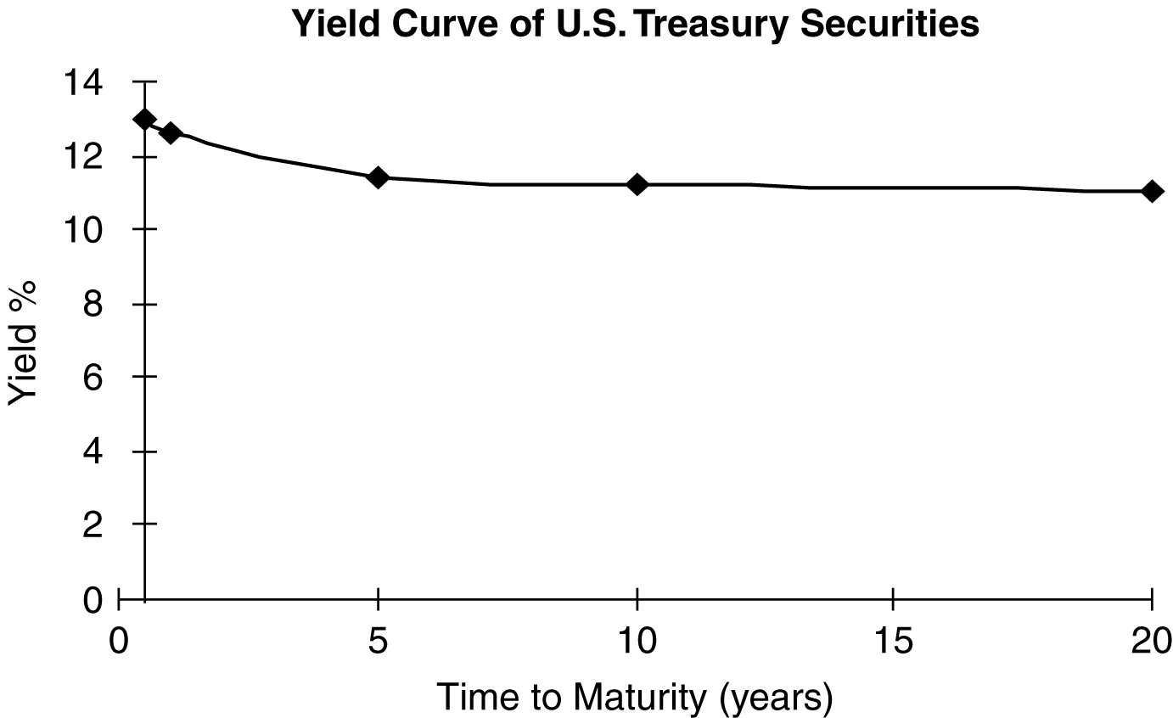

b. The yield curve is slightly downward sloping, reflecting lower expected future rates of interest. The curve may reflect a general expectation for an economic recovery due to inflation coming under control and a stimulating impact on the economy from the lower rates. However, a slowing economy may diminish the perceived need for funds and the resulting interest rate being paid for cash. Obviously, the second scenario is not good for business and highlights the challenge of forecasting the future based on the term structure of interest rates.

P6-5. Nominal interest rates and yield curves

LG 1; Challenge

a. r_{l} = r* + IP + RP₁

For U.S. Treasury issues, RP = 0

r_{F} = r* + IP

20-year bond: R_{F} = 2.5% + 9% = 11.5%

3-month bill: R_{F} = 2.5% + 5% = 7.5%

2-year note: R_{F} = 2.5% + 6% = 8.5%

5-year bond: R_{F} = 2.5% + 8% = 10.5%

b. If the real rate of interest (r*) drops to 2.0%, the nominal interest rate in each case would decrease by 0.5% point.

c.

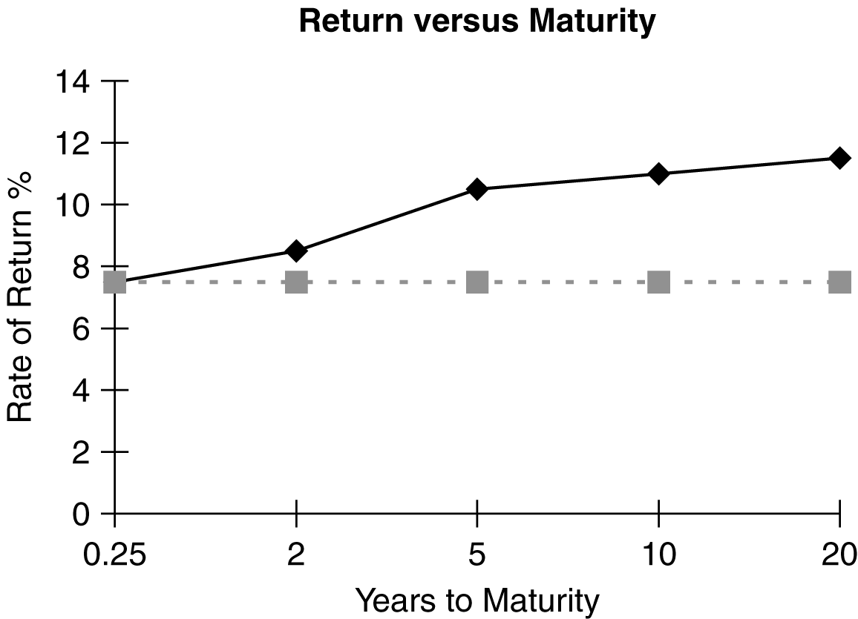

The yield curve for U.S. Treasury issues is upward sloping, reflecting the prevailing expectation of higher future inflation rates.

d. Followers of the liquidity preference theory would state that the upward-sloping shape of the curve is due to the desire by lenders to lend short term and the desire by business to borrow long term. The dashed line in the part c graph shows what the curve would look like without the existence of liquidity preference, ignoring the other yield curve theories.

e. Market segmentation theorists would argue that the upward slope is due to the fact that under current economic conditions there is greater demand for long-term loans for items such as real estate than for short-term loans such as seasonal needs.

P6-6. Nominal and real rates and yield curves

LG 1; Challenge

Real rate of interest (r*):

r_{i} = r* + IP + RP

RP = 0 for Treasury issues

r* = r_{i} − IP

a.
Security | Nominal Rate (r_{j}) | – | IP | = | Real Rate of  Interest (r*)
A | 12.6% | – | 9.5% | = | 3.1%
B | 11.2% | – | 8.2% | = | 3.0%
C | 13.0% | – | 10.0% | = | 3.0%
D | 11.0% | – | 8.1% | = | 2.9%
E | 11.4% | – | 8.3% | = | 3.1%

b. The real rate of interest decreased from January to March, remained stable from March through August, and finally increased in December. Forces that may be responsible for a change in the real rate of interest include changing economic conditions such as the international trade balance, a federal government budget deficit, or changes in tax legislation.

c.

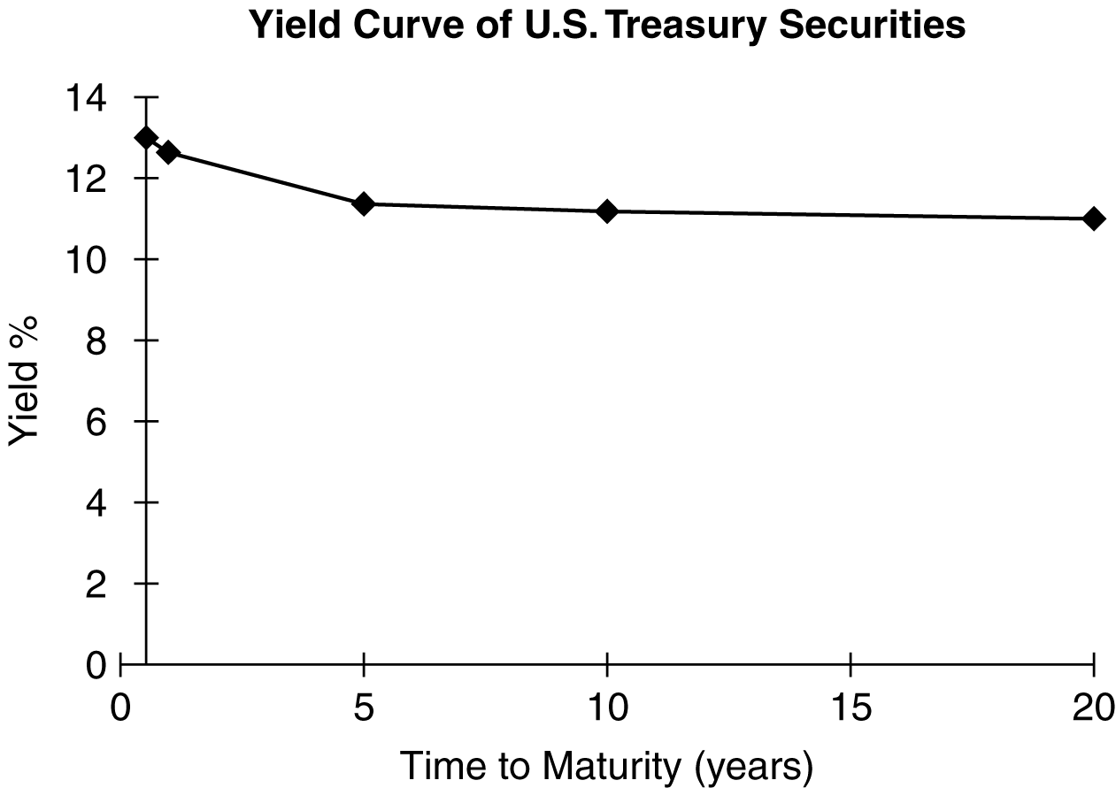

d. The yield curve is slightly downward sloping, reflecting lower expected future rates of interest. The curve may reflect a current, general expectation for an economic recovery due to inflation coming under control and a stimulating impact on the economy from the lower rates.

P6-7. Term structure of interest rates

LG 1; Intermediate

a.

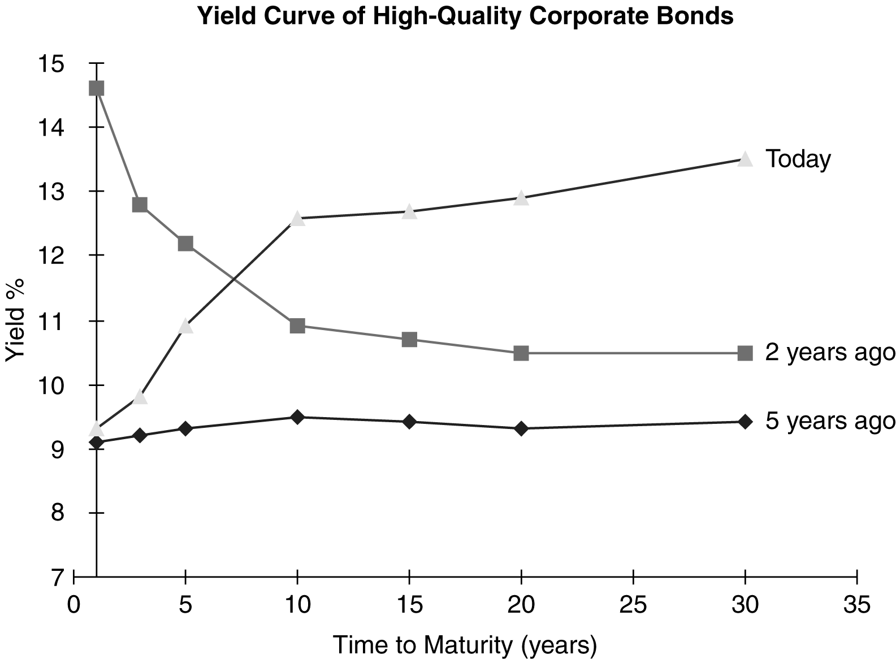

b. and c.

Five years ago, the yield curve was relatively flat, reflecting expectations of stable interest rates. Two years ago, the yield curve was downward sloping, reflecting lower expected interest rates, which could be due to a decline in the expected level of inflation. Today, the yield curve is upward sloping, reflecting higher expected future rates of interest.

d. Five years ago, the 10-year bond was paying 9.5%, which would result in approximately 95% in interest over the coming decade. At the same time, the 5-year bond was paying just 9.3%, or a total of 46.5% over the 5 years. According to the expectations theory, investors must have expected the current 5-year rate to be 9.7% because at that rate, the total return over 10 years would have been the same on a 10-year bond and on two consecutive 5-year bonds. The numbers are given below.

{(9.5% × 10) − (9.3% × 5)} ÷ 5

= {95% − 46.5%} ÷ 5

= 48.5% ÷ 5 = 9.7%

P6-8. Risk-free rate and risk premiums

LG 1; Basic
a.
nominal return = real rate + inflation rate
real rate = 4% – 2% = 2%

b.
nominal return = real rate + inflation rate + risk premium
A: 2% + 6% +4% = 12%
B: 2% + 5.5% + 5% = 12.5%
C: 2% + 5% + 2% = 9%
D: 2% + 4.8+ 3% = 9.8%
E: 2% + 6% + 6% = 14%

c.
It is because the security has different maturity, the expected inflation is an average inflation over the period until its maturity.

P6-9. Risk premiums

LG 1; Intermediate

a. R_{Ft} = r* + IP_{t}

Security A: R_{F3} = 2% + 9% = 11%

Security B: R_{F15} = 2% + 7% = 9%

b. Risk premium:

RP = default risk + maturity risk + liquidity risk + other risk

Security A: RP = 1% + 0.5% + 1% + 0.5% = 3%

Security B: RP = 2% + 1.5% + 1% + 1.5% = 6%

c. r_{i} = r* + IP + RP or r₁ = r_{F} + risk premium

Security A: r₁ = 11% + 3% = 14%

Security B: r₁ = 9% + 6% = 15%

Security A has a higher risk-free rate of return than Security B due to expectations of higher near-term inflation rates. The issue characteristics of Security A in comparison to Security B indicate that Security A is less risky.

P6-10. Bond interest payments before and after taxes

LG 2; Intermediate
- The price of the bond is $1,000
The number of bond you need to issue is: $50,000,000/$1,000 = 50,000

- The company need to pay both coupon ($60) and par ($1,000)
The total expense =

- As interest payments are tax-deducible, the after-tax cost of interest payment is:
The total after-tax expense = $51,860,000

P6-11. Bond prices and yields

LG 4; Basic
a.
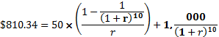
r =7.8%

b.
current yield = 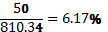

c.
Current yield only reflect the yield of the bond at the current moment, not the total return over the duration of the bond.

d.
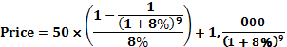

Price of the bond 1 year later = $812.59

Total return = 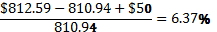

P6-12. Personal finance: Valuation fundamentals

LG 4; Basic

a. Cash flows: CF₁₋₅ $1,200

CF₅ $5,000

Required return: 6%

b.

Using Calculator:

N = 5, I = 6, PMT = $1,200, FV = $5,000

Solve for PV: $8791

The maximum price you should be willing to pay for the car is $8,791 because, if you paid more than that amount, you would be receiving less than your required 6% return.

P6-13. Valuation of assets

LG 4; Basic
 |  |  |  |  | Present Value of
Asset | End of Year | Amount |  |  | Cash Flows
A | 1 | $ 5,000 | N = 3, I = 18 |  | $10,871.36
 | 2 | $ 5,000 | PMT = $5,000
 | 3 | $ 5,000
B | 1–∞ | $ 300 | 300 ÷ 0.15 |  | $2,000
C | 1 | 0 | N = 5, I = 16 |  | $16,663.96
 | 2 | 0 | FV = $35,000
 | 3 | 0
 | 4 | 0
 | 5 | $35,000
D | 1–5 | $ 1,500 | N = 6, I = 12, |  | $9,713.53
 | 6 | 8,500 | PMT = $1,500  FV = $7,000
E | 1 | $ 2,000 | Use Cash Flow Worksheet |  | $14,115.27
 | 2 | 3,000
 | 3 | 5,000
 | 4 | 7,000
 | 5 | 4,000
 | 6 | 1,000

P6-14. Personal finance: Asset valuation and risk

LG 4; Intermediate

a.
N | PMT | @ 10%  Low Risk |  | @ 15%  Average Risk |  | @ 22%  High Risk
CF_{1–4} | $3,000 | $ 9,510 |  | $ 8,565 |  | $ 7,481
CF₅ | 15,000 | 9,314 |  | 7,458 |  | 5,550
Calculator solutions: |  | $18,823.42 |  | $16,022.59 |  | $13,030.91

b. The maximum price Laura should pay is $13,030.92. Unable to assess the risk, Laura would use the most conservative price, therefore assuming the highest risk.

c. By increasing the risk of receiving cash flow from an asset, the required rate of return increases, which reduces the value of the asset.

P6-15. Basic bond valuation

LG 5; Intermediate
- Original Price
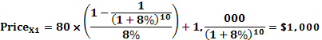
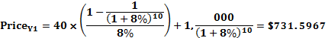
New Price:
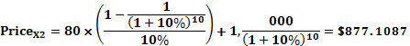
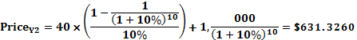
The percentage change in Bond X = 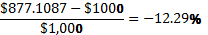
The percentage change in Bond Y = 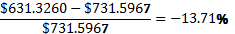

b. New Price:
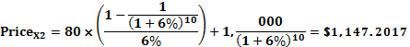
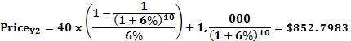
The percentage change in Bond X = 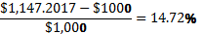
The percentage change in Bond Y = 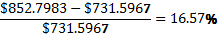

- Bond Y is riskier than bond X. It is because bond Y has fewer coupons, it has more interest rate risk.

P6-16. Bond valuation—annual interest

LG 5; Basic
Bond | Calculator Inputs | Calculator Solution
A | N = 20, I = 12, PMT = 0.14 × $1,000 = $140, FV = 1,000 | $1,149.39
B | N = 16, I = 8, PMT = 0.08 × $1,000 = $80, FV = $1,000 | $1,000.00
C | N = 8, I = 13, PMT = 0.10 × $100 = $10, FV = $100 | $ 85.60
D | N = 13, I = 18, PMT = 0.16 × $500 = $80, FV = $500 | $ 450.90
E | N = 10, I = 10, PMT = 0.12 × $1,000 = $120, FV = $1,000 | $1,122.89

P6-17. Bond value and changing required returns

LG 5; Intermediate

a.
Bond | Calculator Inputs | Calculator Solution
(1) | N = 12, I = 11%, PMT = $110, FV = $1,000 | $1,000.00
(2) | N = 12, I = 15%, PMT = $110, FV = $1,000 | $ 783.18
(3) | N = 12, I = 8%, PMT = $110, FV = $1,000 | $1,226.08

b.

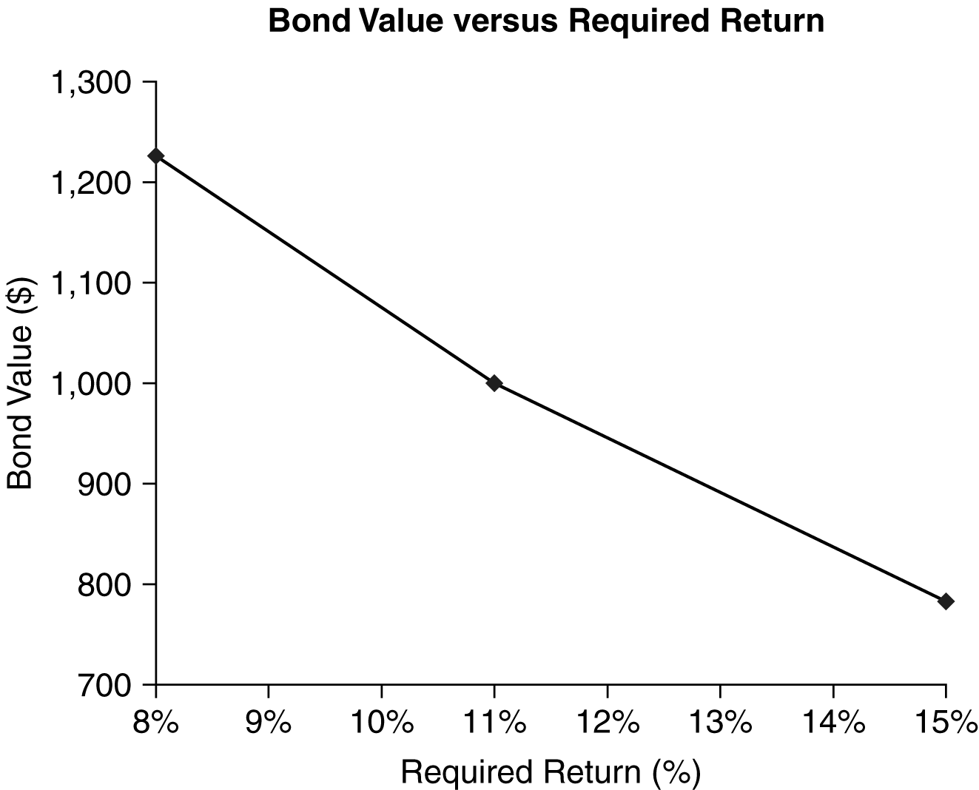

c. When the required return is less than the coupon rate, the market value is greater than the par value, and the bond sells at a premium. When the required return is greater than the coupon rate, the market value is less than the par value; the bond therefore sells at a discount. When the required return is equal to the coupon rate, the market value is equal to the par value.

d. The required return on the bond is likely to differ from the coupon interest rate because either
(1) economic conditions have changed, causing a shift in the basic cost of long-term funds, or
(2) the firm’s risk has changed.

P6-18. Bond value and time—constant required returns

LG 5; Intermediate

a.
Bond | Calculator Inputs | Calculator Solution
(1) | N = 15, I = 14%, PMT = $120, FV = $1,000 | $877.16
(2) | N = 12, I = 14%, PMT = $120, FV = $1,000 | $886.79
(3) | N = 9, I = 14%, PMT = $120, FV = $1,000 | $901.07
(4) | N = 6, I = 14%, PMT = $120, FV = $1,000 | $922.23
(5) | N = 3, I = 14%, PMT = $120, FV = $1,000 | $953.57
(6) | N = 1, I = 14%, PMT = $120, FV = $1,000 | $982.46

b.

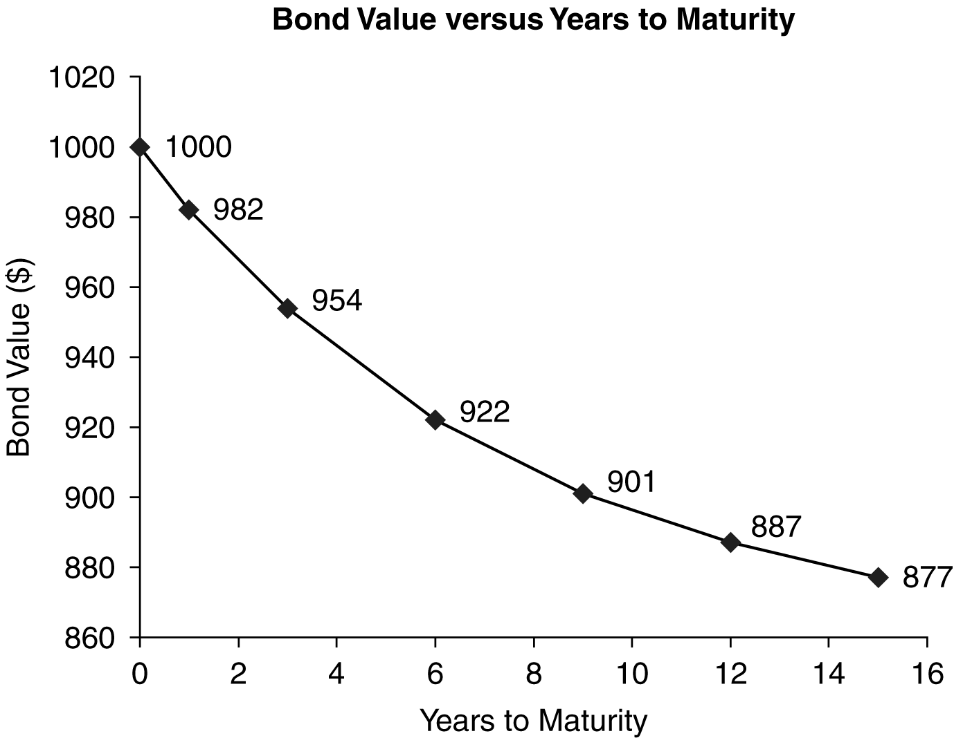

c. From the graph we can conclude that, all else remaining the same, when the required return differs from the coupon interest rate and is assumed to be constant to maturity, the bond value approaches the par value.

P6-19. Personal finance: Bond value and time—changing required returns

LG 5; Challenge

a.
Bond | Calculator Inputs | Calculator Solution
(1) | N = 5, I = 8%, PMT = $110, FV = $1,000 | $1,119.78
(2) | N = 5, I = 11%, PMT = $110, FV = $1,000 | $1,000.00
(3) | N = 5, I = 14%, PMT = $110, FV = $1,000 | $ 897.01

b.
Bond | Table Values | Calculator Solution
(1) | N = 15, I = 8%, PMT = $110, FV = $1,000 | $1,256.78
(2) | N = 15, I = 11%, PMT = $110, FV = $1,000 | $1,000.00
(3) | N = 15, I = 14%, PMT = $110, FV = $1,000 | $ 815.73

c.
 |  | Value
Required Return | Bond A |  | Bond B
8% | $1,119.78 |  | $1,256.75
11% | 1,000.00 |  | 1,000.00
14% | 897.01 |  | 815.73

The greater the length of time to maturity, the more responsive the market value of the bond to changing required returns, and vice versa.

d. If Lynn wants to minimize interest rate risk in the future, she would choose Bond A with the shorter maturity. Any change in interest rates will impact the market value of Bond A less than if she held Bond B.

P6-20. Yield to maturity

LG 6; Basic
Bond | Coupon Rate | Coupon frequency | Time to maturity | Yield to maturity | Price
A | 5% | semi-annually | 5 years | 5% | $1,000
B | 5 | annually | 5 | 5 | $1,000
C | 7 | semi-annually | 7 | 7 | $1,000
D | 7 | annually | 10 | 7 | $1,000
E | 12 | semi-annually | 8 | 8 | $1,233.05
F | 10 | annually | 8 | 7 | $900.65

P6-21. Yield to maturity

LG 6; Intermediate
a.
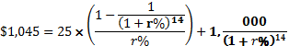
r = 2.1250%
yield to maturity =

- You should buy the bond. The relationship between bond price and bond yield is inverse. If the interest rate drop in a near future, the bond price will increase.

P6-22. LG 6: Yield to maturity

LG 6; Intermediate

a.
 |  | Calculator
Bond | Approximate YTM | Solution
A | = = 12.36% | 12.71%
B | = 12.00% | 12.00%
C | = = $10.38% | 10.22%
D | = = 13.02% | 12.81%
E | = = 8.77% | 8.95%

b. The market value of the bond approaches its par value as the time to maturity declines. The yield-to-maturity approaches the coupon interest rate as the time to maturity declines. Case B highlights the fact that if the current price equals the par value, the coupon interest rate equals the yield to maturity (regardless of the number of years to maturity).

P6-23. Personal finance: Bond valuation and yield to maturity

LG 2, 5, 6; Challenge

a. N = 5, I = 12%, PMT = 0.06 × $1,000 = $60; FV = $1,000

Solve for PV = $783.71

N = 5, I = 12%, PMT = 0.14 × $1,000 = $140; FV = $1,000

Solve for PV = $ 1,072.10

b. Number of Bond A bonds = $20,000 ÷ $783.71 = 25.520

Number of Bond B bonds = $20,000 ÷ $1072.10 = 18.655

c. Interest income of A = 25.520 bonds × $60 = $1,531.20

Interest income of B = 18.655 bonds × $140 = $2,611.70

d. At the end of the 5 years both bonds mature and will sell for par of $1,000.

N = 5, I = 10%, PMT= $60, Solve for FV = $366.31

Total future cash flows: $366.31 + $1,000 = $1,366.31

N = 5, I = 10%, PMT = $140, Solve for FV = $854.71

Total future cash flows: $854.71 + $1,000 = $1,854.71

e. The difference is due to the differences in interest payments received each year. The principal payments at maturity will be the same for both bonds. Using the calculator, the yield to maturity of Bond A is 11.76%, and the yield to maturity of Bond B is 11.59% with the 10% reinvestment rate for the interest payments. Mark would be better off investing in Bond A. The reasoning behind this result is that for both the bonds the principal is priced to yield 12%. However, Bond B is more dependent upon the reinvestment of the large coupon payment at the yield to maturity to earn the 12% than is the lower coupon payment of Bond A.

P6-24. Bond valuation—semiannual interest

LG 6; Intermediate
The semi-annual rate you earn is:
r = 4%.

The bond yield should be 8%.
Since the bond yield equals to the coupon rate, the bond value should be equal to par. The bond value is $1,000.

P6-25. Bond valuation—semiannual interest

LG 6; Intermediate
Bond | Computer Inputs | Calculator Solution
A | N = 24, I = 4%, PMT = $50, FV = $1,000 | $1,152.47
B | N = 40, I = 6%, PMT = $60, FV = $1,000 | $1,000.00
C | N = 10, I = 7%, PMT = $30, FV = $500 | $ 464.88
D | N = 20, I = 5%, PMT = $70, FV = $1,000 | $1,249.24
E | N = 8, I = 7%, PMT = $3, FV = $100 | $ 76.11

P6-26. Bond valuation—quarterly interest

LG 6; Challenge
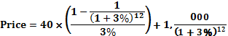
Price = $1,099.54

P6-27. Ethics problem

LG 1; Intermediate

Student answers will vary. Some students may argue that such a policy decreases the reliability
of the rating agency’s bond ratings because the rating is not purely based on the quantitative and nonquantitative factors that should be considered. One of the goals of the new law is to discourage such a practice. Other students may argue that, like a loss leader, ratings are a way to generate additional business for the rating firm.

■ Case

Case studies are available on MyFinanceLab.

Evaluating Annie Hegg’s Proposed Investment in Atilier Industries Bonds
This case demonstrates how a risky investment can affect a firm’s value. First, students must calculate
the current value of Atilier’s bonds, rework the calculations assuming that the firm makes the risky investment, and then draw some conclusions about the value of the firm in this situation. In addition to gaining experience in valuation of bonds, students will see the relationship between risk and valuation.

a. Annie should convert the bonds. The value of the stock if the bond is converted is

50 shares × $30 per share = $1,500

If the bond was allowed to be called in the value, it would be on $1,080.

b. Current value of bond under different required returns – annual interest

1. N = 25, I = 6%, PMT = $80, FV = $1,000

Solve for PV = $1,255.67

The bond would be at a premium.

2. N = 25, I = 8%, PMT = $80, FV = $1,000

Solve for PV = $1000.00

The bond would sell at its par value.

3. N = 25, I = 10%, PMT = $80, FV = $1,000

Solve for PV = $818.46

The bond would be at a discount.

c. Current value of bond under different required returns – semiannual interest

1. N = 50, I = 3%, PMT = $40, FV = $1,000

Solve for PV = $1,257.30

The bond would be at a premium.

2. N = 50, I = 4%, PMT = $40, FV = $1,000

Solve for PV = $1,000.00

The bond would be at par value.

3. N = 50, I = 5%, PMT = $40, FV = $1,000

Solve for PV = $817.44

The bond would be at a discount.
Under all three required returns for both annual and semiannual interest payments the bonds are consistent in their direction of pricing. When the required return is above (below) the coupon the bond sells at a discount (premium). When the required return and coupon are equal the bond sells at par. When the change is made from annual to semiannual payments, the value of the premium and par value bonds increase while the value of the discount bond decreases. This difference is due to the higher effective return associated with compounding frequency more often than annual.

d. If expected inflation increases by 1%, the required return will increase from 8% to 9%, and the bond price would drop to $901.77. This amount is the maximum Annie should pay for the bond.

N = 25, I = 9%, PMT = $80, FV = $1,000

Solve for PV = $901.77

e. The value of the bond would decline to $924.81 due to the higher required return and the inverse relationship between bond yields and bond values.

N = 25, I = 8.75%, PMT = $80, FV = $1,000

Solve for PV = $924.81

f. The bond would increase in value and a gain of $110.61 would be earned by Annie.

N = 22, I = 7%, PMT = $80, PV = $1,000

Solve for PV = $1,110.61

g. The bond would increase in value and a gain of $91.08 would be earned by Annie.

Bond value at 7% and 15 years to maturity.

N = 15, I = 7%, PMT = $80, FV = $1,000

Solve for PV = $1,091.08

The bond is more sensitive to interest rate changes when the time to maturity is longer (22 years) than when the time to maturity is shorter (15 years). Maturity risk decreases as the bond gets closer to maturity.

h. Antilier Industries provides a yield of 8% ($80) and is priced at $983.80 (0.98380 × 1,000). Hence, the current yield is 80/983.80 = 0.0813, or about 8.13%. Using the calculator, the YTM on this bond assuming annual interest payments of $80, 25 years to maturity, and a current price of $983.80 would be 8.15%.

i. Annie should probably not invest in the Atilier bond. There are several reasons for this conclusion.

1. The term to maturity is long, and thus, the maturity risk is high.

2. An increase in interest rates is likely due to the potential downgrading of the bond, thus driving the price down.

3. An increase in interest rates is likely due to the possibility of higher inflation, thus driving the price down.

4. The price of $983.75 is well above her minimum price of $901.77, assuming an increase in interest rates of 1%.

■ Spreadsheet Exercise
The answer to Chapter 6’s CSM Corporation spreadsheet problem is located on the Instructor’s Resource Center at www.pearsonglobaleditions.com/gitman under the Instructor’s Manual.

■ Group Exercise

Group exercises are available on MyFinanceLab.
This chapter is concerned with credit ratings. Each group is asked to use current information from their shadow firm to flesh out the details for their fictitious firm. The first lesson students will learn is the lack of transparency in the bond market, particularly when compared to the stock market. Updated information is not as easily compared across multiple sites and details are often sketchy. Because a recent debt issuance is needed, the assignment can be redirected from publicly accessed websites to the most recent filings with the SEC.
The steps for the assignment are very straightforward. Each group is asked to retrieve the interest rate of a recent debt issuance. For many firms there will be multiple offerings; any recent filing will suffice. This information on rates is then combined with the credit rating of the offering. Students should realize the same firm can be given different ratings on different offerings according to each offering’s covenants. Using the current yield on a comparable Treasury, the risk premium can then be calculated.
The final step for the group is to address a potential capital investment. The interest rate will be derived from the information of the shadow firm; however ,the details of the project are entirely up to the discretion of the group. Students should be encouraged to get creative, as this is the firm they will be living with for another two months.

