Part 4
Risk and the Required Rate of Return
Chapters in this Part

Chapter 8 Risk and Return

Chapter 9 The Cost of Capital

Integrative Case 4: Eco Plastics Company

Chapter 8
Risk and Return

■ Instructor’s Resources

Overview
This chapter focuses on the fundamentals of the risk and return relationship of assets and their valuation. For the single asset held in isolation, risk is measured with the probability distribution and its associated statistics: the mean, the standard deviation, and the coefficient of variation. The concept of diversification is examined by measuring the risk of a portfolio of assets that are perfectly positively correlated, perfectly negatively correlated, and those that are uncorrelated. Next, the chapter looks at international diversification and its effect on risk. The Capital Asset Pricing Model (CAPM) is then presented as a valuation tool for securities and as a general explanation of the risk-return tradeoff involved in all types of financial transactions. Chapter 8 highlights the importance of understanding the relationship of risk and return when making professional and personal decisions.

■ Suggested Answer to Opener-in-Review Question
In the chapter opener you learned that Bill Miller’s investment performance was alternating between the very top and the very bottom of his profession. What aspect of his investment strategy would lead you to expect that his performance might exhibit greater volatility than that of other mutual funds? In the table below, we show the annual performance from 2009 to 2012 of Miller’s Opportunity fund and the S&P 500 index.
 | Opportunity | S&P 500
Year | Fund Return | Return
2009 | 76.0% | 26.5%
2010 | 16.6% | 15.1%
2011 | –34.9% | 2.11%
2012 | 39.6% | 16.0%
Calculate the average annual return of the Opportunity fund and the S&P 500. Which performed better over this period? If you had invested $1,000 in each investment at the beginning of 2009, how much money would you have in each investment at the end of 2012? Calculate the standard deviation of the Opportunity fund’s return and those of the S&P 500. Which is more volatile?
Average annual return of the Opportunity fund = (76.0% + 16.6% − 34.9% + 39.6%) / 4 = 97.30% / 4 = 24.33%
Average annual return of the S & P 500 = (26.5% + 15.1% + 2.11% + 16.0%) / 4 =59.71% / 4 = 14.93%
Opportunity fund performed better over this period.
Money in each investment at the end of 2012:
Opportunity fund = $1,000 × (1 +2 4.33%) = $1,243.25
S & P Return = $1,000 × (1 + 14.93%) = $1,149.28
Year Return (Return – average return)²
2009 76.0% 26.70%
2010 16.60% 0.60%
2011 −34.90% 35.08%
2012 39.60% 2.33%
Total 64.71%
Standard deviation = √64.71% = 80.44

Answers to Review Questions

1. Risk is defined as the chance of financial loss, as measured by the variability of expected returns associated with a given asset. A decision maker should evaluate an investment by measuring the chance of loss, or risk, and comparing the expected risk to the expected return. Some assets are considered risk free; the most common examples are U.S. Treasury issues.

2. The return on an investment (total gain or loss) is the change in value plus any cash distributions over a defined time period. It is expressed as a percent of the beginning-of-the-period investment. The formula is:

Realized return requires the asset to be purchased and sold during the time periods the return is measured. Unrealized return is the return that could have been realized if the asset had been purchased and sold during the time period the return was measured.

3. a. The risk-averse financial manager requires an increase in return for a given increase in risk.

b. The risk-neutral manager requires no change in return for an increase in risk.

c. The risk-seeking manager accepts a decrease in return for a given increase in risk.

Most financial managers are risk averse.

4. Scenario analysis evaluates asset risk by using more than one possible set of returns to obtain a sense of the variability of outcomes. The range is found by subtracting the pessimistic outcome from the optimistic outcome. The larger the range, the greater the risk associated with the asset.

5. The decision maker can get an estimate of project risk by viewing a plot of the probability distribution, which relates probabilities to expected returns and shows the degree of dispersion of returns. The more spread out the distribution, the greater the variability or risk associated with the return stream.

6. The standard deviation of a distribution of asset returns is an absolute measure of dispersion of risk around the mean or expected value. A higher standard deviation indicates a greater project risk. With a larger standard deviation, the distribution is more dispersed, and the outcomes have a higher variability, resulting in higher risk.

7. The coefficient of variation is another indicator of asset risk; however, this measures relative dispersion. It is calculated by dividing the standard deviation by the expected value. The coefficient of variation indicates how volatile an asset’s returns are relative to its average or expected return. Therefore, the coefficient of variation is a better basis than the standard deviation for comparing risk of assets with differing expected returns.

8. An efficient portfolio is one that maximizes return for a given risk level or minimizes risk for a given level of return. Return of a portfolio is the weighted average of returns on the individual component assets:

where:

n = number of assets

w_{j} = weight of individual assets

= expected returns

The standard deviation of a portfolio is not the weighted average of component standard deviations; the risk of the portfolio as measured by the standard deviation will be smaller. It is calculated by applying the standard deviation formula to the portfolio assets:

9. The correlation between asset returns is important when evaluating the effect of a new asset on the portfolio’s overall risk. Returns on different assets moving in the same direction are positively correlated, while those moving in opposite directions are negatively correlated. Assets with high positive correlation increase the variability of portfolio returns; assets with high negative correlation reduce the variability of portfolio returns. When negatively correlated assets are brought together through diversification, the variability of the expected return from the resulting combination can be less than the variability or risk of the individual assets. When one asset has high returns, the other’s returns are low and vice versa. Therefore, the result of diversification is to reduce risk by providing a pattern of stable returns.

Diversification of risk in the asset selection process allows the investor to reduce overall risk by combining negatively correlated assets so that the risk of the portfolio is less than the risk of the individual assets in it. Even if assets are not negatively correlated, the lower the positive correlation between them, the lower their resulting portfolio return variability.

10. The inclusion of foreign assets in a domestic company’s portfolio reduces risk for two reasons. When returns from foreign-currency-denominated assets are translated into dollars, the correlation of returns of the portfolio’s assets is reduced. Also, if the foreign assets are in countries that are less sensitive to the U.S. business cycle, the portfolio’s response to market movements is reduced.

When the dollar appreciates relative to other currencies, the dollar value of a foreign-currency-denominated portfolio declines and results in lower returns in dollar terms. If this appreciation is due to better performance of the U.S. economy, foreign-currency-denominated portfolios generally have lower returns in local currency as well, further contributing to reduced returns.

Political risks result from possible actions by the host government that are harmful to foreign investors or possible political instability that could endanger foreign assets. This form of risk is particularly high in developing countries. Companies diversifying internationally may have assets seized or the return of profits blocked.

11. The total risk of a security is the combination of nondiversifiable risk and diversifiable risk. Diversifiable risk refers to the portion of an asset’s risk attributable to firm-specific, random events (strikes, litigation, loss of key contracts, etc.) that can be eliminated by diversification. Nondiversifiable risk is attributable to market factors affecting all firms (war, inflation, political events, etc.). Some argue that nondiversifiable risk is the only relevant risk because diversifiable risk can be eliminated by creating a portfolio of assets that are not perfectly positively correlated.

12. Beta measures nondiversifiable risk. It is an index of the degree of movement of an asset’s return in response to a change in the market return. The beta coefficient for an asset can be found by plotting the asset’s historical returns relative to the returns for the market. By using statistical techniques, the “characteristic line” is fit to the data points. The slope of this line is beta. Beta coefficients for actively traded stocks are published in the Value Line Investment Survey, in brokerage reports, and several online sites. The beta of a portfolio is calculated by finding the weighted average of the betas of the individual component assets.

13. The equation for the capital asset pricing model is:
r_{j} = R_{F} + [b_{j} × (r_{m} − R_{F})],

where:
r_{j} = the required (or expected) return on asset j
R_{F} = the rate of return required on a risk-free security (a U.S. Treasury bill)
b_{j} = the beta coefficient or index of nondiversifiable (relevant) risk for asset j
r_{m} = the required return on the market portfolio of assets (the market return)

The security market line (SML) is a graphical presentation of the relationship between the amount of systematic risk associated with an asset and the required return. Systematic risk is measured by beta and is on the horizontal axis, while the required return is on the vertical axis.

14. a. If there is an increase in inflationary expectations, the security market line will show a parallel shift upward in an amount equal to the expected increase in inflation. The required return for a given level of risk will also rise.

b. The slope of the SML (the beta coefficient) will be less steep if investors become less risk averse, and a lower level of return will be required for each level of risk.

■ Suggested Answer to Focus on Ethics Box:
If It Sounds Too Good to Be True, It Probably Is
What are some hazards of allowing investors to pursue claims based on their most recent accounts statements?
Allowing claims based on fraudulent statements reduces investors’ incentive to perform due diligence. If investors are allowed to profit from fraud engineered by their investment manager, becoming a “victim” of fraud could become a desired outcome, as investors’ primary incentive would be to secure the largest possible return, legitimate or not.

■ Suggested Answer to Global Focus Box:
An International Flavor to Risk Reduction
International mutual funds do not include any domestic assets, whereas global mutual funds include both foreign and domestic assets. How might this difference affect their correlation with U.S. equity mutual funds?
The difference between global funds and international funds is that global funds can invest in stocks and bonds around the world, including U.S. securities, whereas international funds invest in stocks and bonds around the world but not U.S securities. Therefore, global funds are more likely to be correlated with U.S. equity mutual funds because a significant portion of their portfolios are likely to be U.S. equities. An investor seeking increased international diversification in a portfolio should consider international funds over global funds or increase the portion of the portfolio devoted to global funds if seeking diversification through global funds.

■ Answers to Warm-Up Exercises

E8-1. Total annual return

Answer: ($0 + $12,000,000 − $10,000,000) ÷ $10,000,000 = $2,000,000 ÷ $10,000,000 = 20%

Logistics, Inc., doubled the annual rate of return predicted by the analyst. The negative net income is irrelevant to the problem.

E8-2. Expected return

Answer:
Analyst | Probability | Return | Weighted Value
1 | 0.35 | 5% | 1.75%
2 | 0.05 | −5% | −0.25%
3 | 0.20 | 10% | 2.00%
4 | 0.40 | 3% | 1.20%
Total | 1.00 | Expected return | 4.70%

E8-3. Comparing the risk of two investments

Answer: CV₁ = 0.10 ÷ 0.15 = 0.6667 CV₂ = 0.05 ÷ 0.12 = 0.4167

Based solely on standard deviations, Investment 2 has lower risk than Investment 1. Based on coefficients of variation, Investment 2 is still less risky than Investment 1. Because the two investments have different expected returns, using the coefficient of variation to assess risk is better than simply comparing standard deviations because the coefficient of variation considers the relative size of the expected returns of each investment.

E8-4. Computing the expected return of a portfolio

Answer: r_{p}= (0.25 × 0.048) + (0.5× 0.152) + (0.25 × 0.234)

= 0.012+ 0.076 + 0.0585= 0.1465=14.65%

The portfolio is expected to have a return of approximately 14.7%.

E8-5. Calculating a portfolio beta

Answer:

Beta = (0.20 × 1.15) + (0.10 × 0.85) + (0.15 × 1.60) + (0.20 × 1.35) + (0.35 × 1.85)

= 0.2300 + 0.0850 + 0.2400 + 0.2700 + 0.6475 = 1.4725

E8-6. Calculating the required rate of return

Answer:

a. Required return = 0.05 + 1.8 (0.10 − 0.05) = 0.05 + 0.09 = 0.14

b. Required return = 0.05 + 1.8 (0.13 − 0.05) = 0.05 + 0.144 = 0.194

c. Although the risk-free rate does not change, as the market return increases, the required return on the asset rises by 180% of the change in the market’s return.

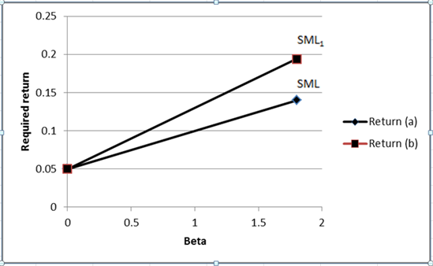

■ Solutions to Problems

P8-1. Rate of return:

LG 1; Basic

a. Investment A: Return = $\frac{\text{71},\text{000}−\text{63},\text{000}+6,\text{100}}{\text{63},\text{000}}=\text{22}\text{.}\text{38}\text{\%}$

Investment B: Return $\frac{\text{32},\text{000}−\text{35},\text{000}+2,\text{800}}{\text{35},\text{000}}=−0\text{.}\text{57}\text{\%}$

b. Investment A should be selected because it has a higher rate of return for the same level
of risk.

P8-2. Return calculations:

LG 1; Basic
Investment | Calculation | r_{t}(%)
A | ($20,100 − $23,400 − $2,800) ÷ $23,400 | –26.07
B | ($324,000 − $225,000 + $16,000) ÷ $225,000 | 51.11
C | ($8,000 − $6,500 + $700) ÷ $6,500 | 33.85
D | ($46,500− $36,600 + $3,580) ÷ $36,600 | 36.83
E | ($52,800 − $62,700 − $500) ÷ $62,700 | –16.59

P8-3. Risk preferences

LG 1; Intermediate

a. The risk-neutral manager would accept Investments A and B because these have higher returns than the 15% required return and the risk doesn’t matter.

b. The risk-averse manager would accept Investment A because it provides the highest return and has the lowest amount of risk. Investment A offers an increase in return for taking on more risk than what the firm currently earns.

c. The risk-seeking manager would accept Investments B and C because he or she is willing to take greater risk without an increase in return.

d. Traditionally, financial managers are risk averse and would choose Investment A, since it provides the required increase in return for an increase in risk.

P8-4. Risk analysis

LG 2; Intermediate

a.
Expansion | Range
A | 24% − 16% = 8%
B | 30% − 10% = 20%

b. Project A is less risky because the range of outcomes for A is smaller than the range for Project B.

c. Because the most likely return for both projects is 20% and the initial investments are equal, the answer depends on your risk preference.

d. The answer is no longer clear because it now involves a risk-return tradeoff. Project B has a slightly higher return but more risk, while A has both lower return and lower risk.

P8-5. Risk and probability

LG 2; Intermediate

a.
Camera | Range
R | 30% − 20% = 10%
S | 35% − 15% = 20%

b.
 | Possible  Outcomes | Probability  P_{ri} | Expected Return  r_{i} | Weighted  Value (%)(r_{i} × P_{ri})
Camera R | Pessimistic | 0.25 | 20 | 5.00%
 | Most likely | 0.50 | 25 | 12.50%
 | Optimistic | 0.25 | 30 | 7.50%
 |  | 1.00 | Expected return | 25.00%
Camera S | Pessimistic | 0.20 | 15 | 3.00%
 | Most likely | 0.55 | 25 | 13.75%
 | Optimistic | 0.25 | 35 | 8.75%
 |  | 1.00 | Expected return | 25.50%

c. Camera S is considered more risky than Camera R because it has a much broader range of outcomes. The risk-return tradeoff is present because Camera S is more risky and also provides a higher return than Camera R.

P8-6. Bar charts and risk

LG 2; Intermediate

a.

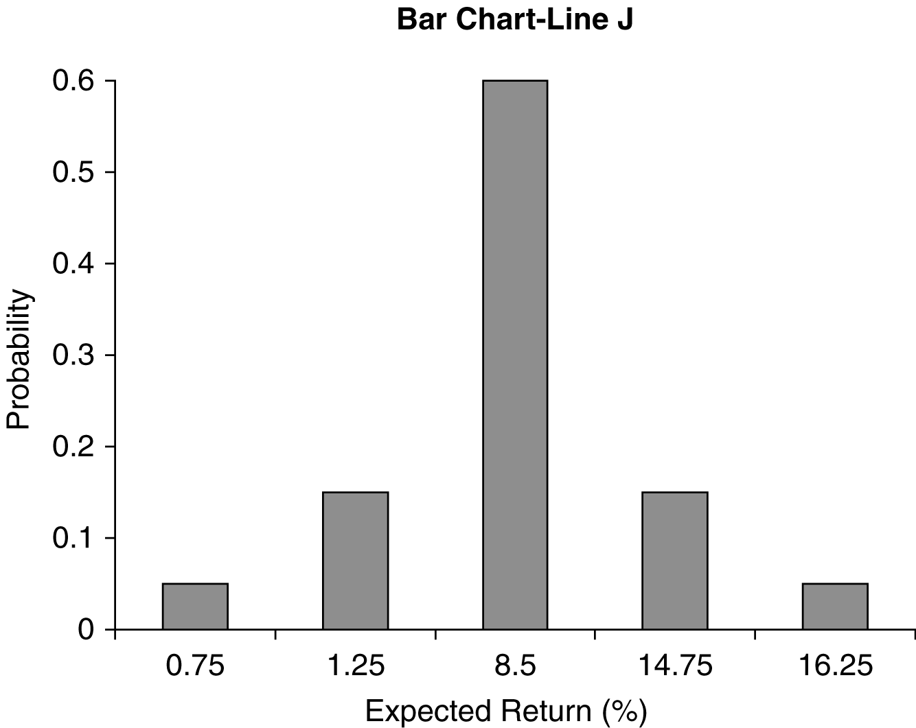

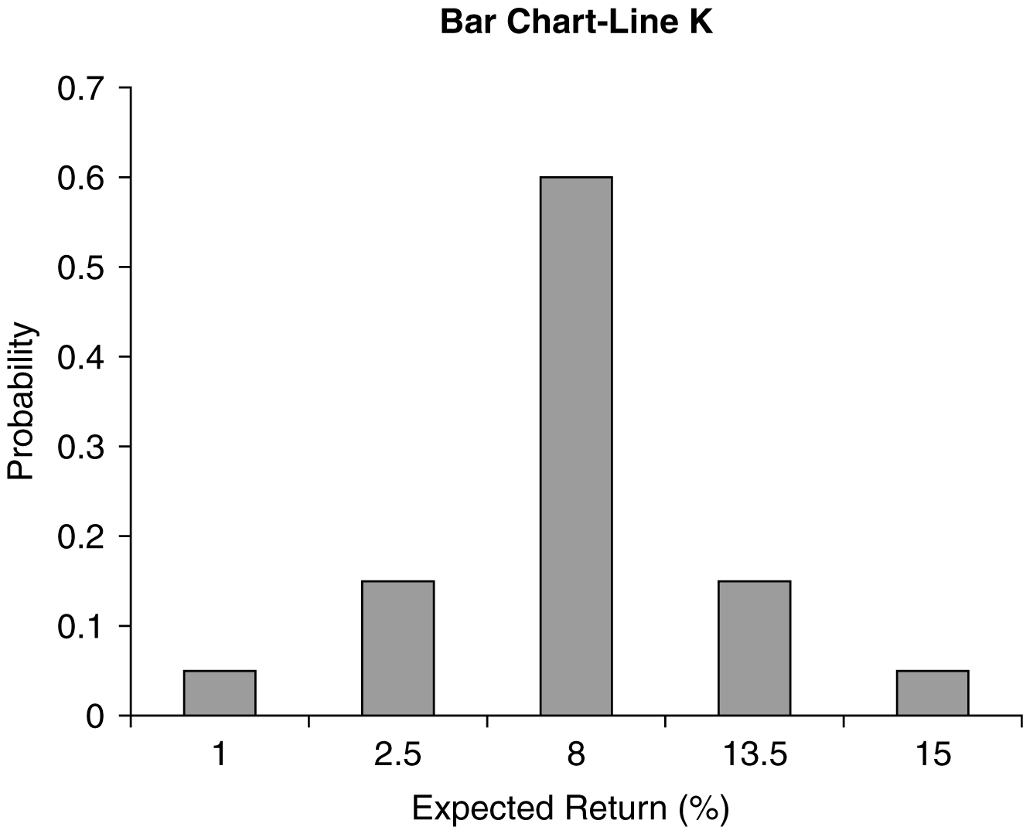

b.
 | Market  Acceptance | Probability  P_{ri} | Expected Return  r_{i} | Weighted Value  (r_{i} × P_{ri})
Line J | Very Poor | 0.05 | 0.0075 | 0.000375
 | Poor | 0.15 | 0.0125 | 0.001875
 | Average | 0.60 | 0.0850 | 0.051000
 | Good | 0.15 | 0.1475 | 0.022125
 | Excellent | 0.05 | 0.1625 | 0.008125
 |  | 1.00 | Expected return | 0.083500
Line K | Very Poor | 0.05 | 0.010 | 0.000500
 | Poor | 0.15 | 0.025 | 0.003750
 | Average | 0.60 | 0.080 | 0.048000
 | Good | 0.15 | 0.135 | 0.020250
 | Excellent | 0.05 | 0.150 | 0.007500
 |  | 1.00 | Expected return | 0.080000

c. Line K appears less risky due to a slightly tighter distribution than line J, indicating a lower range of outcomes.

P8-7. Coefficient of variation:

LG 2; Basic

a. A

B

C

D

b. Asset C has the lowest coefficient of variation and is the least risky relative to the other choices.

P8-8. Standard deviation versus coefficient of variation as measures of risk

LG 2; Basic

a. Project A is least risky based on range with a value of 0.04.

b. Project A has the lowest standard deviation. The standard deviation measure fails to take into account both the volatility and the return of the investment. Investors would prefer higher return but less volatility, and the coefficient of variation provices a measure that takes into account both aspects of investors’ preferences. Project D has the lowest CV, so it is the least risky investment relative to the return provided.

c. A

B

C

D

In this case Project D is the best alternative because it provides the least amount of risk for each percent of return earned. Coefficient of variation is probably the best measure in this instance because it provides a standardized method of measuring the risk-return tradeoff for investments with differing returns.

P8-9. Personal finance: Rate of return, standard deviation, coefficient of variation

LG 2; Challenge
a. |  | Stock Price |  |  |  |  | Variance
 | Year | Beginning |  | End |  | Returns | (Return–Average Return)²
 | 2012  2013  2014  2015 | 14.36  21.55  64.78  72.38 |  | 21.55  64.78  72.38  91.80 |  | 50.07%  200.60%  11.73%  26.83% | 0.0495  1.6459  0.3670  0.2068
b. | Average return |  |  |  |  | 72.31%
c. | Sum of variances |  |  |  |  |  | 2.2692
 |  |  |  |  |  |  |  | 3 | Sample divisor (n − 1)
 |  |  |  |  |  |  |  | 0.7564 | Variance
 |  |  |  |  |  |  |  | 86.97% | Standard deviation
d. |  |  |  |  |  |  |  | 1.20 | Coefficient of variation
e. | The stock price of Hi-Tech, Inc. has definitely gone through some major price changes over this time period. It would have to be classified as a volatile security having an upward price trend over the past 4 years. Note how comparing securities on a CV basis allows the investor to put the stock in proper perspective. The stock is riskier than what Mike normally buys, but if he believes that Hi-Tech, Inc., will continue to rise, then he should include it. The coefficient of variation, however, is greater than the 0.90 target.

P8-10. Assessing return and risk

LG 2; Challenge

a. Project 257

(1) Range: 1.00 − (−0.10) = 1.10

(2) Expected return:
Rate of Return  r_{i} | Probability  P_{ri} | Weighted Value  r_{i} × P_{ri} | Expected Return
−0.10 | 0.01 | −0.001
0.10 | 0.04 | 0.004
0.20 | 0.05 | 0.010
0.30 | 0.10 | 0.030
0.40 | 0.15 | 0.060
0.45 | 0.30 | 0.135
0.50 | 0.15 | 0.075
0.60 | 0.10 | 0.060
0.70 | 0.05 | 0.035
0.80 | 0.04 | 0.032
1.00 | 0.01 | 0.010
 | 1.00 |  | 0.450

(3) Standard deviation:
r_{i} |  |  | ² | P_{ri} | ² × P_{ri}
−0.10 | 0.450 | −0.550 | 0.3025 | 0.01 | 0.003025
0.10 | 0.450 | −0.350 | 0.1225 | 0.04 | 0.004900
0.20 | 0.450 | −0.250 | 0.0625 | 0.05 | 0.003125
0.30 | 0.450 | −0.150 | 0.0225 | 0.10 | 0.002250
0.40 | 0.450 | −0.050 | 0.0025 | 0.15 | 0.000375
0.45 | 0.450 | 0.000 | 0.0000 | 0.30 | 0.000000
0.50 | 0.450 | 0.050 | 0.0025 | 0.15 | 0.000375
0.60 | 0.450 | 0.150 | 0.0225 | 0.10 | 0.002250
0.70 | 0.450 | 0.250 | 0.0625 | 0.05 | 0.003125
0.80 | 0.450 | 0.350 | 0.1225 | 0.04 | 0.004900
1.00 | 0.450 | 0.550 | 0.3025 | 0.01 | 0.003025
 |  |  |  |  | 0.027350

(4)

Project 432

(1) Range: 0.50 − 0.10 = 0.40

(2) Expected return:
Rate of Return  r_{i} | Probability  P_{ri} | Weighted Value  r_{i} × P_{ri} | Expected Return
0.10 | 0.05 | 0.0050
0.15 | 0.10 | 0.0150
0.20 | 0.10 | 0.0200
0.25 | 0.15 | 0.0375
0.30 | 0.20 | 0.0600
0.35 | 0.15 | 0.0525
0.40 | 0.10 | 0.0400
0.45 | 0.10 | 0.0450
0.50 | 0.05 | 0.0250
 | 1.00 |  | 0.300

(3) Standard deviation:
r_{i} |  |  |  | P_{ri}
0.10 | 0.300 | −0.20 | 0.0400 | 0.05 | 0.002000
0.15 | 0.300 | −0.15 | 0.0225 | 0.10 | 0.002250
0.20 | 0.300 | −0.10 | 0.0100 | 0.10 | 0.001000
0.25 | 0.300 | −0.05 | 0.0025 | 0.15 | 0.000375
0.30 | 0.300 | 0.00 | 0.0000 | 0.20 | 0.000000
0.35 | 0.300 | 0.05 | 0.0025 | 0.15 | 0.000375
0.40 | 0.300 | 0.10 | 0.0100 | 0.10 | 0.001000
0.45 | 0.300 | 0.15 | 0.0225 | 0.10 | 0.002250
0.50 | 0.300 | 0.20 | 0.0400 | 0.05 | 0.002000
 |  |  |  |  | 0.011250

σ_{Project 432} = = 0.106066

(4)

b. Bar Charts

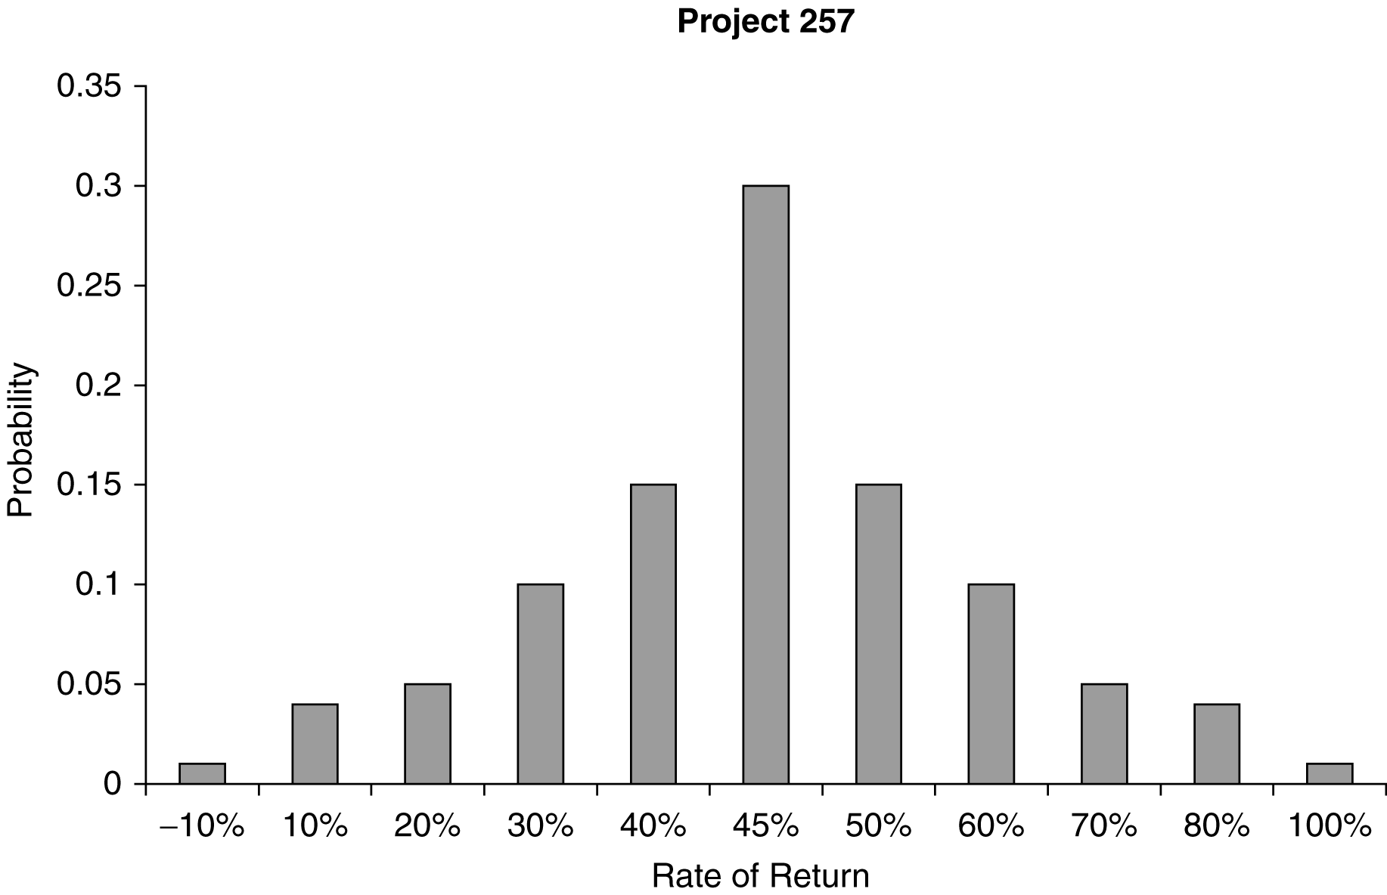

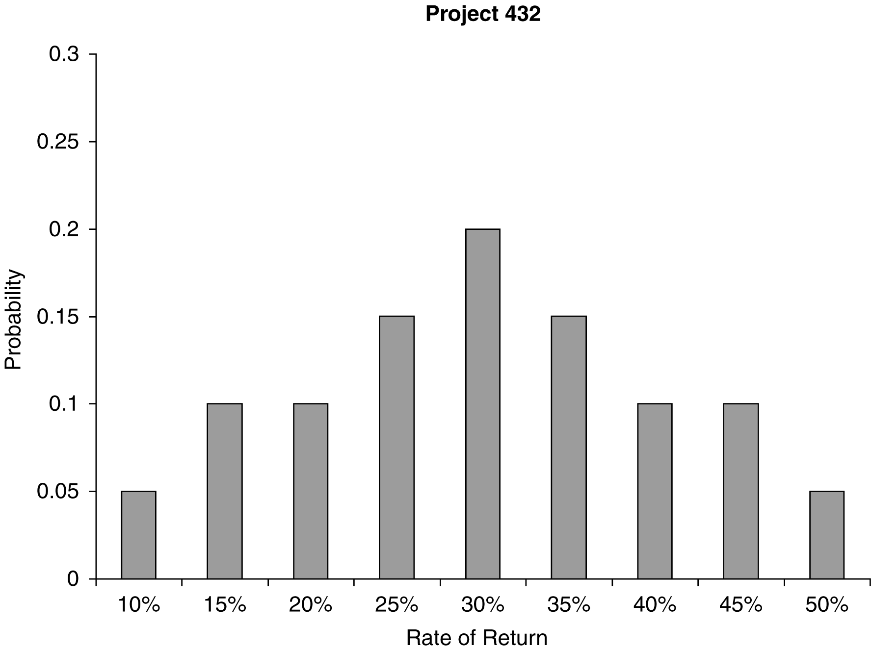

c. Summary statistics
 | Project 257 | Project 432
Range | 1.100 | 0.400
Expected return | 0.450 | 0.300
Standard deviation | 0.165 | 0.106
Coefficient of variation (CV) | 0.3675 | 0.3536

Because Projects 257 and 432 have differing expected values, the coefficient of variation should be the criterion by which the risk of the asset is judged. Because Project 432 has a smaller CV, it is the opportunity with lower risk.

P8-11. Integrative—expected return, standard deviation, and coefficient of variation

LG 2; Challenge

a. Expected return:
 | Rate of Return  r_{i} | Probability  P_{ri} | Weighted Value  r_{i} × P_{ri} | Expected Return
Asset F | 0.40 | 0.10 | 0.04
 | 0.10 | 0.20 | 0.02
 | 0.00 | 0.40 | 0.00
 | −0.05 | 0.20 | −0.01
 | −0.10 | 0.10 | −0.01
 |  |  |  | 0.04

Asset G | 0.35 | 0.40 | 0.14
 | 0.10 | 0.30 | 0.03
 | −0.20 | 0.30 | −0.06
 |  |  |  | 0.11
Asset H | 0.40 | 0.10 | 0.04
 | 0.20 | 0.20 | 0.04
 | 0.10 | 0.40 | 0.04
 | 0.00 | 0.20 | 0.00
 | −0.20 | 0.10 | −0.02
 |  |  |  | 0.10

Asset G provides the largest expected return.

_{b.} _{Standard deviation:}
 |  | ² | P_{ri} | σ² | σ_{r}
Asset F | 0.40 − 0.04 = 0.36 | 0.1296 | 0.10 | 0.01296
 | 0.10 − 0.04 = 0.06 | 0.0036 | 0.20 | 0.00072
 | 0.00 − 0.04 = −0.04 | 0.0016 | 0.40 | 0.00064
 | −0.05 − 0.04 = −0.09 | 0.0081 | 0.20 | 0.00162
 | −0.10 − 0.04 = −0.14 | 0.0196 | 0.10 | 0.00196
 |  |  |  | 0.01790 | 0.1338
Asset G | 0.35 − 0.11 = 0.24 | 0.0576 | 0.40 | 0.02304
 | 0.10 − 0.11 = −0.01 | 0.0001 | 0.30 | 0.00003
 | −0.20 − 0.11 = −0.31 | 0.0961 | 0.30 | 0.02883
 |  |  |  | 0.05190 | 0.2278
Asset H | 0.40 − 0.10 = 0.30 | 0.0900 | 0.10 | 0.009
 | 0.20 − 0.10 = 0.10 | 0.0100 | 0.20 | 0.002
 | 0.10 − 0.10 = 0.00 | 0.0000 | 0.40 | 0.000
 | 0.00 − 0.10 = −0.10 | 0.0100 | 0.20 | 0.002
 | −0.20 − 0.10 = −0.30 | 0.0900 | 0.10 | 0.009
 |  |  |  | 0.022 | 0.1483

Based on standard deviation, Asset G appears to have the greatest risk, but it must be measured against its expected return with the statistical measure coefficient of variation because the three assets have differing expected values. An incorrect conclusion about the risk of the assets could be drawn using only the standard deviation.

c.

Asset F:

Asset G:

Asset H:

As measured by the coefficient of variation, Asset F has the largest relative risk.

P8-12. Normal probability distribution

LG 2; Challenge

a. Coefficient of variation: CV =

Solving for standard deviation: 0.75 = σ_{r} ÷ 0.189

σ_{r} = 0.75 × 0.189 = 0.14175

b. (1) 68% of the outcomes will lie between ±1 standard deviation from the expected value:

(2) 95% of the outcomes will lie between ± 2 standard deviations from the expected value:

(3) 99% of the outcomes will lie between ±3 standard deviations from the expected value:

c.
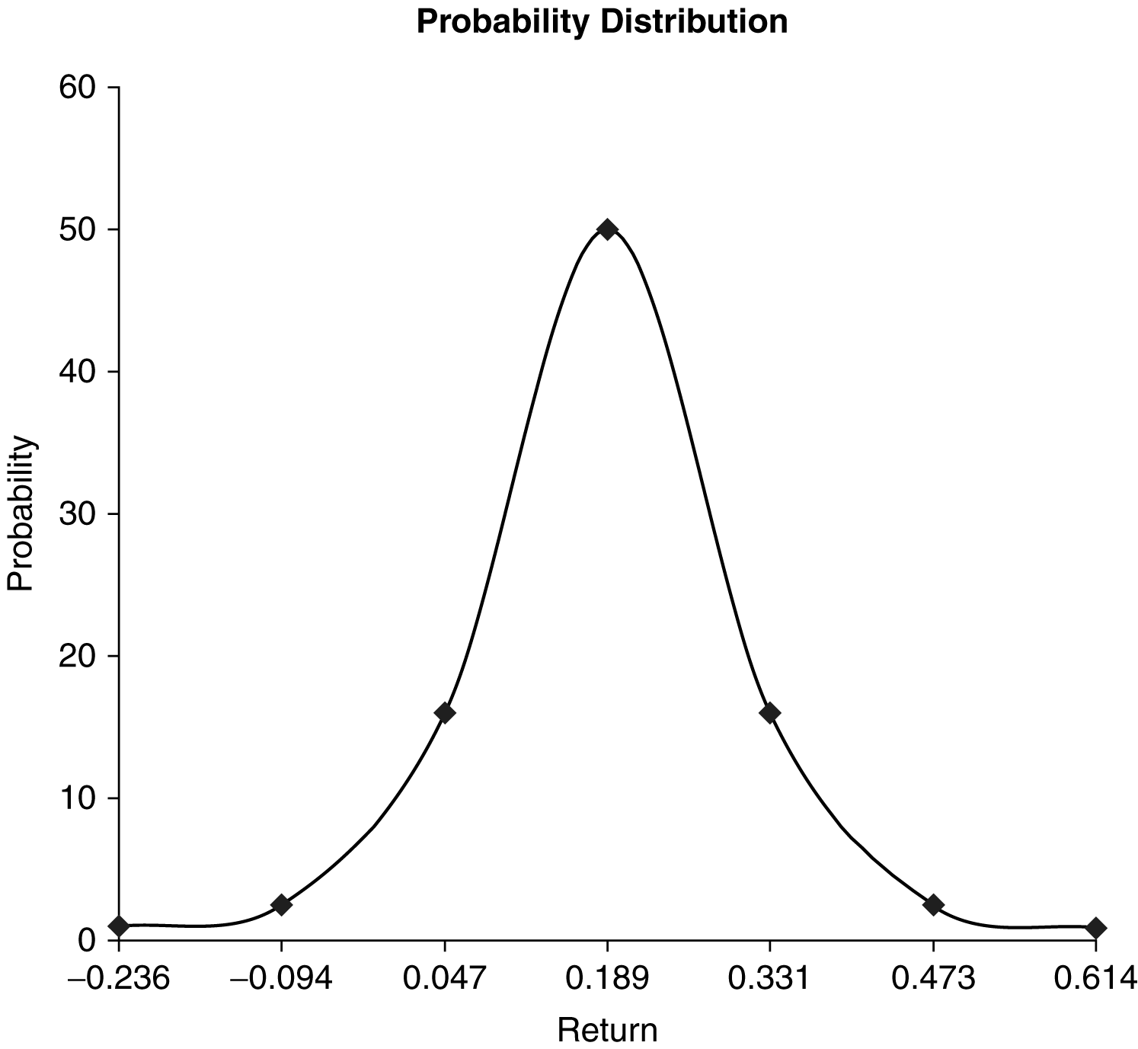
Return

P8-13. Personal finance: Portfolio return and standard deviation

LG 3; Challenge

a. Expected portfolio return for each year: r_{p} = (w_{L} × r_{L}) + (w_{M} × r_{M})
Year | Asset L  (w_{L} × r_{L}) |  | Asset M  (w_{M} × r_{M}) | Expected  Portfolio Return
Year | Asset L  (w_{L} × r_{L}) | + | Asset M  (w_{M} × r_{M}) | r_{p}
2015 | (14% × 0.40 = 5.6%) | + | (20% × 0.60 = 12.0%) | = | 17.6%
2016 | (14% × 0.40 = 5.6%) | + | (18% × 0.60 = 10.8%) | = | 16.4%
2017 | (16% × 0.40 = 6.4%) | + | (16% × 0.60 = 9.6%) | = | 16.0%
2018 | (17% × 0.40 = 6.8%) | + | (14% × 0.60 = 8.4%) | = | 15.2%
2019 | (17% × 0.40 = 6.8%) | + | (12% × 0.60 = 7.2%) | = | 14.0%
2020 | (19% × 0.40 = 7.6%) | + | (10% × 0.60 = 6.0%) | = | 13.6%

b. Portfolio return:

c. Standard deviation:

d. The assets are negatively correlated.

e. Combining these two negatively correlated assets reduces overall portfolio risk.

P8-14. Portfolio analysis

LG 3; Challenge

a. Expected portfolio return:

Alternative 1: 100% Asset F

Alternative 2: 50% Asset F + 50% Asset G
Year | Asset F  (w_{F} × r_{F}) |  | Asset G  (w_{G} × r_{G}) | Portfolio Return  r_{p}
Year | Asset F  (w_{F} × r_{F}) | + | Asset G  (w_{G} × r_{G})
2016 | (16% × 0.50 = 8.0%) | + | (17% × 0.50 = 8.5%) | = | 16.5%
2017 | (17% × 0.50 = 8.5%) | + | (16% × 0.50 = 8.0%) | = | 16.5%
2018 | (18% × 0.50 = 9.0%) | + | (15% × 0.50 = 7.5%) | = | 16.5%
2019 | (19% × 0.50 = 9.5%) | + | (14% × 0.50 = 7.0%) | = | 16.5%

Alternative 3: 50% Asset F + 50% Asset H
Year | Asset F  (w_{F} × r_{F}) |  | Asset H  (w_{H} × r_{H}) | Portfolio Return  r_{p}
Year | Asset F  (w_{F} × r_{F}) | + | Asset H  (w_{H} × r_{H}) | Portfolio Return  r_{p}
2016 | (16% × 0.50 = 8.0%) | + | (14% × 0.50 = 7.0%) | 15.0%
2017 | (17% × 0.50 = 8.5%) | + | (15% × 0.50 = 7.5%) | 16.0%
2018 | (18% × 0.50 = 9.0%) | + | (16% × 0.50 = 8.0%) | 17.0%
2019 | (19% × 0.50 = 9.5%) | + | (17% × 0.50 = 8.5%) | 18.0%

b. Standard deviation:

(1)

(2)

(3)

c. Coefficient of variation: CV =

d. Summary:
 | r_{p}: Expected Value  of Portfolio | σ_{rp} | CV_{p}
Alternative 1 (F) | 17.5% | 1.291% | 0.0738
Alternative 2 (FG) | 16.5% | 0 | 0.0
Alternative 3 (FH) | 16.5% | 1.291% | 0.0782

Because the assets have different expected returns, the coefficient of variation should be used to determine the best portfolio. Alternative 3, with positively correlated assets, has the highest coefficient of variation and therefore is the riskiest. Alternative 2 is the best choice; it is perfectly negatively correlated and therefore has the lowest coefficient of variation.

P8-15. Correlation, risk, and return

LG 4; Intermediate

a. (1) Range of expected return: between 8% and 13%

(2) Range of the risk: between 5% and 10%

b. (1) Range of expected return: between 8% and 13%

(2) Range of the risk: 0 < risk < 10%

c. (1) Range of expected return: between 8% and 13%

(2) Range of the risk: 0 < risk < 10%

P8-16. Personal finance: International investment returns

LG 1, 4; Intermediate

a. Return_{pesos} =

b.

c. Return_{us$} =

d. The two returns differ due to the change in the exchange rate between the peso and the dollar. The peso had depreciation (and thus the dollar appreciated) between the purchase date and the sale date, causing a decrease in total return. The answer in part c is the more important of the two returns for Joe. An investor in foreign securities will carry exchange-rate risk.

P8-17. Total, nondiversifiable, and diversifiable risk

LG 5; Intermediate

a. and b.

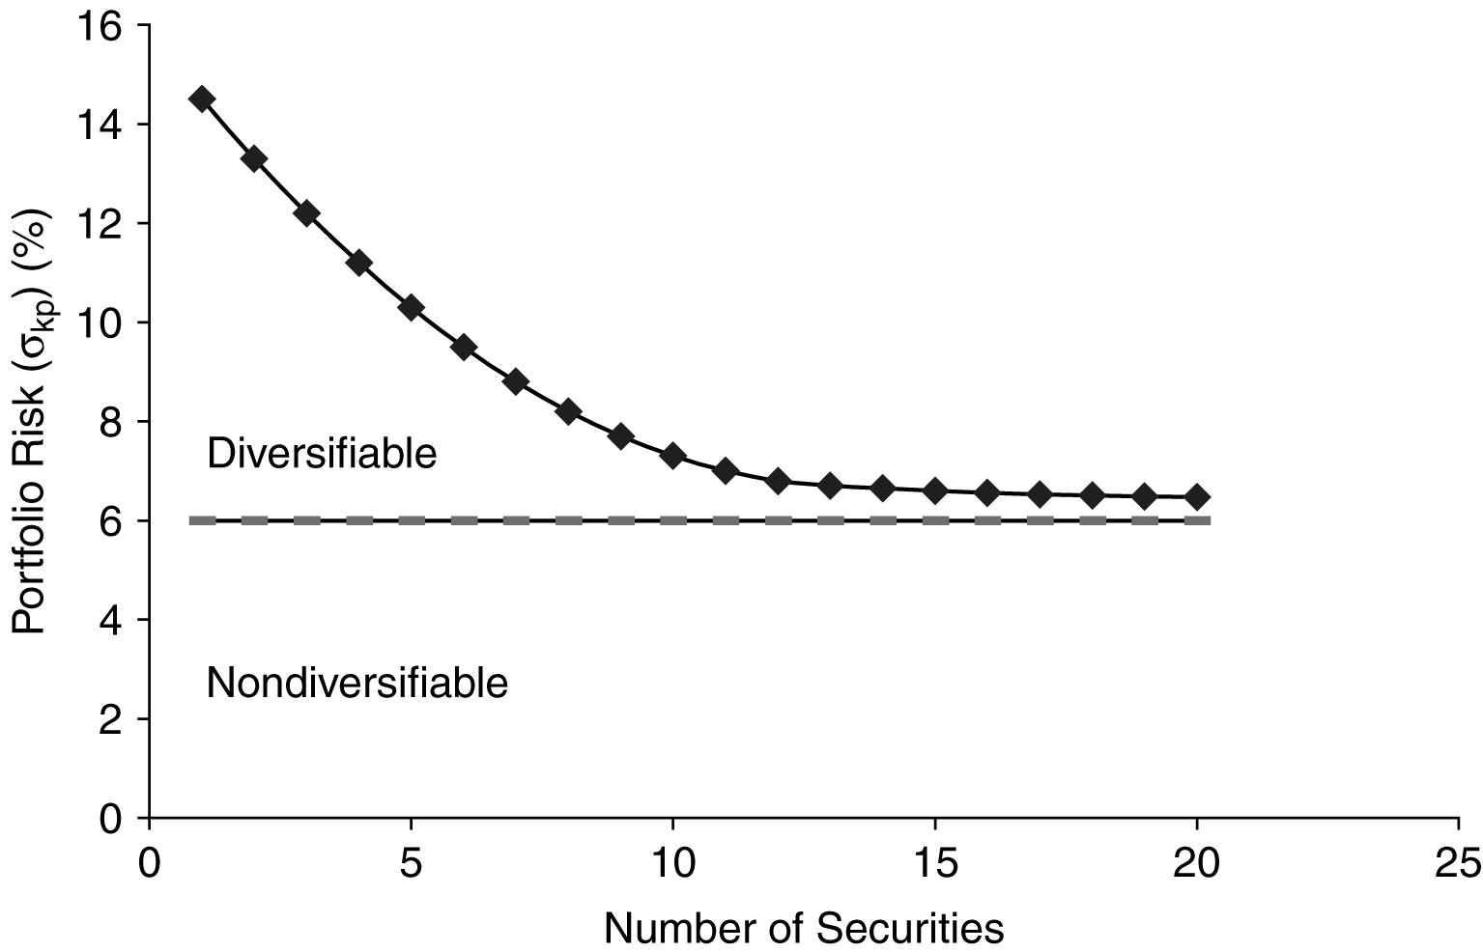

c. Only nondiversifiable risk is relevant because, as shown by the graph, diversifiable risk can be virtually eliminated through holding a portfolio of at least 20 securities that are not positively correlated. David Talbot’s portfolio, assuming diversifiable risk could no longer be reduced by additions to the portfolio, has 6.47% relevant risk.

P8-18. Graphic derivation of beta

LG 5; Intermediate

a.

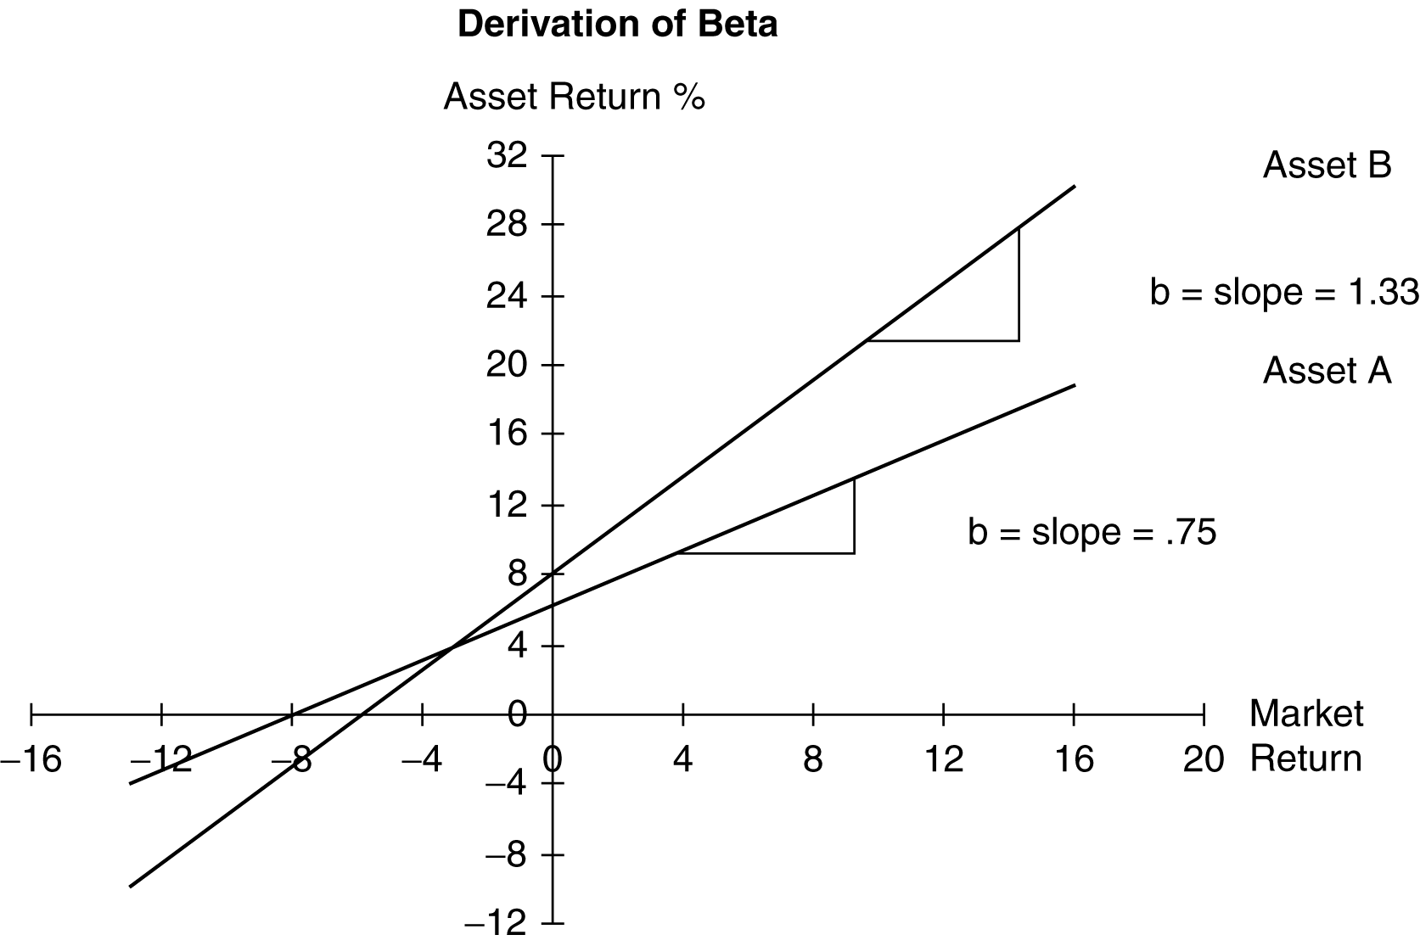

b. To estimate beta, the “rise over run” method can be used:

Taking the points shown on the graph:

A financial calculator with statistical functions can be used to perform linear regression analysis. The beta (slope) of line A is 0.79; of line B, 1.379.

c. With a higher beta of 1.33, Asset B is more risky. Its return will move 1.33 times for each one point the market moves. Asset A’s return will move at a lower rate, as indicated by its beta coefficient of 0.75.

P8-19. Graphical derivation and interpretation of beta

LG 5; Intermediate

a. With a return range from −20% to + 30%, Biotech Cures, exhibited in Panel B, is the more risky stock. Returns are widely dispersed in this return range regardless of market conditions. By comparison, the returns of Panel A’s Cyclical Industries Incorporated only range from about −20% to + 40%. There is less dispersion of returns within this return range.

b. The returns on Cyclical Industries Incorporated’s stock are more closely correlated with the market’s performance. Hence, most of Cyclical Industries’ returns fit around the upward-sloping least-squares regression line. By comparison, Biotech Cures has earned returns approaching 60% during a period when the overall market experienced a loss. Even if the market is up, Biotech Cures has lost almost half of its value in some years. So, Cyclical Industries Inc. has a lower beta than Biotech Cures.

c. On a standalone basis, Biotech Cures Corporation is riskier. However, if an investor was seeking to diversify the risk of their current portfolio, the unique, nonsystematic performance of Biotech Cures Corporation makes it a good addition. Other considerations would be the mean return for both (here Cyclical Industries has a higher return when the overall market return is zero), expectations regarding the overall market performance, and level to which one can use historic returns to accurately forecast stock price behavior.

P8-20. Interpreting beta

LG 5; Basic

Effect of change in market return on asset with beta of 0.8:

a. 0.8× (42%) = 33.6% increase

b. 0.8× (−32%) = 25.6% decrease

c. 0.8× (0%) = no change

d. The asset is less risky than the market portfolio, which has a beta of 1. The higher beta makes the return move more than the market.

P8-21. Betas

LG 5; Basic

a. and b.
Asset | Beta | Decrease in  Market Return | Expected Impact  on Asset Return | Increase in  Market Return | Impact on  Asset Return
W | 0.90 | −0.10 | –0.09 | 0.10 | 0.09
X | –0.60 | −0.10 | 0.06 | 0.10 | –0.06
Y | 1.80 | −0.10 | −0.18 | 0.10 | 0.18
Z | 2.30 | −0.10 | –0.23 | 0.10 | 0.23

c. Asset X would be the appropriate choice because it is a defensive asset, moving in opposition to the market. In an economic downturn, Asset X’s return is increasing.

d. Asset Z should be chosen because it will have the highest increase in return.

P8-22. Personal finance: Betas and risk rankings

LG 5; Intermediate

a.
 | Stock | Beta
Most risky | B | 1.40
 | A | 0.80
Least risky | C | −0.30

b. and c.
Asset | Beta | Increase in  Market Return | Expected Impact  on Asset Return | Decrease in  Market Return | Impact on  Asset Return
A | 0.80 | 0.12 | 0.096 | −0.05 | −0.040
B | 1.40 | 0.12 | 0.168 | −0.05 | −0.070
C | −0.30 | 0.12 | −0.036 | −0.05 | 0.015

d. In a declining market, an investor would choose the defensive stock, Stock C. While the market declines, the return on C increases.

e. In a rising market, an investor would choose Stock B, the aggressive stock. As the market rises one point, Stock B rises 1.40 points.

P8-23. Personal finance: Portfolio betas: b_{p} =

LG 5; Intermediate

a.
 |  | Portfolio X |  |  |  | Portfolio Y
Asset | Beta | W_{X} | W_{X} × b_{X} |  |  | W_{Y} | W_{Y} × b_{Y}
1 | 2.5 | 0.20 | 0.50 |  |  | 0.10 | 0.25
2 | 0.8 | 0.10 | 0.08 |  |  | 0.30 | 0.24
3 | 1.2 | 0.30 | 0.36 |  |  | 0.10 | 0.12
4 | 0.9 | 0.10 | 0.09 |  |  | 0.30 | 0.27
5 | 1.6 | 0.30 | 0.48 |  |  | 0.20 | 0.32
 |  | b_{X}= |  | 1.51 |  | b_{Y}= |  | 1.20

b. Portfolios X and Y are both more risky than the market (average risk). Comparatively speaking, Portfolio Y is slightly less risky than Portfolio X. Portfolio X’s return will move more than Portfolio Y’s for a given increase or decrease in market return. Thus, Portfolio X is the more risky.

P8-24. Capital asset pricing model (CAPM): r_{j} = R_{F} + [b_{j} × (r_{m} − R_{F})]

LG 6; Basic
States | r_{j} | = | R_{F}+ [b_{j} × (r_{m}−R_{F})]
A | 44.4% | = | 6% + [2.40 × (22% −6%)]
B | 0.5% | = | 3% + [–0.50 × (8% −3%)]
C | 14.5% | = | 10% + [0.90 × (15% −10%)]
D | 18.0% | = | 12% + [1.00 × (18% − 12%)]
E | 8.5% | = | 5% + [0.70 × (10% −5%)]

P8-25. Personal finance: Beta coefficients and the capital asset pricing model

LG 5, 6; Intermediate

To solve this problem you must take the CAPM and solve for beta. The resulting model is:

a. $\text{Beta}=\frac{\text{13}\text{\%}−3\text{\%}}{\text{12}\text{\%}−3\text{\%}}=\frac{\text{10}\text{\%}}{9\text{\%}}=1\text{.}\text{1111}$

b. $\text{Beta}=\frac{\text{25}\text{\%}−3\text{\%}}{\text{12}\text{\%}−3\text{\%}}=\frac{\text{22}\text{\%}}{9\text{\%}}=2\text{.}\text{4444}$

c. $\text{Beta}=\frac{\text{16}\text{\%}−3\text{\%}}{\text{12}\text{\%}−3\text{\%}}=\frac{\text{13}\text{\%}}{9\text{\%}}=1\text{.}\text{4444}$

d. $\text{Beta}=\frac{\text{18}\text{\%}−3\text{\%}}{\text{12}\text{\%}−3\text{\%}}=\frac{\text{15}\text{\%}}{9\text{\%}}=1\text{.}\text{6666}$

e. If you are willing to take a maximum of average risk then you will be able to have an expected return of only 12%. (r= 3% + 1.0(12% − 3%) =12 %.)

P8-26. Manipulating CAPM: r_{j} = R_{F} + [b_{j} × (r_{m} − R_{F})]

LG 6; Intermediate

a. r_{j} = 5% + [2.2 × (32% − 5%)]

r_{j} = 64.4%

b. 23.75% = R_{F} + [1.25 × (20% −R_{F})]

R_{F} = 5%

c. 18% = 8% + [1.2 × (r_{m}− 8%)]

r_{m} = 16.33%

d. 15% = 3% + [b_{j} × (15% − 3%)

b_{j} = 1

P8-27. Personal finance: Portfolio return and beta

LG 1, 3, 5, 6: Challenge

a. b_{p} = (0.20)(0.80) + (0.35)(0.95) + (0.30)(1.50) + (0.15)(1.25)

= 0.16 + 0.3325 + 0.45 + 0.1875 = 1.13

b. r_{A}

r_{B}

r_{C}

r_{D}

c. r_{P}

d. r_{A} = 4% + [0.80 × (10% − 4%)] = 8.8%

r_{B} = 4% + [0.95 × (10% − 4%)] = 9.7%

r_{C} = 4% + [1.50 × (10% − 4%)] = 13.0%

r_{D} = 4% + [1.25 × (10% − 4%)] = 11.5%

e. Of the four investments, only C (15% vs. 13%) and D (12.5% vs. 11.5%) had actual returns that exceeded the CAPM expected return (15% vs. 13%). The underperformance could be due to any unsystematic factor that would have caused the firm not to do as well as expected. Another possibility is that the firm’s characteristics may have changed such that the beta at the time of the purchase overstated the true value of beta that existed during that year. A third explanation is that beta, as a single measure, may not capture all of the systematic factors that cause the expected return. In other words, there is error in the beta estimate.

P8-28. Security market line, SML

LG 6; Intermediate

a, b, and d.

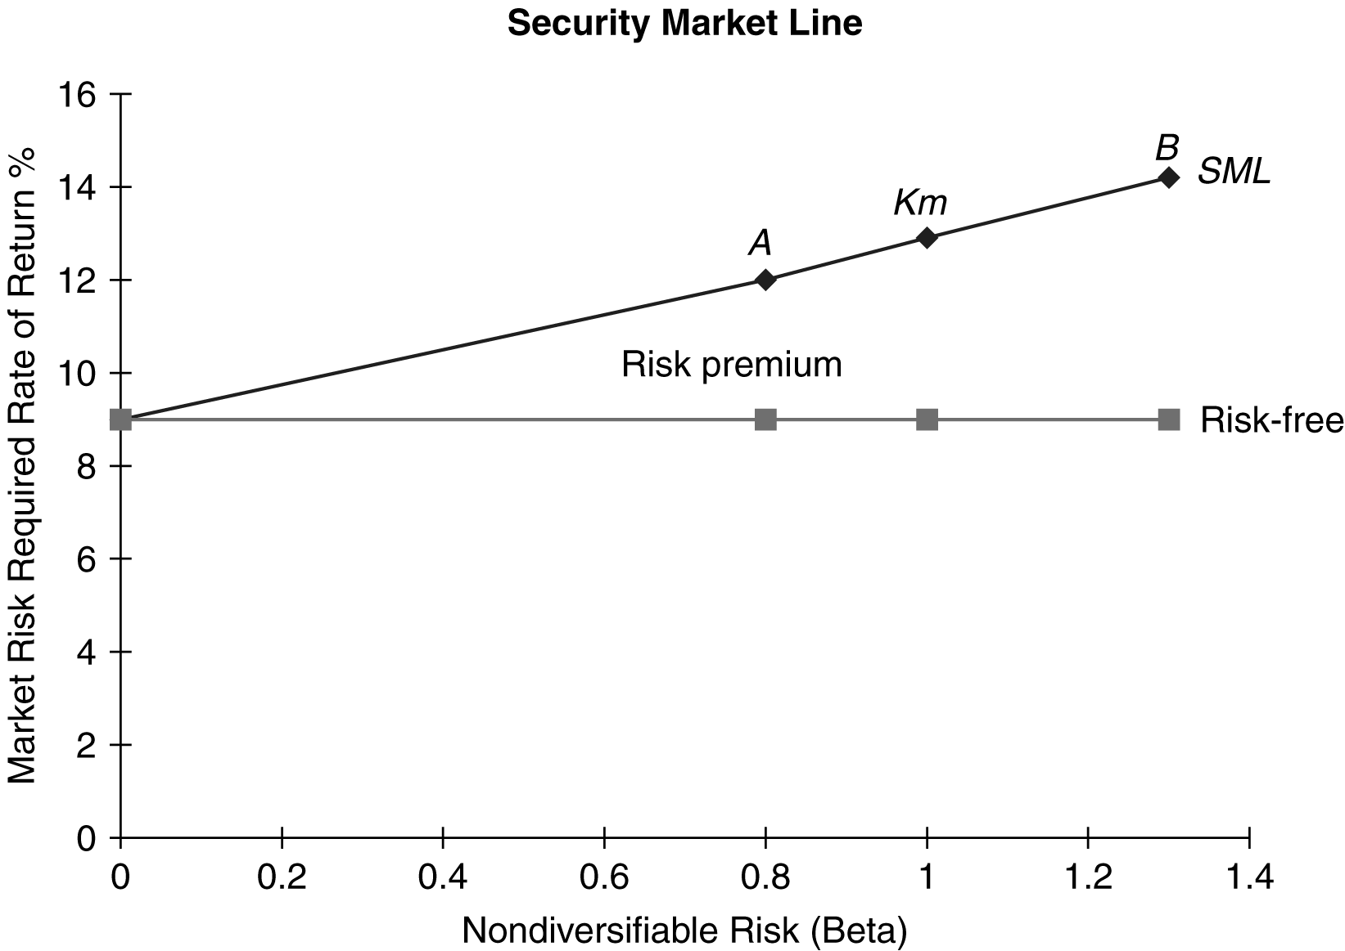

c. r_{j} = R_{F} + [b_{j} × (r_{m} − R_{F})]

Asset A

r_{j} = 0.09 + [0.80 × (0.13 − 0.09)]

r_{j} = 0.122

Asset B

r_{j} = 0.09 + [1.30 × (0.13 − 0.09)]

r_{j} = 0.142

d. Asset A has a smaller required return than Asset B because it is less risky, based on the beta of 0.80 for Asset A versus 1.30 for Asset B. The market risk premium for Asset A is 3.2% (12.2% − 9%), which is lower than Asset B’s market risk premium (14.2% − 9% = 5.2%).

P8-29. Shifts in the security market line

LG 6; Challenge

a, b, c, d.

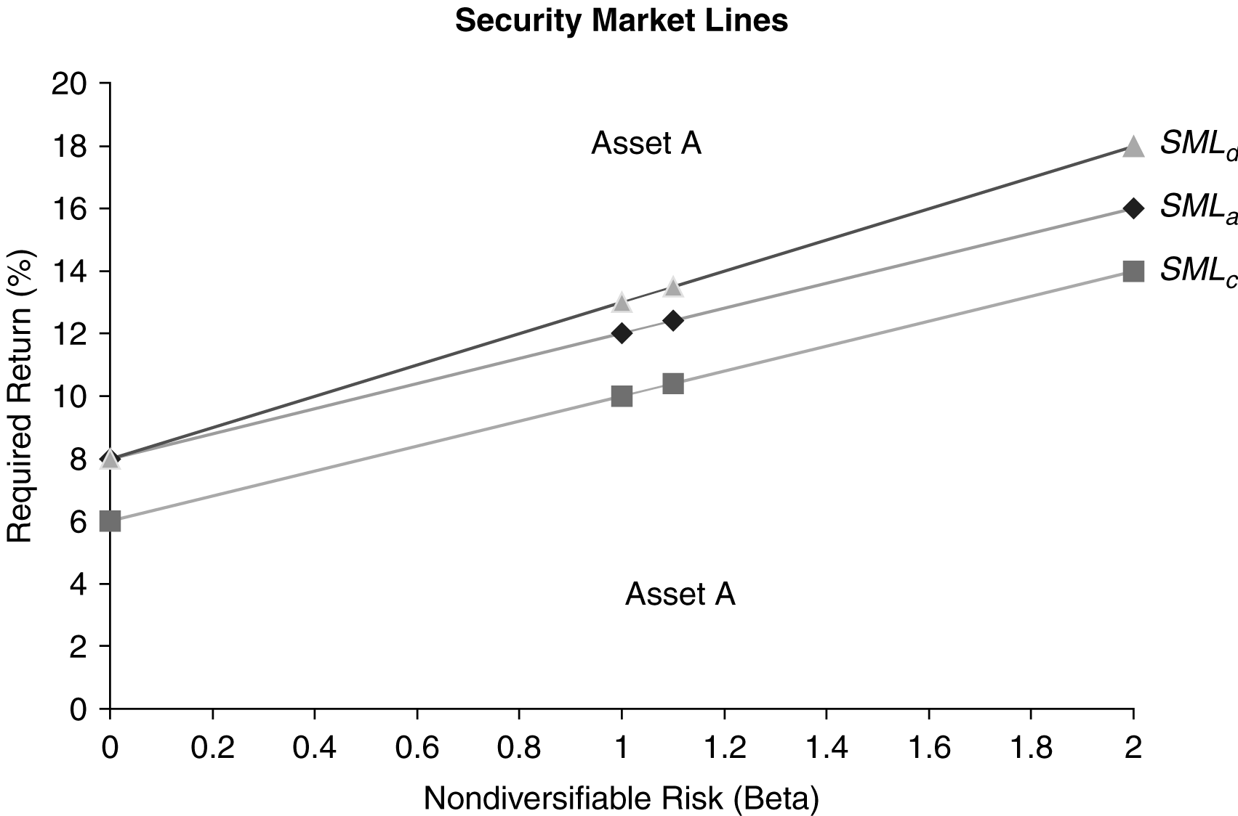

b. r_{j} = R_{F} + [b_{j} × (r_{m} − R_{F})]

r_{A} = 8% + [1.1 × (12% − 8%)]

r_{A} = 8% + 4.4%

r_{A} = 12.4%

c. r_{A} = 6% + [1.1 × (10% − 6%)]

r_{A} = 6% + 4.4%

r_{A} = 10.4%

d. r_{A} = 8% + [1.1 × (13% − 8%)]

r_{A} = 8% + 5.5%

r_{A} = 13.5%

e. (1) A decrease in inflationary expectations reduces the required return as shown in the parallel downward shift of the SML.

(2) Increased risk aversion results in a steeper slope because a higher return would be required for each level of risk as measured by beta.

P8-30. Integrative—risk, return, and CAPM

LG 6; Challenge

a.
Project | r_{j} | = | R_{F} + [b_{j} × (r_{m} − R_{F})]
A | r_{j} | = | 9% + [1.5 × (14% − 9%)] | = | 16.50%
B | r_{j} | = | 9% + [0.75 × (14% − 9%)] | = | 12.75%
C | r_{j} | = | 9% + [2.0 × (14% − 9%)] | = | 19.00%
D | r_{j} | = | 9% + [0 × (14% − 9%)] | = | 9.00%
E | r_{j} | = | 9% + [(−0.5) × (14% − 9%)] | = | 6.50%

b. and d.

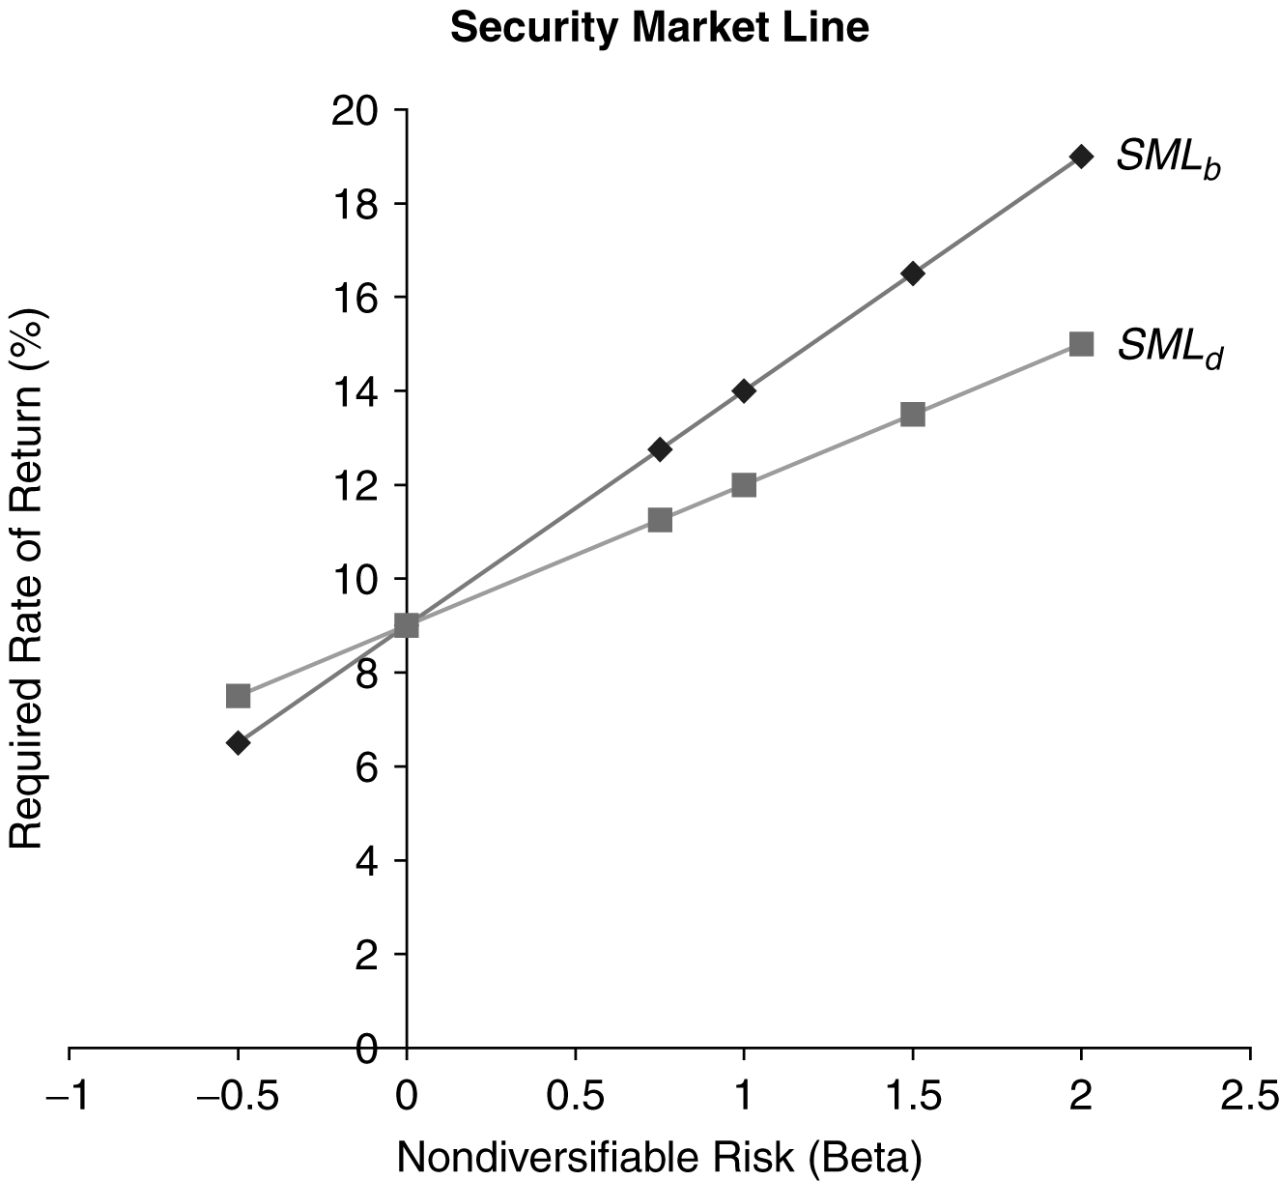

c. Project A is 150% as responsive as the market.

Project B is 75% as responsive as the market.

Project C is twice as responsive as the market.

Project D is unaffected by market movement.

Project E is only half as responsive as the market but moves in the opposite direction as the market.

d. See graph for new SML.

r_{A} = 9% + [1.5 × (12% − 9%)] = 13.50%

r_{B} = 9% + [0.75 × (12% − 9%)] = 11.25%

r_{C} = 9% + [2.0 × (12% − 9%)] = 15.00%

r_{D} = 9% + [0 × (12% − 9%)] = 9.00%

r_{E} = 9% + [−0.5 × (12% − 9%)] = 7.50%

e. The steeper slope of SML_{b} indicates a higher risk premium than SML_{d} for these market conditions. When investor risk aversion declines, investors require lower returns for any given risk level (beta).

P8-31. Ethics problem

LG 1; Intermediate

Investors expect managers to take risks with their money, so it is clearly not unethical for managers to make risky investments with other people’s money. However, managers have a duty to communicate truthfully with investors about the risk that they are taking. Portfolio managers should not take risks that they do not expect to generate returns sufficient to compensate investors for the return variability.

■ Case

Case studies are available on MyFinanceLab.

Analyzing Risk and Return on Chargers Products’ Investments
This case requires students to review and apply the concept of the risk-return tradeoff by analyzing two possible asset investments using standard deviation, coefficient of variation, and CAPM.

a. Expected rate of return:

Asset X:
Year | Cash  Flow (C_{t}) | Ending  Value (P_{t}) | Beginning  Value (P_{t – 1}) | Gain/  Loss | Annual Rate  of Return
2006 | $1,000 | $22,000 | $20,000 | $2,000 | 15.00%
2007 | 1,500 | 21,000 | 22,000 | −1,000 | 2.27
2008 | 1,400 | 24,000 | 21,000 | 3,000 | 20.95
2009 | 1,700 | 22,000 | 24,000 | −2,000 | −1.25

Asset X: (continued)
Year | Cash  Flow (C_{t}) | Ending  Value (P_{t}) | Beginning  Value (P_{t – 1}) | Gain/  Loss | Annual Rate  of Return
2010 | 1,900 | 23,000 | 22,000 | 1,000 | 13.18
2011 | 1,600 | 26,000 | 23,000 | 3,000 | 20.00
2012 | 1,700 | 25,000 | 26,000 | −1,000 | 2.69
2013 | 2,000 | 24,000 | 25,000 | −1,000 | 4.00
2014 | 2,100 | 27,000 | 24,000 | 3,000 | 21.25
2015 | 2,200 | 30,000 | 27,000 | 3,000 | 19.26

Average expected return for Asset X = 11.74%

Asset Y:
Year | Cash  Flow (C_{t}) | Ending  Value (P_{t}) | Beginning  Value (P_{t – 1}) | Gain/  Loss | Annual Rate  of Return
2006 | $1,500 | $20,000 | $20,000 | $ 0 | 7.50%
2007 | 1,600 | 20,000 | 20,000 | 0 | 8.00
2008 | 1,700 | 21,000 | 20,000 | 1,000 | 13.50
2009 | 1,800 | 21,000 | 21,000 | 0 | 8.57
2010 | 1,900 | 22,000 | 21,000 | 1,000 | 13.81
2011 | 2,000 | 23,000 | 22,000 | 1,000 | 13.64
2012 | 2,100 | 23,000 | 23,000 | 0 | 9.13
2013 | 2,200 | 24,000 | 23,000 | 1,000 | 13.91
2014 | 2,300 | 25,000 | 24,000 | 1,000 | 13.75
2015 | 2,400 | 25,000 | 25,000 | 0 | 9.60

Average expected return for Asset Y = 11.14%

b. σ_{r} =

Asset X:
Year | Return  r_{i} | Average  Return, r |  | ²
2006 | 15.00% | 11.74% | 3.26% | 0.001063
2007 | 2.27 | 11.74 | −9.47 | 0.008968
2008 | 20.95 | 11.74 | 9.21 | 0.008482
2009 | −1.25 | 11.74 | −12.99 | 0.016874
2010 | 13.18 | 11.74 | 1.44 | 0.000207
2011 | 20.00 | 11.74 | 8.26 | 0.006823
Asset X: (continued)
Year | Return  r_{i} | Average  Return, r |  | ²
2012 | 2.69 | 11.74 | −9.05 | 0.008190
2013 | 4.00 | 11.74 | −7.74 | 0.005991
2014 | 21.25 | 11.74 | 9.51 | 0.009044
2015 | 19.26 | 11.74 | 7.52 | 0.005655
 |  |  |  | 0.071297

Asset Y:
Year | Return  r_{i} | Average  Return, r |  | ²
2006 | 7.50% | 11.14% | −3.64% | 0.001325
2007 | 8.00 | 11.14 | −3.14 | 0.000986
2008 | 13.50 | 11.14 | 2.36 | 0.000557
2009 | 8.57 | 11.14 | −2.57 | 0.000660
2010 | 13.81 | 11.14 | 2.67 | 0.000713
2011 | 13.64 | 11.14 | 2.50 | 0.000625
2012 | 9.13 | 11.14 | −2.01 | 0.000404
2013 | 13.91 | 11.14 | 2.77 | 0.000767
2014 | 13.75 | 11.14 | 2.61 | 0.000681
2015 | 9.60 | 11.14 | −1.54 | 0.000237
 |  |  |  | 0.006955

c. Summary statistics:
 | Asset X | Asset Y
Expected return | 11.74% | 11.14%
Standard deviation | 8.90% | 2.78%
Coefficient of variation | 0.76 | 0.25

Comparing the expected returns calculated in part a, Asset X provides a return of 11.74%, only slightly above the return of 11.14% expected from Asset Y. The higher standard deviation and coefficient of variation of Investment X indicates greater risk. With just this information, it is difficult to determine whether the 0.60% difference in return is an adequate compensation for the difference in risk. Based on this information, however, Asset Y appears to be the better choice.

d. Using the capital asset pricing model, the required return on each asset is as follows:

Capital asset pricing model: r_{j} = R_{F} + [b_{j} × (r_{m} − R_{F})]
Asset | R_{F} + [b_{j} × (r_{m} − R_{F})] | = | r_{j}
X | 7% + [1.6 × (10% − 7%)] | = | 11.8%
Y | 7% + [1.1 × (10% − 7%)] | = | 10.3%

From the calculations in part a, the expected return for Asset X is 11.74%, compared to its required return of 11.8%. On the other hand, Asset Y has an expected return of 11.14% and a required return of only 10.8%. This makes Asset Y the better choice.

e. In part c, we concluded that it would be difficult to make a choice between X and Y because the additional return on X may or may not provide the needed compensation for the extra risk. In part d, by calculating a required rate of return, it was easy to reject X and select Y. The required return on Asset X is 11.8%, but its expected return (11.74%) is lower; therefore, Asset X is unattractive. For Asset Y, the reverse is true, and it is a good investment vehicle.

Clearly, Chargers Products is better off using the standard deviation and coefficient of variation, rather than a strictly subjective approach, to assess investment risk. Beta and CAPM, however, provide a link between risk and return. They quantify risk and convert it into a required return that can be compared to the expected return to draw a definitive conclusion about investment acceptability. Contrasting the conclusions in the responses to parts c and d above should clearly demonstrate why Junior is better off using beta to assess risk.

f. 1. Increase in risk-free rate to 8% and market return to 11%:
Asset | R_{F} + [b_{j} × (r_{m} − R_{F})] | = | r_{j}
X | 8% + [1.6 × (11% − 8%)] | = | 12.8%
Y | 8% + [1.1 × (11% − 8%)] | = | 11.3%

2. Decrease in market return to 9%:
Asset | R_{F} + [b_{j} × (r_{m} − R_{F})] | = | r_{j}
X | 7% + [1.6 × (9% − 7%)] | = | 10.2%
Y | 7% + [1.1 × (9% − 7%)] | = | 9.2%

In Situation 1, the required return rises for both assets, and neither has an expected return above the firm’s required return.

With Situation 2, the drop in market rate causes the required return to decrease so that the expected returns of both assets are above the required return. However, Asset Y provides a larger return compared to its required return (11.14 − 9.20 = 1.94), and it does so with less risk than Asset X.

■ Spreadsheet Exercise
The answer to Chapter 8’s stock portfolio analysis spreadsheet problem is located on the Instructor’s Resource Center at www.pearsonglobaleditions.com/gitman under the Instructor’s Manual.

■ Group Exercise
Group exercises are available in MyFinanceLab.
This exercise uses current information from several websites regarding the recent performance of each group’s shadow firm. This information is then compared to a relevant index. The time periods for comparison are 1 and 5 years. Calculated annual returns and basic graphical analysis begin the process of comparison. Correlation between the firm and the market is investigated.
Accurate and timely information is the first message of this assignment. Students are encouraged to look at several sites and also to search for others. The information content of the different sites can then be compared. This information is used to get students to see how basic stock market analysis is done. As always, parts of this exercise can be modified or dropped at the adopter’s discretion. One suggestion is to add other corporations to the comparison(s). Also, some of the more complex calculations could be eliminated.

