Chapter Three

Risk and Return Models

Measuring risk:

Expected return🡪 the rate of return that investors expect to make over a time horizon that they will hold the asset.

Actual return🡪 The rate of return that investors actually make over the holding period. (It may be different from the expected return).

For a risk free asset 🡪 expected return = actual return.

Investors has to consider the following in addition to expected return:

1. The spread of the actual returns around the expected return which is captured by the variance or the standard deviation; the greater the standard deviation🡪 the higher the risk.
2. Skewness captures the bias toward positive or negative returns.
3. Kurtosis captures price jumps. (The shape of the tails of the distribution is measured by the kurtosis). Fatter tails🡪 higher kurtosis 🡪 higher tendency of the price of the investment to jump in either directions.

**Calculating standard deviation using historical returns:**

**R = (Pt-Pt-1+Div)/Pt-1**

**Sample Variance = the sum of (r – Rbar)^2/(n-1)**

**Standard deviation = The square root of the variance.**

T

**Population distribution moments:**

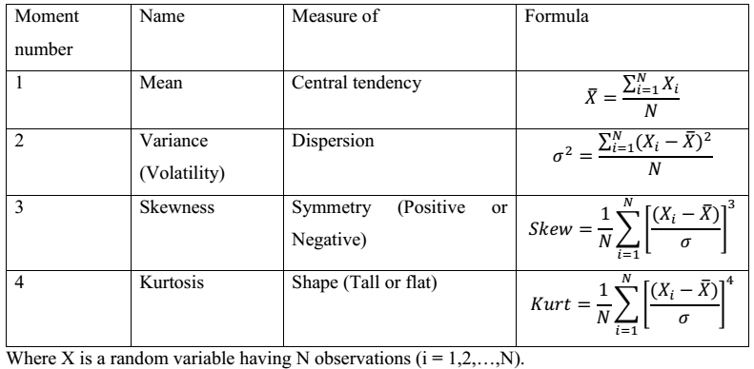

Total risk = diversifiable risk + non-diversifiable risk

Diversification minimizes risk.

Types of risks:

1. Firm-specific risks-🡪 diversifiable risk.
2. Project risk: an individual project may have higher or lower cash flows than expected because of misestimating. --> This risk can be diversified away if the firm invests in a number of projects.
3. Competitive risk: Whereby earnings and cash flows on a project are affected positively or negatively by the competitors’ actions. 🡪 This risk can be diversified away if the firm invests (buys) its competitors. Or it can be diversified away if the stockholders of the firm hold stocks in the competitors.
4. Industry-specific risk: includes legal risk, technological risk and commodity risk. --> This risk can be diversified away if the firm diversifies across industries or if the stockholders hold stocks from different industries.
5. International risk: includes political risk and currency exchange rate risk. --> Companies can reduce their exposure to currency exchange rate risk by borrowing in the local currency to fund projects. Investors can reduce this international risk by investing across countries. (Political risk is sometimes correlated across countries and cannot be diversified away).
6. Market risk 🡪 non-diversifiable risk.

Market cannot be diversified away.

1. Inflation
2. Interest rate changes
3. Risk preferences of investors
4. Economic growth