CH 20 Short-Term Financing

**\*Sources of Foreign Financing**

**1) Internal short-term financing**

* + Before an MNC’s parent or subsidiary in need of funds searches for outside funding, it should check other subsidiaries’ cash flow positions to determine whether any internal funds are available.

قبل أن تكون الشركة الأم أو الشركة التابعة لشركة متعددة الجنسيات بحاجة إلى أموال للبحث عن تمويل خارجي ، يجب أن تتحقق من أوضاع التدفقات النقدية للشركات التابعة الأخرى لتحديد ما إذا كانت هناك أموال داخلية متاحة

* + Internal Control over Funds - An MNC should have an internal system that consistently monitors the amount of short-term financing by all subsidiaries.

الرقابة الداخلية على الأموال - يجب أن يكون لدى الشركة متعددة الجنسيات نظام داخلي يراقب باستمرار مبلغ التمويل قصير الأجل من قبل جميع الشركات التابعة

**2) External short-term financing**

* + **Short-term notes or unsecured debt securities:** Short-term notes typically have maturities of 1, 3, or 6 months with interest based on LIBOR.

السندات قصيرة الأجل أو سندات الدين غير المضمونة: السندات قصيرة الأجل لها آجال استحقاق تبلغ 1 أو 3 أو 6 أشهر مع الفائدة على أساس العمل.

* + **Commercial paper (euro-commercial paper):** The selling price is not guaranteed to the issuers. Maturities can be tailored to the issuer’s preferences.

الأوراق التجارية (الأوراق التجارية باليورو): سعر البيع غير مضمون للمصدرين. يمكن تخصيص آجال الاستحقاق بما يتناسب مع تفضيلات المُصدر.

* + **Bank loans**: Direct loans from banks maintain a relationship with banks.

القروض المصرفية: تحافظ القروض المباشرة من البنوك على علاقة مع البنوك.

**3) MNCs had limited access to short-term funding during the credit crisis.**

**4)MNCs borrow foreign currency, sometimes to match future cash inflows.**

**5)Comparison of interest rates among currencies**

Developing countries tend to have higher inflation and a low level of saving, causing interest rates to be relatively high.

**The actual or effective financing rate will differ from the quoted rate based on:**

1. The interest rate charged by the bank.
2. The movement in the borrowed currency’s value over the time of the loan.



where *rf* = effective financing rate

*S* = spot rate

*if* = interest rate of the foreign currency

OR

**RF=(1+IF)*(1+EF)-1**

IF=IR

EF=PERCENTGE CHANGE

Example

Sarasota, Inc., needs funds for 1 year and is aware that the 1-year interest rate in U.S. dollars is 12 percent while the interest rate from borrowing Swiss francs is 8 percent. Sarasota forecasts that the Swiss franc will appreciate from its current rate of $.45 to $.459, or by 2 percent over the next year. The expected value for ef [written as E(ef)] will therefore be 2 percent. Thus, the expected effective financing rate [E(rf)] will be

**RF=(1+IF)*(1+EF)-1**

The interest rate = 8%

Ef(اذا ما كان معطينا انها 2%لازم اوجدها )

Ef= 0.459-0.45/0.45=2%

(1+0.08)+(1+0.02)-1

0.1016

EXAMPLE

Assume that expected of the condition of dollar appreciates by over life, the exchange rate of NZ=0.50 at this time but after 1 year the exchange rate arrive at 0.60, give 8% IR ON lone and depreciate on the Canadian dollar what effective financing rat

RF=(1+IF)*(1+EF)-1

Ef= 0.60-0.50/0.50 = 0.20

(1+8%)*(1+20%)-1=0.296 or 29.6%

لما يحكي اوجد

مهممممممم

effective financing rat portfolio

**Rp=Wa(Ra)+Wb(Rb)**

Rp=effective financing rat portfolio

R= effective financing rat of currency

W= the % of total fund financing from currency

Example

Valparaiso, Inc., considers borrowing a portfolio of Japanese yen and Swiss francs to finance its U.S.

operations. Half of the needed funding would come from each currency. To determine how the variance in this portfolio’s effective financing rate is related to characteristics of the component currencies, assume the following information based on historical information for several 3-month

periods:

■ Mean effective financing rate of Swiss franc for 3 months(ra) = 3%.

■ Mean effective financing rate of Japanese yen for 3 months(rb) = 2%.

■ The standard deviation of the Swiss franc’s effective financing rate = .04.

■ The standard deviation of the Japanese yen’s effective financing rate = .09.

■ The correlation coefficient of effective financing rates of these two currencies = .10.

Given this information, the mean effective rate on a portfolio (RP) of funds financed 50 percent

by Swiss francs and 50 percent by Japanese yen is determined by totaling the weighted individual

a)effective financing rates portfolio :

**Rp=Wa(Ra)+Wb(Rb)**

=(0.5*0.03)+(0.5*0.02)

=0.015+0.01=0.115

b)The variance of this portfolio’s effective financing rate over time is

نفس الي بشابتر 13

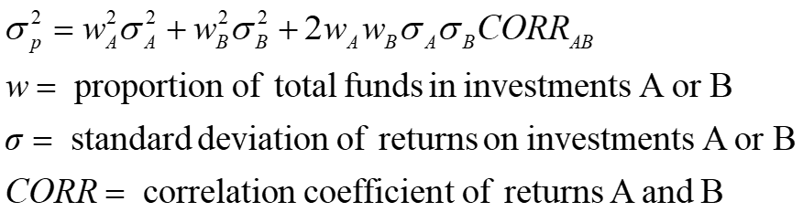

**0.5)2*(0.04)2+(0.5)2 *(0.09)2+2*0.5*0.5*0.04*0.09*0.1=)**

**0.0026**