Chapter 15
Stock Analysis and Valuation

■ True/False

1. The long-term return on the average stock as measured by the S&P index has been positive and worth the risk.

Answer: True

Difficulty: Easy

2. Prudent analysis and careful stock selections can enhance your personal wealth.

Answer: True

Difficulty: Easy

3. The most up-to-date quotes of stock prices may be found in The Wall Street Journal.

Answer: False

Difficulty: Moderate

4. The daily stock quotations found in most large newspapers will not tell you the annual dividends paid per share of stock.

Answer: False

Difficulty: Easy

5. The daily stock quotations found in most large newspapers will tell you the closing price per share of stock for the previous day’s trading, the range of prices the stock traded the previous day, and
a range of trading prices for the last year.

Answer: True

Difficulty: Easy

6. The two parts of a company’s balance sheet: (1) assets and (2) liabilities and shareholder’s equity, must be equal or in balance.

Answer: True

Difficulty: Easy

7. The income statement for a company is like a budget in that it shows how much money the company would like to have made in a given accounting period.

Answer: False

Difficulty: Moderate

8. A good measure of a company’s liquidity is the current ratio, which is the ratio of its short-term assets to its short-term liabilities.

Answer: True

Difficulty: Easy

9. A firm with a low debt ratio relative to the industry norm has a high degree of financial leverage and therefore may have a relatively high risk of default.

Answer: False

Difficulty: Moderate

10. A high times interest earned ratio means that the firm should be more capable of covering its debt payments.

Answer: True

Difficulty: Difficult

11. When you look at inventory turnover (cost of goods sold divided by average daily inventory), a high ratio means a company is more efficient than those with lower ratios.

Answer: True

Difficulty: Moderate

12. Value Line Investment Survey provides an extremely detailed analysis of a firm’s financial data.

Answer: True

Difficulty: Easy

13. Economic growth, as measured by increases in the gross domestic product (GDP) signals the start
of a bull market where stock prices are bound to rise.

Answer: False

Difficulty: Moderate

14. Fiscal policy, the means by which the U.S. government imposes taxes on individuals and corporations and spends its money, has an impact on spending and thus an impact on the stock of some companies.

Answer: True

Difficulty: Easy

15. Interest rates can affect economic growth and therefore have a direct impact on stock prices.

Answer: False

Difficulty: Moderate

16. Low interest rates tend to entice investors into the stock market where they can achieve better returns.

Answer: True

Difficulty: Easy

17. Before buying a stock, you should estimate its future market value, just as you would the future value of a car or a home.

Answer: True

Difficulty: Easy

18. Technical analysis and fundamental analysis are methods commonly used by investors to value stocks.

Answer: True

Difficulty: Easy

19. The price-earnings method used to value stock is limited because it assumes that the firm has the same PE ratio as its competitors.

Answer: True

Difficulty: Moderate

20. The price-revenue method of valuing stock may accurately compare a company’s revenues to those of competitors, but does not consider how the company manages costs to yield profits.

Answer: True

Difficulty: Moderate

■ Multiple Choice

1. Which of the following is not a good source of current stock quotations?

(a) Newspapers, such as The Wall Street Journal

(b) Magazines, such as Fortune

(c) News television networks, such as CNBC

(d) Web sites

Answer: B

Difficulty: Easy
Using the following exhibit to answer questions 2–7.

Exhibit 15.1 Daily Stock Quotations

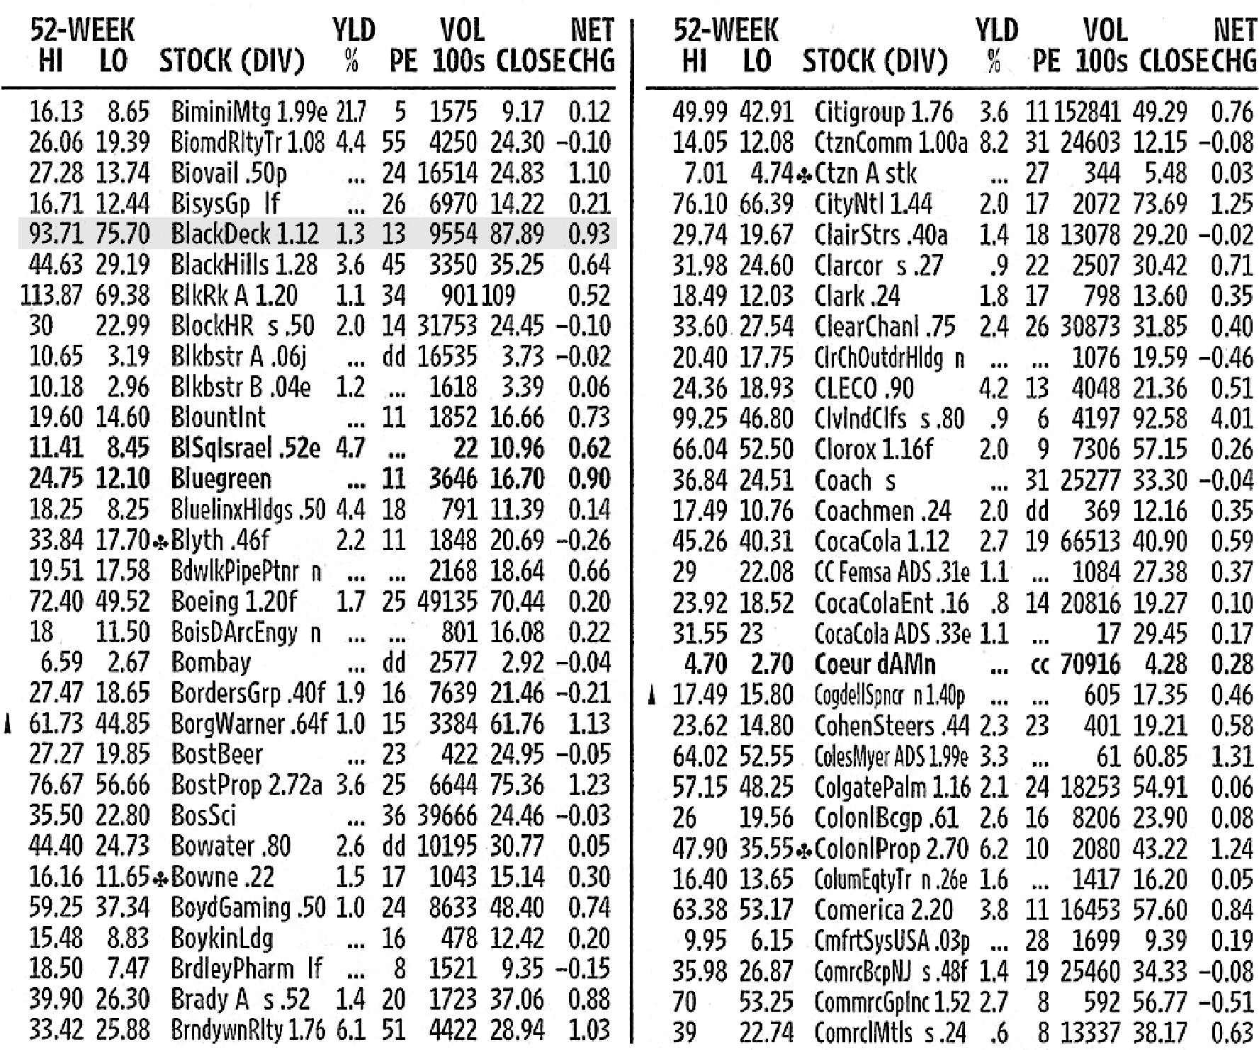

Copyright © 2006 Dow Jones & Company, Inc. All Rights Reserved.

2. What is the highest price paid for a share of Coca Cola stock in the last 52 weeks?

(a) $40.90

(b) $45.26

(c) $40.31

(d) $1.12

Answer: B

Difficulty: Easy

3. If you have 100 shares of CitiGroup, how much would you expect to receive in dividends annually?

(a) $176

(b) $360

(c) $1,100

(d) $76

Answer: A

Difficulty: Easy

4. Approximately how much did Clorox earn per share of common stock during the last year?

(a) $1.16

(b) $2.00

(c) $0.26

(d) $6.35

Answer: D

Difficulty: Difficult

5. How many shares of Brady A were traded the previous day?

(a) 1,723

(b) 17,230

(c) 172,300

(d) 1,723,000

Answer: C

Difficulty: Moderate

6. What was the closing price per share for BlackHills on the day before the trading shown on this listing?

(a) $29.19

(c) $35.25

(c) $34.61

(d) $35.89

Answer: C

Difficulty: Difficult

7. Which of the following stocks is the best value considering only the dividend it pays?

(a) BlackDeck

(b) Boeing

(c) BoWater

(d) CitiGroup

Answer: D

Difficulty: Moderate

8. A PE of 10 means that the firm’s stock price is ten times the firm’s

(a) earnings per share.

(b) book value.

(c) net income.

(d) dividends.

Answer: A

Difficulty: Easy

9. A company’s earnings are $3 per share, its dividend is $2 per share, and its stock price is $30 per share. Its PE ratio is

(a) 15.

(b) 10.

(c) 1.5.

(d) 33.

Answer: B

Difficulty: Easy

10. A company’s annual report usually includes all of the following but

(a) an auditor’s report.

(b) testimonials from employees.

(c) a letter from the CEO.

(d) management discussion and analysis.

Answer: B

Difficulty: Easy

11. Assets and liabilities on the balance sheet are classified as

(a) personal and business.

(b) short-term and long-term.

(c) fundamental and discretionary.

(d) secure and insecure.

Answer: B

Difficulty: Moderate

12. In reading a corporate income statement, cost of goods sold is subtracted from

(a) revenue.

(b) operating expenses.

(c) earnings before interest and taxes.

(d) taxes.

Answer: A

Difficulty: Easy

13. Which two financial statements are used to assess profitability?

(a) Cash flow and balance sheet

(b) Income statement and cash flow

(c) Income statement and balance sheet

(d) Cash flow and owner’s equity

Answer: C

Difficulty: Easy

14. Investors use a firm’s balance sheet and income statement to analyze all of the following characteristics except

(a) liquidity.

(b) financial leverage.

(c) profitability.

(d) cash flow from operations.

Answer: D

Difficulty: Easy

15. If you wish to evaluate the liquidity of a firm you could look at the

(a) current ratio.

(b) debt ratio.

(c) inventory turnover.

(d) return on net assets.

Answer: A

Difficulty: Easy

16. Which of the following ratios measures efficiency?

(a) Times interest earned

(b) Inventory turnover

(c) Return on assets

(d) Return on equity

Answer: B

Difficulty: Moderate

17. If you wish to evaluate the profitability of a firm you could look at the

(a) current ratio.

(b) debt ratio.

(c) inventory turnover.

(d) return on net assets.

Answer: D

Difficulty: Moderate

18. __________ is a measure of profitability that measures net profit as a percentage of sales.

(a) Return on equity

(b) Return on assets

(c) Net profit margin

(d) Operating profit margin

Answer: C

Difficulty: Moderate

19. In order to compute the debt ratio of a firm you would use the

(a) assets and liabilities.

(b) assets and revenue.

(c) liabilities and expenses.

(d) revenues and expenses.

Answer: A

Difficulty: Moderate

20. If you wish to evaluate the financial leverage of a firm you could look at the

(a) current ratio.

(b) debt ratio.

(c) inventory turnover.

(d) return on net assets.

Answer: B

Difficulty: Moderate

21. If you were a supplier of a company selling goods on 30-day terms, you would be most concerned with ratios measuring

(a) liquidity.

(b) financial leverage.

(c) efficiency.

(d) profitability.

Answer: A

Difficulty: Moderate

22. Revenue inflating techniques, which are unethical, consist of all of the following except

(a) recording all payments for a five-year contract, even though you have just received the first year’s payment.

(b) offering discounts if customers purchase before year-end.

(c) reporting all sales as revenue even when the cash has not been received.

(d) counting all orders as revenue, even though it is likely that many of the orders will be canceled.

Answer: B

Difficulty: Moderate

23. When aggregate demand by consumers __________, firms produce __________ products to accommodate the demand.

(a) rises; less

(b) rises; more

(c) declines; more

(d) All of the above.

Answer: B

Difficulty: Easy

24. When economic conditions are weak, the aggregate demand for products and services __________.

(a) declines.

(b) increases.

(c) remains the same.

(d) may either decline or increase.

Answer: A

Difficulty: Easy

25. Stocks would be most favorably affected by

(a) a decline in interest rates and a decline in inflation.

(b) an increase in interest rates and a decline in inflation.

(c) a decline in interest rates and an increase in inflation.

(d) an increase in interest rates and an increase in inflation.

Answer: A

Difficulty: Easy

26. The demand for which of the following will decrease the most with a weak economy?

(a) Cereal

(b) Bread

(c) Boats

(d) Paper towels

Answer: C

Difficulty: Easy

27. The means by which the U.S. government imposes taxes on individuals and corporations and by which it spends its money is the __________ policy.

(a) taxing

(b) fiscal

(c) financial

(d) spending

Answer: B

Difficulty: Easy

28. When corporate taxes rates are __________, the after-tax earnings of corporations are __________, which means __________ money for shareholders.

(a) increased; decreased; more

(b) decreased; increased; more

(c) increased; increased; more

(d) decreased; decreased; less

Answer: B

Difficulty: Moderate

29. Which of the following actions of the U.S. government could not be considered part of fiscal policy?

(a) Federal Reserve open market operations

(b) The Tax Relief Act of 2001

(c) Operation Enduring Freedom

(d) Creating the Department of Homeland Security

Answer: A

Difficulty: Moderate

30. Generally, stocks perform better when interest rates are

(a) low.

(b) high.

(c) average.

(d) Stocks are unaffected by interest rates.

Answer: A

Difficulty: Easy

31. One of the most commonly used measures of inflation is the

(a) gross domestic product.

(b) fiscal policy.

(c) consumer price index.

(d) inflation factor.

Answer: C

Difficulty: Moderate

32. A measure of inflation that represents prices of various products, such as groceries, household products, housing, and gasoline is the __________ index.

(a) consumer price

(b) cost of living

(c) inflationary

(d) household

Answer: A

Difficulty: Easy

33. The __________ is a measure of inflation that represents prices of products such as coal, lumber, and metals that are used to produce other products.

(a) CPI

(b) PPI

(c) inflation index

(d) cost of living index

Answer: B

Difficulty: Moderate

34. Since more products are available through Web sites, competition in some industries has

(a) stayed the same.

(b) increased.

(c) decreased.

(d) not been affected.

Answer: B

Difficulty: Easy

35. According to the text, individuals should estimate the market value of stock just as they estimate the market value of

(a) a suit.

(b) a home.

(c) a toaster.

(d) a computer.

Answer: B

Difficulty: Easy

36. When researching a stock to buy, you look for a stock that is

(a) overvalued.

(b) correctly valued.

(c) undervalued.

(d) not valued yet.

Answer: C

Difficulty: Easy

37. Fundamental analysis is based on all of the following except

(a) the firm’s revenue.

(b) the firm’s earnings.

(c) the firm’s stock price over the last year.

(d) the firm’s sensitivity to economic conditions.

Answer: C

Difficulty: Easy

38. An increased demand for stock __________ the price.

(a) has no effect on

(b) increases

(c) decreases

(d) stabilizes

Answer: B

Difficulty: Easy

39. Which of the following methods is used most often to value stock?

(a) Price-earnings method

(b) Price-revenue method

(c) General evaluation of the economy, industry, and economy

(d) Technical analysis

Answer: A

Difficulty: Moderate

40. Which of the following is not a method used to assess the value of stock?

(a) Price-earnings method

(b) Price-revenue method

(c) Technical analysis

(d) Sum of the digits method

Answer: D

Difficulty: Easy

41. How much should a share of stock be worth for a firm whose earnings per share are $4 if the industry’s average PE ratio is 11?

(a) $40

(b) $44

(c) $48

(d) $88

Answer: B

Difficulty: Moderate

42. If a firm uses less technology than its competitors, the PE ratio used to assess its share price will be

(a) higher than its competitors.

(b) the same as its competitors.

(c) lower than its competitors.

(d) unrelated to its competitors.

Answer: C

Difficulty: Difficult

43. If a company’s PE is 20 and its industry’s mean PE is 15, the company is considered to be

(a) over valued.

(b) fairly valued.

(c) under valued.

(d) market valued.

Answer: A

Difficulty: Moderate

44. Which of the following is a limitation of the PE method?

(a) No constraints

(b) Finding EPS or earning per share information

(c) Difficulty forecasting earnings

(d) Using the formula

Answer: C

Difficulty: Moderate

45. __________ is a method of valuing stocks in which the revenue per share of a specific firm
is multiplied by the mean industry ratio of share price to revenue.

(a) Price-earnings method

(b) Price-revenue method

(c) General evaluation of the economy, industry, and economy

(d) CAPM model

Answer: B

Difficulty: Easy

46. If the expected revenues of a stock per share are $20 and the mean industry PR ratio is 2, should Judy purchase stock at a market price of $44?

(a) Yes

(b) No

(c) Maybe

(d) Depends on other factors

Answer: B

Difficulty: Easy

47. If a company’s revenue is $2,000,000, it has 100,000 shares of stock outstanding, and is currently selling for $40 per share, its PR is

(a) 8.

(b) 2.

(c) 4.

(d) 20.

Answer: B

Difficulty: Moderate

48. One of the limitations of the PR method is

(a) it is not very useful if the firm has experienced negative earnings.

(b) it does not give credit to firms with lower costs.

(c) projected earnings are difficult to estimate.

(d) corporate liabilities are only estimates.

Answer: B

Difficulty: Moderate

49. The CPI is used as part of the __________ analysis.

(a) economy

(b) industry

(c) firm

(d) government

Answer: A

Difficulty: Easy

50. A(n) __________ stock market is a market in which stock prices fully reflect information that is available to investors.

(a) inefficient

(b) efficient

(c) sold out

(d) factored

Answer: B

Difficulty: Easy

■ Fill in the Blank

1. The current market price of a share of stock divided by its most recent annual earnings per share is equal to the __________-__________ __________.

Answer: price-earnings ratio

2. __________ __________ __________ is a measure of economic growth that measures the total value of all products and services produced in the country.

Answer: Gross domestic product

3. The Tax Relief Act of 2001 is an example of the government’s use of __________ __________ to impact economic growth.

Answer: fiscal policy

4. The __________ __________ __________ is the most common measure of inflation.

Answer: consumer price index

5. The debt ratio and times interest earned ratio are two ways to evaluate the __________ __________ of a firm.

Answer: financial leverage

6. *When you evaluate a stock by estimating its future cash flows and discounting these cash flows by your required rate of return, you are using the __________ __________ method.

Answer: present value

*Appendix

■ Matching

1. _____ efficient stock market (a) statement of assets, liabilities, and net worth

2. _____ price-revenue method (b) financial statements, notes, and other company

information

3. _____ income statement (c) measure of inflation that represents consumer products

4. _____ net profit margin (d) measure of profitability, net profit/stockholder’s equity

5. _____ price-earnings method (e) stock prices fully reflect available information

6. _____ average collection period (f) method of valuing stock with earnings per share times the

mean industry price earnings

7. _____ return on equity (g) measures revenues, expenses, earnings for a specific time

8. _____ balance sheet (h) valuation method in which the industry’s average ratio of

share price to revenue is multiplied by revenue per share

for a specific firm

9. _____ CPI (i) measure of efficiency, accounts receivable/average
daily sales

10. _____ annual report (j) measure of profitability, net profit/net sales
Answers
1. e 5. f 9. c
2. h 6. i 10. b
3. g 7. d
4. j 8. a

■ Essay/Short Answer

1. List three ratios from the following categories, liquidity, financial leverage, profitability and define how to calculate them.

Answer:
Liquidity – Current ratio = current assets/current liabilities
Financial leverage – Debt ratio = total debt/total assets
Profitability – Net profit margin = earnings/sales
Return on assets = earnings/sales
Return on equity = earnings/equity

2. Name three sources of reference material to find industry and/or firm-specific information.

Answer: Value Line Investment Survey, Standard and Poor’s, Moody’s

3. Where or how can you obtain a corporate annual report and additional investment analysis?

Answer: Many annual reports are on companies’ Web sites or can be requested and mailed. Additional investment analysis for different companies is available on the Web and in reference materials.

4. A technology company has just completed ratio analysis on its annual report. What or where should these ratios be compared to give perspective? What is a limitation of ratio analysis?

Answer: Within the company, prior history is a good comparison. Industry comparison, within the technology industry. In using ratio analysis, the size and age of the company should be factored in.

■ Financial Planning Problems

1. Compute the PE ratio for a company with total revenues of $1,000,000, net income of $250,000,
2 million shares of common stock outstanding, and a current stock price of $2.50 per share.

(a) 5

(b) 4

(c) 20

(d) 10

Answer: $250,000/2,000,000 = 0.125 EPS

$2.50/0.125 = 20

2. A company’s total assets are $2,500,000 of which $500,000 are current. The firm’s liabilities are $1,650,000 of which $250,000 are current. Determine the company’s current ratio.

(a) 2.0

(b) 1.52

(c) 10

(d) 1.58

Answer: $500,000/$250,000 = 2.0

3. A company’s net income after taxes is $350,000. They paid taxes of $50,000 and incurred interest charges of $100,000. Compute the company’s times interest earned ratio.

(a) 3.5

(b) 4.0

(c) 5.0

(d) 2.0

Answer: ($350,000 + $50,000 + $100,000)/$100,000 = 5.0

4. A company’s total assets are $2,500,000 of which $500,000 are current. The firm’s liabilities are $1,650,000 of which $250,000 are current. Determine the company’s debt ratio. (Round to two decimal points.)

(a) 0.56

(b) 0.66

(c) 0.63

(d) 0.50

Answer: ($1,650,000 – $250,000)/$2,500,000 = 0.56

5. Compute the net profit margin for a company with total sales of $1,000,000, net income of $250,000, 2 million shares of common stock outstanding, and a current stock price of $2.50 per share.

(a) 50%

(b) 12.5%

(c) 25%

(d) 40%

Answer: $250,000/$1,000,000 = 25%

