Chapter 16
Quick Breads

Quick breads are leavened with chemical leavening agents like BP, BS, Cream of tartar, but not yeast like yeast breads. Examples include: Pancakes, muffins, waffles, biscuits, cream puffs (éclairs) etc.
Quick breads contain 4 basic ingredients: flour, liquid, eggs, and fat.
In most quick breads there is also a chemical leavening agent such as BP or BS.
In some types of quick breads, eggs are the only leavening agent. Examples: popovers & cream puffs.
Everything beyond these basic ingredients is for variation in flavor and texture.

Proportions of ingredients in quick breads
Product | Flour | Liquid | Eggs | Fat/oil | Sugar | Salt | BP | BS
- Popovers | 1c | 1c | 2-3 | 0-1tsp |  | ¼-1/3 tsp
- Cream Puffs | 1c | 1c | 4 | ½ c |  | ¼ tsp
- Muffins | 1 c | ½ c | ½-1 | 1-2 Tbsp. | 1-2 Tbsp. | ½ tsp | 1& ½-2 tsp
- Waffles | 1 c | 2/3 c | 1-2 | 3 Tbsp. | 1 tsp | ½ tsp | 1-2 tsp
- Pancakes with milk | 1 c | 2/3 c | 1 | 1 Tbsp. | 1 tsp | ¼-1/2 tsp | 1-2 tsp
- Pancakes with thick buttermilk or yogurt | 1 c | 1 c | 1 | 1-2 Tbsp. |  | ¼-1/2 tsp | ¼-1/2 tsp  optional | ½ tsp
- Pancakes with thick sour cream | 1 c | 1 c | 1 |  |  | ¼-1/2 tsp | ¼-1/2  optional | ½ tsp
- Biscuits | 1 c | Rolled  (1/3 c)  Dropped  (3/8 c) |  | 2-3 Tbsp.  fat |  | ½ tsp | 1& ½-2 tsp
- Scones | 1 c | 1/3 c cream | 1 | 2-3 Tbsp. | 1 Tbsp. | 1/8 tsp | 2 tsp

Images of some quick breads
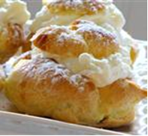  Cream Puffs | 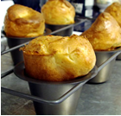  Popovers | 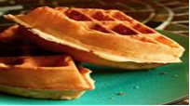  Waffles
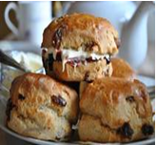  Scones | 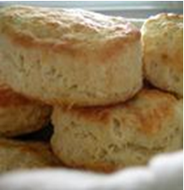  Biscuits

What Happens During Baking

- Solid fats melt:
- Flaky biscuits and pie crusts occur when pockets of fat melt. Melting fat adds tenderness to the product.
- Gases form and expand:
- As gases expand –air, steam, CO2→ cell walls stretch, become thinner, and therefore become tender. Product size and volume increase.
- Microorganisms die:
- Yeast, mold, bacteria, and viruses die. Yeast stops producing CO2 once it dies. Salmonella if present in the eggs also dies, etc.
- Egg, milk, and gluten in flour proteins stretch(denature) and coagulate:
- Initially the proteins stretch as the mixture rises in the oven, then the proteins coagulate, this makes the protein more rigid (firm), meaning no longer able to stretch, thus settling the structure of the baked product.
- Starch gelatinizes:
- Moist flour gelatinizes when heated; the starch granules absorb water and swell, therefore providing structure.
- Gases evaporate:
- As gases escape, a dry or crisp crust develops. The product will also lose weight as moisture is lost (water vapor).

- Browning: Caramelization and Maillard browning occurs:
- Baked goods develop a brown crust and a desirable baked flavor due to caramelization and Maillard browning. This does not happen in the microwave.

- Maillard reaction: is a chemical reaction between: sugar & amino acids which leads to browning.

- Caramelization: is the oxidation of sugar when sugar is exposed to dry heat which leads to browning.

- Browning does not occur in the microwave.

