**

Faculty Of Pharmacy, Nursing and Health Professions

Nutrition and Diet

Anatomy and Physiology lab

Report #3: Heart Rate (Recording of an electrocardiogram)

Doctor: Munir Qazzaz.

Instructor: Kiyan Samrah.

Date of experiment: 28- 10- 2021

Date of submission: 18- 11-2021

Name and ID numbers:

**Ola Hammad, 1200725**

Objective

* The recording of the electrocardiogram was a very useful experiment as it helped us to know the recording of the normal EKG and learn how to read the ECG sheet and see if it is normal.
* The aim of this study is to establish the normal ECG limits for adult, without established heart disease, stratified by gender and age and others disease.

Introduction

Electrocardiogram (ECG), ECG also known as an EKG, it is a test that examines how the heart is working by measuring the electrical activity of the heart. The heart has two tones, (dup) is the first tone and (lop) is the second, with each heartbeat an electrical pulse or wave travels through the heart that gives off electrical activity. There are 12 leads placed in the limbs and chest to record electrical activity, but in this laboratory 4 leads were placed on the legs and hands, there is some factors that effect on the electrical activity of the myocardium such as: Change in posture, Vigorous activity, exaggerated respiratory movement, Drinking ice water, Smoking.

Understanding the origin of the heartbeat can help the anesthetist know when and how to identify a potential problem. An ECG complex consists of a PQRST complex. The sinoatrial node (SA) is the pacemaker of the heart and produces the P wave. The QRS wave is produced by the atrioventricular node (AV). The P wave in an ECG complex indicates atrial depolarization. The QRS is responsible for ventricular depolarization and the T wave is ventricular repolarization. If a P wave is absent there is a lack of atrial depolarization. This is also known as atrial standstill. P waves that are combined in the QRS complexes are indicative of ventricular tachycardia or a junctional tachycardia. Present P waves that are without a QRS are indicative of an atrial depolarization that has not been conducted through the AV node. A QRS complex without a P wave demonstrate premature or. escape beats. The ECG gives three reading: 1 Left side of the heart. 2 and 3 Inferior aspect of the heart. Lead II is most commonly used.  Lead II (and the chest leads) most consistently show the clearest P Wave which can be diagnostic of many common arrhythmias. (1)

Materials and Procedure

* Electrocardiogram machine
* ECG recording paper
* Electrocardiogram gel
* Reclined Stretcher

Prepare the electrocardiograph for use in a quiet room.

* The person should remove any accessories he wears.
* Let the person lie down and be relaxed and comfortable.
* The black one is used as a control; it is put on the right leg.
* The green is put on the left leg.
* The yellow on the left arm.
* The red on the right arm.

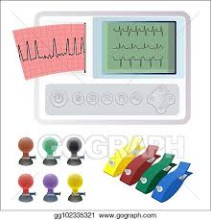

Calculations

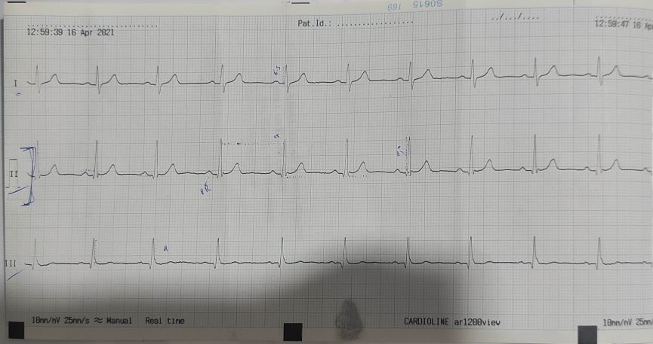

1. RR

= 300/ large boxes

= 300/ 3= 100 bpm

From the second reading of the device:

= 1500/ small boxes

= 1500/ 22= 68 bpm

1. Sitting

|  |  |  |  |
| --- | --- | --- | --- |
| From | P | QRS complex | T |
| mm | 1 | 13.5 | 3 |
| mv | 0.1 | 1.35 | 0.3 |

1. Sec

* PR interval

= small boxes * 0.04

= 6* 0.04

=0.24 s

* QRS interval

= small boxes * 0.04

= 3* 0.04

=0.12 s

* ST interval

= small boxes * 0.04

=7* 0.04

=0.28s

1. The mm of the 3 recording
2. 6.5 mm
3. 13.5 mm
4. 9 mm

Note: 25 mm/s = 10 boxes

Discussion and Conclusion

Normal ECG note that the heart is beating in a regular sinus rhythm between 60 - 100 beats per minute (specifically 82 bpm). All the important intervals on this recording are within normal ranges.PR interval normally between 0.12 and 0.20 seconds. QRS complex duration less than or equal to 0.12 seconds. ST interval can be slightly elevated (up to 2.0 mm in some precordial leads. QT interval durations normally less than or equal to 0.40 seconds for males and 0.44 seconds for females. (2)

My ECG is 68 bpm (in normal rang). The PR interval is 0.24 s (is high than normal). The QRS is 0.1 (They are generally the same for everyone) (in normal rang). The ST interval is 0.28 s (in normal rang). The QT interval from me is 0.32 (in normal rang for the women).

We used (Method 1500) to calculate the EKG waves which give us more accurate numbers. In this lab, I obtained an electrocardiogram (ECG), which is a recording of the heart's electricity, by placing small sensors on the arms and legs. The test was fast, safe and painless. In general, the results were normal and regular in PQRST intervals.

References

1. BUSH VETERINARY NEUROLOGY Service (2018). Cardiology- the ABCs of the PQRST Heather Carter LVT, VTS (Anesthesia & Analgesia). Retrieved from

<https://bvns.net/wp-content/uploads/2018/10/Cardiology-the-ABC%E2%80%99s-of-the-PQRST.pdf>

1. faculty of Health Sciences. Queen's University 2017. Medicine. Retrieved from <https://meds.queensu.ca/academics/simulation>