

Faculty Of Pharmacy, Nursing and Health Professions

Nutrition and Diet

Anatomy and Physiology lab

Report #7: Urine test

Doctor: Munir Qazzaz.

Instructor: Kiyan Samrah.

Date of experiment: 28- 10- 2021

Date of submission: 18- 11-2021

Name and ID numbers:

**Ola Hammad, 1200725**

Objective

* Urine test It is used to detect and treat a range of disorders, such as urinary tract infection, kidney disease, diabetes ... and other disorders, and we did it to see if we suffer from something wrong.

Introduction

The urinary system includes the kidneys, ureters, bladder and urethra. This system filters your blood, removing waste and excess water. This waste becomes urine. The most common urinary issues are bladder infections and urinary tract infections (UTIs)

The urinary system works as a filter, removing toxins and wastes from your body through urine. It uses a series of tubes and ducts to pass this waste. These tubes are connected to your blood vessels and digestive system. Your urinary system helps the rest of your body work properly. Your urinary system filters your blood to get rid of what your body doesn’t need. It eliminates extra water and salt, toxins, and other waste products. Different parts of the urinary system perform tasks including: Filtering blood, Separating the toxins, you don’t need from the nutrients you do need, Storing and carrying urine out of your body.

A urinalysis is a test of your urine. It's used to detect and manage a wide range of disorders, such as urinary tract infections, kidney disease and diabetes. A urinalysis involves checking the appearance, concentration and content of urine. For example, a urinary tract infection can make urine look cloudy instead of clear. Increased levels of protein in urine can be a sign of kidney disease.

Unusual urinalysis results often require more testing to find the source of the problem.

The sample is sent to a lab, where it is examined for the following:

*PHYSICAL COLOR AND APPEARANCE or MICROSCOPIC APPEARANCE

The urine sample is examined under a microscope to: Check if there are any cells, urine crystals, urinary casts, mucus, and other substances and identify any bacteria or other germs.

*CHEMICAL APPEARANCE (urine chemistry)

A special strip (dipstick) is used to test for substances in the urine sample. The strip has pads of chemicals that change color when they come in contact with substances of interest.

Examples of specific urinalysis tests that may be done to check for problems include: red blood cell urine test, Glucose urine test, Protein urine test, Urine pH level test, Ketone’s urine test Bilirubin urine test and Urine specific gravity test.

Data + Results

Table 1: Urinalysis physical examination results

|  |  |
| --- | --- |
| Physical Examination |  |
| Color | yellow |
| Turbidity | hazy |
| Urine Sediments | Epithelia cells, did not work with me because slide was compressed. |

Figure 1: No figure because the slide was compressed (the cells was damaged).

Table 2: Urinalysis dipstick chemical examination results

|  |  |
| --- | --- |
| Chemical Examination |  |
| RBC | 2-3 |
| Glucose | - |
| Urobilinogen | - |
| Bilirubin | - |
| Protein | - |
| Nitrite | - |
| Ketones | - |
| pH | 5 |
| WBC | 0-1 |
| Specific Gravity | 1.025 |

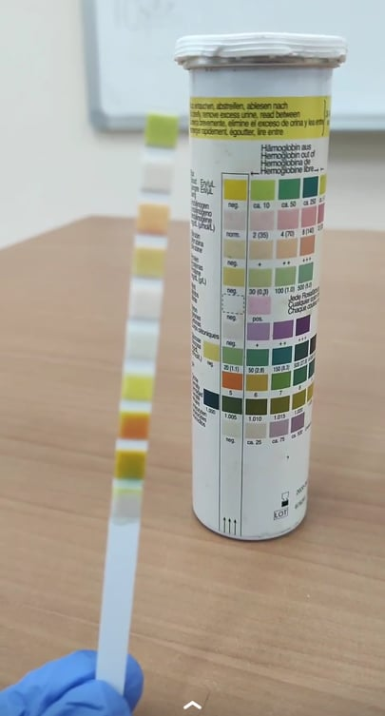

Figure 2: My Chemical Examination of my urine test

Discussion

In Physical Examination urine color, it should be straw, yellow or colorless {the normal is yellow}. Urine Turbidity it should be clear, hazy or cloudy {the normal is hazy} and in Urine Sediments we have a cell such as Squamous epithelial cell, Eumorphic erythrocytes -disc-shaped and we will compered

In Physical Examination my urine color is yellow its normal, my urine Turbidity is hazy its normal and in Urine Sediments I saw only Epithelia cells, did not work with me because slide was compressed.

Freshly voided urine is often described as straw or amber yellow. However, the normal color. as a result of a pigment called urochrome, may have a considerable range. Concentrated urine resulting from loss of water in severe sweating will be very yellow; a light amber yellow is more characteristic of dilute urine. Certain deviations from the normal yellow or amber color may be the result of disease, whereas other color changes have no pathological significance. For example, a brownish yellow or green color may a result of bile pigments and suggest liver disease. A smoky brown or reddish urine usually indicates a diseased condition but may on occasion be a result of ingestion of plant dyes in beets and rhubarb. (3) Urine Turbidity The turbidity of the urine sample is gauged subjectively and reported as: clear, slightly cloudy, cloudy, opaque, or flocculent Normally, fresh urine is clear to very slightly cloudy. Excess turbidity results from the presence of suspended particles in the urine. The cause can usually be determined based on the results of the microscopic urine sediment examination. Common causes of abnormal turbidity include: increased cells (RBC, WBC), numerous crystals, bacteria, lipiduria (lipids often rise to the surface), mucus (especially in horses), semen, fecal contamination. (4) Organized urine sediment consists of biological elements such as leukocytes, erythrocytes, epithelial cells, casts, bacteria, fungi, parasites and sperm. Unorganized urine sediment contains crystals of various salts, for instance oxalate, phosphate, urate, and amorphous salts. Sediment in urine indicates the bottom line. If you notice white particles in your urine, it's likely from genital discharge or a problem in your urinary tract, such as kidney stones or possible infection. If you have significant symptoms that accompany the white particles in your urine, you may want to see your doctor (5). Urine pH: Freshly voided urine is generally acid (about pH 5.7) but the normal range is between pH 4.7 and 7. The urine pH depends on diet. A high protein diet results in an acid urine and a vegetable diet in alkaline urine. The urine pH is also subject to a day/night (diurnal) variation. Determination of urine specification gravity gives information concerning concentration of dissolved substances in the sample. Water has a specific gravity of 1.000. The normal range of urine specific gravity is 1.005 to 1.030. As a general "rule of thumb" when urine volumes are high, specific gravity is low. Because the concentration of the substances is lower. Red blood cells, white blood cells, glucose, ketones, proteins, bilirubin and urobilinogen should not be present in the urine. If any of these are found, it could be one of the following: Acidity (pH): The pH level indicates the amount of acid in urine. The pH level might indicate a kidney or urinary tract disorder. Concentration: A measure of concentration shows how concentrated the particles are in your urine. A higher-than-normal concentration often is a result of not drinking enough fluids. Protein: Low levels of protein in urine are typical. Small increases in protein in urine usually aren't a cause for concern, but larger amounts might indicate a kidney problem. Sugar: The amount of sugar (glucose) in urine is typically too low to be detected. Any detection of sugar on this test usually calls for follow-up testing for diabetes. Ketones as with sugar, any number of ketones detected in your urine could be a sign of diabetes and requires follow-up testing. Bilirubin is a product of red blood cell breakdown. Usually, bilirubin is carried in the blood and passes into your liver, where it's removed and becomes part of bile. Bilirubin in your urine might indicate liver damage or disease. Evidence of infection. Either nitrites or leukocyte esterase — a product of white blood cells — in your urine might indicate a urinary tract infection. Blood in your urine requires additional testing. It may be a sign of kidney damage, infection, kidney or bladder stones, kidney or bladder cancer, or blood disorders. (6)

Colors and their meaning Ketones: the method is based on a variant of legal's test, the alkaline-buffered test zone contains glycine and sodium mitroprusside, the presence of methyl ketones will color the test zone violet. 4. Ascorbic acid: is determined by the decoloration of Tillmann's reagent, the presence of ascorbic will change the color from grey-blue to orange. Glucose: is determined enzymatically, using glucose oxidase, peroxidase and a chromogen, the intensity of the green or blue color formed by the reaction is dependent upon the glucose concentration (other sugars are not indicated). Blood: the buffered zone for glucose contains an organic peroxide and chromogen, the peroxidative effect of hemoglobin produces a green color. 7. pH: contains an indicator, which ensures a marked change of color between pH 5 and 9. The indicator is nor affected by protein. Protein: the zone is impregnated with buffered solution of tetra bromphenol-blue, with yellow indicator which changes towards blue in the presence of protein, its sensitive in the case of albumin, other proteins are less sensitive. Nitrite: based on indirect demonstration of nitrite-forming bacteria in the urine, the buffered test zone is impregnated with an amine and a coupler, the amine is diazotized by the nitrite contained in the urine, the coupling reaction leads to the formation of a reddish violet pigment. (7)