

Faculty Of Pharmacy, Nursing and Health Professions

Nutrition and Diet

Anatomy and Physiology lab

Report #2: Blood presser in different position

Doctor: Munir Qazzaz.

Instructor: Kiyan Samrah.

Date of experiment: 21- 10- 2021

Date of submission: 4- 11-2021

Group participants name and ID numbers:

(Ola Hammad, 1200725)

(Lamis Ramadan,1202115)

(Majdal Alkhatib,1201563)

(Muna Dweik, 1201119)

(Aya Mtoor, 1203362)

Objective

Identifying the blood pressure measurement for each student in different position. The blood pressure increases or decreases in different position in the blood pressure was measured.

Introduction

Blood pressure: pressure that is exerted by the blood upon the walls of the blood vessels and especially arteries and that varies with the muscular efficiency of the heart, the blood volume and viscosity, the age and health of the individual, and the state of the vascular wall, Blood pressure is taken using two measurements: systolic (measured when the heart beats, when blood pressure is at its highest) and diastolic (measured between heart beats, when blood pressure is at its lowest). Blood pressure is written with the systolic blood pressure first, followed by the diastolic blood pressure (for example 120/80).

They send impulses to the cardiovascular center to regulate blood pressure. ... At lower blood pressures, the degree of stretch is lower and the rate of firing is slower. When the cardiovascular center in the medulla oblongata receives this input, it triggers a reflex that maintains homeostasis. In order to maintain homeostasis in the cardiovascular system and provide adequate blood to the tissues, blood flow must be redirected continually to the tissues as they become more active. In a very real sense, the cardiovascular system engages in resource allocation, because there is not enough blood flow to distribute blood equally to all tissues simultaneously. For example, when an individual is exercising, more blood will be directed to skeletal muscles, the heart, and the lungs. Following a meal, more blood is directed to the digestive system. Only the brain receives a more or less constant supply of blood whether you are active, resting, thinking, or engaged in any other activity.

High blood pressure has many risk factors, including: Age, Race, Family history, being overweight or obese, Not being physically active, using tobacco, too much salt (sodium) in your diet, too little potassium in your diet, Drinking too much alcohol, Stress and Certain chronic conditions. The excessive pressure on your artery walls caused by high blood pressure can damage your blood vessels as well as your organs. The higher your blood pressure and the longer it goes uncontrolled, the greater the damage.

Blood pressure readings may vary according to the method and mode of measurement, and it may increase or decrease. Among these situations that may affect the blood pressure reading:) hand lowered sitting, heart level standing, hand raised standing, standing on lower leg, hand in hot water, hand in cold water, holding breathing, exhaling breathe (3).

Data

Table1: Blood pressure between hand in hot water and cold water

|  |  |  |
| --- | --- | --- |
| Student | Blood pressure hand in hot water | Blood pressure hand in cold water |
| 1 | 92/70 | 109/99 |
| 2 | 111/84 | 107/75 |
| 3 | 118/76 | 131/82 |
| 4 | 113/104 | 162/84 |
| 5 | 99/68 | 111/80 |
| Average | 106.6/80.4 | 124/84 |

Tabel2: Blood pressure between normal, holding and exhaling breath

|  |  |  |  |
| --- | --- | --- | --- |
| Student | Blood pressure normal breath | Blood pressure holding breath | Blood pressure exhaling breath |
| 1 | 96/56 | 106/73 | 107/71 |
| 2 | 96/68 | 102/68 | 99/73 |
| 3 | 123/71 | 129/91 | 117/70 |
| 4 | 107/64 | 106/73 | 96/70 |
| 5 | 93/73 | 109/80 | 95/72 |
| Average | 103/66.4 | 110.4/77 | 102.8/71.2 |

Tabel3: Blood pressure between heart level in sitting, standing, lowered and standing

|  |  |  |  |  |
| --- | --- | --- | --- | --- |
| Student | Blood pressure heart level sitting | Blood pressure heart level standing | Blood pressure hand lowered sitting | Blood pressure hand raised standing |
| 1 | 96/56 | 92/72 | 106/57 | 74/55 |
| 2 | 96/68 | 90/75 | 103/65 | 75/46 |
| 3 | 123/71 | 102/64 | 125/73 | 87/51 |
| 4 | 107/64 | 102/94 | 110/74 | 72/52 |
| 5 | 93/73 | 86/61 | 101/73 | 83/52 |
| Average | 103/66.4 | 94/73.2 | 109/68.4 | 78.2/51.2 |

Discussion

When measuring blood pressure in more than one case, it was noticed that the blood pressure changes either by an increase or decrease from the normal state according to the change in the condition. In the case of measuring blood pressure when placing the hand in cold water, the data showed a high rise in blood pressure to about 107 systolic and 75 diastolic، this is due to the narrowing of the arteries as a result of the low temperature, and thus the blood pressure on the walls of the arteries increases.

In the case of placing the hand in hot water, a decrease in blood pressure was observed, due to the expansion of the arteries, and thus the blood pressure on the walls of the arteries decreased.

pressure is the force of the heart's pumping of blood into the arteries. There are many factors that change blood pressure, including: Decreased volume of blood flowing in the arteries and other. When measuring blood pressure in more than one case, it was noticed that the blood pressure changes either by an increase or decrease from the normal state according to the change in the condition (4).

In the case of measuring blood pressure when placing the hand in cold water, the data showed a high rise in blood pressure to about (107 _ 162) systolic and (75 _ 99) diastolic، this is due to the narrowing of the arteries as a result of the low temperature, and thus the blood pressure on the walls of the arteries increases (5).

In the case of placing the hand in hot water, a decrease in blood pressure was observed (92 _ 118) mmHg systolic and (68 _104) mmHg diastolic, due to the expansion of the arteries, and thus the blood pressure on the walls of the arteries decreased.

The results also showed that when blood pressure was measured from the area above the ankle, a significant increase was observed, with an average increase of 65 mmHg in systolic and 62 mmHg in diastolic compared to ankle blood pressure in the supine position, as data showed 165 to 196 mmHg systolic and 127 to 154 mmHg diastolic, blood pooling in the feet as a result of gravity, and thus the blood pressure on the arteries in this area increases.

 Ankle pressure test is used to check whether a person has peripheral arterial disease. If the arteries are narrow, this limits blood flow to the legs, and thus increases blood pressure in this area.

Results

1. Average systolic and diastolic blood pressures of five students are shown while sitting with their hands at heart level Sitting, hand down, standing hand at heart level, standing with hand raised.

Table 1: Average

|  |  |  |
| --- | --- | --- |
| Positions | Systolic pressure | Diastolic pressure |
| Heart level sitting | 101.8 | 67.8 |
| Hand lowered sitting | 109 | 68.4 |
| Heart level standing | 115.6 | 85 |
| Hand raised standing | 78.32 | 51.2 |

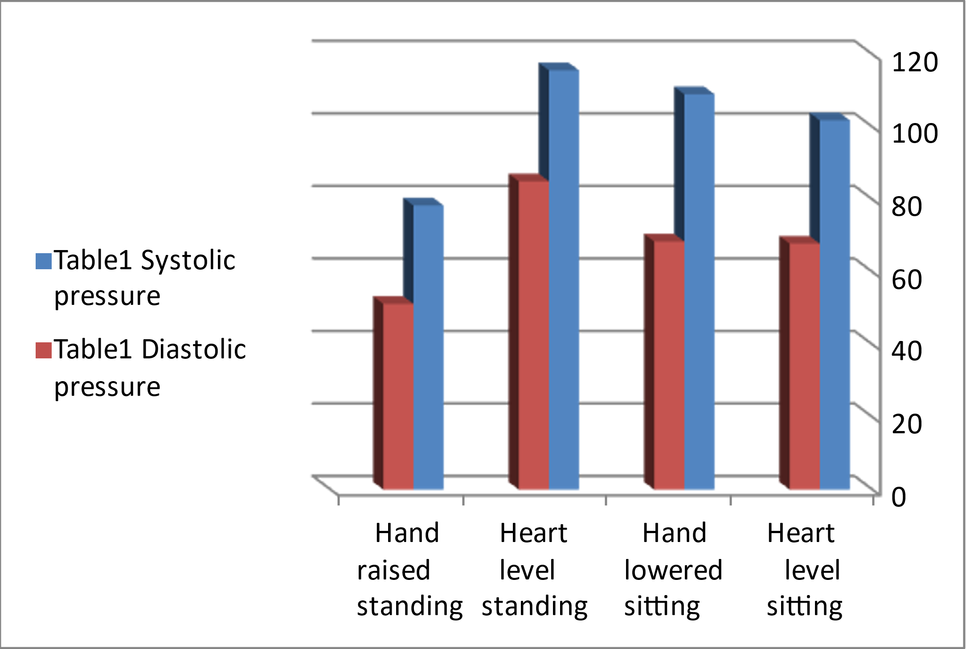

Figure 1: Graphically shows the data in Table 1 sitting with their hands at heart level Sitting, hand down, standing, hand at heart level, standing with hand raised.

1. Average systolic and diastolic blood pressures of five students are shown while holding the hand in hot water and in the cold hand.

Table 2: Average

|  |  |  |
| --- | --- | --- |
| Positions | Systolic pressure | diastolic pressure |
| Blood pressure Hand in hot water | 106.6 | 80.4 |
| Blood pressure hand in cold water | 124 | 84 |

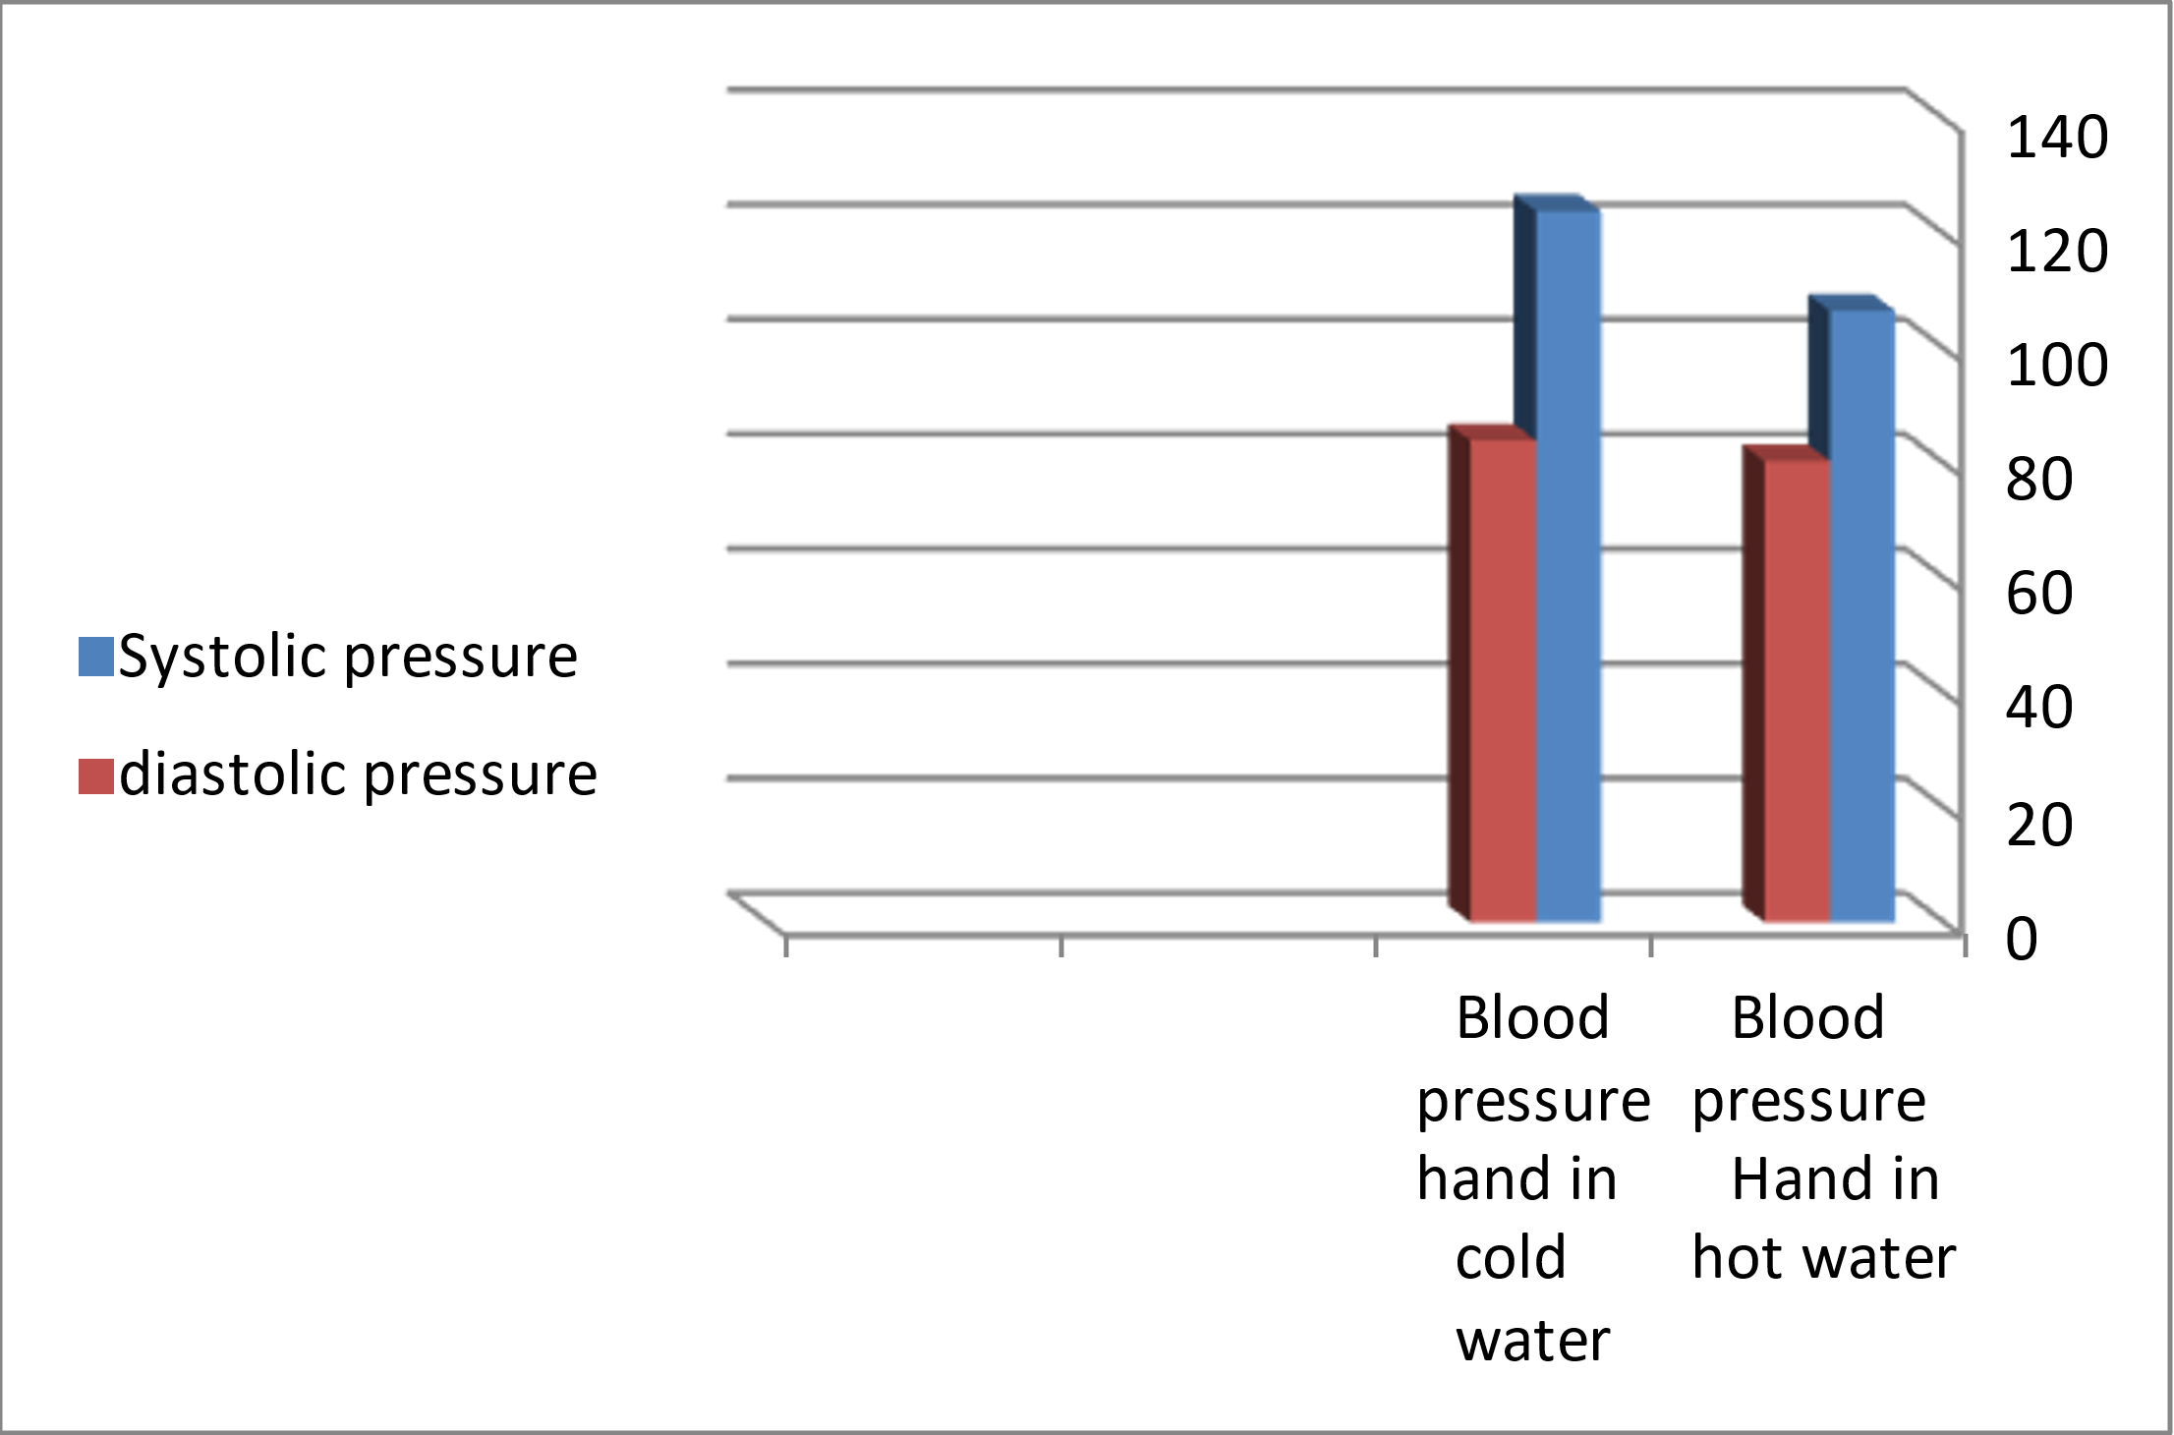

Figure 2: Graphically shows the data in Table. 2 holding the hand in hot water and in the cold hand.

1. Average systolic and diastolic blood pressures are shown for five students during normal breathing, holding and exhaling.

Table 3: average

|  |  |  |
| --- | --- | --- |
| Position | Systolic pressure | diastolic pressure |
| Blood pressure normal breathing | 103 | 66.4 |
| Blood pressure holding breathe | 112.8 | 78.6 |
| Blood pressure exhaling breathe | 102.8 | 71.2 |

Figure 3: Graphically shows the data in Table 3 normal breathing, holding and exhaling.

Conclusion

The aim of the experiment was to know the differences in blood pressure in terms of the area from which the temperature situation is examined, its effect on blood pressure and the effect of breathing on pressure, from which we can give tried and tested advice based on facts that have been tested for patients with blood pressure, athletes and those who live with different temperatures To keep blood pressure at a normal level for them, according to factors that may be temporary or permanent, environment, sports activity, age, medication, disease (for example, metabolic syndrome and high blood pressure), pregnancy, alcohol, caffeine, and other factors.

References

1. Webster, M (2021). Blood pressure. Merriam Webster. Retrieved from

<https://www.merriam-webster.com/dictionary/blood%20pressure?fbclid=IwAR14VBSERAL-C9ZjnSJuMvk317saM3xfrOIvkKxPn6F_QunSFrIi_mmf9EE>

1. Mayoclinic, (2021). High Blood Pressure. Retrieved from

<https://www.mayoclinic.org/diseases-conditions/high-blood-pressure/symptoms-causes/syc-20373410?fbclid=IwAR1O21tCACIE4T6d34JzP2d0KME4fLIaycypkqqNzN5nucAQwxpEhymzOrw>

1. Lumen, Control of Blood Pressure (2021). Lumen Leaving. Retrieved from

<https://courses.lumenlearning.com/boundless-ap/chapter/control-of-blood-pressure/>

1. Merck and Co (2021). HEALTH TOPICS & CHAPTERS. MSD and the MSD Manuals. Retrieved from

<https://www.msdmanuals.com/home/heart-and-blood-vessel-disorders/low-blood-pressure-and-shock/low-blood-pressure>

1. [Malhotra](https://pubmed.ncbi.nlm.nih.gov/?term=Malhotra+A&cauthor_id=12368575), [Cohen](https://pubmed.ncbi.nlm.nih.gov/?term=Cohen+D&cauthor_id=12368575), [Townsend](https://pubmed.ncbi.nlm.nih.gov/?term=Townsend+RR&cauthor_id=12368575). Arun, Debbie, Raymond (2021). National Library Of Medicine. Pub Med .gov. Retrieved from

https://www.mayoclinic.org/diseases-conditions/high-blood-pressure/expert-answers/blood-pressure/faq-20058250