

Faculty Of Pharmacy, Nursing and Health Professions

Nutrition and Diet

Anatomy and Physiology lab

Report #4: Hematology

Doctor: Munir Qazzaz.

Instructor: Kiyan Samrah.

Date of experiment: 4-11- 2021

Date of submission: 18- 11-2021

Name and ID numbers:

**Ola Hammad, 1200725**

Questions...

1. MCV when its high and low, what does it mean?

MCV stands for mean corpuscular volume. There are three main types of corpuscles (blood cells) in your blood–red blood cells, white blood cells, and platelets. An MCV blood test measures the average size of your red blood cells, also known as erythrocytes.

Measuring the average size of red blood cells is very helpful in determining which type of anemia a person has. For example:

* High MCV is seen with [folic acid B9 deficiency](https://www.verywellhealth.com/vitamin-b12-deficiency-2488570)
* Low MCV is seen with [iron deficiency](https://www.verywellhealth.com/iron-deficiency-signs-and-symptoms-2507719) anemia

3. How we calculate PCV+ Hb?

PCV= (RBC/ (RBC + Puffy+ Plasma)) *100

Hb= PCV/3

We put the blood sample in centrifuge It is separated into three parts: RBC (The densest layer (, Puffy (medium density (, Plasma (the lowers density).

4. How to know different blood types, explain anti A, B and D

|  |  |  |  |
| --- | --- | --- | --- |
| Blood Type | A | B | D |
| AB+ | + | + | + |
| AB- | + | + | - |
| A+ | + | - | + |
| A- | + | - | - |
| B+ | - | + | + |
| B- | - | + | - |
| O+ | - | - | + |
| O- | - | - | - |

2. Types of WBCs explain each different:

|  |  |  |  |  |
| --- | --- | --- | --- | --- |
| Types/ From | Colors | Nucleus | When it increases | Function |
| Neutrophils | light-pink to bluish-purple, “neutral” color | Have a multi-lobed nucleus | infections or injuries | helps heal damaged tissues and resolve infections |
| Eosinophils | reddish-orange | generally, has a nucleus with two lobes | in parasitic infection | movement to inflamed areas, trapping substances, killing cells, anti-parasitic and bactericidal activity, participating in immediate allergic reactions, and modulating inflammatory responses |
| Basophils | deep purplish-blue to dark purple-red | segmented nuclei | In infections, severe allergies, or an overactive thyroid gland | part in "immune surveillance"**,** release the histamine in their granules during an allergic reaction or asthma attack |
| Lymphocytes  (B and T) | dark purple | a very large nucleus | High lymphocyte blood levels indicate your body is dealing with an infection or other inflammatory condition. Sometimes, lymphocyte levels are elevated because of a serious condition, like leukemia. | antibody production, direct cell-mediated killing of virus-infected and tumor cells, and regulation of the immune response. |
| Monocytes | blue-gray cytoplasm containing | a bilobed nucleus | An infection by a bacteria, virus or fungus can cause an increase in monocyte levels. This is because the body creates more monocytes to fight the invader. An absolute monocyte high can also be a response to stress, chronic infections or autoimmune disorders. | clean up dead cells in the body |

5. Blood film how should it look like? Why?

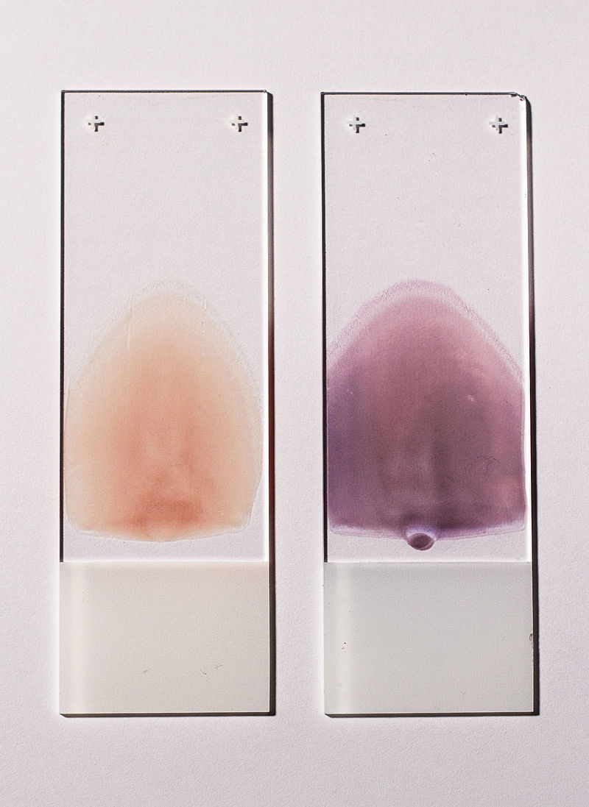

As shown in the picture above, this is the normal form of Blood film.

If it is not in this shape (slightly zigzag) there will be clotting of red blood cells so that they are close to each other in the form of bundles.

But if there are many zigzags, we will have killed all the cells.