Objective

The respiratory and the lungs’ normal function rate

Results

1. Calculations:

|  |  |
| --- | --- |
| Volumes & Capacities | Measured Result (L/s) |
| Tidal Volume (TV) | 0.56 |
| Inspiratory Reserve Volume (IRV) | 1.30 |
| Expiratory Reserve Volume (ERV) | 1.00 |
| Inspiratory Capacity (IC) | 2.00 |
| Vital Capacity (VC) | 3.00 |

The Diagram:

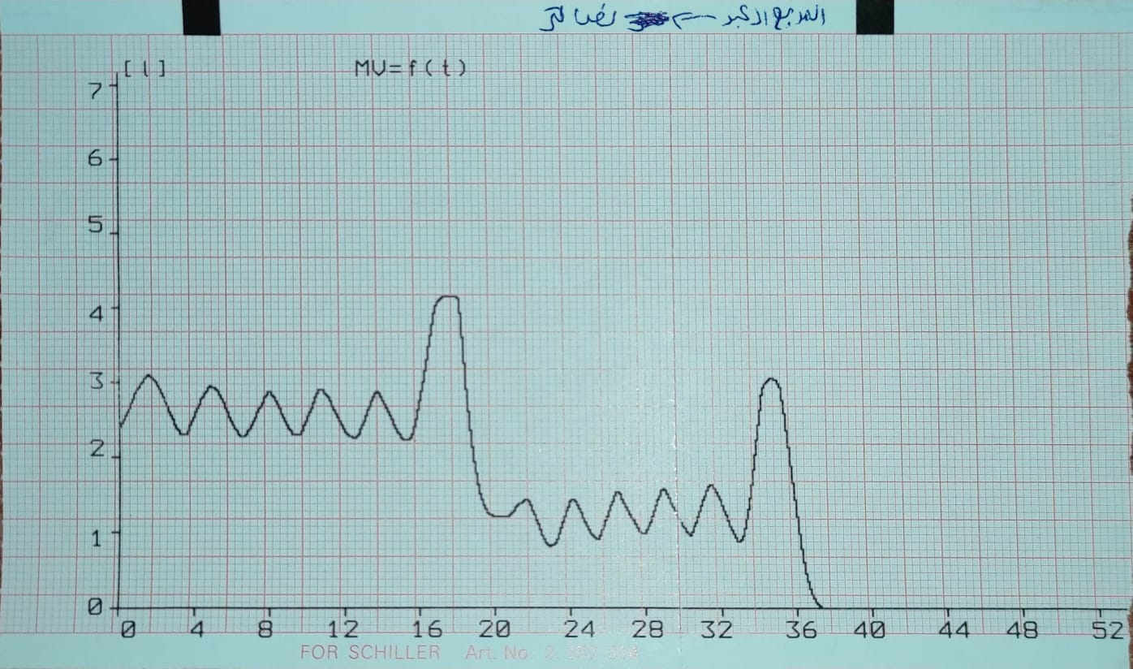

Figure 1: The respiratory lungs of our group (Aya).