

Faculty Of Pharmacy, Nursing and Health Professions

Nutrition and Diet

Anatomy and Physiology lab

Report #6: Respiratory Volumes And

Doctor: Munir Qazzaz.

Instructor: Kiyan Samrah.&Isrsr

Date of experiment: 25- 11- 2021

Date of submission: 9- 12-2021

Group participants name and ID numbers:

(Ola Hammad, 1200725)

(Lamis Ramadan,1202115)

(Majdal Alkhatib,1201563)

(Aya Mtoor, 1203362)

Objective

The respiratory and the lungs’ normal function rate

Introduction

Residual volume (RV) is the volume of air remaining in the lungs after maximum forceful expiration. In other words, it is the volume of air that cannot be expelled, thus causing the alveoli to remain open at all times. The residual volume remains unchanged regardless of the lung volume at which expiration was started. Reference values for residual volume are 1 to 1.2 L, but these values are dependent on factors including age, gender, height, weight, and physical activity levels.

The residual volume is an important component of the total lung capacity (TLC) and the functional residual capacity (FRC). TLC is the total volume of the lungs at maximal inspiration which is about 6 L on average, though true values are dependent on the same factors that affect residual volume. FRC is the amount of air remaining in the lungs after a normal, physiologic expiration. The TLC, FRC, and RV are absolute lung volumes and cannot be measured directly with spirometry. Instead, they must be calculated using indirect measurement techniques such as gas dilution or body plethysmography. Calculating the residual volume can give an indication of lung physiology and pathology.

)1)

What is spirometer?

Spirometry is a standard test doctors use to measure how well your lungs are functioning. The test works by measuring airflow into and out of your lungs.

To take a spirometry test, you sit and breathe into a small machine called a spirometer. This medical device records the amount of air you breathe in and out as well as the speed of your breath.

Doctors use spirometry tests to [diagnoseTrusted Source](https://www.ncbi.nlm.nih.gov/books/NBK560880/) these conditions: COPD, asthma, restrictive lung disease, such as interstitial pulmonary fibrosis, other disorders affecting lung function. They also allow your doctor to monitor chronic lung conditions to check whether your current treatment is improving your breathing. Spirometry is often done as part of a group of tests known as [pulmonary function tests](https://www.healthline.com/health/pulmonary-function-tests).(2)

When considering lung volumes, it is useful to divide the total space within the lungs into volumes and capacities. These allow an assessment of the mechanical condition of the lungs, its musculature, airway resistance and the effectiveness of gas exchange at the alveolar membrane. Furthermore they are generally cheap, non-invasive and simple tests.

**Tidal volume:** Volume that enters and leaves with each breath, from a normal quiet inspiration to a normal quiet expiration, average 0.5

**Inspiratory reserve volume:** Extra volume that can be inspired above tidal volume, from normal quiet inspiration to maximum inspiration, average 2.5L, relies on muscle strength, lung compliance (elastic recoil) and a normal starting point (end of tidal volume).

**Expiratory reserve volume:** Extra volume that can be expired below tidal volume, from normal quiet expiration to maximum expiration, average 1.5L, relies on muscle strength and low airway resistance.**(3)**

Discussion

**Discussion**

**\*Factors affect respiratory volumes:**

1. Body size

2. Difference between sexes, Males, Females Vital capacity with males is 2.5 liter per m2 body surface area with females it is 2 liter/m2

3. Physical conditions:

-decrease VC in case of diseases pneumonia or emphysema.

-any decrease in lung space in the thoracic cavity such as Tumor in the thoracic cavity or enlargement of blood vessels due to heart disease.

-disorder in muscle activity muscular or neuronal

**\*Vital Capacity (VC)**

It is the total amount of air exhaled after maximal inhalation.

A healthy person's vital capacity should be between 3 and 5 liters. This value depends on age, sex, weight, height, and ethnicity.

Aya's results in ideal nomogram showed that the vital capacity values =2.9 and that its a normal value

\***The calculations in diagram** showed that 1. the tidal volume (TV) =( .56 L) ,the normal adult value approximately 300-500ml 2. IRV =1.30 L and the normal adult value = 1900-3300 ml , 3. EVR = 1 L and the normal adult value =700-1200 ml, 4. The last one it's a VC that = 3 and its approximately equal the value that calculated from nomogram

(4)

Results

1. Calculations:

|  |  |
| --- | --- |
| Volumes & Capacities | Measured Result (L/s) |
| Tidal Volume (TV) | 0.56 |
| Inspiratory Reserve Volume (IRV) | 1.30 |
| Expiratory Reserve Volume (ERV) | 1.00 |
| Inspiratory Capacity (IC) | 2.00 |
| Vital Capacity (VC) | 3.00 |

Ided nomograph

Height:150

Weight:55

Surface in square:=1.45*2

2.9=

The Diagram:

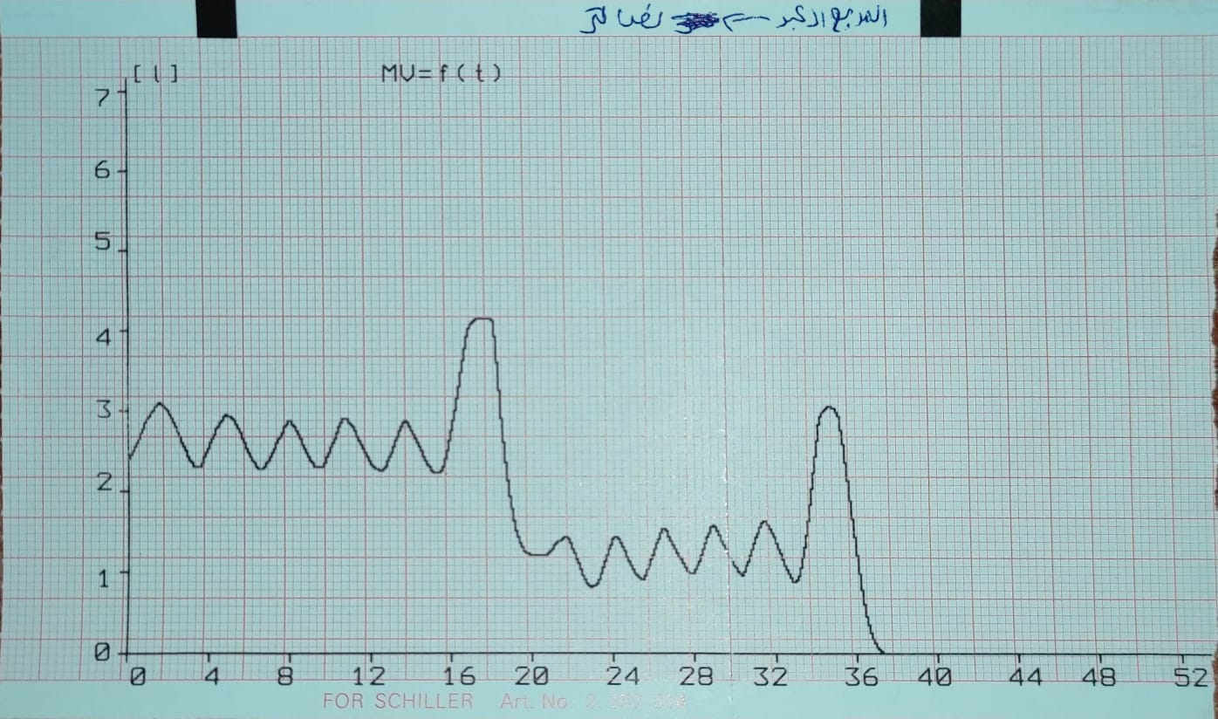

Figure 1: The respiratory lungs of our group (Aya).

References

1-Residual volume (RV). (2021). National Library Of Medicine.

<https://pubmed.ncbi.nlm.nih.gov/29630222/>

2-  [Cirino](https://www.healthline.com/authors/erica-cirino).E.(2021). Healthline. Spirometry

<https://www.healthline.com/health/spirometry>

3-Surti.F.(2020). TeachMe Physiology. respiratory graph description

<https://teachmephysiology.com/respiratory-system/ventilation/lung-volumes/>

)4)

Lung volume, physiopedya

<https://www.physio-pedia.com/Lung_Volumes>

Vital Capacity Calculator, omni calculator,

<https://www.omnicalculator.com/health/vital-capacity>

)

ABU HAMADEH,R,(2012) ,PHYSIOLOGY 345 LABORATORY EXPERIMENT

<https://ritaj.birzeit.edu/bzu-msgs/attach/1937535/Manual++for+Anatomy++Physiology.pdf>