**\*Anatomy and Physiology Lab Report Guidance\***

- The report consists of the following parts:

1. **Cover page**

* Birzeit university logo
* Course name and course code
* Name of the experiment
* Name of participants/students with their academic number

1. **Objectives**
2. **Introduction**
3. **Experimental data**
4. **Results**
5. **Discussion**
6. **Conclusion**
7. **References**

* **Objectives :**

Write the experiment objectives whether by giving a brief statement, or by making every object as a point.

* **Introduction:**

The part of introduction should take half a page. However, this part must gives the reader a brief introduction on the anatomy and physiology related to the experiment, an introductory of the experiment, and the purpose of the experiment

* **Experiment data and Results:**

This part should be presented as Tables, Figures (Line graphs), or Histogram (Bar graphs). Furthermore, make sure that name of participants must be attached to their values correctly, and that every data related to this part is correct and without any typing errors.

* **Discussion:**

This part can be summarized as discussing your results, in which means that every group need to: **1-** present how the experiment was done (experiment process), **2-** comparing between values, **3-** showing the normal and abnormal values, **4-** explaining why some results (if found) came as an abnormal result, and **5-** showing factors that could influence their results.

**Note: try to attach pictures (if possible) that could help in explaining the discussion part**

* **Conclusion:**

Give a clear and simple conclusion to the whole experiment, **1-** concluding the facts and knowledge gained throughout the experiment, **2-** very short conclusion of the discussed results, and **3-** give a reflection of the group opinion about the experiment

* **References:**

Put the references (sources) as points, as the following:

* If the reference is a book/manual, then write the book/manual full name, main author name, and book edition
* If the reference from a website, then put the website URL

**Notes for ECG Experiment report:**

1. 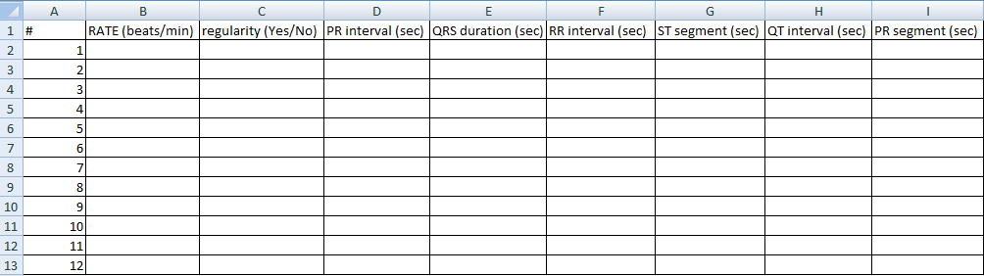Every group must fill the ECG table that has been attached to the Facebook group by Dr. Rania (as showed below), and then show this table as their Experimental data in the ECG report.
2. Every group need to compare the data used in the ECG table with each other, and follow the rest of guidance in the Discussion part.
3. Every group need to discuss the Standing ECG results.
4. Every group should compare between their flat/supine ECG and Standing ECG.

Note: remember to attach ECG strips pictures in the discussion part

**^_^ Wish you all the best ^_^**

**Fuad AlFayyah, BSN, RN**

**Etaf Nazal, BSN, RN**