

**NURS 142 section 4 .**

**Name of the experiment : ECG .**

**- Asmaa Mousa 1192471 .**

**- Aya Arouri 1191397 .**

**- Sara Saleh 1192125 .**

**Objectives:**

* Measurement of the electrical activity of the heartbeat .
* Calculate the heart rate .
* Heartbeat rhythm .
* Knowledge of heart related problems .
* The efficiency of making atrioventricular node .
* Knowing the natural sinus rhythm .

**Introduction**

Anatomy of the heart: The heart consists of 4 chambers, the atrium and the right ventricle, the atrium and the ventricle, and more other details.

When the heart contracts, the heart pumps blood in a regular rhythm determined by a group of cells in the sinoatrial node, and these cells produce a current, and this contraction travels to the AV node, and then travels through the system that conducts the heart , Heart rate and rhythm are measured by ECG, in addition to providing evidence of blood flow to the heart muscle.

Routine EKG. Ten electrodes are needed to produce 12 electrodes of the heart. An electric wire is placed, on the chest, and a six-wire pulled through the chest. Mementos from every electrode. The scene on which the recordings are printed is the ECG.

The ECG trial shows everything related to the heartbeat whether it is regular or not, the normal time between one beat and the next, the problems associated with the irregular ECG (lack of a normal rhythm) and an abnormal heart rhythm.

The purpose of the experiment is Find out if the ECG is normal or abnormal ,Comparison of each student's ECG while standing and when he supin position , Find out the normal rate of heart rhythm and compare student results with it .

**Experiment data and Results .**

|  |  |  |  |  |  |  |  |  |
| --- | --- | --- | --- | --- | --- | --- | --- | --- |
|  | RATE  (beats/min) | Regularity  (Yes or No) | PR interval  (sec) | QRS  duration  (sec) | RR interval (sec) | ST  segment  (sec) | QT interval  (sec) | PR segment (sec) |
| Aya | **100 beats/min** | **Yes** | **0,14 sec** | **0,1 sec** | **0,6 sec** | **0,8 sec** | **0,36 sec** | **0,06 sec** |
| Sara | **85,7 beats/min** | **Yes** | **0,12 sec** | **0,08 sec** | **0,6 sec** | **0,8 sec** | **0,24 sec** | **0,04 sec** |
| Asmaa | **100 beats/min** | **Yes** | **0,16 sec** | **0,08 sec** | **0,6 sec** | **0,8 sec** | **0,32 sec** | **0,04 sec** |
| Enas  (stand) | **100 beats/min** | **Yes** | **0,14 sec** | **0.08 sec** | **0,6 sec** | **0,1 sec** | **0,4 sec** | **0,06 sec** |

**Discussion**

Everyone in the group performed the experiment in a supine position, a sticky substance (LASIX) was applied to the limbs and the Leads were applied: the right hand was the red lead , the left hand was the yellow lead , the left leg had the green lead , the right leg had the black lead , the device was turned on and a filter was started, then start And reading was done (ECG sheet), data were calculated for each individual and knowledge of normal and abnormal

Then the data was compared with one of the group members (Enas), who performed the experiment while standing for five minutes, and then the results were extracted through the device (ECG sheet( .

The heart rate for each person in the normal group is the normal range (60_100) beats per minute.

The PR period in the supine position for each person in the group is normal because the normal rhythm to PR is between 0.12 - 0.20 sec

The QRS duration in the supine position for each person in the group is normal because the normal rhythm to QRS is 0.08 - 0.1 sec.

The RR interval in the supine position for each person in the group is normal because the normal rhythm RR is between 0.6 _ 1 sec

The ST segment is in the supine position, for everyone in the group is normal because the normal rhythm to ST is between 0.04 - 0.12 sec .

The QT interval in the supine position for each individual in the group is abnormal because the normal rhythm to QT is between 0.4 _ 0.43 sec.

The PR segment in the supine position for each group member is normal because the normal rhythm to PR segment is between 0.04 - 0.08 sec .

The reason for the value of the QT interval is abnormal when it is the presence of some heart disease, or a defect in HR, where the relationship is inverse. If the HR increases, the QT decreases and vice versa , A prolonged QTc interval is a risk factor for ventricular tachyarrhythmias and sudden death.

Factors affecting heart rate: age, exercise, posture, time, temperature, area, pressure, non-cardiac diseases, nerves.

Changing the position of the body if the supine or standing changes, a slight change, due to several reasons, including the role of gravity, as blood flows towards the extremities when standing, making it difficult for the heart to pump

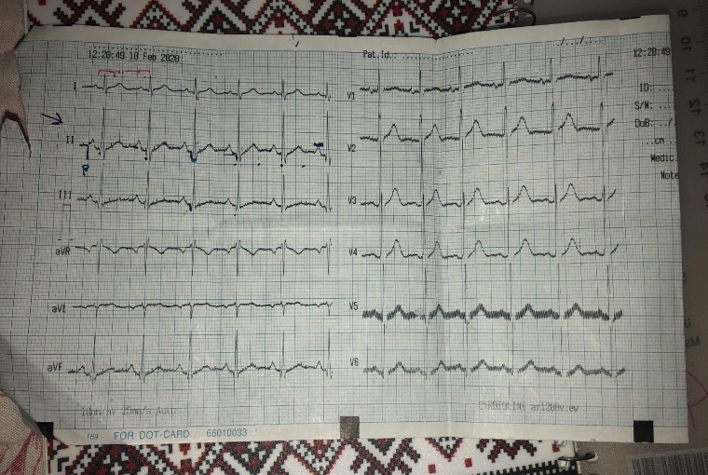

**Asmaa ECG**



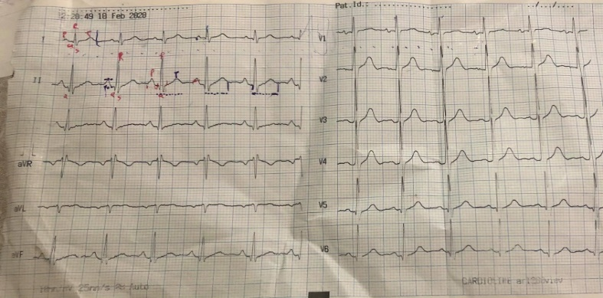

**Aya ECG**



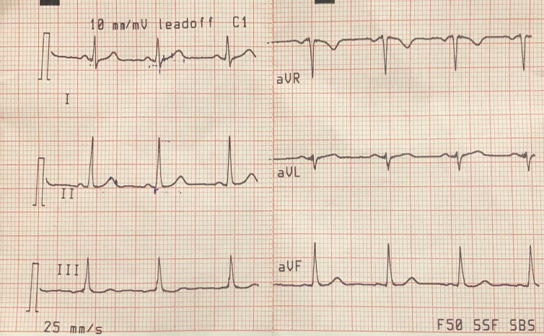

**Sara ECG**

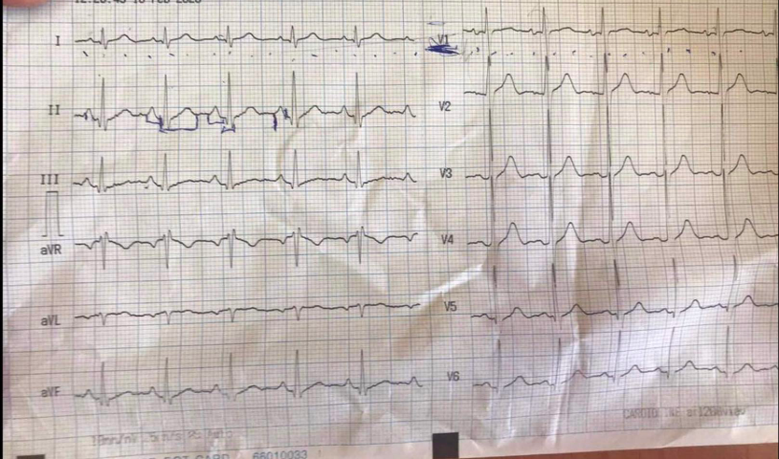

**Enas ECG**

**Conclusion.**

We learned through the experience of calculating the heartbeat and discovering it if it is natural or abnormal, and knowing the presence of diseases through the presence of a defect in the pace and rhythm of the heart, we enjoyed completing this experience, and it was one of the most beautiful experiences we have experienced in the field of nursing.

**References:-**

1. **The Book of Fundamentals (Heart Rate and Rhythm).**

**2- ECG paper.**

**3- Our Personal Opinions.**

**4 - The Book of Anatomy.**

**5- https://healthfully.com/91420-factors-affect-heart-rate.html**