First semester 2020/2021

Anatomy & Physiology - NURS142

**Report 1**

**ECG experiment**

Date submitted: 24/10/2020

Students: Wisam Nassar -1191985

Mais Abu Hamdan-1190859

Instructor: Dr. Rania Abu Hamdah

**Objectives:**

1- To refresh information regarding cardiac conduction activity.

2- To attach the ECG electrodes perfectly on their sites.

3- To avoid any environmental and social factors which can reflect changes in ECG like body position and metal materials attached to the body, stress and relaxing.

4- To analyze normal electrocardiography, the waves fissures, segments and intervals.

5- To measure different values from ECG chart like HR and rhythm thus determine some abnormalities like tachycardia, bradycardia and dysrhythmias.

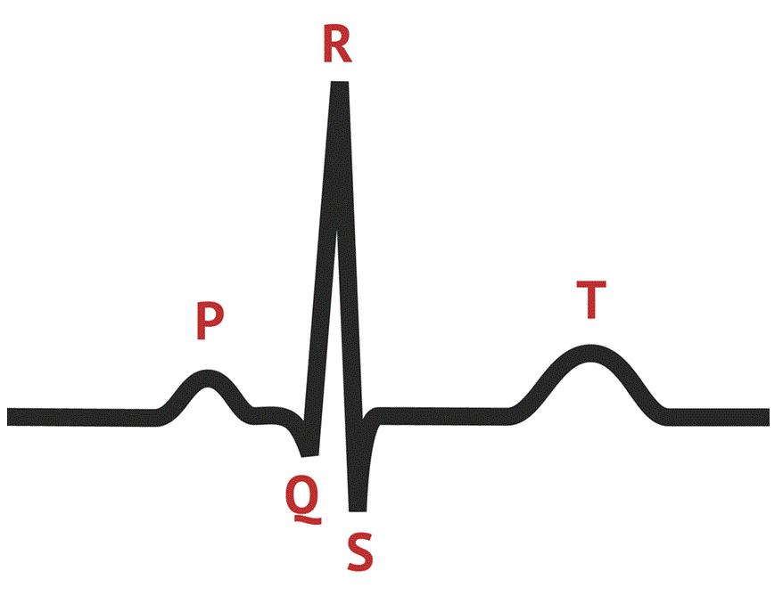**Introduction:**

Electrocardiography is a method used to assess conduction system of the heart from the base to apex, this system control the electrical activity of the heart thus causing contractions and relaxation of cardiac muscle. It’s primarily powered by an action potential initiates from a group of cells located in the upper part of the wall of right atrium forming a node called sinoatrial node acting as the anatomical pacemaker of the heart generating AP in normal rhythm 60-100 times/min; however, its responsible to distribute electrical signal through the walls of atria represented by P wave on ECG chart causing it to contract and another node located in the wall between right atrium and right ventricle called atrioventricularnode (AV), this node act as a wire between the SA node and conduction tract of ventricles, it transfers AP from SA node to bundles of his in the heart septum –represented by Q slope on ECG- and it also generate its own AP in rhythm of 40-60 times/min, then the conduction activity disturbs through bundles of Purkinje and this is reflected by QRS complex on ECG chart and finally the T wave reflects the repolarization of ventricles. Regarding the repolarization of atria, it occurs in the same time of a higher change in amplitude- QRS complex thus it’s not detected. ECG experiment teach us how to attach our bodies to the ECG device correctly, we used limb leads -bipolar leads- in a stand and sitting positions for all students and we analyze collected data and notice changes in our charts related to different factors. The experiment aims to teach us dealing with normal ECG regarding values and how to measure it.

|  |  |  |  |  |  |  |  |  |
| --- | --- | --- | --- | --- | --- | --- | --- | --- |
| **Team Data:** Name | RATE (beats/min) | regularity (Yes/No) | PR interval (sec) | QRS duration (sec) | RR interval (sec) | ST segment (sec) | QT interval (sec) | PR segment (sec) |
| #1 Wisam | 94 | yes | 0.16 | 0.076 | 0.64 | 0.09 | 0.32 | 0.06 |
| #2  Mais | 88 | yes | 0.12 | 0.07 | 0.68 | 0.14 | 0.38 | 0.05 |

|  |  |  |  |  |  |  |  |  |
| --- | --- | --- | --- | --- | --- | --- | --- | --- |
| **Volunteer data:** Position | RATE (beats/min) | regularity (Yes/No) | PR interval (sec) | QRS duration (sec) | RR interval (sec) | ST segment (sec) | QT interval (sec) | PR segment (sec) |
| Standing- figure (3) | 88 | yes | 0.12 | 0.08 | 0.68 | 0.12 | 0.32 | 0.14 |
| Supine – figure (4) | 65 | yes | 0.14 | 0.1 | 0.92 | 0.12 | 0.32 | 0.16 |

**Experimental data and results:**

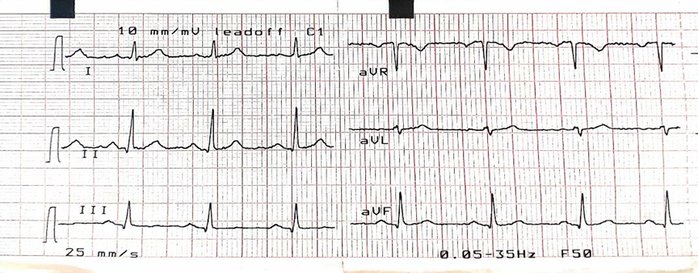

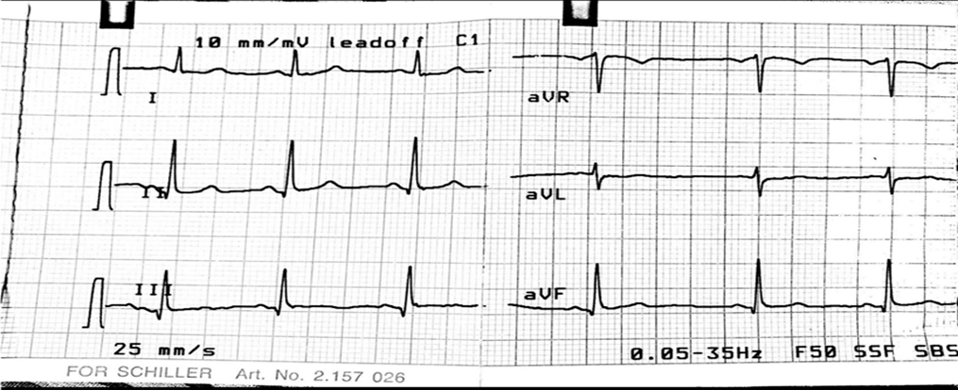 *Figure #1

*Figure #2

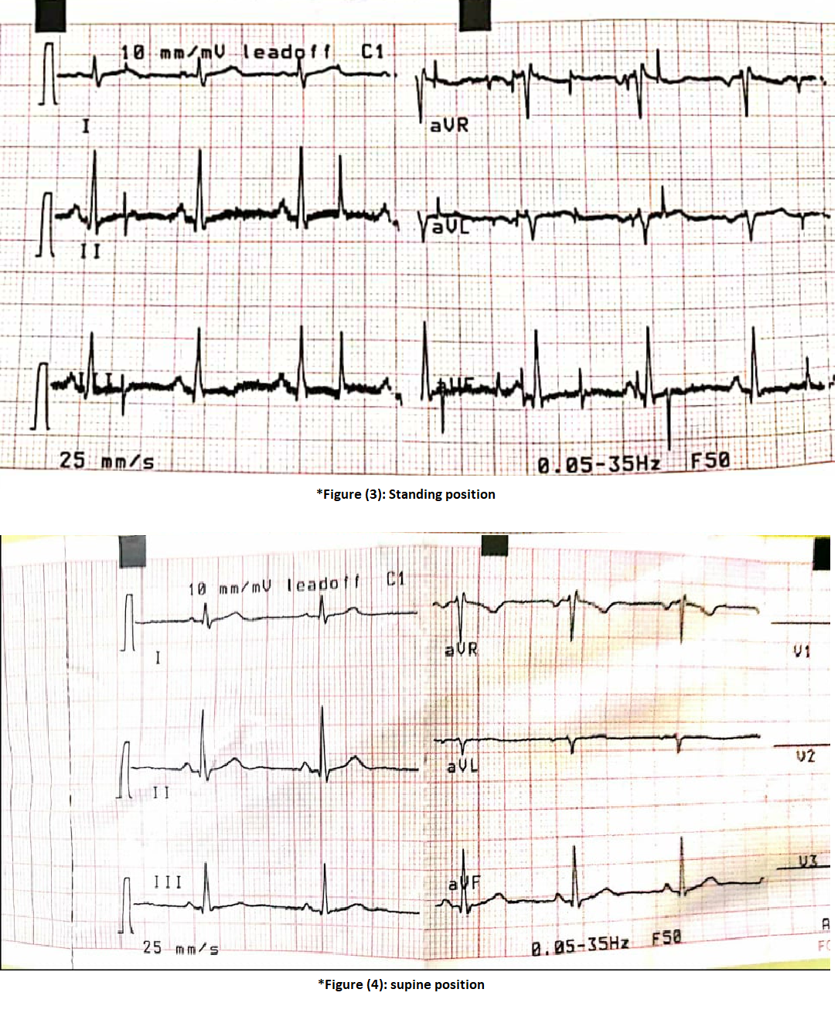

**Discussion:**

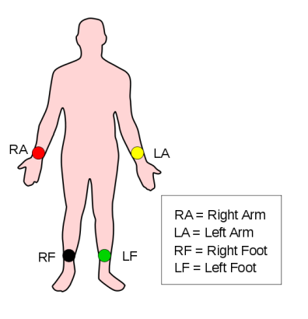We start by removing all of metal things attached to our bodies like belts, earrings and accessories because they can disturb electrical signal on the skin thus affecting ECG results. The experiment is done in both sitting and standing position. Lubricant jell is used on sensors of limb leads, to enhance the signal, then these leads attached in sequence of: red lead on the wrist of right limb, yellow lead on the wrist of left limb, green lead on 5cm above the ankle of left leg and black lead the same on the right leg. First we measured the ECG in supine position for all of the members, then, standing ECG is performed for a volunteer in supine position and another in standing position for 5 minutes.

**Normal findings in ECG:** HR: 60-100 regular, PR interval: 0.12-0.2 sec, QRS duration: 0.08-0.1 sec, RR interval: 0.6-1.2 sec, ST segment: 0.08-0.12, QT interval: > 0.44 in males and > 0.46 in females, PR segment: 0.05-0.12.

**Factors may affect the results:**

1. gender 5. cardiac diseases

2. emotion 6. Environmental factors

3. nutrition 7. Mental status

4. physical exercise 8. medications

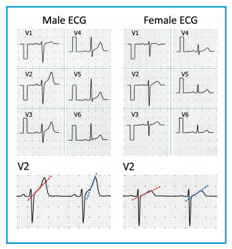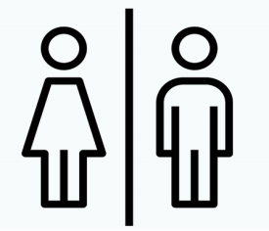Wisam is male and Mais is female. Based on normal values, all of results gained from ECG charts are normal, some of durations can be slightly delay or shrink due to low device accuracy. According to *gender related ECG changes*, normally, Mais has shorter PR interval and QRS complex, lower ECG amplitude, longer QT interval and ST segment.

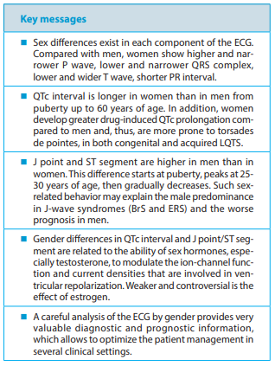

* Adapted from Gender differences in the 12-lead electrocardiogram: clinical implications and prospects Vincenzo Carbone1, Franco Guarnaccia1, Giovanni Carbone2, Giovanni Battista Zito1, Ugo Oliviero2, Silvia Soreca1, Francesca Carbone21, Outpatient Cardiology, Regional Associations Outpatient Cardiologists (A.R.C.A.); 2 Department of Translational Sciences, University “Federico II”, Naples, Italy. Received 28 august 2019; accepted 9 January 2020

Both of students were in the same mental and nutritional conditions as they are studying in the lab, both had eaten their breakfast, both are healthy and no one has any cardiovascular problems, no one smoke or perform physical exercise and both were silent, but Mais was lying for 30 min before measuring while Wisam was in light activity in the lab, this make the difference in their HR to be the least for Mais despite the normal difference represents higher HR for females compared to males.

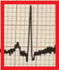The Position is also an important factor which can affect ECG, standing ECG values differ from supine position. it reflects increasing in HR, decreasing in PR interval, RR interval and QRS duration, slight change in ST segment and QT interval and shorter PR segment. These ECG changes are detected when these values compared with supine position. As we show, the heart rate increases in standing position because when the person stand up, the blood flow under the force of gravity into the lower extremities. Body response to this condition by vasoconstriction of peripheral blood vessels and increase heart rate to maintain blood flow into the heart and the brain, another factor contributing in this case is stress on the volunteer, he was shy.

A right QRS complex deviation is detected in standing position as a result of changing anatomical position of the body, expansion of the chest and dropping of the diaphragm.

Note: The waves in the standing position ECG chart aren’t impure because the volunteer was slightly moving his extremities until we alerted him.

**Conclusion:**

ECG is a critical and enjoyable cardiac assessment which help us to determine cardiac disorders, it’s like a mirror reflecting the cardiac situation behind the chest wall and represents the conduction system from the base to the apex of the heart thus know the problem and start treating it. Its affected by many factors which cause changes in heart rate and rhythm, duration of waves, amplitude or waveform, like gender which create differences between male and female ECG, and the position of the body which alter the anatomical position of the heart and blood flow and of course cardiac disease, also the condition in which the ECG is measured is also an important factor whether the stimulus is emotional or physical.

In this experiment we learn how to measure ECG segments and intervals, heart rate and amplitude and we build basic information about normal values thus gaining the ability to determine abnormal values in cases we face.

**References:**

**1. Gender differences in the 12-lead electrocardiogram: clinical implications and prospects – research article**

Vincenzo Carbone1, Franco Guarnaccia1, Giovanni Carbone2, Giovanni Battista Zito1, Ugo Oliviero2, Silvia Soreca1, Francesca Carbone21, Outpatient Cardiology, Regional Associations Outpatient Cardiologists (A.R.C.A.); 2 Department of Translational Sciences, University “Federico II”, Naples, Italy. Received 28 august 2019

accepted 9 January 2020

**2.** **Effect of Body Position on a Mobile, Vector-Derived, 12-Lead Electrocardiogram – research article**

Péter Kenedi1*, István Préda2,3, Jessica Thuer1, Ádám Székely2, Marcus Skribek2,3, David Triebl1, Athar Abu Helou1 and Markus Riemenschneider1

1 Personal *MedSystems* GmbH, Frankfurt, Germany

2 Department of Cardiology, Central Hospital of the Hungarian Defence Forces, Budapest, Hungary

3 Department of Cardiology and Cardiovascular Surgery, Semmelweis University, Budapest, Hungary *Corresponding Author: Péter Kenedi, Personal *MedSystems* GmbH, Frankfurt, Germany.

Received: July 18, 2018; Published: July 30, 2018

**3. Human Anatomy and Physiology, 9th edition**

Authors: Elaine N.Marieb, R.N., Ph.D.

Katja Hoehn, M.D., Ph.D.

**4.** **Anatomy and Physiology laboratory manual**

Author: Dr. Rania abu Hamdah