

**Adnan Abu Arqoub**

**1182551**

**Pulmonary Function Test**

**6/11/2019**

**Introduction :**

Breathing is a vital process that the body do to get the Oxygen demand for the nutrition of the body tissues, lungs has certain amount of air getting into it, leaving it and remaining in it. In this experiment these volumes will be taken analysed and discussed.

**Data Analysis :**

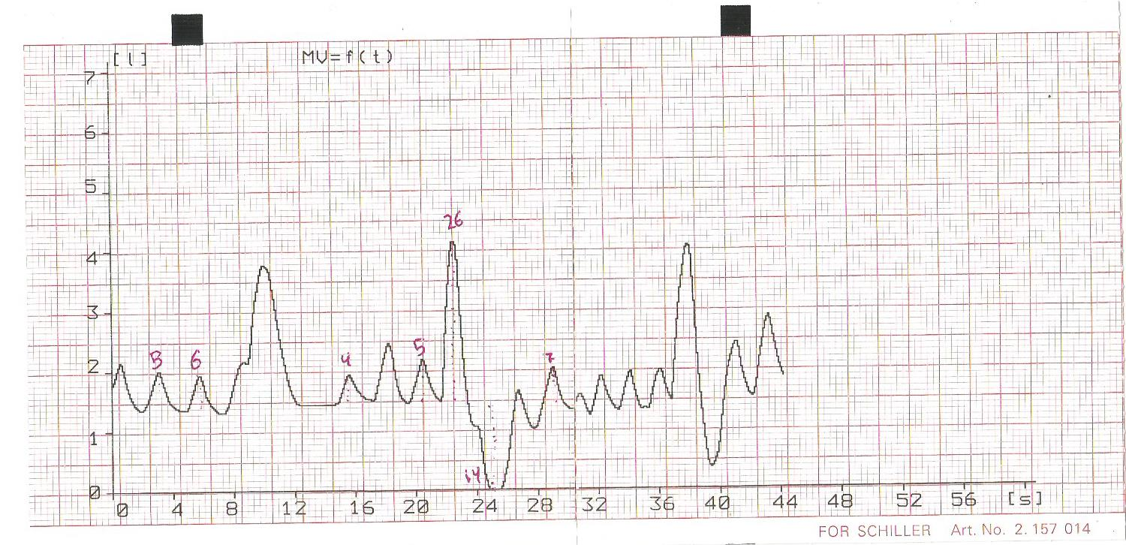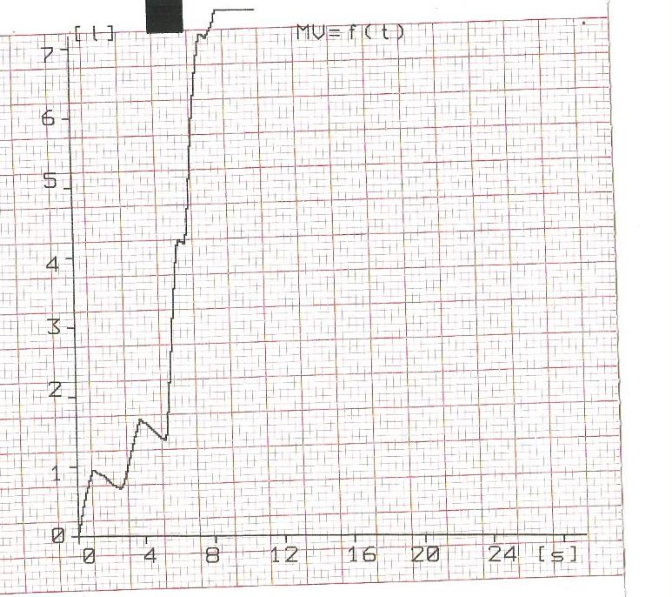

**Results :**

Figure 1 :

This figure shows the volume of (Tidal volume, inspiratory reserve volume, expiratory reserve volume, Vital capacity of the lung) In liters.

**Discussion :**

the previous results shows that the tidal volume (0.5 L), inspiratory reserve volume (2.6 L), expiratory reserve volume (1.4 L) and the vital capacity (4 L) , For a subject with a Body mass index (BMI) of 18. According to Principles of anatomy & physiology (2007), the normal range for tidal volume is (0.5 L), inspiratory reserve volume (3.1 L), expiratory reserve volume (1.2 L) and the vital capacity (4.8 L) In men , which make the results taken normal. In the article The effects of body mass index on lung volumes ( Jones RL 2006) States that the Body mass index does not affect the vital capacity of an individual (the study included subjects with BMI lower than 18.5 that had vital capacity ~3.02 L )which does not match the vital capacity of this subject.

In the asthma simulated experiment shows readings that are unusual from the obstructed air movement which show a low forced expiratory volume/ forced vital capacity (FEV1/FVC) ratio, normal (or even increased) total lung capacity, according to Interpretation of Pulmonary Function Tests (James Allan --).

**Conclusion :**

Pulmonary function tests are useful for all the volumes going in and out of the lung, and also useful for the diagnosis of different diseases like asthma and so like shown in this report,