First semester 2020/2021

Anatomy & Physiology -NURS142

**Report 3**

**Physiological parameters experiment**

**-Pulse, BP, T & RR-**

Date submitted: 14/11/2020

Students: Wisam Nassar -1191985

Instructor: Dr. Rania Abu Hamdah

**Objectives:**

1- To identify the digital instrument of the dinamap and interpret the readings on the screen

2- To measure vital signs manually (directly) and digitally (indirectly) including heart rate, blood pressure, temperature and respiratory rate.

3- To use sphygmomanometer and thermometer devices accurately and determine pulse sites.

4- To notice the environmental effect of temperature (hot and cold water), the change in body position, breath cessation and the position of the hand used in tests on vital signs.

**Introduction:**

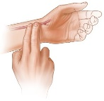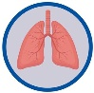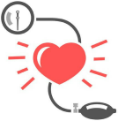Vital signs are group of physiological parameters that show the general situation of the body, they are the most important indicators about how well are the body essential functions. These vital signs include pulse which can measured directly on major arteries (temporal, carotid, apical, radial, ulnar, brachial, femoral, popliteal & posterior tibial and dorsalis pedis) or indirectly by using a monitor, arterial blood pressure using brachial artery in adult and femoral artery in children and infants, its measured invasively by sphygmomanometer device or a monitor (e.g: Dinamap) and invasively by a sensor (in ICU for e.g) and it consist of a lower value called “diastolic” represents arterial blood pressure during the stretch of heart ventricles –diastole- and a higher value called “systolic” represents arterial blood pressure during ventricular contraction –end of systole-. another parameters are respiration rate, it’s measured for an inspiration and an expiration as one breath by noticing chest respiratory movements, it gives a view about respiratory system situation, body temperature that reflects the state of metabolism activity in the body and inflammatory response against pathogens, its measured electronically, digitally or by mercurial thermometer in four common sites. Finally, oxygen saturation (SPO2) and Pain are also vital signs, first one is an indicator about oxygenation in our bodies thus determine respiratory system related diseases and the second one is the cause which encourage the patient to seek help so its highly taken into consideration and it helps in diagnosis and those two parameters are not part of this experiment. However, changes in these parameters indicate a change in body situation so they are used as a view of patients health status and a continuous assessment in critical cases and during operations. This experiment aims to learn us how to form the baseline of vital signs and to deal with device used for, and to interrupt changes of values in different situations as a part of homeostatic maintaining mechanism in our bodies.

|  |  |  |  |
| --- | --- | --- | --- |
| **Physiological parameter** | **Wisam** | **Batool** | **Shadeen** |
| I. Heart rate ( beat per min) |  |  |  |
| 1. Direct | 82 | 70 | 82 |
| 2. Indirect | 92 | 80 | 90 |
| Standing HR 5 mins | 100 | 80 | 90 |
| HR (cold) | 91 | 66 | 82 |
| HR (hot) | 95 | 69 | 84 |
| HR after breath cessation | 98 | 65 | 96 |
| HR (hand at the level of the heart) | 97 | 72 | 87 |
| HR (hand above the level of the heart) | 88 | 86 | 82 |
| II. Temperature |  |  |  |
| Oral | 37.8 | 36.6 | 36.6 |
| Axillary | 37.3 | 36.1 | 36.1 |
| Flexed Elbow | 36.6 | 35.1 | 35.1 |
| III. Respiratory Rate |  |  |  |
| Breaths per minute | 20 | 12 | 18 |
| Standing RR 5 mins | 18 | 20 | 12 |
| RR (cold) | 16 | 16 | 12 |
| RR (hot) | 18 | 14 | 20 |
| RR after breath cessation | 12 | 14 | 20 |
| RR (hand at the level of the heart) | 15 | 18 | 22 |
| RR (hand above the level of the heart) | 17 | 14 | 19 |
| IV. Blood pressure |  |  |  |
| Digital | 125/85 | 89/83 | 109/70 |
| Auscultatory method (Systole/ Diastole) | 127/83 | 100/85 | 115/75 |
| Standing BP 5 mins (Systole/ Diastole) | 130/81 | 108/60 | 147/83 |
| BP (cold) | 118/68 | 103/61 | 119/70 |
| BP (hot) | 109/60 | 105/59 | 111/65 |
| BP after breath cessation | 120/70 | 92/56 | 113/69 |
| BP (hand at the level of the heart) | 110/70 | 88/84 | 116/63 |
| BP (hand above the level of the heart) | 105/61 | 84/45 | 129/73 |

**Experimental data and results:**

**Discussion:**

**\*Normal findings of vital signs in adult:** HR: 60-100 bpm, T: 36.5-37.2 orally, RR: 12-20 and BP: systole (90-120) and diastole (60-80)

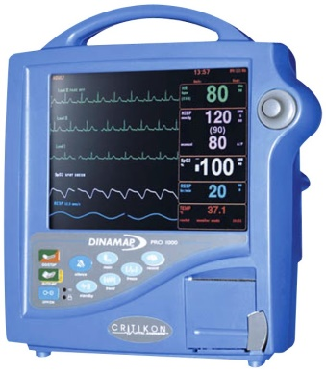We start by checking resting vital signs for all of the team members and forming a base line. Pulse for all of the team members (all are adults) by palpating radial artery directly by the tips of index and middle fingers while sitting, blood pressure manually using sphygmomanometer device, temperature using mercurial thermometer and all of the results fall in the normal range. Then, using dinamap, they are checked indirectly and all of the results are normal. A little elevation in HR is noticed for all the group’s members when we compare indirect HR with direct HR due to unavailability of dinamap after we did HR directly so we skip for another tests in another situations and make some efforts. BP was normal for all but it reflects a slight lowering for Batool, it’s not considered as abnormal specially she don’t complain any symptoms.

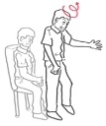In standing position for 5 mins, normally, heart rate is elevated compared to sitting position because when the body stand up, the blood flow increases to the lower extremities by gravity so the body response to this event by increasing heart rate to let the blood reach the brain sufficiently. This is clear for Wisam but for Shadeen and Batool it’s not because they were standing up for more than 20 mins while they were engrossing with lab works so no time to rest for a few and retest after standing for 5 mins but regarding indirect HR its measured after some efforts and stress so it reflects an elevation compared to manual BP in addition to lack of experience and need for practice.

BP and RR in standing position were measured in the same time. Normally, blood pressure is not supposed to be dropped otherwise it’s called postural hypotension and its associated with cardiovascular problems, medications, endocrine and neurologic problems. The results were normal with slightly elevation for Shadeen, she was mad because of long time lab and the amount of tasks we had to do.

Respiratory rate depends on the posture of the body so there is a change between RR in resting position and in standing. When the body is erected, metabolism rate increase in order to power the muscles in addition to postural change in lung capacity so slightly elevation in RR thus increase of ventilation is supposed to be detected, this is not such clear in the results because the respiration test are done in random way and not in the same sequence in the table.

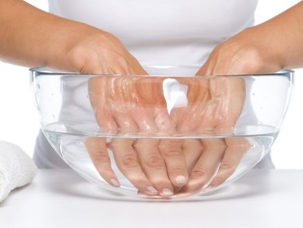We turn to measure heart rate, blood pressure and respiratory rate when putting hand in hot and in cold water for 15 mins after the *Standing 5 mins* tests are done. First using hot water, the results show an elevation in HR compared to the previous test because hot water cause vasodilation of peripheral blood vessels in a try to cool the body by increase blood flow out from the core of the body (to the skin) thus decrease blood pressure and cause increase in pulse to compensate the drop in blood pressure. the test with cold water is done directly next to hot, and the results show an opposite effect of hot water because cold water cause vasoconstriction of peripheral blood vessels to maintain the temperature of the core of the body so the blood pressure is increased due to increase of the resistance and heart rate return to pre normal values after a slight increase happened in first 1 min of immersion in a try to warm the hand. Regarding respiratory rate, putting hand in ice or in hot water does not affect respiratory rate because cold receptors in hands are tolerance to changes in body temperature thus less neural drive in triggered in the CNS from afferent nerves when compared to back region which contain many cold receptors with high sensitivity to cold.

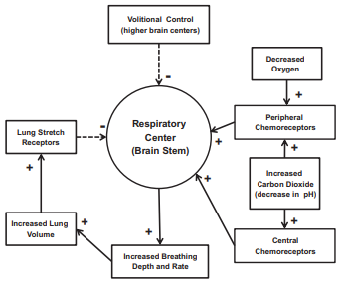Next was a cessation of breathing for 15 mins to determine the changes in BP, pulse and respiratory rate. Normally, the blood return from lower extremities upward to the heart under pressure gradient. After cessation, as the results show, there isa decrease in blood pressure and increase in heart rate because cessation of breathing cause a positive pressure in the chest which decrease venous return to the right side of the heart from lower limbs, decrease in CO which leads to decrease blood pressure determined by baroreceptors thus inhibit vagus nerve (parasympathetic activity on the heart) causing an increase in Heart rate to compensate the drop in BP. Regarding respiratory rate, chemoreceptors are stimulated by the elevated level of carbon dioxide and decreased level of oxygen in the blood due to reduced ventilation so an order from respiratory center in the brain stem is sent to increase respiratory rate and depth during rebreathing in order to reduce carbon dioxide level in the blood compared to resting respiratory rate for all members except Wisam because he was resting on a bed in the lab for 20 mins before measuring so he had calm breathing with healthy lungs (not a smoker), note: resting RR and RR after cessation are normal, they reflect a slight elevation may rationalized by destructions in the lab.

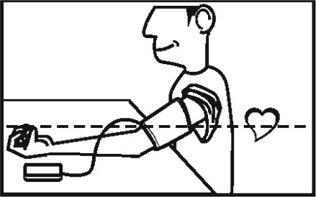Blood pressure, pulse and respiratory rate are measured in two arm positions: at the level of the heart and over the level of the heart. First, all the results for the three parameters are normal with arm at the level of the heart especially blood pressure which is more accurate while there is no effect of gravity on the blood flow through blood vessels, but blood pressure while the arm is over the level of the heart (underestimation) decreases because the heart pump the blood against the gravity thus reducing the vascular resistance due to slight decrease in blood flow in the arm while heart rate and respiratory rate are not affected by the position of the arm and they stay constant.

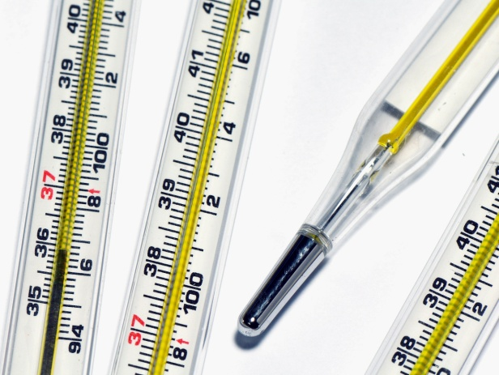Temperature measurement: Using mercurial thermometer, oral, axillary and flexed elbow temperature are measured. Oral results were normal for all the team members while they fall in 36.5c-37.2c except wisam’s because he was wearing heavy jacket. Oral measurement considered as a reference for axillary normal ranges by reducing 0.5 from lower and higher normal value so the normal range for axillary temperature is 36c-36.7c. As for flexed elbow, it’s not a common for measuring body temperature. It reflects a decrease when compared to axillary and oral but in the proportion for all members and this decrease attributed to less blood vessels in elbow region compared to oral and axillary.

Gender is a factor which affect heart rate, blood pressure and body temperature. Normally, females have resting heart rate higher than males but the results show the opposite because Wisam had walked slowly from the entrance of the university to the collage in the opposite side so his heart rate is elevated due to exercise. Regarding BP, normally, males’ blood pressure usually higher than females’ blood pressure. gender also has its effect on body temperature between male and female due to metabolic rate. Women have a lower metabolic rate compared to male so the heat produced in their bodies is less than males thus the average of females’ body temperature is less than the average of males’ body temperature and females have higher sensitivity to cold weather so they feel cool and need jackets in weather males feel it usual, this is clear in our results that Shadeen and Batool (females) have higher body temperature than Wisam (male) in the same weather and environmental conditions.

**Conclusion:**

Physiological parameters included in the experiment are vital signs which are under body self-control mechanism that aim to maintain body homeostasis and make the internal environment suitable for survival when changes affect body state like immersion of a part of the body –hand- in hot and cold water (thermal factor), body position and respiration situation which reflect several changes on vital signs based on their effect on blood vessels and the affect part of the body. Manually, the accuracy of measuring is developing by practice so for beginner its more accurate to measure vital signs digitally.

Our opinion regarding the experiment: It’s a very important aspect of science in Nursing to measure vital signs perfectly and being aware of factors which can affect these physiological parameters and what the hides behind of them of health problems or certain conditions obtained with further interpretation based on vital signs and from another aspect, it encourages our realizing of gender normal differences on these parameters. From the practical aspect, we spent a lot of time practicing on sphygmomanometer device to measure blood pressure manually and compare the results we got with dinamap results to check accuracy so it’s a good chance to improve our ability. It was a long experiment with many measurements done in groups so it reinforces team working and scientific discussion.

**References:**

**1. Harvard Health Publishing, Harvard Medical School, Trusted advice for a healthier life.** <https://www.health.harvard.edu/heart-health/is-swimming-in-cold-water-okay-for-my-heart>

**2. The National Center for Biotechnology** <https://www.ncbi.nlm.nih.gov/pmc/articles/PMC3521833/>

**3. Human Anatomy and Physiology, 9th edition**

Authors: Elaine N.Marieb, R.N., Ph.D.

Katja Hoehn, M.D., Ph.D.

**4. Anatomy and Physiology laboratory manual**

Author: Dr. Rania abu Hamdah

**5. The ins and outs of breath holding: simple demonstrations of complex respiratory physiology - Sourcebook of Laboratory Activities in Physiology**

Rachel J. Skow,1 Trevor A. Day,2 Jonathan E. Fuller,1 Christina D. Bruce,2 and Craig D. Steinback1 1 Faculty of Physical Education and Recreation, University of Alberta, Edmonton, Alberta, Canada; and 2 Faculty of Science and Technology, Mount Royal University, Calgary, Alberta, Canada Submitted 13 February 2015; accepted in final form 5 June 2015

Web address: https://journals.physiology.org/doi/pdf/10.1152/advan.00030.2015

**6. American physiological society:** Postural changes in respiration, [Elizabeth Brogdon Franseen](https://journals.physiology.org/doi/abs/10.1152/ajplegacy.1943.138.2.364?journalCode=ajplegacy) and [F. A. Hellebrandt](https://journals.physiology.org/doi/abs/10.1152/ajplegacy.1943.138.2.364?journalCode=ajplegacy)

<https://journals.physiology.org/doi/abs/10.1152/ajplegacy.1943.138.2.364?journalCode=ajplegacy>

**7. The respiratory and cardiovascular response to immersion in cold and warm water**. By W. R. KEATINGE and M. EVANS. From the Department of Experimental Medicine, University of Cambridge. <https://physoc.onlinelibrary.wiley.com/doi/pdf/10.1113/expphysiol.1961.sp001519>

**8. Fundamental of nursing tenth edition**

Kozier & Erb’s