

**Human Anatomy & Physiology2 -NURS142**

**Report 6**

**Reaction Time experiment**

**Group C:**

Yafa Abu Layya -1201212

Anfal Abu Zaida -1202663

Sabreen Maali -1200805

Ayat Abuzahra -1200538

Fatima Sumreen -1201624

**09/12/2021**

**Objectives:**

**1-** To discuss how the brain response to sensory stimuli (light, sound and touch).

**2-** To determine the relationship between eyes state (open or close) and the function of inner ear in achieving body equilibrium.

**3-** To test the fine of innervation on certain body skin parts.

**4-** to determine abnormal tests’ results and compare them with normal values.

**Introduction:**

The nervous system is the first controlling system of the body which control over all voluntary and involuntary body functions, it’s the most important system of the body thus anything affect it may be considered as life threatening. The core of nervous system is central nervous system which consist of brain and spinal cord, it consists of specific regions with specific controlling function in the body. The compliment to CNS is peripheral nervous system which consist of nerves innervating all the body (somatic and autonomic pathways), these nerves in somatic nervous system are classified into efferent (motor) and afferent (sensory) nerves.

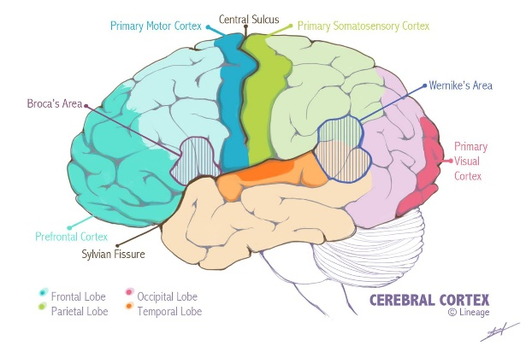In this place, we will discuss neural response to certain sensory effectors integrated in cortex layer of the brain which includes three functional parts: somatosensory area where the sensory impulses are received from sensory nerves, motor area where the motor instructions are sent through motor nerves and sensory association area where the analyzing of sensory information occur thus the type and shape of body response in motor association area is determined.

In this experiment, we measure how fast the nervous system receive, integrate and response to some sensations, how much our bodies can maintain equilibrium, and the patency of skin innervation.

**Experimental data and results:**

*Table1: The results of the experiment.*

|  |  |  |  |  |  |  |  |
| --- | --- | --- | --- | --- | --- | --- | --- |
| Students | Sensory reflex time  (seconds) | | | Vestibular reflex (seconds) | | Two points discriminations (cm) | |
| Light | Touch | Sound | seconds | | ventrally | Dorsally |
| Eyes opened | Eyes closed |
| Yafa | 0.19 | 0.6 | 0.22 | 45 | 8 | 1 | 1.5 |
| Anfal | 0.11 | 0.14 | 0.12 | 50 | 10 | 1.5 | 2 |
| Sabreen | 0.16 | 0.8 | 0.10 | 25 | 5 | 1 | 2 |
| Ayat | 0.18 | 0.6 | 0.22 | 46 | 7.4 | 1 | 2.5 |
| Fatima | 0.13 | 0.23 | 0.20 | 48 | 3 | 0.5 | 2 |

**Discussion:**

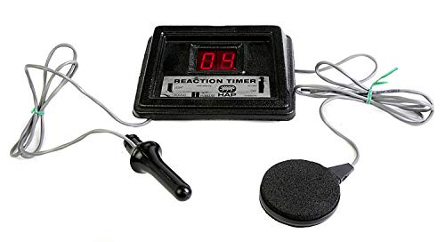We start the experiment with reaction time apparatus, the device which consist of a keypad, digital screen which count time of response, a settings button to change between type of stimuli (light or sound) and a control button to measure sensory reflex time which reflect how fast the nervous system response to: visual stimulus (light): one member of the team hold the control button behind of his/her body invisibly so the tested partner hold the keypad and supposed to response when seeing the light, audible stimulus that’s performed in the same way as visual but with sound stimulus and touch stimulus: same but the difference in this examination that the stimulus is manual (wooden sticks) on back of the tested partner so he/she can’t distinguish the time when the stimulus is triggered in anyway other than touch.

Sensory reflex time normal averages: Light: 0.20-0.25sec, touch: 0.15sec, Sound: 0.17sec. The data show that Yafa, Anfal, Sabreen, Ayat and Fatima sensory reflex time results are abnormal in sound reflex it show delaying in response due to distractions, whereas Yafa, Anfal, Sabreen, Ayat and Fatima results for light reflex show high response which reflects high focusing and less distractions, for touch examination, the stimulus was strong which caused pain so we were confused thus the result is abnormal.

In general, there are gender-based differences in responding to sensory stimuli between males and females which is described as males' response innately faster than females. In addition, the latency of the reaction timer also affects measurements.

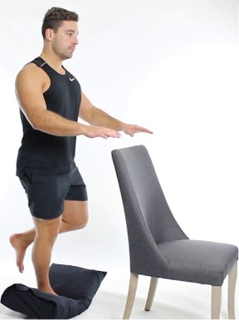Moving to vestibular test, a member from the team is standing with arms are slightly apart and stretched on the straighter in front of the body and a leg is flexed twice, once with open eyes and another with close eyes. This consideration takes place in equilibrium state of the body because vision supports the body balance by realizing the surroundings and helps in determining feet places, this shows why normal vestibular reflex is approximately 43 sec with open eyes in females and males whereas it's 8.5 sec with close eyes in female and 10.2 sec for males all age fall in 18-39. Fatima's result was abnormal because he hadn't had breakfast and he raised his leg more than what is supposed to, Ayat's results were abnormal because she was tired and long-time standing in the lab; however, there’s no correlation between women and men and balance but women are more likely to lose balance.

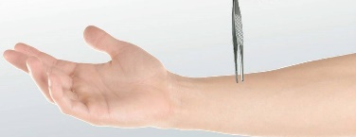Finally, two points discrimination test is done in this sequence: picking up 2 wooden sticks and stimulate the skin of forearm region dorsally and ventrally in shape of an open mouth tong, the wooden sticks are separated 10-15 degree to stimulate the skin and distance between them reduced gradually until the tested person feels them as one stick, then the distance between the sticks is the result of two points discrimination test.

Normal values of two points discrimination test are 1.6±1 cm dorsally and 1.56±0.9 cm ventrally. All results are normal for both of team members, but Fatima has 0.5cm ventrally which reflect slight dropping despite she doesn't have neural problems, perhaps she has more sensitivity.

**Conclusion:**

Sensory time reflex and 2 points discriminations are sensation tests that's used to determine neural response to sensory stimuli using body's sensations (eyes, ears and skin), thus the patency of innervation to receive signals, transport it into the CNS, and response to them through somatic motor nerves, whereas Vestibular test is a test of the ability of inner ear (vestibulocochlear nerve) to achieve balance of the body. These tests give idea about the peripheral neural system status and reception power of nerves of sensory organ of the body (eyes and ears) and determine the balance ability of the body.