

**Recording Of An Electrocardiogram**

**Adnan Abu Arqoub**

**1182551**

**Date : 23/10/2019**

**Introduction:**

The human heart beat at all times, contracting and relaxing at certain rhythms, these rhythms are controlled by the heart electrical system, using electrical impulses that travel a special pathway, in this experiment the electrocardiogram for one subject has been taken and will be shown.

**Data analysis** :

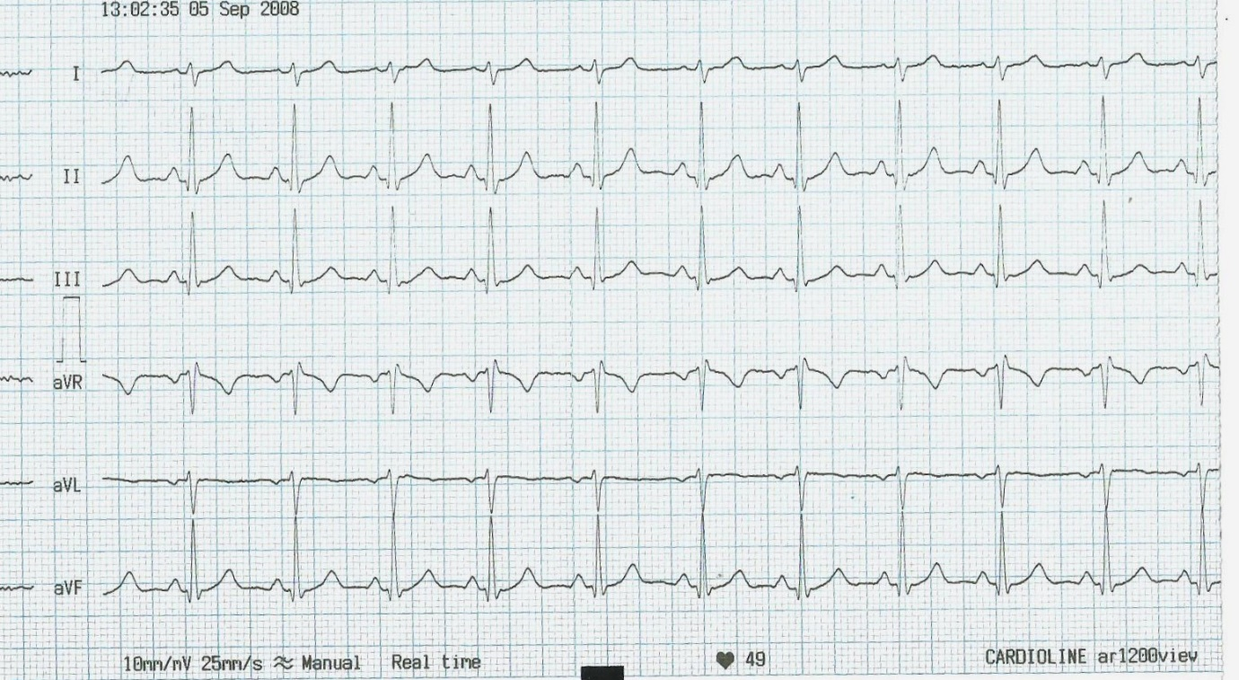

**Results**: The data is taken from the electrocardiogram lead II, four cardiac cycles has been measured .

Figure 1:

Each column represent the average of the electric potential for that group, ( each group is the average for four readings )

Figure 2:

This figure shows the time taken for each group to be completed (each group is the average of 4 readings )

**Discussion:**

## In the book of Clinical Methods: The History, Physical, and Laboratory Examinations. 3rd edition (1990) says the normal electric potential of P wave should not exceed (0.25 mV), The normal electric potential of R wave should be in the range of (0.5-2.7 mV), and the T wave should not exceed (0.5mV) these readings tell us that the data collected is in the normal range .

## In an article shared on the University of Nottingham (2016) says that the P-R interval should be between (0.12 - 0.20 Sec) The R-R interval should be between (0.6 - 1.2 Sec) The Q-T interval Should be between (0.35 – 0.43 Sec), And at last the QRS Should be between (0.08 – 0.12 Sec). these readings tell us that the data collected is in the normal range.

## Conclusion :

## All in all, the Electrocardiogram shows us how the cardiac cycle happens from and electrical view ( P wave, QRS wave, T wave),with every wave representing a stage in the cardiac cycle and it having a specific duration time and electrical potential.