

Human Anatomy and Physiology 2 LAB

NURS142 Section 2

Dr. Abdul-Salam Abdul-Ghani

**Testing Glucose Tolerance over Time and Saliva Production**

**Group B:**

Deema Abuasi 1202426

Aya Khattab 1203087

Noor Salih 1201651

Shadeen Halhooly 1192147

Ibraheem Ayyad 1202314

25/11/2021

*Introduction:*

Saliva is a liquid substance present in the mouths of animals and humans and is secreted by the salivary glands. Saliva facilitates the process of swallowing and sliding food through the esophagus. It works to moisten food and give it a doughy texture; Saliva also protects the internal surfaces that cover the wall of the mouth and prevents them from drying out, as the acidity and quantity of saliva varies from one person to another. The amount of saliva increases during the chewing process because saliva breaks down the materials before they enter the stomach. The PH of saliva varies when a person is chewing and when he is not chewing anything. There is a significant difference in saliva volume and PH values ​​before and after chewing anything.

Also, the blood sugar level is an important indicator of your health. You must know what the normal sugar level is and how to keep your blood sugar within those normal ranges. A fasting person has a generally lower sugar level than a person who has eaten. Since we do get most of our sugar intake from food, the more we eat the higher the sugar levels. In this experiment, we tested the body’s reaction to sugar from fasting to indulging large amounts of sugar, so we can see the body’s reaction.

*Objectives:*  
  
1. Know the difference of a fasting (8 hours) person’s blood sugar and a non-fasting person’s blood sugar.

2. Observe how the body reacts to sugar after fasting.

3. Discover the difference between the acidity and quantity of saliva in students.

4. Notice the differences of saliva volume and PH before and after chewing.

*Methods:*

**1-Glucose Test**

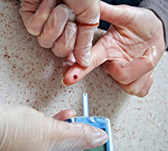You must first turn on the glucose meter (Glucometer) and insert the chip into the designated hole, after that you have to prick the tip of the finger with the special needle. Applying pressure on either side of the finger to enable blood to drain and accumulate at the tip of the finger. The blood drained should be placed on the measuring chip. The device displays the level of sugar in the blood within a few seconds. After the examination is completed, place a piece of cotton on the puncture site to stop the bleeding and absorb the rest of it.

**2- Saliva Tests:**

1. Keep mouth open for five minutes without moving your mouth or swallowing saliva, then spit out the saliva into a collecting tube.
2. Chew for five minutes, and then spit the saliva into a collecting tube.
3. Chew Parafilm for five minutes, and the spit the saliva into a collecting tube.
4. 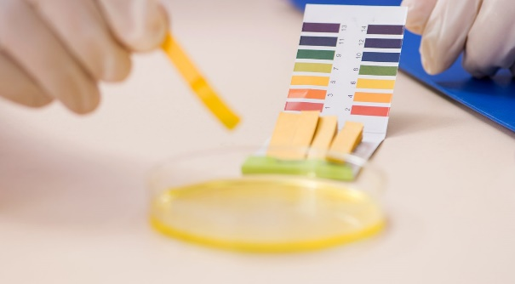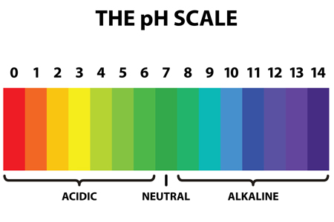A colorimeter can be used to measure the PH of saliva. A vial is filled with saliva and a reagent is added to produce a pH-dependent color change. The color is compared with a chart or standard to determine the pH value.

*Results:*

**Table#1:**

**Saliva volumes and pHs with the mouth at rest, chewing, and chewing parafilm.**

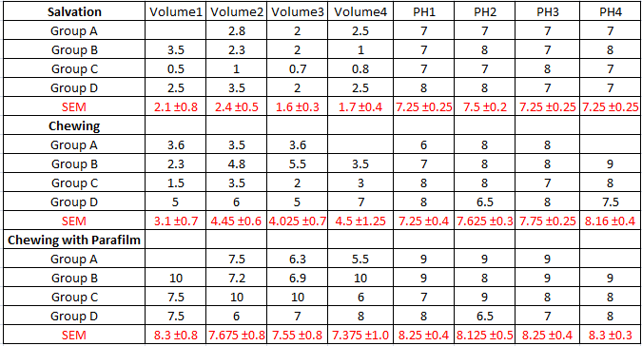

**Table#2:**

**Glucose toleration after fasting:**

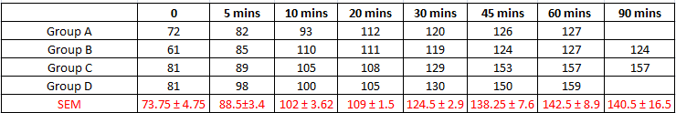

**Graph#1:**

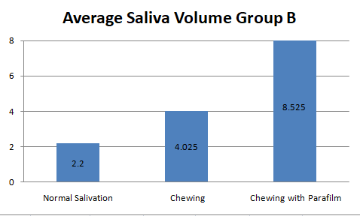**Average Saliva Volume for Group B:**

**Graph#2:**

**Glucose Tolerance over time for Group B:**

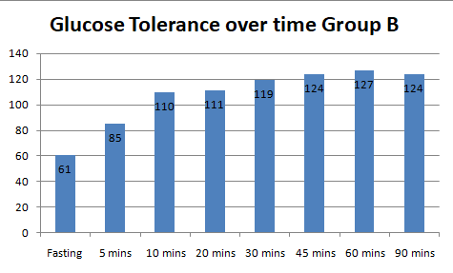

*Discussion:*

In this laboratory, we did two experiments; the first was the glucose tolerance test to check the speed of glucose entering the blood or to detect diabetes. To do this test, Deema fasted for 12 hours before the experiment. She then measured the glucose in the blood, and it was found within the normal range (60-105 mg/dl). The test was repeated multiple times after she drank a glass of water containing 10 spoons of sugar, and the tests lasted for an hour and a half. The results showed that sugar does not enter the blood all at once, but rather until it returns to its normal rate in the blood.

As for the saliva experiment, it consisted of three stages: the first stage was to open the mouth for 5 minutes without moving it. The result of the whole team was within the normal range (1.4-2ml/5min), except for Ibrahim, whose result was slightly higher than the normal range, and this could be due to him thinking about food. The pH was within the normal range as well (6.8-7.6) except for Noor and Aya; it was slightly higher than the normal range probably because they ate before the experiment.

In the second stage, the values ​​increased for the whole group and this is due to the stimulation of the salivary glands by the chewing process, except for Ibrahim, whose value was less than when there was no chewing process. The reason is because he swallowed some saliva. As for the pH, we noticed a slight increase due to the stimulation of the salivary glands.

In the last stage, which is to stimulate the chewing process with parafilm, the results showed a noticeable increase in the amount of saliva, and this is due to the presence of a strong stimulus. This indicates that there were no problems with the team, and also the pH increased, as the mouth became alkaline.

*Conclusion:*  
  
    The results showed that the more time passed for the fasting person who drank water with 10 spoons of sugar, the higher the blood glucose level rose to a certain limit (no more than 180 for a normal person), and the higher the blood glucose level, the more the body stimulates the secretion of insulin, so it can move the glucose from the blood and into the cells. The results of the saliva experiment revealed several stimuli for its secretion, where the difference was in the amount of saliva secretion, the rate, and acidity of saliva (normal saliva acidity ranged between 6.2 - 7.6), where the collection by opening the mouth (our results- V=2L, pH 7.4) was less than by chewing (V=3.6,Ph 7.6). And chewing without anything the rate was less than chewing a piece of paper (V=7.7,Ph 8.2). This may be due to the person himself or the possibility of swallowing saliva (where there must be an error) or according to the strength of the stimulus, and the difference in acidity may be due to the type of food or the amount of bacteria inside the mouth or for other reasons.