

**NURS 142 section 3.**

**Name of the experiment : Basic Physiological Parameters .**

**- Asmaa Mousa 1192471 .**

**- Aya Arouri 1191397 .**

**- Sara Saleh 1192125 .**

**Objectives:**

Knowledge of vital signs in normal conditions and the ability to know some things that may affect these indicators and change their values ​​and compare them with normal values .

**Introduction :**

The vital processes (body temperature, pulse rate, blood pressure, and respiratory rate) are medical physiological measurements in order to assess general physical health, include evidence of diseases or symptoms associated with diseases, and check on the functioning of the physiological functions, it is possible to increase or decrease the values ​​based on several Factors including age, location of measurement, effort, and many others.

In this experiment we calculated (body temperature, respiratory rate, blood pressure and pulse) in the normal position, and calculated them under the influence of several things (after placing the hands in cold water, warm water, the hand at the level of the heart, above the level of the heart ...) We used some devices in this experiment, including the sphegnamanometer, dinamap hand watch, thermometer ...

The purpose of the experiment was to know if there is a difference in the different positions that were measured in it and whether the original value that was measured in the normal situation will be affected with the values ​​after these positions, and to know the reasons for the difference in the values ​​in the event that the value is increased or decreased from the original value.

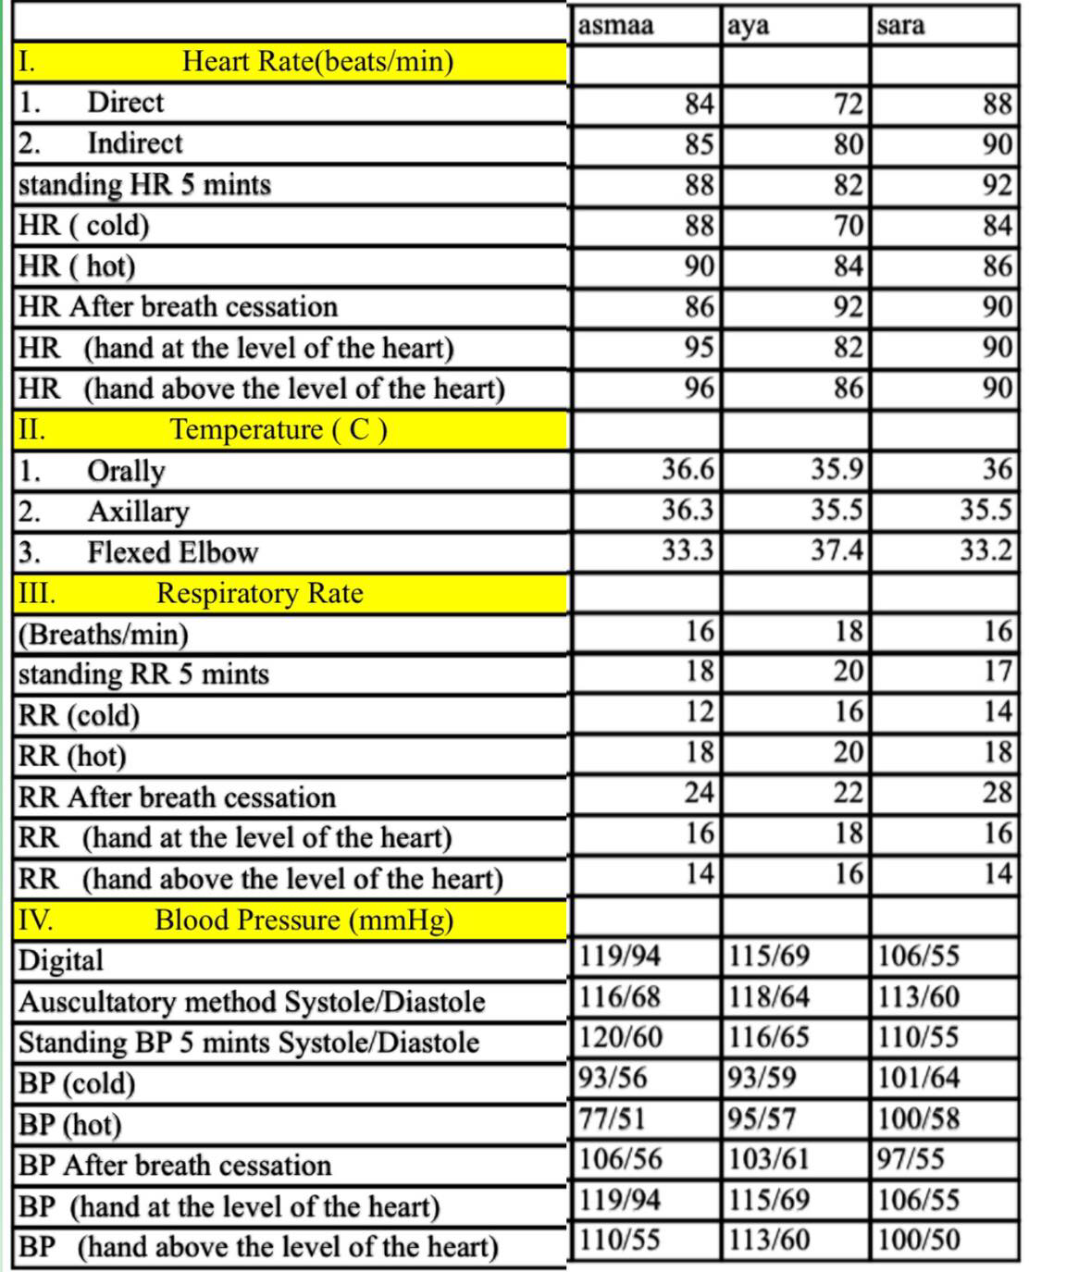**Experiment data and Results .**

**Discussion :**

**1-(HR)** \How to conduct an experiment with comparison.

Pulse (direct)

Each person checked the pulse of another person by placing two fingers on the radial artery with the clock timing (one minute) and everyone had a normal pulse during one minute (60_100) beats every minute

Either check the pulse (indirect)

It was through the Dynamab device, where it senses the person’s pulse within a minute by placing the finger inside the device and then measures the person’s pulse and the percentage of oxygen saturation and the pulse was within normal limits (60_100) beats per minute .

In the same way, we measured the heartbeat of each person in the group after exposure to several conditions, namely standing for 5 minutes, placing the hand in cold water (low temperature), placing the hand in hot water (high temperature), raising the hand above the level of the heart and at the level of the heart .

When standing for five minutes, we noticed that the pulse readings were still within the normal limits, but they increased by a little more than the reading of the pulse device (dynamab) due to stress and change of position and this is normal because the pulse will return to its normal position within two seconds unless there is an imbalance of the heart or thyroid activity .

When placing the hand in cold water, an increase in the heart rate should be noted as a result of activation of the sympathetic nervous system, contraction of the artery, a decrease in the amount of blood reaching the extremities and a decrease in the amount of blood loaded with oxygen, the heart rate increases, normal values ​​(names) where the pulse rises, As for the values ​​of (Sarah, Aya) and it is possible because the hand does not stay for a longer time in cold water and the feeling of cold and low temperature, or a defect in the device, or a defect in the experience, or the feeling of the internal heat prior to disease .

When placing the hand in hot water, an increase in the heart rate is also supposed, because when the environment is hot, the body needs to lose its temperature to balance with the internal and external temperature, even with the increase in the heart rate, the values ​​of (any and names) increase, and this is normal, as for (Sarah) its value is not Natural and the reasons may be as I mentioned earlier

But when breathing is blocked, it is also normal for an increase in the heart rate, because the body needs to compensate for the lost oxygen, so the heartbeat increases to increase the amount of blood arriving and carrying oxygen. Correctly holding the breath, or the different duration of breathing stops for each person, or laughing and lack of focus .

When we placed our hand at the level of the surface of the heart and examined the heartbeat, the values ​​should remain the same, Sarah's value remained the same (90), as for each and every Asma, their value increased, it may have increased as a result of making a slight effort before performing the heartbeat test , The time between the first examination of the heartbeat (in the normal position) and the examination (when the hand was at the level of the heart), and the previous checks in between (the hand in hot and cold water, breath cessation . Breathe and stand for 5 min). In this situation, or it could be that the cause was the person in a state of fear or tension.

Anemia, hyperthyroidism, diabetes, and heart rhythm disturbances can all affect.

When we placed our hand on the level of the surface of the heart and examined the heart rate, the values ​​are supposed to be higher than the value at rest, all values ​​were normal

Anemia, hyperthyroidism, low fluid intake in the body, diabetes, and heart rhythm disturbances can all affect.

**2-Temp**\(Celsius)

We first calculated the temperature with a thermometer from several locations

**First** by orally : We put the thermometer in the mouth area, the normal is 36.5-37,We found the values ​​Asmaa (36.6) Aya (35.9) Sarah (36)

Asmaa was a natural value as for Sarah, and she was not that accurate, but was slightly less as a result of either drinking or eating cold food, or a hormonal change on that day, such as the date of ovulation that occurred on that day, or it could be a result of being affected by the cold air temperature.

**The second** region from which the value was calculated is the axillary. We placed the thermometer in the axilla region and waited for the thermometer to sound indicate of ending. Normally the result would be (36-36.5).

The results were as follows: Asma (36.3), Aya (35.5), Sarah (35.5)

It was the result of Asmaa normal, but any less than normal as a result of sweating, for example, or the temperature of the cold weather, or as a result of a person feeling cold or as a result of cold drinking or eating cold food .

The result may be more than normal as a result of sweating, for example, or the temperature of a hot air, or as a result of the person feeling hotor or as a result of hot drinking or hot food.

**The thired** region from which the value was calculated is the flixed elbow. We placed the thermometer in the flixed elbow, after we bend the hand, and waited for the thermometer to sound to indicate the end. There is no normal common rate but it can be estimated over 35

The results were as follows: Asmaa (33.3), Aya (37.4), Sarah (33.3)

It was a natural result, but Asmaa and Sarah are less than normal, as a result of sweating, for example, or the temperature of the cold weather, or as a result of a person feeling cold or eating cold food or drinking a cold drink.

And the result is abnormal as a result of sweating, for example, the temperature of a hot or cold atmosphere, or the result of a person feeling hot or cold, or as a result of drinking or eating cold or hot food.

Note: We sterilized the thermometer with alcohol when moving in all measured areas, and when switching it between us

**3- (Respiratory Rate)**\How to conduct an experiment (respiratory rate), we calculated the respiration rate for each of us in one minute (we calculated it on the phone watch) and the values ​​of all groups were normal, the normal rate of breathing 12-20 breaths per minute , Factors that may affect the respiratory rate: respiratory diseases such as asthma, ventilation, exertion, blood pressure, weather (cold, hot), psychological .

Then we stood for five minutes, then we calculated the breathing rate again for a minute (by wristwatch), and we noticed that each of us had an increased respiration rate (1-2 degrees) from the values ​​we had calculated normal.

Normal position after standing for 5 minutes. Increased respiratory rate , The reason for the change in respiratory rate (increase) was the change in position and exertion , Among the factors that may lead to abnormal values: It is possible that the breathing rate is not calculated correctly the first time. When the attempt is repeated, the individual will relax, and there will be no increase in values ,and If the individual notices that I am calculating their breathing rate then the correct values ​​will not appear .

Each person puts their hand in a bowl full of ice (according to their ability) and then we calculated the respiratory rate using Dynamap, the normal position is that the respiratory rate should decrease, the values ​​of all group members were normal (all the respiratory rate values ​​decreased after we put our hands in an ice container ) , It is normal for the respiratory rate to decrease, and the reason for this is that when feeling cold, the arteries narrow, and thus the blood that reaches the extremities decreases (and this blood is loaded with oxygen), and the respiratory rate decreases, among the factors that may affect the respiratory rate are the patient’s attention when calculating the respiratory rate, that the person does not place his hand sufficiently in the ice container, and the delay in calculating the respiratory rate after removing his hand from the vessel.

In the experiment of calculating the respiratory rate when placing his hand in a hot bowl: the individual puts his hand in a hot bowl and then we directly calculate the respiratory rate using the dynamo, the values ​​of the group members were normal (all their values ​​increased when placing their hands in a hot bowl), the normal situation is high values Respiratory rate, and the reason for this is that the arteries expand at high temperatures, which leads to an increase in the rate of blood flow to the extremities (this blood is loaded with oxygen), which leads to an increase in the rate of respiration.

Among the factors that may affect the respiratory rate when placing the hand in a hot container, the hand is not placed enough in the container, and the respiratory rate is not calculated immediately after the hand comes out of the container.

When breathing is suppressed, the respiratory rate is supposed to increase in order to compensate for the amount of oxygen that did not enter the body, so the person increases his breathing involuntarily, the values ​​of (Asmaa, Sarah, Aya) were normal, but among the factors that may affect and lead to a decrease in the respiratory rate Too short or impaired respiratory system, inability to take in sufficient oxygen, or feeling tired .

We examined the heart rate and the hand at the level of the heart, we checked the respiratory rate by means of a DynMap, and it is assumed, in comparison with the normal position, that the rate of breathing and the hand at the level of the heart surface equals the rate of breathing in the normal position (the resting position)

For the whole group, the rate was normal. The values ​​may be abnormal in the case of: asthma, mild exertion of a person that greatly affects his breathing, heart problems, obesity and other influencing factors.

While examining the heart rate and the hand above the level of the heart, we examined the respiratory rate by means of a DynMap, and it is assumed compared to the normal position of the individual that the rate of breathing and the hand at the level of the heart surface is more than the respiratory rate (increases) in the normal position (the resting position) as a result of light exertion ,

In all of the group, the rate was abnormal as the respiratory rate decreased. The values ​​may be abnormal for reasons: poor judgment, The time between the first examination of the respiratory rate (in the normal position) and the examination (when the hand is at the level of the heart), and the previous examinations between them (the hand in hot and cold water, respiratory arrest. Standing for 5 minutes) and among the factors that may generally affect the rate of breathing are some diseases Such as asthma, respiratory disease and heart disease .

**4- BP :**

We measured BP for each of us using DynMap and the results of all members of the group were normal, as the normal range for BP is 100-120 / 60-80, and there are some factors that may affect BP such as some diseases, age, stress, smoking, alcohol. Eat salt a lot .

We measured the BP of each of us using auscultatory, we heard the first pulse and the last pulse and knew the BP of each of us, and the results of all members of the group were normal, as the normal range of BP is 100-120 / 60-80, and there are some factors that may affect BP such as some diseases, age, stress, smoking, alcohol, excessive salt intake .

We measured the BP of each individual in the group with DynMap after standing for 5 min. The normal situation after standing for a certain period of time increased BP, and the values ​​of all group members increased, and this is normal due to standing for 5 min.

Affected by the same factors that were mentioned previously .

We each put our hand in an ice (cold) container and then immediately we calculated BP using Dynamap, the normal situation is that all values ​​go down, and the values ​​of all group members were normal because they decreased, and the reason for that decrease in blood pressure after placing the hand in an ice container is that the arteries will shrink due to Cold and thus the pressure drops, Affected by the same factors that were mentioned previously , In addition, the values ​​may not change because the hand is not sufficiently placed in the cold container, or the pressure is not calculated immediately after the hand is removed from the container.

We measured BP when placing the hand in a hot bowl, then removing the hand from the bowl and calculating BP directly via the dynamo. The normal situation is for the values ​​to rise due to the dilation of the blood vessels (due to heat) leading to increased blood flow and increased blood pressure, the values ​​at aya & sara were increased BP (for the cold bowl experiment in which BP decreased, because the two trials were consecutive) And, this is normal, as for Asma, the pressure has decreased, and the reason may be a mistake in the measurement or not having enough time to put the hand in hot water, the factors that affect blood pressure have been mentioned previously.

We calculated BP after breath cassation by means of dynamap. The normal state of BP is the increase, because the body wants to compensation the oxygen, so the circulation of blood increases, so the BP increases. . The factors affecting pressure were previously mentioned.

We calculated BP when the hand was at the level of the heart by the dynamap, and the values ​​were normal and did not change, because the hand was in a resting position without any activity or effort.

We calculated blood pressure when the hand was above the heart level in the dynamo. The normal situation is for the pressure to increase because when the hand is above the level of the heart it exerts little effort, but the values ​​of the group members decrease slightly (2-4 degrees). One of the possible reasons for the fact that values ​​are low is wrong taking.

The factors affecting pressure were previously mentioned.

**Conclusion.**

In the calculation of the values ​​of vital signs, it has been shown that each sign may change its value when performing different positions in addition to the influencing factors (cold or hot weather, tension ...) in each of the normal values, the group concluded that the vital signs are not fixed It can change according to several factors and several situations .

**References:-**

1. **The Book of Fundamentals**

**2- https://www.hopkinsmedicine.org/health/conditions-and-diseases/vital-signs-body-temperature-pulse-rate-respiration-rate-blood-pressur**

**3- Our Personal Opinions.**

**4 - The Book of Anatomy.**

The end .