

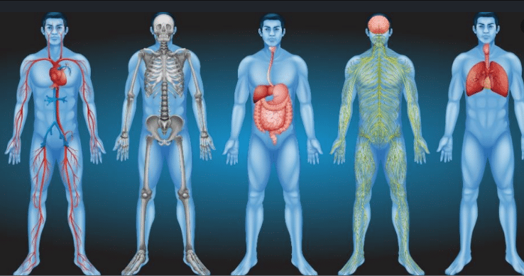Faculty of Nursing, Pharmacy& allied Health Sciences  
LAB 1: Anatomy of the body  
doctor's name: Abdul Salam Abdul Ghani  
Student name:   
Ayat Abu Zahra 1200538  
Yafa Abu Layya 1201212  
Sabreen Maali 1200805  
Fatima Yousef 1201624  
Anfal Faqeeh 1202663

7/10/2021 ☺

Anatomy of the body:  
The human body is a biological machine made of body systems; groups of organs that work together to produce and sustain life.  
In the anatomy lab, we got acquainted with many body systems, including them:  
\***Digestive System**

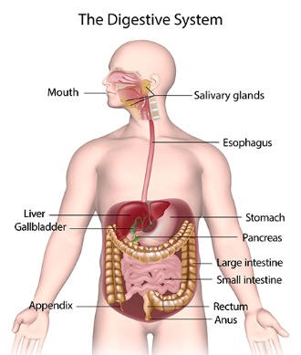The digestive system is a group of organs working together to convert food into energy and basic nutrients to feed the entire body. Food passes through a long tube inside the body known as the alimentary canal or the gastrointestinal tract (GI tract).  
The organs are digestive system:  
1_ **Mouth**

Food begins its journey through the digestive   
system in the mouth, also known as the oral   
cavity. Inside the mouth are many accessory   
organs that aid in the digestion of food—the   
tongue, teeth, and salivary glands. Teeth   
chop food into small pieces, which are   
moistened by saliva before the tongue and   
other muscles push the food into the pharynx.  
  
2_ **Pharynx**The pharynx, is a funnel-shaped tube

connected to the posterior end of the mouth.   
The pharynx is responsible for the passing of   
masses of chewed food from themouth to the   
esophagus.  
  
3_ **Esophagus**

The esophagus is a muscular tube connecting the pharynx to the stomach that is part of the upper gastrointestinal tract. It carries swallowed masses of chewed food along its length.  
  
   
  
  
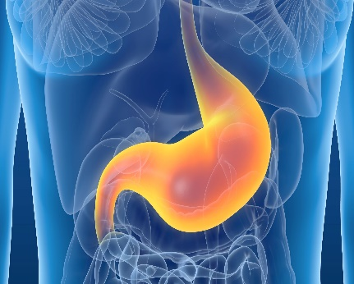4_ **Stomach**The stomach is a muscular sac that is located on the left side of the abdominal cavity, just inferior to the diaphragm. In an average person. This major organ acts as a storage tank for food.  
  
5_ **Small Intestine**

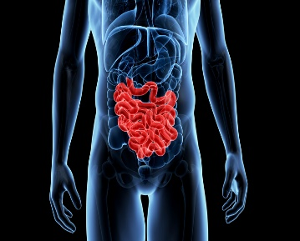The small intestine is a long, thin tube about 1 inch in diameter and is part of the lower gastrointestinal tract. It is located just inferior to the stomach and takes up most of the space in the abdominal cavity. The entire small intestine is coiled like a hose and the inside surface is full of many ridges and folds. These folds are used to maximize the digestion of food and absorption of nutrients.   
  
  
  
6_ **Liver and Gallbladder**

The liver is a roughly triangular accessory organ of the digestive system located to the right of the stomach, just inferior to the diaphragm and superior to the small intestine. The gallbladder is a small, pear-shaped organ located just posterior to the liver. The gallbladder is used to store and recycle excess bile from the small intestine so that it can be reused for the digestion of subsequent meals.  
  
7_ **Pancreas**

The pancreas is a large gland located just inferior and posterior to the stomach. The pancreas secretes digestive enzymes into the small intestine to complete the chemical digestion of foods.  
  
8_ **Large Intestine**

The large intestine is a long, thick tube about 2.5 inches in diameter. It is located just inferior to the stomach and wraps around the superior and lateral border of the small intestine. The large intestine absorbs water and contains many symbiotic bacteria that aid in the breaking down of wastes to extract some small amounts of nutrients. Feces in the large intestine exit the body through the anal canal.

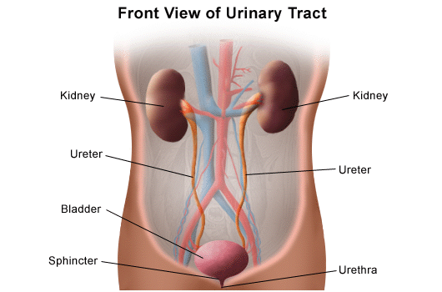*Renal System  
The urinary system's function is to filter blood and create urine as a waste by-product. The organs of the urinary system include the kidneys, renal pelvis, ureters, bladder and urethra.

**1_Two kidneys**: This pair of purplish-brown organs is located below the ribs toward the middle of the back. Their function is to:

* Remove waste products and medicines from the body
* Balance the body's fluids
* Balance a variety of electrolytes
* Release hormones to control blood pressure
* Release a hormone to control red blood cell production
* 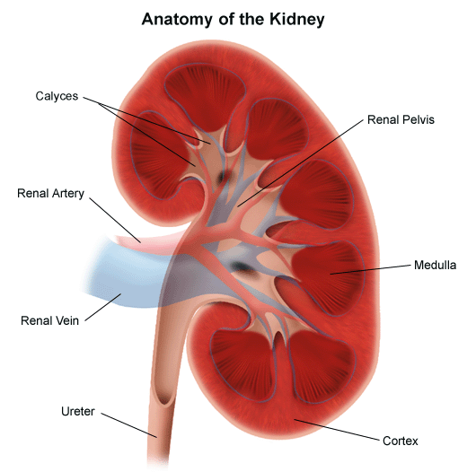Help with bone health by controlling calcium and phosphorus

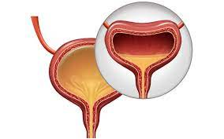**2_ Two ureters**: These narrow tubes carry urine from the kidneys to the bladder. Muscles in the ureter walls keep tightening and relaxing. This forces urine downward, away from the kidneys. If urine backs up, or is allowed to stand still.  
  
**3_ Bladder**: This triangle-shaped, hollow organ is located in the lower belly. It is held in place by ligaments that are attached to other organs and the pelvic bones. The bladder's walls relax and expand to store urine. They contract and flatten to empty urine through the urethra.  
  
  
  
  
  
  
  
  
  
  
  
 **4_ Two sphincter muscles**. These circular muscles help keep urine from leaking by closing tightly like a rubber band around the opening of the bladder.  
  
**5_ Nerves in the bladder**: The nerves alert a person when it is time to urinate, or empty the bladder.  
  
**6_ Urethra**: This tube allows urine to pass outside the body. The brain signals the bladder muscles to tighten. This squeezes urine out of the bladder. At the same time, the brain signals the sphincter muscles to relax to let urine exit the bladder through the urethra. When all the signals happen in the correct order, normal urination happens.

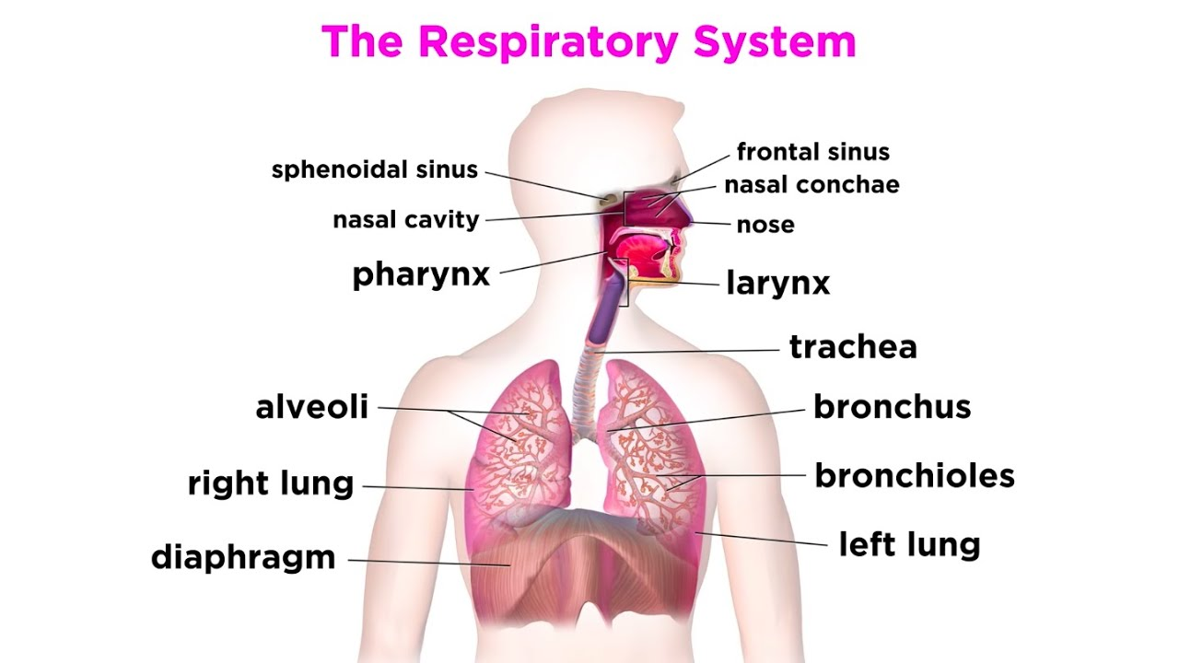* Respiratory System:  
Your respiratory system is the network of organs and tissues that help you breathe. This system helps your body absorb oxygen from the air so your organs can work. It also cleans waste gases, such as carbon dioxide, from your blood.

The respiratory system has many different parts that work together to help you breathe. Each group of parts has many separate components.

*Your airways deliver air to your lungs. Your airways are a complicated system that includes your:  
  
1_Mouth and nose  
2_Sinuses  
3_Pharynx (throat  
4_Trachea  
5_Bronchial tubes  
6_Lungs  
  
*Some of the other components of your respiratory system include:

1_Cilia  
2_Epiglottis  
3_Larynx (voice box)

*When you breathe out, your blood carries carbon dioxide and other waste out of the body. Other components that work with the lungs and blood vessels include:  
  
1_Alveoli  
2_Bronchioles  
3_Capillaries   
4_Lung lobes  
5-Pleura

*Muscles and bones help move the air you inhale into and out of your lungs. Some of the bones and muscles in the respiratory system include your:

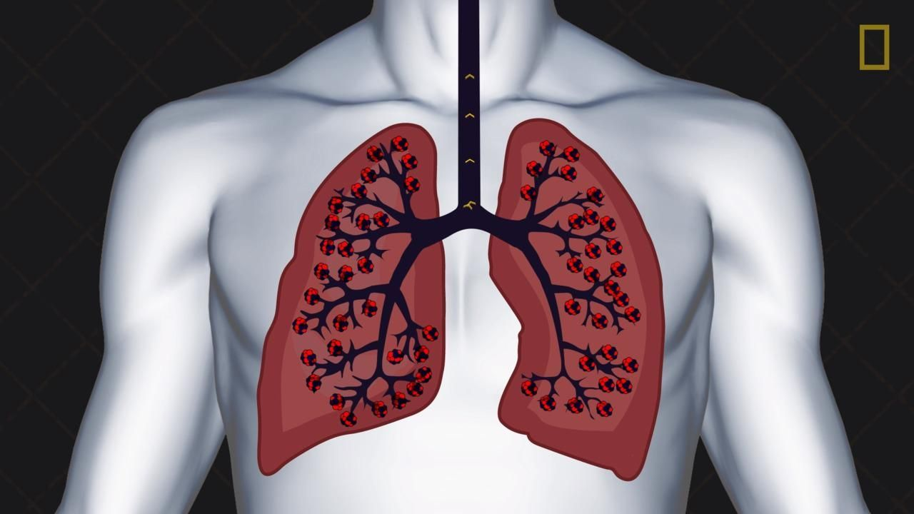1_Diaphragm   
2_Ribs

THANK YOU ☺