Organs Photos | Function | Location | Organs
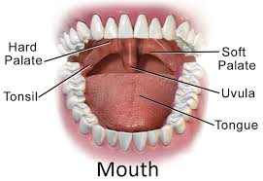 | The mouth is the beginning of the digestive process, as it chews food | along the body's midline inferior to the nose and superior to the chin | Mouth
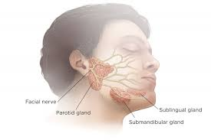 | They secrete saliva that helps moisten food so that we can swallow it easily. It also contains an enzyme called amylase, which makes it easier for the stomach to break down starches in food. | There are three salivary glands: the parotid glands located on the inside of the cheeks and the submandibular glands at the bottom of the mouth. sublingual glands under the tongue | Salivary glands
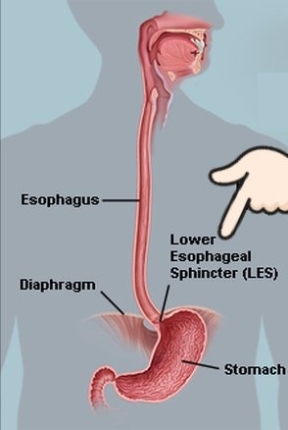 | transport material from the mouth to the stomach | posterior to the trachea and in front of the spine | Esophagus
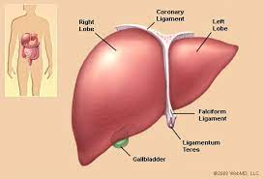 | Its main function in the digestive system is to process nutrients absorbed from the small intestine | in the upper right-hand portion of the abdominal cavity, beneath the diaphragm, and on top of the stomach, right kidney, and intestines | Liver
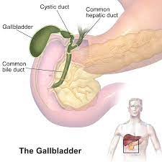 | Its function is to store the bile needed for digestion. When we eat, the gallbladder contracts to send bile into the digestive system | under the liver | Gallbladder
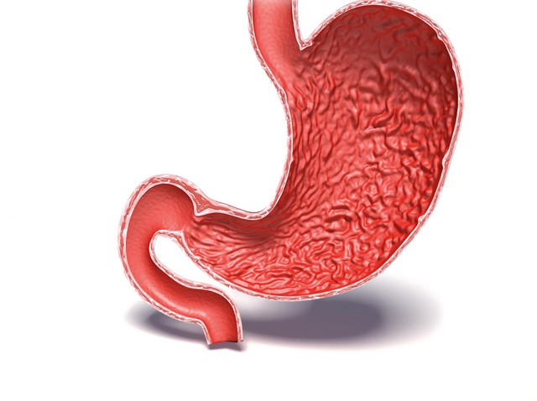 | It secretes enzymes that aid in digestion and the breakdown of food into a usable form | on the left side of the upper abdomen | Stomach
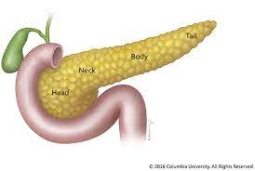 | During digestion, the pancreas makes enzymes. These enzymes work to break down sugars, fats, and starches. | behind the stomach in the upper left abdomen | Pancreas
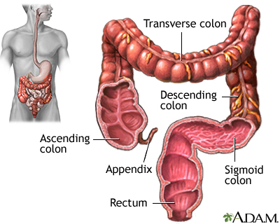 | The purpose of the large intestine is to absorb water and salts from substances that have not been digested as food, and to get rid of any leftover waste. | The large intestine wraps around the border of the abdominal cavity from the right side of the body, through the upper abdomen, and finally the left side. | Large intestine
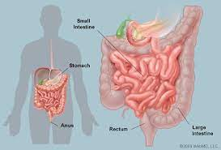 | The small intestine breaks down food from the stomach and absorbs many nutrients from the food | It is located in the central and lower abdominal cavity | Small intestine
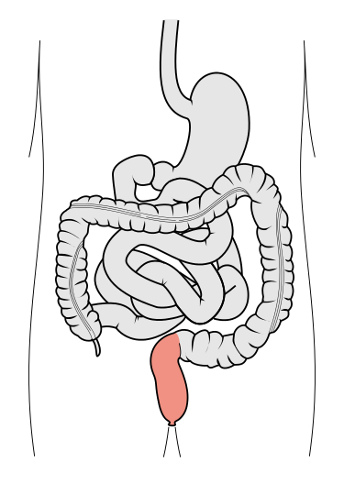 | The rectum's job is to receive stool from the colon, let you know that there is stool to be evacuated (pooped out) and to hold the stool until evacuation happens | is a chamber that begins at the end of the large intestine, immediately following the sigmoid colon, and ends at the anus | Rectum
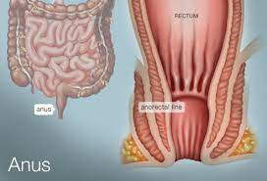 | it's a site of feces excretion, and it's one of the medication routes such as enema in case of constipation | The anus is the opening where the gastrointestinal tract ends and exits the body. The anus starts at the bottom of the rectum, the last portion of the colon (large intestine). The anorectal line separates the anus from the rectum | Anus

