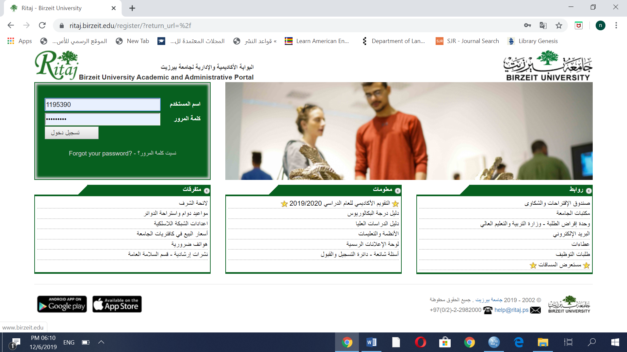

**Hematology Assignment**

Students name: Aya arouri , Sara amira , Asmaa Mousa

Submission date: 1191397 , 1192125 , 1192471

**Read the following case, and answer the mentioned questions related to the case**

A 26 years old female client went to the clinic complaining of symptoms related to anemia, after the examination the physician requested a Complete Blood Count (CBC) test on the date of 20.02.2011, and the results of the analysis as it shown in Figure-1. However, the physician diagnosed the type of anemia and prescribed the appropriate treatment. Thus, the physician requested another CBC test at 26.03.2011, in order to reevaluate the case and the treatment given treatment, and the CBC results are shown in Figure-2. Furthermore, after approximately 18 days, the patient made her third CBC analysis, and it was on 14.04.2011, and the result were as shown in Figure-3 .

**Answer the following questions :**

Q1) which type of anemia did the physician diagnosed?

1) Iron deficiency anemia (IDA)

Q2) The RDW was in the first CBC analysis 19 μm, in the second analysis it was 29 μm, and in the final CBC it became 27 μm. Based on the results of the RDW, do you think that there was an improvment (good prognosis) in the client’s case, or it became worse (bad prognosis) ? and why?

2) Yes, there was a good prognosis because It was clear that the doctor gave the patient iron because it caused her blood level to rise, which led to an increase in RDW