BIRZEIT UNIVERSITY

FACULTY OF NURSING AND ALLIED HEALTH PROFESSIONS
NURS 250 Adult Health

Student’s Name:  Aya Manassrah | Date of nursing care: 18/12/2021
Patient’s Initial: N.S | Room Number: 04
Birth Date: 5/7/1970 | Ward : Medical
Gender: Male | Admission date: 16/12/2021
Marital Status: Married | Diagnosis: Urgency Hypertensive Crisis

2.Chief Complaints:

When the patient entered the hospital he was complaining chiefly from: Dizziness, severe headache & Blurry vision. The patient also said: “ I was unable to walk at all.”

3.History of present illness:

He has just an Urgency Hypertensive Crisis.

5.Past Medical History:

- psychiatric disorder (include: Severe Nervousness, convulsions, loss of control over his actions, & Depression.)

6.Past Surgical History:

- Platinum (metal rod as internal fixation) in the Rt. leg as a result of a bullet wound.

7.Nutritional History:

Regular diet ( Healthy meals mainly full with vegetables, chicken, Meat, & legume.) & The patient is smoking 1 packet daily.

8.Allergies:

- Unknown As for Food
- Sensitive to Trihexyphenidyl Medication.

9.Physical exam

Review of systems; subjective and objective data:

- Skin:
- During The assessment that’s related to Integumentary system, that’s started in the skin status: he has an oily skin, as for usual sun exposure, he sits daily under the sun for 30 min, no infections, no scabs, & capillary refill test is done and it was normal (blood returns within 2 s ).

- There is a bruise in the Lt. hand & Rt. Leg & varicose veins in the Rt. ankle.

- Face and Neck:

- no acne, no lesions, symmetrical nasolabial folds, no distended veins in the neck.

- Eyes:

The pupil light reflex is done, & the pupils constricted equally. The test of six cardinal field of gaze is done & the pt. was responsive perfectly.The shape of eyes is normal (the palpebral fissure is at the same height with bridge of nose& the outer canthus at the same height with the upper part of the auricle.)

- Ears:
no drainage is inspected, the color of the ears coordinated with rest of body, no pain felt when the tragus is palpated.

- Nose:
No freckle is inspected on the nose, the color is consistent with the rest of face, The smell sensation is intact, the nostrils is symmetrical bilaterally .

- Mouth and Throat:
intact oral cavity, no inflammation or redness in the gum is inspected, the taste sensation is good, there’s no hypertrophy in tonsils.

- Chest and lungs:
The color of chest is consistent with the rest of body , no scars, no lesions is inspected, no masses or tenderness is palpated, as for percussion the sound was resonance ( normal), chest expansion is symmetrical bilaterally, there isn’t abnormal findings as for chest & lungs.

- Heart and circulatory system:

Carotid artery is symmetrical bilaterally in pulse rate & rhythm& volume, no bruit sound is heard, the HR is slightly high (101 bpm) & Bp is normal ( 111/93 mmHg), there isn’t abnormal sounds (S3&S4).

- Abdomen:
There is no voids & the hair is distributed equally on the abdomen, no pulsations is inspected or palpated, no lesions, no scars, no masses or tenderness during palpation.

- Skeletal system:

There isn’t abnormal findings, intact skeletal structure.

- Neurological system:

The Glasgow coma scale is performed and the pt. was oriented, & his eyes are opened because he was awake, & he was responsive during motor function test.

- Social environment:

The Pt. lives with his family, and he has a very strong relationship with them , his family help him make decisions as he said, and also he doesn’t like the public sessions just the familial ones.

10.Diagnostic procedures and laboratory tests with interpretations:

ECG
Figure 1: client’s ECG
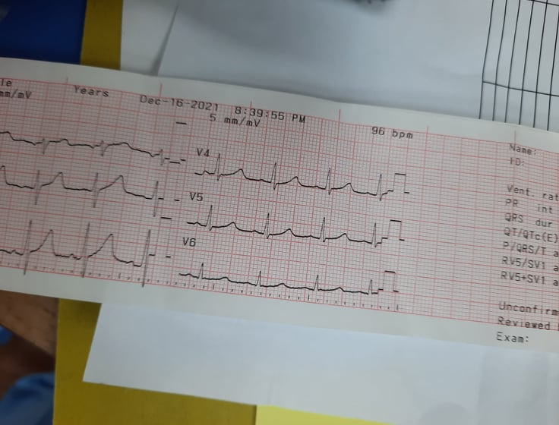

• HR: 96 bpm
• PR interval: 3.5*0.04= 0.14s
• Regularity: Regular
• QRS duration: 2*0.04= 0.08s
• Presence of P-wave: Sinus P wave (3*0.04= 0.12s)
• Isoelectric ST-segment: 3*0.04= 0.12 s
• T waves: 3*0.04= 0.12

,X-RAY: Free
11.Laboratory Data:

Test | Date | Patient’s Value | Normal Value | Unit | Meaning of Abnormal Value
Red blood cells (RBCs) | 16/12/2021 | 5.78 | 4.69-6.13 | M/uL | Normal
White blood cells (WBCs) | 16/12/2021 | 10.1 | 4.6-11 | K/uL | Normal
Platelet Crit | 16/12/2021 | 0.25 | (-) | % | Normal
Mean Cell volume(MCV) | 16/12/2021 | 92.2 | 80-100 | fL | Normal
Hematocrit(HCT) | 16/12/2021 | 53.3 | 43.5-53.7 | % | Normal
Hemoglobin(HGB) | 16/12/2021 | 17.8 | 13.5-17 | g/dL | A high hemoglobin level may indicate: Lung or Heart disease.

12.Pathophysiology: of the current disease:

Hypertensive crisis is defined as a systolic pressure greater than 180 or a diastolic pressure greater than 120 mmHg. Hypertensive crisis can be further classified as hypertensive urgency or a hypertensive emergency depending on end-organ involvement including cardiac, renal, or neurologic injury. Hypertensive urgency is defined by a markedly elevated blood pressure, usually in the same range seen in a hypertension emergency, but without the rapid progression of target-organ involvement. Hypertensive emergency occurs when elevated blood pressure is responsible for symptoms, signs, or laboratory evidence of end-organ damage, such as mental status changes (hypertensive encephalopathy), intracranial hemorrhage, retinopathy, aortic dissection, cardiac ischemia or congestive heart failure, or acute renal failure. The central nervous system is particularly susceptible to high blood pressure. The effects of extreme elevations in blood pressure include intense arterial spasm of the cerebral arteries with hypertensive encephalopathy. Cerebral vasoconstriction probably is an exaggerated homeostatic response designed to protect the brain from excesses of blood pressure and flow. The regulatory mechanisms often are insufficient to protect the capillaries, and cerebral edema frequently develops. As it advances, papill edema (i.e., swelling of the optic nerve at its point of entrance into the eye) ensues, giving evidence of the effects of pressure on the optic nerve and retinal vessels. The person may have headache, restlessness, confusion, stupor, motor and sensory deficits, and visual disturbances. In severe cases, convulsions and coma follow.
The complications associated with a hypertensive crisis demand immediate and rigorous medical treatment in an intensive care unit with continuous monitoring of arterial blood pressure.Because chronic hypertension is associated with autoregulatory changes in coronary artery, cerebral artery, and kidney blood flow, care should be taken to avoid excessively rapid decreases in blood pressure, which can lead to hypoperfusion and ischemic injury. Therefore, the goal of initial treatment measures should be to obtain a partial reduction in blood pressure to a safer, less critical level, rather than to normotensive levels.

13.Signs and symptoms :

- Blurry vision.
- Dizziness.
- Severe headache.
- Activity intolerance.
- Acute pain during cold in his Rt. leg due to internal fixation by metal rods.
- Nervousness & loss of control over his actions due to psychiatric disorder.

14.Treatment:

As for Hypertensive Crisis, oral agents can be administered with the goal of normalizing blood pressure within 24-48 hrs. Oral doses of fast –acting agents such as beta-adrenergic blockers ( i.e. labetalol), ACEI (i.e. clonidine) are recommended for the treatment of HTN urgencies. Extremely close hemodynamic monitoring of the Patient’s blood pressure & Cardiovascular status is required during treatment of HTN emergencies & urgencies. Taking VS every 5 min is appropriate if the blood pressure is changing rapidly , taking VS at 15-30 min intervals in a more stable situation may be sufficient.

15.Medications:

Name/ Dosage | Action | Rational | Evaluation | Side Effects
Amicor  (Atorvastatin) 10mg | HMG-CoA reductase inhibitor, inhibits rate-limiting step in cholesterol biosynthesis by competitively inhibiting HMG-CoA reductase. | Indicated as an adjunct to diet for treatment of elevated total-C, Apo B, and TG levels and to increase HDL-C in patients with primary hypercholesterolemia (heterozygous familial and nonfamilial) and mixed dyslipidemia , & to reduce the risk of stroke & heart attack. | Not met because he’s hunger striker. | - Diarrhea  - Nasopharyngitis  - Arthralgia  - Nausea  - Headache
Olanzapine  ( Zyprexa) 5mg | May act through combination of dopamine and serotonin type 2 receptor site antagonism. | Indicated for acute/maintenance treatment of manic or mixed episodes associated with bipolar 1 disorder; may be used adjunctively to valproate or lithium in the treatment of manic or mixed episodes associated with bipolar disorder. | Not Met for the same reason | - Orthostatic HTN  - Weight gain  - Dizziness  - Insomnia  - Weakness
Klonopin  (clonazepam) 1mg | Long-acting benzodiazepine that increases the presynaptic GABA inhibition and reduces the monosynaptic and polysynaptic reflexes. | is used alone or in combination with other medications to control certain types of seizures. It is also used to relieve panic attacks (sudden, unexpected attacks of extreme fear and worry about these attacks). | Not Met for the same reason | - Dizziness  - Fatigue  - Confusion  - Coughing  - Memory impairment

16.Nursing care plan:

List of Nursing Diagnosis:

  - Decreased Cardiac output r/t increased blood pressure (increased Afterload) a.m.b ( decreased activity tolerance).
  - Acute pain (headache) r/t increased Cerebrovascular pressure a.m.b (blurred vision & Dizziness.)
  - Ineffective therapeutic regimen management r/t Conflicting health values.
  - Fluids & electrolytes imbalance.
  - Acute pain during cold r/t previous surgery (internal fixation of the bones by metal rods in the Rt. leg).
  - Risk for CVA r/t increased blood pressure.

  - Deficient knowledge.

Nursing care plan (5) DX:
On the other file.

17.Home health teaching and continuing care
(specific for your patient)
(Diet, exercise, medication, dressing, smoking……..)

- The Pt. is recommended to stop smoking.
- The Pt. is recommended to think positively & minimize his nervousness.
- The Pt. is recommended also to do exercises daily as he han as possible.

18.Citation of the reference:

- Text Book Of Medical Surgical Nursing, Brunner & Suddarth’s 13th Edition.

- Essentials Of Pathophysiology, Carol Mattson Porth 4th Edition.

- Medscape Application.

