BIRZEIT UNIVERSITY

FACULTY OF NURSING AND ALLIED HEALTH PROFESSIONS
NURS 250 Adult Health

Student’s Name:  Aya Manassrah | Date of nursing care: 12.06.2022
Patient’s Initial: H.M | Room Number: 304-1
Birth Date: 18.08.1960 | Ward : Surgery
Gender: Male | Admission date: 12.06.2022
Marital Status: Married | Diagnosis: Acute Pancreatitis

2.Chief Complaints:

When the patient entered the hospital he was complaining chiefly from: severe epigastric pain of 5 hrs duration , radiated to the back

3.History of present illness:

He has just an Acute Pancreatitis.

5.Past Medical History:

- Hypertension & Ischemic heart disease( S/P Cardiac Catheterization in2019 with stent.)

6.Past Surgical History:

- Free

7.Nutritional History:

Diverse & Healthy meals ( Regular diet).

8.Allergies:
- NKFDA
9.Physical exam

Review of systems; subjective and objective data:

- Skin:
- During The assessment that’s related to Integumentary system, that’s started in the skin status: he has a dry,warm, intact skin, no infections, no scabs, & capillary refill test is done and it was normal (blood returns within 2 s ).

- Face and Neck:

- no acne, no lesions, symmetrical nasolabial folds, no distended veins in the neck.

- Eyes:

The pupil light reflex is done, & the pupils constricted equally. The test of six cardinal field of gaze is done & the pt. was responsive perfectly.The shape of eyes is normal (the palpebral fissure is at the same height with bridge of nose& the outer canthus at the same height with the upper part of the auricle.)

- Ears:
no drainage is inspected, the color of the ears coordinated with rest of body, no pain felt when the tragus is palpated.

- Nose:
No freckle is inspected on the nose, the color is consistent with the rest of face, The smell sensation is intact, the nostrils is symmetrical bilaterally .

- Mouth and Throat:
intact oral cavity, no inflammation or redness in the gum is inspected, the taste sensation is good, there’s no hypertrophy in tonsils.

- Chest and lungs:
The color of chest is consistent with the rest of body , no scars, no lesions is inspected, no masses or tenderness is palpated, as for percussion the sound was resonance ( normal), chest expansion is symmetrical bilaterally, there isn’t abnormal findings as for chest & lungs.

- Heart and circulatory system:

Carotid artery is symmetrical bilaterally in pulse rate & rhythm& volume, no bruit sound is heard, the HR is normal (75 bpm) & Bp is normal ( 128/77 mmHg), there isn’t abnormal sounds (S3&S4).

- Abdomen:
There is no voids & the hair is distributed equally on the abdomen, no pulsations is inspected or palpated, no lesions, no scars, no masses.

There’s a tenderness when the abdomen is palpated because of Acute Pancreatitis status, Abdominal guarding is present

- Skeletal system:

There isn’t abnormal findings, intact skeletal structure.

- Neurological system:

The Glasgow coma scale is performed and the pt. was oriented, & his eyes are opened because he was awake, & he was responsive during motor function test.

- Social environment:

The Pt. lives with his family, and he has a good relationships with the surrounding physical environment.

10.Diagnostic procedures and laboratory tests with interpretations:

ECG
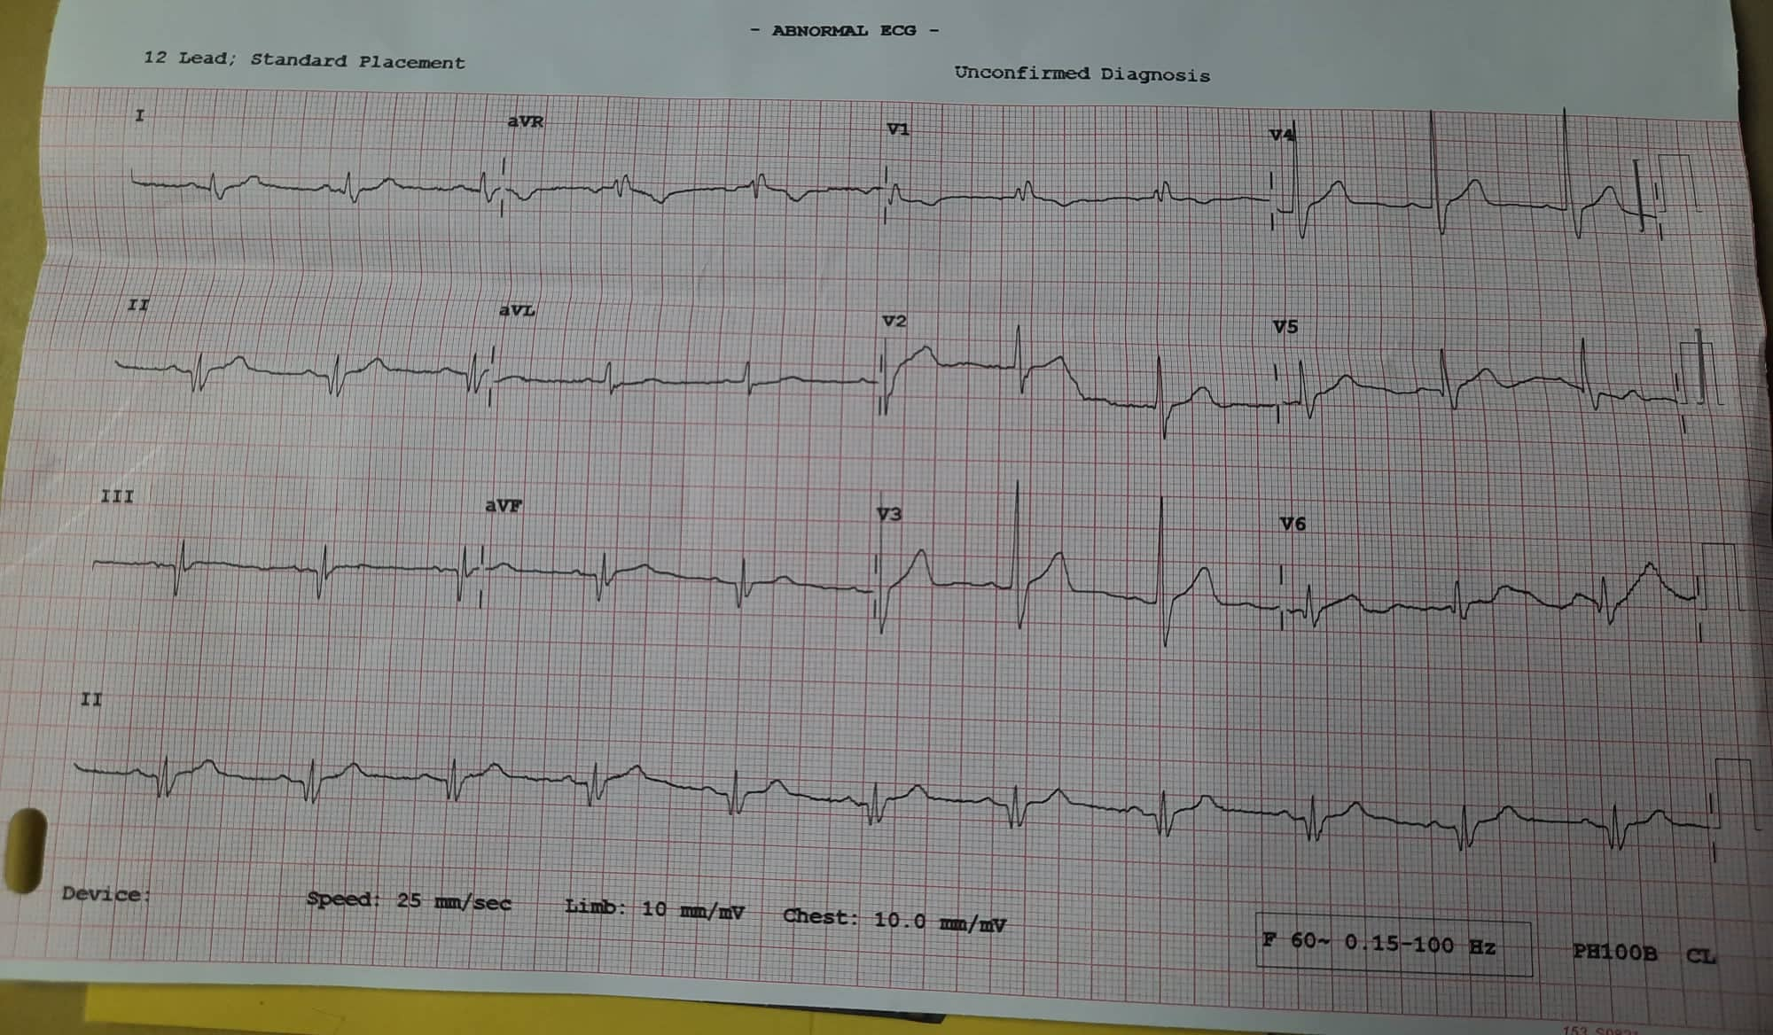
Figure 1: client’s ECG

• HR: 68 bpm
• PR interval: 4.5*0.04= 0.18s
• Regularity: Regular
• QRS duration: 2*0.04= 0.08s
• Presence of P-wave: Sinus P wave (2.5*0.04= 0.1s)
• Isoelectric ST-segment: 3*0.04= 0.12 s
• T waves: 3.5*0.04= 0.14

X-RAY: Free

11.Laboratory Data:

Test | Date | Patient’s Value | Normal Value | Unit | Meaning of Abnormal Value
Red blood cells (RBCs) | 11.06.2022 | 5.03 | 4.69-6.13 | M/uL | Normal
White blood cells (WBCs) | 11.06.2022 | 8.6 | 4.6-11 | K/uL | Normal
Platelet Crit | 11.06.2022 | 0.16 | (-) | % | Normal
Mean Cell volume(MCV) | 11.06.2022 | 83.1 | 80-100 | fL | Normal
Hematocrit(HCT) | 11.06.2022 | 41.8 | 43.5-53.7 | % | Chronic diseases like pancreatic cancer, or inflammation like pancreatitis, can cause anemia.
Hemoglobin(HGB) | 11.06.2022 | 14.1 | 13.5-17 | g/dL | Normal

12.Pathophysiology of the current disease:

Self-digestion of the pancreas by its own proteolytic enzymes, principally trypsin, causes acute pancreatitis. Eighty percent of patients with acute pancreatitis have biliary tract disease or a history of long-term alcohol abuse. These patients usually have had undiagnosed chronic pancreatitis
before their first episode of acute pancreatitis. Gallstones enter the common bile duct and lodge at the ampulla of Vater, obstructing the flow of pancreatic juice or causing a reflux of bile from the common bile duct into the pancreatic duct, thus activating the powerful enzymes within the pan-
creas. Normally, these remain in an inactive form until the pancreatic secretions reach the lumen of the duodenum. Activation of the enzymes can lead to vasodilation, increased vascular permeability, necrosis, erosion, and hemorrhage (Zinner & Ashley, 2007).Other less common causes of pancreatitis include bacterial or viral infection, with pancreatitis occasionally developing as a complication of mumps virus. Spasm and edema of the ampulla of Vater, caused by duodenitis, can probably
produce pancreatitis. Blunt abdominal trauma, peptic ulcer
disease, ischemic vascular disease, hyperlipidemia, hypercalcemia, and the use of corticosteroids, thiazide diuretics, oral contraceptives, and other medications have also been associated with an increased incidence of pancreatitis. Acute pancreatitis may develop after surgery on or near the
pancreas or after instrumentation of the pancreatic duct. Acute idiopathic pancreatitis accounts for up to 10% of the cases of acute pancreatitis. Some experts postulate that these cases may be related to occult microlithiasis (small stones in the bile) (Zinner & Ashley, 2007). In addition,
there is a small incidence of hereditary pancreatitis.The overall mortality rate of patients with acute pancreatitis is high (2% to 10%) because of shock, anoxia, hypotension, or fluid and electrolyte imbalances. This mortality rate may also be related to the 10% to 30% of patients
with severe acute disease characterized by pancreatic and peripancreatic necrosis (Zinner & Ashley, 2007). Attacks of acute pancreatitis may result in complete recovery, may recur without permanent damage, or may progress to chronic pancreatitis. The patient who is admitted to the
hospital with a diagnosis of pancreatitis is acutely ill and needs expert nursing and medical care.

13.Signs and symptoms :

- Severe abdominal pain
- Back pain
- Abdominal distention
- Abdominal guarding
- Decreased peristalsis
- Palpable abdominal mass
- Agitation
- Dyspnea

14.Treatment & Medical Management:

Management of acute pancreatitis is directed toward relieving symptoms and preventing or treating complications. All oral intake is withheld to inhibit stimulation of the pancreas and its secretion of enzymes. Parenteral nutrition plays an important role in the nutritional support of patients with severe acute pancreatitis, particularly in those who are debilitated
and those with a prolonged paralytic ileus (more than 48 to 72 hours) (Zinner & Ashley, 2007). Ongoing research has shown positive outcomes with the use of enteral feedings.The current recommendation is that, whenever possible, the enteral route should be used to meet nutritional needs in patients with pancreatitis. This strategy also has been found to
prevent infectious complications, safely and cost effectively
(DiMagno & DiMagno, 2007; Zinner & Ashley, 2007). Enteral feedings should be started early in the course of acute pancreatitis. Patients who do not tolerate enteral feeding require parenteral nutrition. Nasogastric suction may be used to relieve nausea and vomiting and to decrease painful abdominal distention and paralytic ileus. Research data do not support the routine use of nasogastric tubes to remove gastric secretions in an effort to limit pancreatic secretion. Histamine-2 (H2) antagonists such as cimetidine (Tagamet) and ranitidine (Zantac) may be prescribed to decrease pancreatic activity by inhibiting secretion of gastric acid. Proton pump inhibitors such as pantoprazole (Protonix) may be used for patients who do not tolerate H2 antagonists or for whom this therapy is ineffective.

- IV fluid 4000 R/L over 24 hrs

15.Medications:

Name/ Dosage | Action | Rational | Evaluation | Side Effects
Paracetamol (Perfalgan)  1G IV 1*3 | Paracetamol has a central analgesic effect that is mediated through activation of descending serotonergic pathways | used to relieve mild to moderate pain | Goal is met, pain is relieved. | - Nausea or Vomiting.  - Weakness.  - Bloody and cloudy urine.  - Dizziness.  - Sleeplessness.  - Constipation.  - Skin rash.
Pethidine 50mg IM 1*3 PRN | Pethidine mimics the actions of endogenous neuropeptides via opioid receptors, thereby producing the characteristic morphine-like effects on the mu-opioid receptor | is indicated for the relief of moderate to severe pain. | Goal is met, pain is relieved. | - lightheadedness.  - dizziness.  - weakness.  - headache.  - extreme calm.  - mood changes.  - nausea.  - vomiting.

16.Nursing care plan:

List of Nursing Diagnosis:

- Acute pain and discomfort related to edema, distention of the pancreas, and peritoneal irritation
- Acute pain and discomfort related to excess stimulation of pancreatic secretions
- Imbalanced nutrition: less than body requirements related to inadequate dietary intake, impaired pancreatic secretions, increased nutritional needs secondary to acute illness, and increased body temperature.
- Risk for infection.

Nursing care plan (5) DX:
On the other file.

17.Home health teaching and continuing care
(specific for your patient)
(Diet, exercise, medication, dressing, smoking……..)

Patient is recommended to Maintain bedrest during acute attack. Provide quiet, restful environment. Decreases metabolic rate and GI stimulation and secretions, thereby reducing pancreatic activity. Promote position of comfort on one side with knees flexed, sitting up and leaning forward.

18.Citation of the reference:

- Text Book Of Medical Surgical Nursing, Brunner & Suddarth’s 13th Edition.

- Essentials Of Pathophysiology, Carol Mattson Porth 4th Edition.

- Medscape Application.

