BIOSTATISTICS

NURS3221

**Ahmad Qasem Hajajlah**

**Question 1 :**

|  |  |  |
| --- | --- | --- |
|  | ***Baseline Hb*** | ***HB after taking iron pills*** |
| ***Mean*** | 10.080 | 11.170 |
| ***Median*** | 10.100 | 10.950 |
| ***SD*** | 0.7330 | 0.8341 |
| ***Percentiles*** | 25% ( 9.6000)  50% ( 10.100)  75 (10.725) | 25% (10.775)  50% (10.950)  75% (12.000) |

Using the Paired sample T test the treatment was effective the P value was (0.001) lower than 5% so we reject the null hypothesis, meaning that the effect we had on the Hb after taking the iron pills was statistically significant “ see the output page labelled as Question 1”

**Question 2 :**

Describing the data we have two sets “Plasma B12” is a quantitative data

|  |  |
| --- | --- |
|  | ***Plasma B12*** |
| ***Mean*** | 261.429 |
| ***SD*** | 111.96555 |
| ***Range*** | 120-500 |
| ***Percentiles*** | 25% (190)  50% (220)  75% (322.5) |

For the intrinsic factor its qualitative data

|  |  |
| --- | --- |
|  | ***Intrinsic Factor*** |
| ***Frequency*** | Present 8 “ 57.1%”  absent 6 “42.8%” |
| ***Mode*** | 1 “present” |
| ***Median*** | 1 “present” |

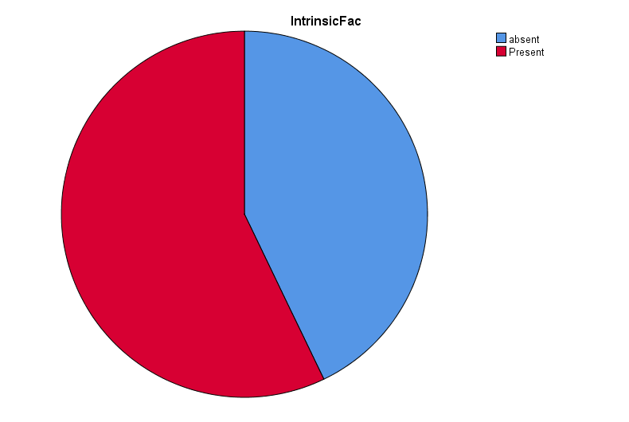

Using the Chi square test we find out that Pearson chi square value is 7.194 which means the relationship between Plasma B12 and the presence of intrinsic factor is weak, by also looking at the P value (0,617) also defined as 61% we have to accept the null hypothesis meaning that the relationship between Plasma B12 and Intrinsic factor in this data set was by chance “look at Question2 output attached”

Question 3 :

A

|  |  |  |
| --- | --- | --- |
|  | ***Cardiac output*** | ***Oxygen volume*** |
|  | ***For the whole Population*** | |
| ***Mean*** | 7.4038 | 0.7150 |
| ***SD*** | 3.45248 | 0.438 |

|  |  |  |  |  |
| --- | --- | --- | --- | --- |
|  | ***Adults*** | | ***Children*** | |
| ***Cardiac output*** | ***Oxygen volume*** | ***Cardiac output*** | ***Oxygen volume*** |
| ***Mean*** | 9.5846 | 0.9062 | 5.2231 | 0.5238 |
| ***SD*** | 3.56858 | 0.51655 | 1.33925 | 0.23168 |

**B**

|  |  |  |  |
| --- | --- | --- | --- |
|  |  | ***Cardiac output*** | ***Oxygen volume*** |
| ***Cardiac output*** | ***Person correlation*** | 1 | 0.939 |
|  | ***P vaule*** | 0.0001 | |

The p value is 0.0001 which means we refuse the null hypothesis and that means that the relationship between cardiac output and oxygen volume is statically significant

**C**

Yes oxygen is affected y Cardiac output each time CO is increased by 1 unit oxygen volume is increased by 0.119

**D**

Age is a partial confounder of the association between cardiac output and oxygen volume and is not a complete confounder but its still significant from the P value of 0.001

**E**

REGRESSION EQUATION :

Oxygen volume = -0.165 + 0.119(CARIDAC OUTPUT)

Oxygen volume = -0.676 + 0.141(CO) + 0.232(age)