

Birzeit University

Faculty of Pharmacy, Nursing and Health Professions

**BIOSTATISTICS**

**NURS3221**

**ADNAN ABU ARQOUB 1182551**

**(Please construct a 2 tables on word to describe the data. One for qualitative variables and another for quantitative variables)**

Quantitative Data

|  |  |  |  |  |
| --- | --- | --- | --- | --- |
|  | **Range** | **Mean SD** | **Median** | **Mode** |
| **Age** | *20-50* | *33.92 / 9.19* | *32.00* | *32* |
| **Weight** | *50kg-93kg* | *68.84 / 10.14* | *68.00* | *70* |
| **Height** | *1.55m-1.86m* | *1.67 / 0.07* | *1.67* | *1.70* |
| **BMI** | *18.14-32.87* | *24.56 / 3.58* | *23.89* | *24.22* |

Qualitative Data

|  |  |  |
| --- | --- | --- |
|  | **Frequency** | **Percent** |
| Sex | | |
| **Male** | *27* | *52.9* |
| **Female** | *23* | *45.1* |
| **Smoking** | | |
| **Non smokers** | *22* | *43.1* |
| **Light** | *15* | *29.4* |
| **Heavy** | *13* | *25.5* |
| **Activity** | | |
| **Not active** | *23* | *45.1* |
| **Active** | *27* | *52.9* |
| **BMIcat** | | |
| **Underweight** | *2* | *3.9* |
| **Normal** | *29* | *56.9* |
| **Overweight** | *15* | *29.4* |
| **Obese** | *4* | *7.8* |
| **AgeCat** | | |
| **20-30** | *22* | *43.1* |
| **31-40** | *16* | *31.4* |
| **41-50** | *12* | *23.5* |

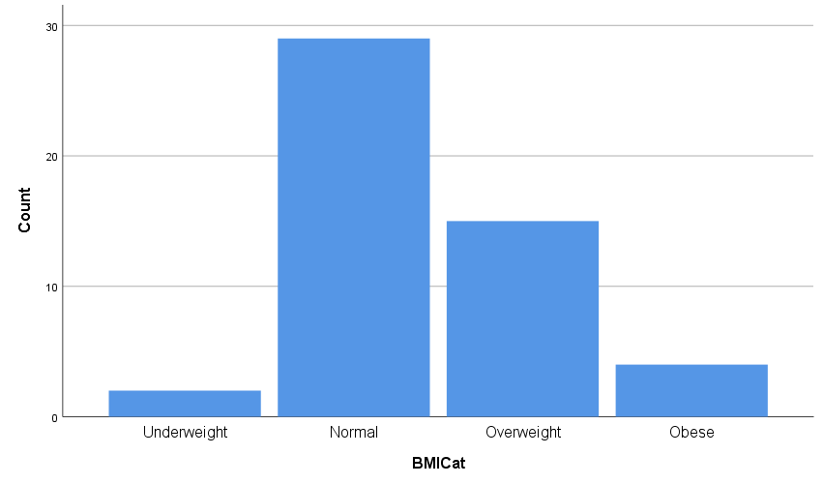**Draw figures for 2 of the qualitative variables.**

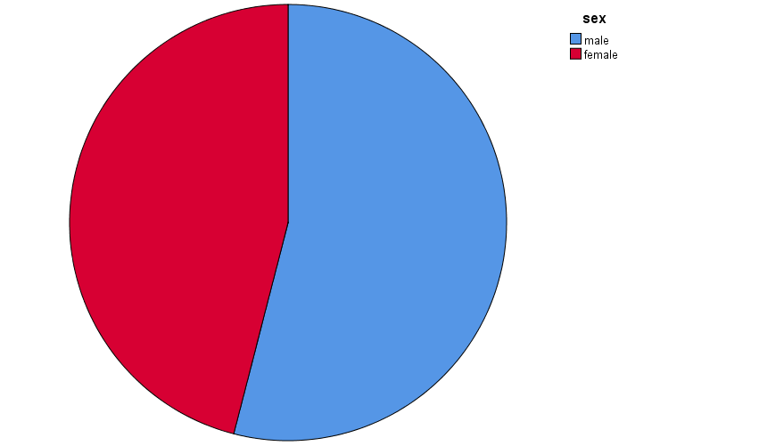

**Draw tables showing the relationship between 1.sex and smoking status, 2. smoking status and physical activity, 3.physical activity and BMI (categorical variable) ( hint use cross-tabulation).**

**Sex & Smoking status**

|  |  |  |  |  |
| --- | --- | --- | --- | --- |
| **Smoking** | | | | |
|  | | **Non** | **light** | **heavy** |
| **SEX** | **Male** | *9* | *11* | *7* |
| **Female** | *13* | *4* | *6* |

**Smoking status & Activity**

|  |  |  |  |
| --- | --- | --- | --- |
| **Activity** | | | |
|  | | **Not active** | **Active** |
| **Smoking status** | **Non smoker** | *7* | *15* |
| **Light** | *10* | *5* |
| **heavy** | *6* | *7* |

**Physical activity & BMIcat**

|  |  |  |  |  |  |
| --- | --- | --- | --- | --- | --- |
| **BMI cat** | | | | | |
|  | | **Underweight** | **Normal** | **Overweight** | **Obese** |
| **Activity** | **Not active** | *0* | *13* | *7* | *3* |
| **Active** | *2* | *16* | *8* | *1* |