

Birzeit University
Faculty of Pharmacy, Nursing and Health Professions
BIOSTATISTICS
NURS3221

ADNAN ABU ARQOUB 1182551

Table 1. Hemoglobin (g/dl) in total population and in different groups
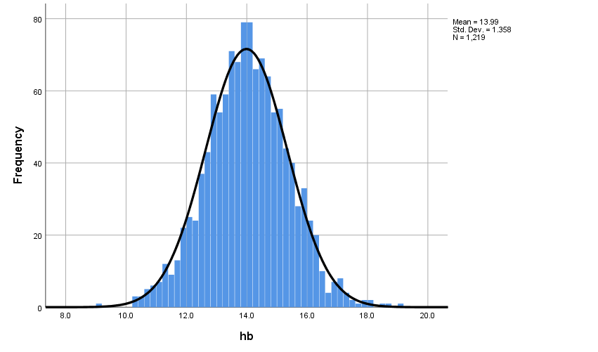
 | N | Range | Mean ± SD | Median (interquartile range) | mode
Total population | 1219 | 9.1-19 | 13.99/1.36 | 14.00 | 13.8
AREA
1 | 585 | 10.3-17.7 | 13.77/1.33 | 13.80  14.2 | 12.9  13.8
2 | 634 | 9.1-19 | 14.19/1.35 | 13.80  14.2 | 12.9  13.8
SEX
Males 1 | 494 | 10.3-19.0 | 13.93/1.43 | 13.8  14.1 | 12.9  13.8
Females 2 | 725 | 9.1-18.6 | 14.02/1.30 | 13.8  14.1 | 12.9  13.8
CLASS
3rd grade | 426 | 10.4-16.7 | 13.55/1.10 | 13.6  14.0  14.5 | 14.1  14.7  13.8
7th grade | 456 | 9.1-17.7 | 14.01/1.33 | 13.6  14.0  14.5 | 14.1  14.7  13.8
10th grade | 337 | 10.3-19 | 14.51/1.50 | 13.6  14.0  14.5 | 14.1  14.7  13.8
district
City (1) | 449 | 10.4-18.6 | 14.21/1.35 | 14.2  14.0  13.4 | 14.5  14.1  13.6
Village (2) | 615 | 9.1-19.0 | 13.99/1.37 | 14.2  14.0  13.4 | 14.5  14.1  13.6
Camp (3) | 155 | 10.6-15.7 | 13.31/1.08 | 14.2  14.0  13.4 | 14.5  14.1  13.6

