**Adnan Abu Arqoub 1182551**

**Antiarrhythmic drugs**

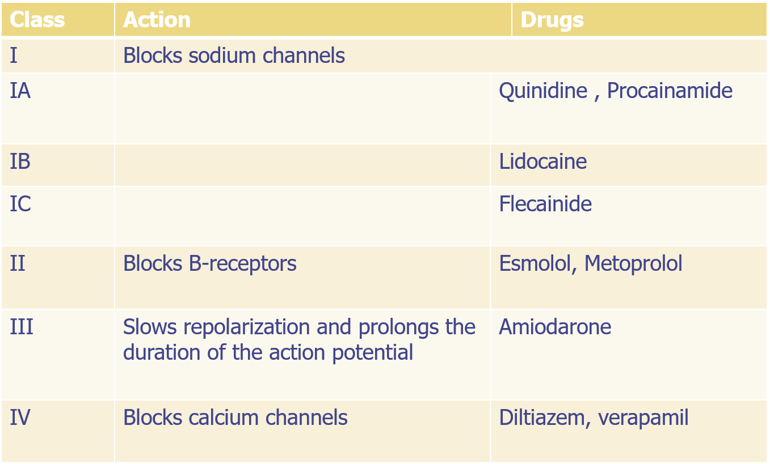

**Unclassified drugs**

 Digoxin

Used for atrial fibrillation and flutter

At toxic doses can cause ventricular tachycardia and fibrillation

 Adenosine 6 mg IV over 1–3 sec followed by rapid saline flush(10 ML )

A second 12 mg dose may be given in 1–2 min if needed

Decreases conduction velocity and automaticity in the AV node

Short duration of action (15 seconds)

IV adenosine is used for acute supraventricular tachycardia