**BIRZEIT UNIVERSITY**

CRITICAL CARE NURSING 2

CASE STUDY 1

Cardiogenic shock

STUDENT NAME :Sara Ameera

STUDENT NUMBER :1192125

INSTRUCTER NAME :Fadi Assi

DATE : NOV 19 2021

**Pt Initials :** A.Z

**Age :**54 Y.O

**Sex:** male

**Hospital:** Ramallah hospital complex .

**Ward:** CCU.

**Bed number :** 5 **Date of Admission :**NOV 9 2021

**Informants:**

PT data from computer system ( nursing note, visit, reports, …)

**Chief Complaints**:

Chest pain, tachypnea, hypotension, fainting

**History of Present Illness :**

The patient was admitted to the hospital with chest pain and shortness of breath. He was admitted to the emergency department, electrocardiograms and blood tests were done, and he was transferred to the cardiac intensive care department for treatment and to remain under observation.

**Past Medical History :**

Diabetes, hypotension, NSTEMI

**Past Surgical History :**

Catheter

**Nutritional History:**

Diabetic diet .

**Allergies:**

Pt hasn't allergy

**Personal Habits (life style) :**

Smoking, athlete

**Physical Assessment:**

**Vital Signs :**

HR :101

Sat : 100

BP :93\63

Temp: 36.6

RR :19

**Head and Face :**

Normal finding( size shape ) ,normal facial expression , normal movement of the head , the top of the ear equal to the canthi of the eye, tempo mandibular joint is normal finding, symmetrical, no JVD,(jugular vein distention).

**Eyes :**

Normal eyes , normal pupils ( PERRLA) , eyebrows symmetrical, eyelashes free of drainage , eye lids symmetrical , conjunctive moist, clear with small blood vessel . CN functioning .

**Ears:**

Hearing is functioning well , external ear symmetrical ,proportion , normal color .

**Nose :**

Normal nose , symmetric , no lesion , sound of breath is normal , the smell in both opening is normal , the nasal cavity is dark pink , smooth without swelling or foreign bodies .

**Mouth and Throat:**

Normal lips , normal teeth , tongue without lumps or nodules , normal movement in tongue and sense of taste ,

Palpate submandibular and parotid glands (no pain ) (pain indicate infection ) , , trachea normal finding , normal thyroid , lymph nodes are normal finding .

**Neck and shoulders:**

Normal neck ( skin color , integrity , shape , symmetry , ROM , trachea normal finding , normal thyroid , lymph nodes are normal finding , distribution hair is normal , the hair is thickness , no infection , there is no scalp lesion , good ROM shoulder, symmetrical shoulder, the distance between the neck and shoulder is symmetrical and appropriate.

**Lungs and Thorax and Breast :**

Normal chest , chest movement in breath is normal , scapular shape and movement are symmetrical , C7 AND T1 are sensible and visible, light sound at pt. say 99,44 , normal sound at breathing (pt. have tachypnea) .

**Cardiocirculatory System:**

pale face , lips , ears , nails(low capillary refill , low clopping) ,jugular vein normal , carotid artery presence pulse, PR is sudden tachycardia , another time weak pulse . Sound at left lateral position .

**Abdomen and Gastrointestinal system :**

Normal abdomen (rounded) , normal umbilicus , no drainage (no infection ) , normal sound at vascular … use bell and start from aorta ((mid line )) .. Lt renal Rt renal , Lt iliac Rt iliac (pulse presence ), GI system normal function, normal bowel sound, urine output normal.

**Arms and Hands :**

ROM Normal finding, presence radial pulse , good collateral circulation , Arm and hand in both sides symmetrical

**Legs and feet :**

ROM normal finding, presence posterior topical & pedal pulses, presence femoral pulse, legs and feet in both sides symmetrical.

**Genitourinary :**

**Neurological system**:

Normal finding in all neuro (olfactory , optic , oculomotor , trochlear , abducens , vestibulocochlear , glossopharyngeal, vagns , accessory , hypoglossal )

**Diagnostic Procedures:**

1. Radiology (x-rays, CT scan, MRI, ultrasound…….etc), ECG.

**ECG :**

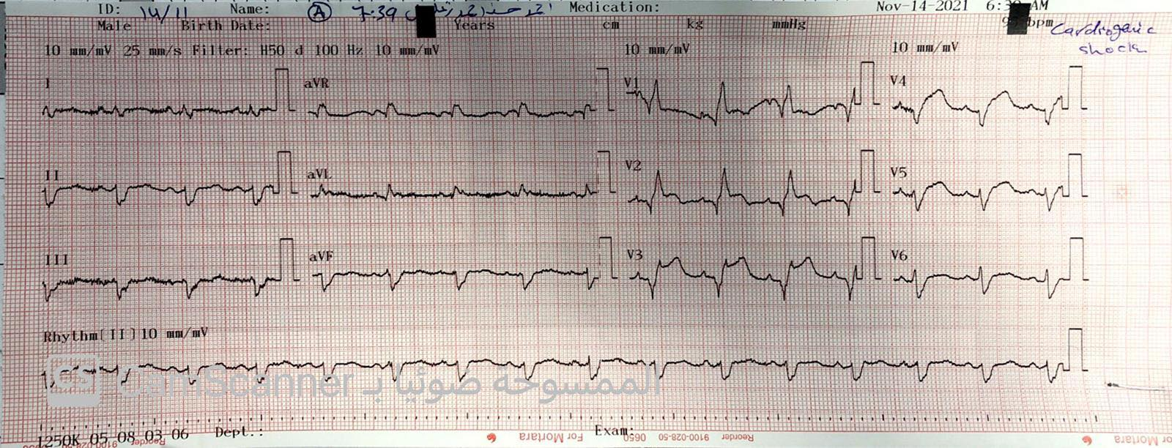

V2 lead:

Rate: **94 bpm**

Regularity: **Regular**

Early/Late Beats: **None**

P Wave Morphology and AV Ratio: **Uniform P waves. A-V Ratio 1:1**

PR Interval: **0.04 seconds**

QRS Duration and Morphology: **Less 0.12seconds (0.08)**

**Identical Morphology**

QT Interval: **Less than ½ the preceding R-R Interval**

**3. Laboratory Data:**

|  |  |  |  |  |  |
| --- | --- | --- | --- | --- | --- |
| **Test** | **Date** | **Patient’s Value** | **Normal Value** | **Interpretation/Reason for abnormality** | **Treatment done for abnormal findings** |
| **RBC** | 7\11 | 3.94 | 4.69-6.13 | anemia.  bone marrow failure.  erythropoietin deficiency | use drugs that make more red blood cells, ESAs work like a hormone (called erythropoietin) made by the kidneys to help the body make its own new red blood cells |
| **HGB** | 7\11 | 12 | 13.5-17 | decreased red blood cell production(altered bone marrow hemoglobin production), red blood cell destruction(liver disease). | Treatment might include oxygen, pain relievers |
| **WBC** | 7\11 | 17.7 | 4.6-11 | fight an infection. A reaction to a drug that increases white blood cell production. A disease of bone marrow, causing abnormally high production of white blood cells | Antibiotics for bacterial infections. Changes to medication if caused by a drug reaction. Treatment for inflammatory conditions. |

1. **Pathophysiology**

**Summary and related to the patient**

**Cardiogenic shock :**

Is a life-threatening condition where your heart suddenly stops pumping enough oxygen-rich blood to your body. This condition is an emergency situation that is usually brought on by a heart attack. It is discovered as it happens and requires immediate treatment in the hospital.

**Causes :**

-Damage the heart’s main pumping chamber (left ventricle). When this happens, the body can’t get enough oxygen-rich blood

- Myocarditis .

- Endocarditis.

- Pulmonary embolism.

**S&S :**

**-Chest pain**

**-Pain or discomfort in your upper body and/or down your left arm**

**-Trouble breathing**

**- Fast or irregular heartbeat**

**-Feeling very weak**

**Medications:**

|  |  |  |  |  |  |  |  |  |  |
| --- | --- | --- | --- | --- | --- | --- | --- | --- | --- |
| **Number** | **Generic Name** | **Trade Name** | **Dose** | **Route** | **Rationale** | **Action** | **Contra- Indications** | **Side Effects** | **Nursing Consideration** |
| **1** | enoxaparin | clexan | 40mg | SC | interfering with how the process of blood clotting occurs. | Anticoagulant |  | Itchy red rash at the injection site; Bleeding at the injection site. |  |
| **2** | Acytlsalicylic acid | aspirin | 100mg | Po | Prevent heart attach | antiplatelet |  | GI ulceration  Upset stomach |  |
| **3** | norepinephrin | norepinephrin | 0.7cc | IV (SLOWLY) | correct hypotension due to depressed vascular tone. | increases MAP primarily through an increase in cardiac output |  | * Arrhythmias, hypertension, Anxiety.   ,apnea |  |

**Nursing care Plan**

|  |  |  |  |  |
| --- | --- | --- | --- | --- |
| **Nursing DX.** | | **Nursing Action** | **Rationale** | **Evaluation** |
| Pt risk of Decreased Cardiac Output r\t Increased or decreased preload or afterload. | | -Assess for any changes in the level of consciousness.  - Assess the client’s VS ( HR, BP , Sat )  - Assess the cardiac rate, rhythm, and ECG. | The first stages of deterioration in the patient's condition are hypotension and loss of consciousness, and therefore they should be observed until adequate cardiac output is maintained.  Cardiac dysrhythmias and ECG may occur as evidence of myocardial ischemia or hypoxia | The patient's VS was taken every 2 hours .  There was no diversion in the patient's consciousness or change in his ECG. |
| Pt risk of Impaired Gas Exchange r\t Changes in the alveolar-capillary membrane. | | - Assess for cyanosis or pallor by examining the skin and nail beds .  -Assist the client when coughing  -Do suction the client when needed.  - Monitor Vs ( sat , RR ) | Cyanosis & pallor occurs due to poor oxygenation and perfusion.  Suction removes secretions (to clean the airway)  During the early stages of shock, the client’s respiratory rate will be increased . | We monitored the patient's skin and extremities, and there was no cyanosis or pallor, and the value of the RR was taken and it was normal, and the patient did not need to do suction. |
|  |  |  |  |
|  |  |  |  |

**Discharge plan :**

Avoid smoking and stress .

Maintain a healthy weight.

Exercise daily to lower blood pressure .

Control hypotension by limit salt and alcohol intake.

**Reflection:**

**REFERENCES:**

-<https://my.clevelandclinic.org/health/diseases/17837-cardiogenic-shock>

- <https://www.medicines.org.uk/emc/product/4499/smpc>

-<https://nurseslabs.com/cardiogenic-shock/#discharge_and_home_care_guidelines>