**BIRZEIT UNIVERSITY**

**CRITICAL CARE NURSING 2**

CASE STUDY 2

( A.C.S )

STUDENT NAME: Aya Arouri .

STUDENT NUMBER :1191397 .

INSTRUCTER NAME : Fadi Saai .

DATE :14 -11– 2021 .

**Pt Initials** : R.A .

**Age** : 39 years .

**Sex**: Male .

**Hospital**: Ramallah medical complex , **Ward** : CCU .

**Bed number** : 6 .

**Date of Admission** : 12-11 -2021 .

**Informants:**

System , patient , flowsheet , critical book , nursing in CCU.

**Chief Complaints :**

Sever chest pain heaviness in nature associated with sweating , nausea & vomiting .

**History of Present Illness :**

On 7-11-2021 the patient complained of severe chest pain, he was diagnosed in STEMI, and he had arterial blockage, the patient was put in PCI and a cardiac catheterization was done, and he returned on 11-12-2021 complaining of chest pain, nausea and vomiting, And PT was placed under acute coronary syndrome until rediagnosed , and continuing in hospital for observation,

**Past Medical History :**

- IMP Interior MI (STEMI ) .

- PCI with STEMI to RCA .

**Past Surgical History :**

In 7-11-2021 , the patient puts PCI

**Nutritional History**:

The Pt in normal diet , he did not shy away from salty or caffeinated food.

**Allergies:**

No allergies .

**Personal Habits (life style) :**

The Pt smokes since 25 y , Pt does not do any exercise .

**Physical Assessment:**

**Vital Signs:**

Temp : 36

Spo2 : 97%

HR : 100 bpm

BP : 124\71

RR : 14 breath per min

**Assessment :**

**\* Head and Face :**

No health history for head or face .

Inspection: I notice the shape and color of the head & face skin, it is not pallor ,no cyanosis in face & head , monitored the patient’s facial expressions , the head and face skin it was neither excessively dry nor sweaty

Palpation : No temperature, when touching the skin it was neither excessively dry nor sweaty , TMJ test: no problem .

I Check the presence and rate of pulse at the head Temporal artery (normal )

A lymph node in face is normal in size and shape .

**\*Eyes:**

No health history for eyes.

Subj data: No pain or blood in eyes .

Inspection: the eyes are the same, the eyelid openings are equal,

I did a six cardinal filed test by moving my finger to examine the eye muscle and nerve 3 and the patient's eye movements with finger movement were normal.

The pupils are round, there is no redness.

The pupil of the eye was examined (test corneal reflex) and it gave a normal reaction

Palpation : the eyes are not swollen.

**\*Ears:**

No health history for ears .

Subj data: Patient is well balanced, no ear pain, and hears well in his ears .

Inspection: The symmetry, shape and size of the ears (normal), and the color of the ears is the same as the color of the rest of the body. No blood comes out of the ear

Palpation : There is no auricle pain , There is no tragus pain

When doing a whisper test the patient hears well from both ears

**\*Nose :**

No health history for nose, Subj data: The patient can smell both nostrils well ,He does not have sinusitis .

No secretion.

**\*Mouth and Throat :**

No health history for mouth and throat

No tooth decay, no gingivitis, no pills in the mouth .

The throat is not inflamed, the gums and lips are not cyanotic, the swallowing is good, her sense of taste is good , Pt does not suffer trouble speaking .

**\*Neck and shoulders:**

Inspection : Monitored the color and shape of the neck and shoulder , the symmetry in the patient's shoulder, , Inspection the thyroid gland ( its normal ) .

The neck and shoulder skin it was neither dry nor sweaty

Palpation : No Temp , ROM for the neck & shoulder is normal .

Check the presence and rate of pulse at the neck carotid artery it was normal .

Palpate the areas over each shoulder blade and the patient does not complain of any pain .

A lymph node in the neck and face is normal in size and shape .

**\*Lungs and Thorax and Breast** :

Inspection :Breasts: Nipples are present and on the same level.

Palpation : palpate the chest and there is no pain or cyanosis .

Auscultation : Lung sound abnormal , Pt has difficult of breath , breathing sounds are wheezing

**\*Cardiocirculatory System :**

Health history: The patient worked cardiac catheter two week ago .

Inspection: the patient's face is pallor, there is no cyanosis in the lips or nails , the pulse is clear ( Apical)

The heart rate is regular .

Palpation : The pulse was calculated in apical and was 110 bpm (normal )

Auscultation :The heart's sound no murmur.

**\* Abdomen and Gastrointestinal system:**

No health history

Inspection : the pulse in the main arteries in the abdomen (present ).

Inspection : There is no bruise on the abdomen

The abdomen is not suffer from bloating

Auscultation : bowel sounds were regular and normal , the sound is bell

**\*Arms and Hands:**

There is no bed source in elbow , no temp or cyanosis, Pt has cannula in Rt hand .

Texture check for arms & hands: The leather is smooth and all the same

Turgor test: + 1 rating (normal) , no edema .

I did palpation for peripheral pulse (Radial ,ulnar and brachial artery) , Every pulse in all artery is present (I was able to feel them)

Normal ROM

Auscultation : The sound finding normal ( flatness ) .

**\*Legs and feet:**

There is no bed source, no temp or cyanosis .

Texture check for legs & feet: The leather is smooth and all the same

Turgor test: + 1 rating (normal) , no edema .

I did palpation for peripheral pulse ( Femoral , popliteal , posterior tibial and dorsalis pedis artery ) , Every pulse in all artery is present (I was able to feel them)

Normal ROM

Auscultation : The sound finding normal ( flatness ) .

**\* Genitourinary :**

No health history

Sub data : Pt goes to the bathroom normal, normal urine color is not dark and does not contain blood .

Do not suffer from constipation or diarrhea

**\*Neurological system :**

Conscious , all nerve is normal.

**Diagnostic Procedures:**

-Radiology (x-rays, CT scan, MRI, ultrasound…….etc): None

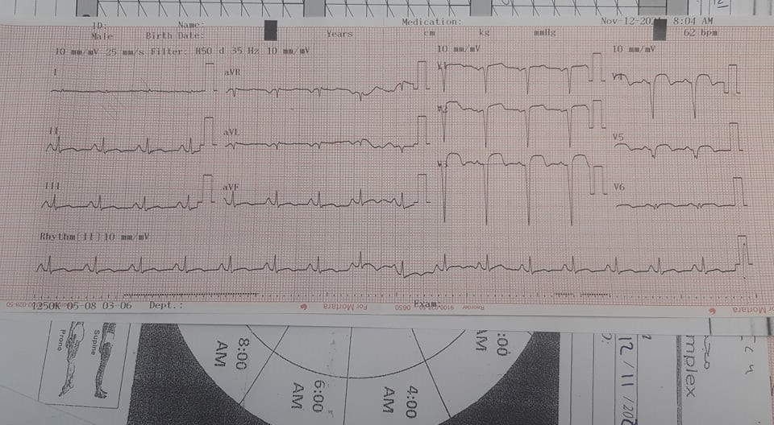**ECG :**

HR : 100 bpm

Regular

P wave : present , Ratio : 1:1

PR interval : 0.20 sec

QRS : 0.08 sec

ST segment : elevation .

**Laboratory Data:**

|  |  |  |  |  |  |
| --- | --- | --- | --- | --- | --- |
| **Test** | **Date** | **Patient’s Value** | **Normal Value** | **Interpretation/Reason for abnormality** | **Treatment done for abnormal findings** |
| **RBC** | 14-11 | 4.7 | 4.69-6.13  M\ul | The value is normal, in cases of RBC deficiency, the causes are either iron deficiency , Anemia . | It does not need treatment because the value is normal . |
| **WBC** | 14-11 | 17.6 | 4.6- 11k\ul | Examination sees increased white blood cells, and increased WBC indicates an infection. | Giving antibiotics to the cause of the infection . |
| **Sodium,**  **serum** | 14-11 | 140 | 135-145 | The value is normal and there is no defect, in case it has a defect, it may be due to diarrhea ….ect . | It does not need treatment because the value is normal . |
| **Potassium, serum** | 14-11 | 3.84 | 3.5-5 | The value is normal and there is no defect, in case it has a defect, it may be due to vomiting …ect . | It does not need treatment because the value is normal . |

1. **Pathophysiology**

**Summary and related to the patient:**

A.C.S : Acute Coronary Syndrome

is a name given to three types of coronary artery disease that are associated with sudden rupture of plaque inside the coronary artery:

- Unstable angina .

- NSTEMI .

- STEMI .

Used to describe a range of conditions associated with sudden, reduced blood flow to the heart ,If the supply of oxygen to the cells becomes too low, the cells of the heart muscles can die , the death of the cells results in damage to muscle tissue, and this is a heart attack or myocardial infarction.

In some cases, the cells do not die, but damage due to an inadequate supply of oxygen results in heart muscles that do not work correctly or efficiently ,the problem may be temporary or permanent. Unstable angina .

The location of the blockage, the length of time that the blood flow is blocked, and the amount of damage that occurs determines the type of acute coronary syndrome:

- Cardiac enzyme .

- Symptoms .

- ECG results

**S &S :**

1-Chest pain or discomfort

2- Pain or discomfort in one or both arms, the back, jaw, neck, or stomach

3-Shortness of breath

4-Dizziness or feeling lightheaded

5- Nausea or vomiting

**Causes :**

1-Older age – men of 45 years or older, women aged 55 years or older

2-High blood pressure or cholesterol

3- Smoking

4-Lack of physical activity

5-Unhealthy diet, obesity, or overweight

6- Family history

**Medications:**

|  |  |  |  |  |  |  |  |  |  |  |
| --- | --- | --- | --- | --- | --- | --- | --- | --- | --- | --- |
|  | **Generic Name** | **Trade Name** | **Dose** | **Route** | **Rationale** | **Action** | **Contra- Indications** | **Side Effects** | | **Nursing Consideration** |
| **1** | **acetylsalicylic acid** | **ASA** | 100mg  1*1 | Oral . | anticoagulant . | Prevent blood clots formation . | Low Vit K level .  Anemia .  Pregnancy .  Bleeding of  stomach . | Stomach irritation .Nausea . | | Assess other medication for possible interactions - especially warfarin which is a special hazard |
| **2** | **Prasugrel** | **Effient** | 10 mg  1*1 | Oral . | platelet inhibitor | inhibits ADP receptors by irreversibly acting on the P2Y12 receptor on platelets. | -Is not recommended in patients 75 years of age or greater, those that weigh<60kg, and patients with a history of stroke or transient ischemic attack . | Bleeding  Hypersens-itivity | may be taken without regard to food.  Instruct patients to take it exactly as prescribed. | |
| **3** | **Clexam** | **Clexan** | 80 mg  1*2 | IM or SC | anticoagulant . | stops unwanted blood clots from forming and can stop any blood clots that have already formed from growing bigger. | with caution in patients with the following conditions: hepatic insufficiency, a bleeding diathesis, uncontrolled arterial hypertension. | Itchy skin.  Pain  Bleeding at the injection site; | Assess for signs of bleeding and hemorrhage, including bleeding gums, nosebleeds, unusual bruising, black/tarry stools. | |
| **4** | **Pantoprazole** | **Pantover** | 40 mg  1*1 | Oral | Antiulcer agents | Prevents the transport of H ions into the gastric lumen by binding to gastric parietal cells, ↓ gastric acid production . | -Contraindicated for people with hypersensitivity | Vomiting.  Abd pain.  Dizziness.  Nausea . | Assess for occult blood.  Assess liver enzymes.  Assess symptoms of heart burn. | |
| **5** | **Rosuvastatin.** | **Rosulip** | 20 mg  1*1 | Oral | Reduces bad cholesterol | reduces bad cholesterol | - Is not recommended for use if pt is allergic to it.  - Avoid taking this medicine if Pt have liver problems | Nausea. weakness.  Muscle pain.  Stomach pain . | Tablet may be taken with or without food .  Tests to regularly monitor your lipid profiles to make sure the medicine is working properly. | |

**Nursing care Plan**

|  |  |  |  |
| --- | --- | --- | --- |
| **Nursing DX.** | **Nursing Action** | **Rationale** | **Evaluation** |
| Risk For acute pain r\t decreased myocardial blood flow . | - Observe for associated symptoms: dyspnea, nausea and vomiting .  - Take VS (HR) .  - Monitor heart rhythm.  - Provide supplemental oxygen . | - Decreased cardiac output stimulates sympathetic and parasympathetic nervous system, causing a variety of symptoms  - VS taken .  -Increases oxygen available for myocardial uptake and reversal of ischemia. | The goal was achieved, the patient is under observation sot any S&S abnormal , vital signs are taken every two hours |
| Pt has Cardiac output r\t changes electrical conduction | - Provide for adequate rest periods.  - Stress importance of avoiding straining down .  - Measure cardiac output . | - To reduces cardiac workload .  - Stress causes vagal stimulation, reducing heart rate (bradycardia), which may be followed by rebound tachycardia, both of which may impair cardiac output. | The patient was kept in a comfortable position, we put Foley's catheter to patient. To keep Pt in bed,  and the family was told to keep him away from any stress and bad news . |

**Discharge plan**

Pt education ,Eating healthy, Do exercising, avoiding smoking, and controlling cholesterol levels.

**Reflection** *:*

My experience with this case was fairly good and the patient was very cooperative.

I learned how to treat a patient identified as A.C.S and know what symptoms he might have and how he should be treated before being diagnosed.

I knew the disease, its causes, complications that may occur, how to treat it, and what we can offer of medicines and care .

**REFERENCES :**

**1- https://my.clevelandclinic.org/health/diseases/16713-cad-acute-coronary-syndrome**

**2-https://www.medicalnewstoday.com/articles/315332#Types%20of%20acute%20coronary%20syndrome**

**3-** [**https://www.webmd.com/drugs/2/drug-1082-3003/aspirin-oral/aspirin-chewable-oral/details/list-contraindications**](https://www.webmd.com/drugs/2/drug-1082-3003/aspirin-oral/aspirin-chewable-oral/details/list-contraindications) **.**

**4- https://www.nursingtimes.net/clinical-archive/medicine-management/aspirin-02-04-2005/**

**5 -** [**https://nursing.com/blog/pantoprazole-protonix/**](https://nursing.com/blog/pantoprazole-protonix/) **.**

**6-** [**https://pharmeasy.in/online-medicine-order/pantover-40mg-tab-150280**](https://pharmeasy.in/online-medicine-order/pantover-40mg-tab-150280) **.**

**7-** [**https://www.practo.com/medicine-info/rosulip-20-mg-tablet-9954**](https://www.practo.com/medicine-info/rosulip-20-mg-tablet-9954)