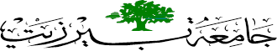
BIRZEIT UNIVERSITY
FACULTY OF NURSING and ALLIED HEALTH PROFESSIONS

Pediatric Case Study
- Student’s Name: Aya Arouri 1191397 . Date: 11\12\2021 .
- Clinical Instructor: Abd Alsalam Alsufi . Clinical Place: Ramallah Hospital
........................................................................................................................................
General Information:
- Initial name: A.A Date of admission: 10\12\2021 .
- Chronological Age: 7 month 10 day
- Sex : Male . Accompanied By: Her mother .
- Medical Diagnosis: First attach febrile convulsion
Past History: "10 points”
- Type of Delivery / Gestation:
Normal C-Section
Full term Premature (…… weeks)
- Date of Birth: 1\5\2021
- Birth history (pregnancy, labor, postnatal)
Pregnancy :was uneventful, and easy, in the first three months of the pregnancy , the mother was given folic acid, and after the 4th month, she was prescribed vitamins such as vitamin D and C, and after the seventh month, she was prescribed iron.
Labor : baby was delivered BY C-Section at week 38 , with birth weight of 2.800KG .
At the 38th week, the mother had a descent of amniotic fluid, she was given induction of labor, but to no avail, she was transferred to a C-section.

- Previous illnesses, injuries, or operations:
Baby had laryngomalacia
There are no past diseases , no history of fever or vomiting
No Dx of nausea , cough or cyanosis .
he did not do any surgery

- Allergies:
The child, at the age of two months, was allergic to formula milk (Similac 1), when he ate it, he vomited and bloated

- Current medication (including vitamins, antipyretics, antibiotics, antihistamines, decongestants, or herbs) :
Rocephin : ( Antibiotic , 216 mg Q12 hr , IV ) .

- Immunisation Statu:
All necessary vaccinations taken .

Up to date:
Vitamin – K
HBV ( Hepatitis B Virus )
BCG (Bacillus Calmette–Guérin)
IPV (INACTIVATED POLIOMYELITIS VACCINE)
OPV (Rotavirus vaccine)
Penta (Pentavalent vaccine)

- Identify deficient immunizations and why:
No incomplete vaccinations, and no vaccinations were delayed

- Chief Complaint:
A day before entering the hospital, the child suffered from symptoms: fever (39.8C), cough and runny nose , admitted to PW due to 1 episodes of abnormal movement in for unrolling of eye and loss of tonicity lasted about 5 min and spontaneously resolved
_________________________________________________________________________
Physical Examination :
- Measurements
 | Client Result | Normal range |  | Client Result | Normal range
Temp. | 36.4 | 36.5 – 37.5 | SPO2 | 97 % | 92-100%
Pulse | 140 | 80 – 140 bpm | Weight | 7.1 Kg | double his birth weight  ( 5- 9 kg )
B/P | 86\ 59 | 80-100\55-60mmHg | Height/Length | 67 Cm | 64-72 cm
Respiration | 33 | 25-40 breath\min | HC | 46 Cm | 43-46 cm
- Use growth chart

- Weight on admission: 7.200 Kg
- Weight changes "overall in past month " : 7.100 Kg
- calculate weight loss percentage if present : 7.2-7.1\7.2 * 100% = 1.38 g
Nutrition: "2 points"
- Type of Diet: Normal diet ( free)
Food Allergy: At the age of two months he suffered from an allergy to similic 1 and the parents changed it to similic advance plus
Other than this type of combination, he was not allergic to any food he ate .
- Appetite status during hospital: The child's appetite has not changed much because his appetite is not good before entering the hospital because he suffers from laryngomalacia
- Special Dietary Needs or Restrictions (WHY?) None Special Dietary Needs or Restrictions
- Factors affecting nutrition/intake: nausea, vomiting, anorexia, diet restriction, cough.
There are no factors .
______________________________________________________________________

- Elimination Pattern:
“2 points”
Baby does not eliminate naturally because he suffers from constipation, so the parents stimulate the stool with the thermometer (Vaseline is placed on it to facilitate its entry)
- Intake / Output: "1 point"

24 Hour Fluid Requirement:  SHOW YOUR calculation → | Calculate: 29,6 ml/hr  Baby weight is 7.100 kg  7.1 x 100ml = 710 ml DS in 24 hours
24 hour output | The mother changes the diaper 3 times a day (the mother is patient with the child when he urinates inside the towel)  urine output was about 0.52 cc /kg /hr

Family History: "2points"

- Family medical history:
Genetic disorders in the father’s family: the grandfather of the child suffers from stress problems, and the grandmother suffers from diabetes
As for the disorders on the mother’s side: the child’s grandmother suffers from diabetes
________________________________________________________________________
- Family Composition ( Genogram ) : Parents and baby ( first baby )

- Occupation and education of family members:
Father : high school ( Tawjeeh ) /handyman
Mother: Baccalaureus/housewife

- Family relationships: There is a relationship, father and mother cousins .

- Home environment: The child lives in a good environment, where the house is well ventilated, far from factories, and the surroundings of the house are full of trees .
_______________________________________________________________________

Physical Examination (Detail ) "30points"
- General:
The child looks well, active , baby has constipation , no dehydrated, no fever, no vomiting and nausea , no polar , no S&S of any distress .

- Skin:
No fever , the skin pinkish color ( normal ) and smooth texture , no dehydration , no pallor, baby has normal palmar creases .
- Eyes:
The eyes are symmetrical and no signs of redness (erythema), the eye has normal reflex to light , The eyelid and eyelashes have no redness or distortions , He does not have any vision problems , he doesn't use any glasses , pupil of equal size and same color ( black).

- Ears:
Ears are symmetric in size ,the ear position is normal ( auricle aligns with the corner of each eye), the ear canal does not have any secretions, earlobes no redness,

- Nose:
The nose is located in the middle of the face just below the eyes and above the lips , Able
to inhale when one of the other nostrils is blocked.

- Mouth/Throat:
Outward appearance is uniform in color, pink, has 2 teeth, gum line is moist & pink , not red, baby's tongue is soft and moist, uvula is in the midline and a fleshy ,Saliva drooling is evident .
Baby has laryngomalacia .

- Neck:
Normal range of motion. No swelling, pulsation in the carotid artery is present , normal
thyroid glands .

- Breasts:
Symmetrical nipples, no rash, no exudate or scar.

- Respiratory:
the chest symmetry in size and shape , The chest circumference is normal 42 cm (less than the head circumference at the age of less than a year) , The movement of the chest wall is bilaterally symmetrical and coordinated with breathing .
Breathing sound is abnormal (wheezing ) , Sat 97% , RR 33 breath per min.

- Cardiovascular:
Baby has apical pulses regular and normal , he has regular rhythm (140 bpm) , good
blood circulation, extremities are warm, no edema, no redness, no cyanosis , All the
pulses in the arteries are present (femoral, carotid, radial, brachial..) .

- Gastrointestinal:
The baby's abdomen is cylindrical in shape , prominent and Tighten uniformly, without creases or wrinkles .
The navel is a normal size and shape, flat and protruding slightly and clean, without any deformities such as a hernia.

- Genitourinary:
The penis and torso have no signs of swelling, skin lesions or infections
The meatus of the urethra is localized at the tip of the glans.

- Musculoskeletal:
The spine is normal, no deformation, all joints ROM are normal and good, there is no cyanosis or swelling , joint no pain .

- Neurologic:
The baby conscious , It has all the reflexes, and its presence means that the nervous system is normal , Examples of normal reflex in a child (rooting and sucking reflex , grasp reflex startle reflex , tonic neck reflex , walking-stepping reflex , moro reflex).

- Endocrine:
The child has normal endocrine glands when do palpation there is no hypo/
hyperthyroidism .

Activity: "2 points"

- Describe child activity:
The child is hyperactive, he is fed formula every three hours, he sleeps well, but if he feels in pain, he does not sleep well (according to the mother), the child accepts everyone and smiles at everyone who plays him .

- Describe therapeutic play activities appropriate for this child during hospitalization:
Because the child was his first day in the hospital, he did not have toys, when I asked the mother about the availability of toys with the child or not, she told me that the father of the child went to buy toys for the child

- Discuss age appropriate safety measures (not hospital safety):
The mother burps the baby after every feeding of formula milk , put the baby to sleep on his back .
__________________________________________________________________________
Sleep and Rest Pattern: "1 points"

- Sleep requirement for age: The normal sleep rate for a seven-month-old child is 10 to 12 hours per day
- Usual 24 hour pattern: He sleeps 10 hours every night .
- Last 24 hour pattern: He could only sleep for 2 hours, and he had a fever all night long .
- Sleeping problem ( at home / hospital ) : None

Pain: "2 points"
- Pain Scale used: Face scale.
- Pain Score: 6 (sever)
- Describe pain characteristics:
He suffers from pain in general, especially in his back, because he was tested for meningitis .

- Usual relief methods and effectiveness:
After the meningitis examination, the child was returned to his mother. There is no need for treatment. He only needs to relax once, but if the pain becomes more severe, we give him an analgesic.
________________________________________________________________________

Discharge Teaching:
- Identify at least three teaching points for the parent and/or child (anticipatory guidance, illness prevention, safety, etc.). Highlight any teaching completed during clinical.
"3 points"
1- Telling the mother to pay attention if the child suffers from high fever, then she should try to reduce it by using water compresses and give a fever reducer such as Akamol.
2- The child's weight must be monitored weekly to see if the child is gaining weight or losing weight and reporting this , and always give the child the medicine that was prescribed by his doctor , In the event of side effects due to the medication, report them
3- Telling the family if convulsions occur with him again, the child should not be shaken, and he must be placed in a safe place ,and if convulsions occur and there is food in his mouth, he must put his head to the side .

Patient Labs or Diagnostic test: (Include most recent lab test / diagnostic procedures / X - ray) "5points"
(Use external paper)
Date | Name of Lab | Result | Normal Value | Rational for the result
10-12 | WBC | 16.4 K\ul | 4.6-11 K\ul | High because febrile convulsions may be caused by a bacterial infection.
10-12 | RBC | 5.25 M\ul | 3.9 5.3 M\ul - | Normal Valve .
10-12 | CBC haemoglobin | 34.5 % | 33-42 & | Normal Valve
11-12 | Sodium serum | 137 | 135-145 mmol\l | Normal Valve
11-12 | Potassium | 5.1 | 3.5-5.3 mmol\l | Normal Valve

Chest X-ray :

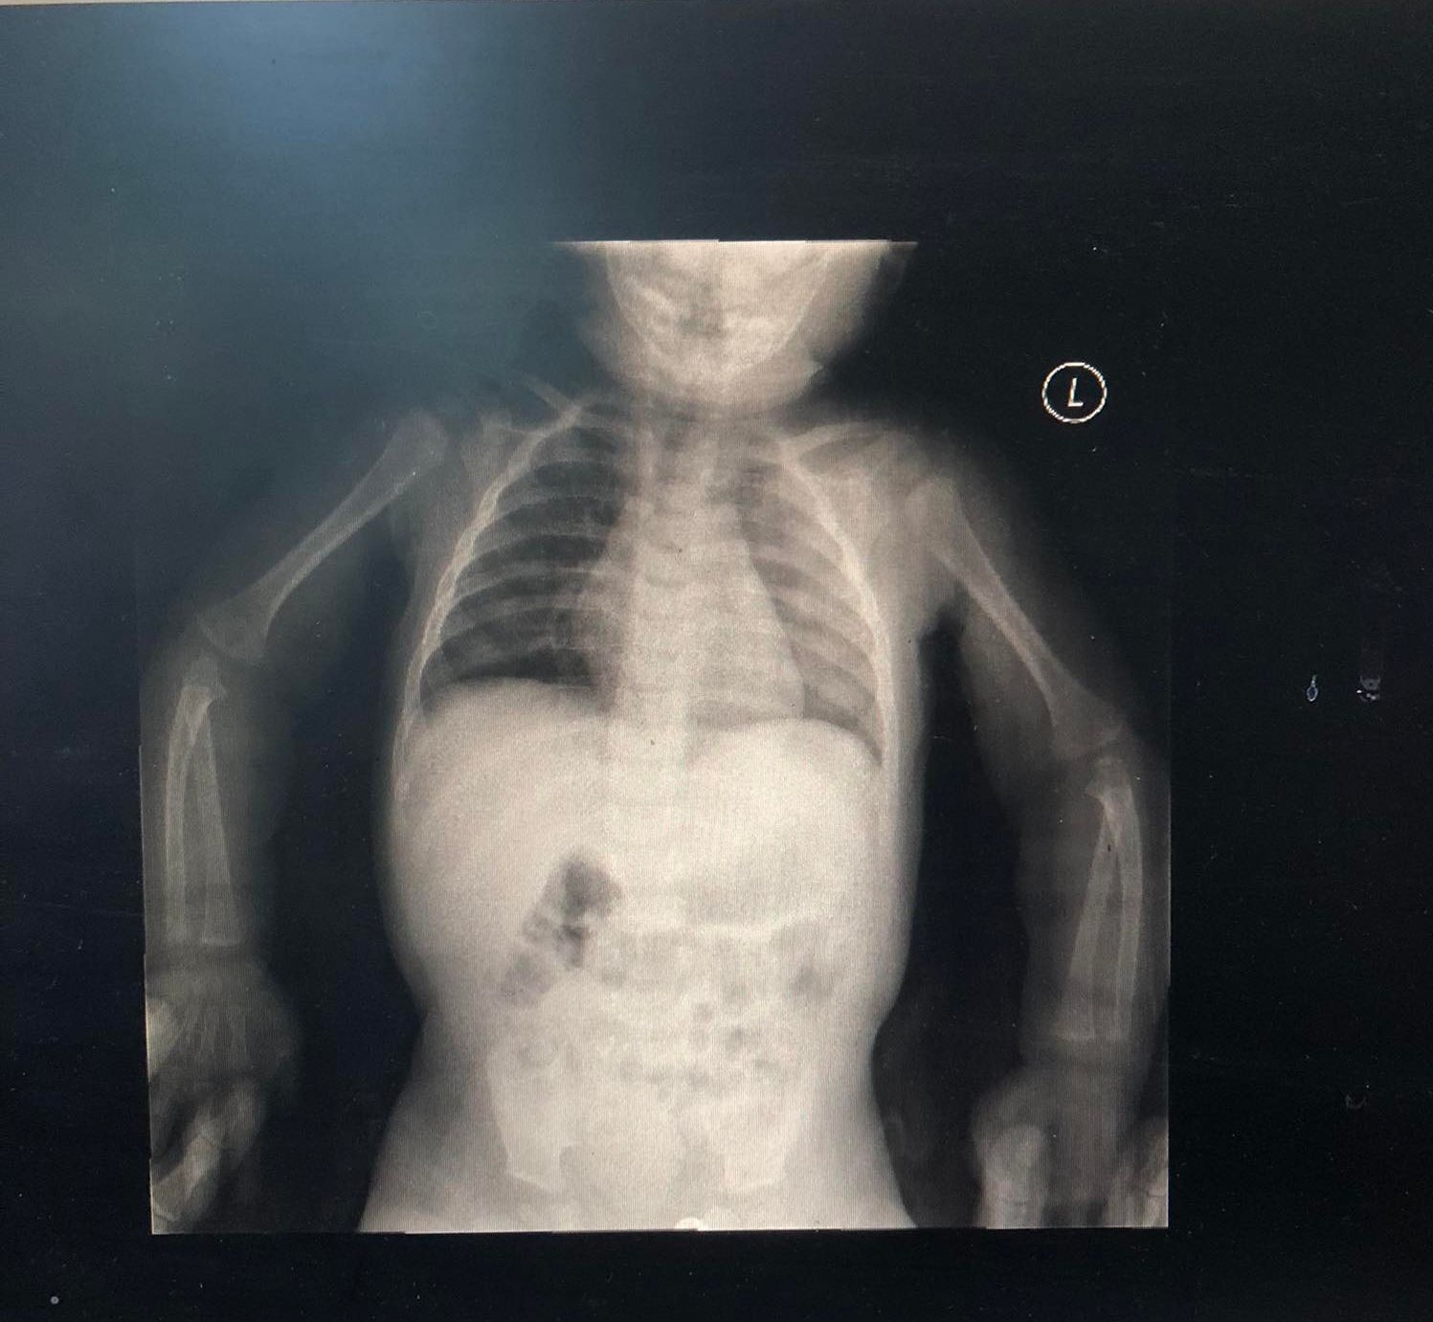

Patient Medication: "5points"
(Use external paper)
Only one medication is prescribed
Medication Name / Generic Name | Dose  --mg/kg  ( Text ) | Prescribed dose | Route / Frequency | Action | Nursing Implication  (Dose safe !!)
Rocephin | -- | 216 mg | IV  Q12hr | Antibiotic  (It works by stopping the growth of bacteria) . | Monitor seizures (if the patient develops or increases seizure activity, it must be reported immediately .  Watch for severe digestive problems (nausea, vomiting, heartburn).
Related Pathophysiology according to the case : (references.)
First attach febrile convulsion : is a fit that occurs in children when they have a high fever , This can happen in children aged 6 months to 6 years , It's not epilepsy and does not cause brain damage ,Whether they are short or long convulsions.
The fit lasts from 2 to 3 minutes and may last up to 15 minutes. If it lasts more than 5 minutes, the child must be taken to the hospital directly.
We can't know when the convulsions will occur , Don't shake or slap your child.
Caused by a bacterial or virus infection .
S & S : 1 loss of consciousness
- eye rolling, so only the whites of their eyes are visible
- twitching of arms and legs
- foaming at the mouth
- breathing difficulty
- pale in skin color
Treatment :
First : fever treatment: Do not overdress them, give them plenty of fluids to drink and give liquid paracetamol or ibuprofen if your child is in pain
The child may need an antibiotic if the infection is bacterial .
https://www.betterhealth.vic.gov.au/health/conditionsandtreatments/fever-febrile-convulsions

Nursing Care Plan: "20 points"
(at least 5 Nsg Dx.)

Nursing diagnosis with long and short term goals | Nursing interventions | Supporting rationale | Evaluation
- Risk of hyperthermia related to bacteria or virus infection .  * Short goal: maintain a normal temperature and prevent overheating  * Long goals: treatment of infection. | - Giving enough fluids (based on the calculations).  - Giving an antipyretic  - Making water compresses . | - Reduce the temperature and do not let it rise too much so that the child does not have convulsions again.  - To prevent Dehydration. | His temperature did not rise again after treatment for the first time, rest in the normal range .  No symptoms of dehydration, fluid intake gave him IVF DS 0.9% at rate 30 cc/hr .  The child also gives up formula 6 times a day, every third of the hour, 90-120 cc  The child had an abnormal sound (wheezing), but it did not reach the point of needing treatment (the breathing is normal and there is no difficulty in it)  The weight of the child was taken and there was a decrease in 1 g .  The parents were taught how to keep the child safe during the seizure and the need to transfer him to the hospital if it lasts five minutes
- Risk of airway dysfunction r\t bronchial or trachea obstruction  *Short term: keep the airway open  * long term: getting rid of infection | -Doing suck (if needed) .  - Elevate the head of the bed.  - Auscultate lungs .  - Provide supplemental O2  ( if needed )  - Monitor baby weight . | In order not to have difficulty breathing, the child also suffers from laryngomalacia, so attention must be paid to the airway so that aspiration does not occur or a foreign body is stuck (choking).
- Risk of injury r\t convulsions (When the level of consciousness decreases during the period of convulsions)  *Short term: To keep the child safe when the seizure occurs  * long term: Treatment the infection . | - Teaching parents how to deal with a child to keep him safe during a seizure  Put the child in a safe place  Do not shake the baby | To prevent problems caused by injury  To protect the baby

