

**Subject:**

Nephrology Rotation

**Homework:**

Proteinuria: what does +3 reflect in urinalysis?

**Instructor:**

Dr. Sona Ladadweh

**Name:**

Noor Ayman Kamel Aburub

**ID:** 1151170

The expressions that are used in urine tests (trace, +1, +2, +3 and +4) are based on protein reagent strip (shown in figure1 below), each expression indicates:

Trace: < 30mg/dL (≈15 mg,dL)

+: 30mg/dL

++: 100mg/dL

+++: 300mg/dL

++++: ≥1000mg/dL

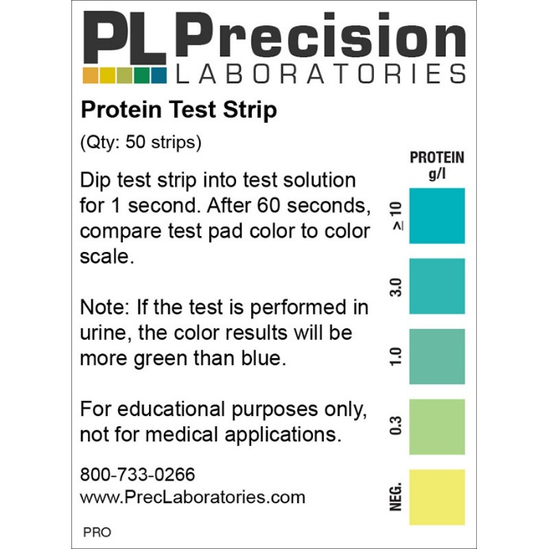

+4

+3

+2

+

Figure1: dipstick readings and corresponding values.

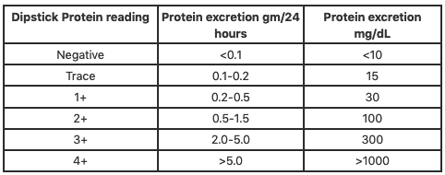

Table1: Protein excretion g/24h and in mg/dL for each dipstick reading.

**Reference:**

Cadogan, M., &amp; Emily. (2020, November 03). Dipstick urinalysis • LITFL • CCC Investigations. Retrieved November 16, 2020, from <https://litfl.com/dipstick-urinalysis/>

**Reference:**

* Cadogan, M., &amp; Emily. (2020, November 03). Dipstick urinalysis • LITFL • CCC Investigations. Retrieved November 16, 2020, from https://litfl.com/dipstick-urinalysis/