**Introduction:-**

Extraction:-  
Dictionary: action of extracting something, Chemically: Separation of a substance from a matrix(The Components of the sample) and Pharmaceutically: Separation of medicinally active portions ,of plant or animal tissue, from the inactive components, by using selective solvent in standard extraction procedures.

An extract is a concentrated preparation of liquid(Fluid extract or tinctures), intermediate(Semi-liquid)or solid(Dry extract) consistency normally produced from dried botanical(Plant) or zoological material(Animal) by a technique involving the use of adequate solvents for obtaining a mixture of compounds. Extracts are prepared by Maceration, Percolation or other suitable, validated methods using ethanol or another suitable solvent. After extraction, unwanted material may be removed it this is deemed appropriate. Three types of extract: Type A, Standardized extracts, extracts standardized to active constituents, Type B, Quantified extracts, extracts standardized to constituents that contribute to the activity, and Type C, Other extracts, extracts standardized to lead compounds of unknown pharmacological relevance, which serve as quality markers.**(1)**

**Discussion:-**

Extraction is a method use to get or remove compounds from mixture(something), there are several methods to do this:-

**1- Liquid-Liquid Extraction(LLE):** Method to separate compounds, based on their relative solubility in two different immiscible liquids. Another name for this method is Solvent Extraction; choose a suitable solvent for the separation of a substance from a mixture by preferentially dissolving it.

The difference between Single and Multistage Batch Extraction:- 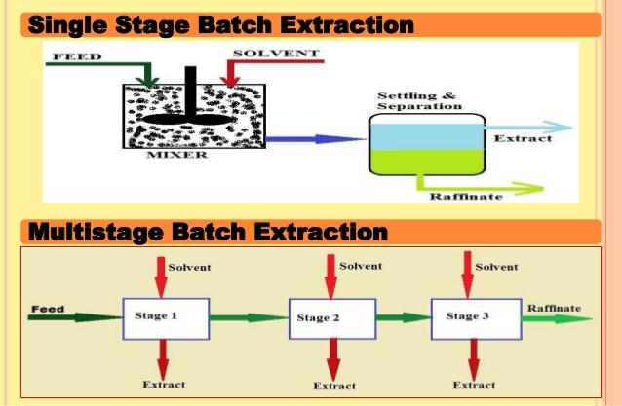

**Figure 1 : Single and Multistage**  
**Raffinate (from French *raffiner*, to refine) is a product which has had a component or components removed**

**2- Solid Phase Extraction(SPE):** SPE is a sample preparation technology that uses solid particle and bringing a liquid test sample in contact with a solid phase. The solvent(Liquid of Gas) is Mobile phase and The solid is Stationary phase. Elute is the process of extracting one material from another by washing with a solvent. Ex. Chromatography and Hot Continuous Extraction (Soxhlet)

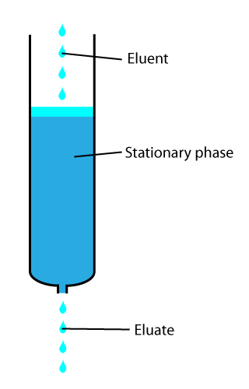

**Figure 2 : Elute Figure 3 : Soxhlet**

**3- Acid-Base Extraction:** This method like LLE and use to extract(Separate) acid or base from mixtures based on their chemical properties.

**4-Maceration :** Powdered Crude drug is placed in a stoppered container with the solvent and allowed to stand at room temperature for a period of 2-3days with frequent moving until the soluble matter(Drug) has dissolved. The mixture then is strained,the marc (the damp solid material, practically free of visible solvent) is pressed, and the combined liquids are clarified by filtration or decantation after standing. Another method is Digestion, used heat during this process, and used when moderately elevated of temperature is not objectionable.**(2)**

**5- Supercritical Fluid Extraction:** Is the process of separating one component from another by using supercritical fluids as the extracting solvent. Supercritical carbon dioxide(Famous type ofSupercritical Fluid ): is a fluid state of carbon dioxide where it is held above its critical temperature(304.25 K, 31.10 °C) and critical pressure(72.9 atm). Advantages of Supercritical CO2 are: Inexpensive, Non-flammable, It can be easily recycled, and easily removed from the product(Evaporates completely), and Safe and Abundant. However, Disadvantage of Supercritical CO2 is non-polar, so cannot always be used as a solvent for polar solutes. Disadvantage of this method is quite expensive.

**6-** **Counter-current Extraction:** Wet raw material is pulverized using toothed disc disintegrators to produce a fine slurry. In this process, the material to be extracted is moved in one direction within a cylindrical extractor where it comes in contact with extraction solvent. The further the starting material moves, the more concentrated the extract becomes. Complete extraction is thus possible when the quantities of solvent and material and their flow rates are optimized. The process is highly efficient, requiring little time and posing no risk from high temperature. Finally, sufficiently concentrated extract comes out at one end of the extractor while the marc falls out from the other end.(2)

**7- Ultrasound Extraction (Sonication):** The procedure involves the use of ultrasound with frequencies ranging from 20 kHz to 2000 kHz; this increases the permeability of cell walls and produces cavitation, its large-scale application is limited due to the higher costs. One disadvantage of the procedure is the occasional but known deleterious effect of ultrasound energy (more than 20 kHz) on the active constituents of medicinal plants through formation of free radicals and consequently undesirable changes in the drug molecules.(2)

**Conclusion:-**

In conclusion, extraction is very important for us to discover, take out or use something and there are a lot of examples of extraction like Decaffeination of coffee and etc..

**Reference:-**

1. Michael Heinrich, Joanne Barnes, Simon Gibbons, and Elizabeth M. Williamson, Fundamentals Of Pharmacognosy And Phytotherapy(Elsevier Limited(Churchill Livingstone), United Kingdom, 2004).

1. Sukhdev Swami Handa, Suman Preet Singh Khanuja, Gennaro Longo, Dev Dutt Rakesh. 2008. Extraction technologies for medicinal and aromatic plants, International centre for science and high technology.