**RESPIRATORY LAB**

ZOOLOGY 142L

TABLE OF CONTENTS

Introduction and Background

Basic Anatomy

Physiology

Functional Lung Volumes and Capacities and Restrictive Pulmonary Conditions

Definitions

Nomograms

BTPS

Effect of Restrictive Lung Disease Conditions

Flow rates (l/s) and Obstructive Pulmonary Conditions

Definitions

Nomograms

BTPS

Effect of Obstructive Lung Disease Conditions

General Methods Description

Respiratory Lab Instrument Information and Operation

Volumes And Capacity Experiments

Objectives

Materials

Procedures

Laptop Computer and LabQuest Unit Setup

Spirometer Transducer

Tidal Volume (TV)

Inspiratory Reserve Volume (IRV)

Expiratory Reserve Volume (ERV)

Forced Vital Capacity (FVC)

Total Lung Capacity (TLC)

Flow Volume Loop Experiments

Objectives

Materials

Procedures

Laptop Computer and LabQuest Unit Setup

Spirometer Transducer

Forced Expiratory Volume, at one second (FEV1)

Forced Vital Capacity (FVC)

Peak Expiratory Flow (PEF) Rate

Collins Respirometer Data Parameters

Collins Spirometer Operation

Respiratory Graph Measurements

APPENDIX A

Hypothesis: Effect of Asthma on Pulmonary Function Test Results (Diagnostics)

ASTHMA

Definition

Acute Asthma

Video

Chronic Asthma

Symptoms

Causes

Risk factors

Tests and diagnosis

Treatments and drugs

Long-term control medications

Quick-relief medications

Medications for allergy-induced asthma

APPENDIX B

Experimental Design: What Measurements Would Provide the Data to Address the Hypothesis

I. Introduction and Background

The respiratory system provides exchange of oxygen (O2) and carbon dioxide (CO2) between the external air and the blood. The respiratory system consists of the nasal cavity, pharynx, larynx, trachea, bronchi, and lungs.

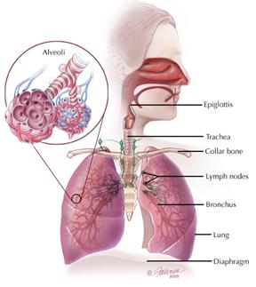

A. Basic Anatomy

1. Tissue characteristics

The lung tissue has three basic physical properties that allow the volume to increase and decrease in order to exchange the air.

**Extensibility** is the property that allows the lung tissue to stretch easily without damage, and expand the volume to bring in air.

**Elasticity** causes the stretched tissue to recoil back to a normal relaxed lung volume. The elasticity is due to the rubber-band nature of the elastin fibers that contract back to a shorter length once they are no longer stretched. The attraction of polar water molecules for each other (surface tension) in the thin layer of inside alveoli pulls the water into a smaller volume. The counteracting effect of molecules called surfactant prevent the surface tension from pulling the layer of water together into a solid droplet, which would completely collapse the alveoli.

The term **compliance** is defined as the ease of expansion of the lungs volume. This means the lung tissue stretches easily, or in other words, it takes a small vacuum (negative pressure) to expand the lung volume.

2. Gross anatomy

Air flows through the pharynx, larynx, trachea, then into the bronchi of the lungs. The bronchi branch many times, into smaller tubes called bronchioles. The bronchioles narrow to become terminal bronchioles and then finally respiratory bronchioles.

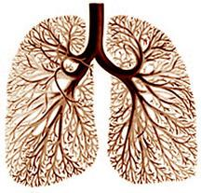 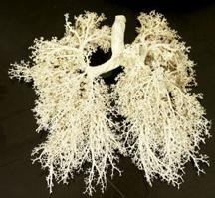

The respiratory bronchioles connect to the alveolar antrum, which is the entry to the alveolar sac, a cluster of many alveoli.

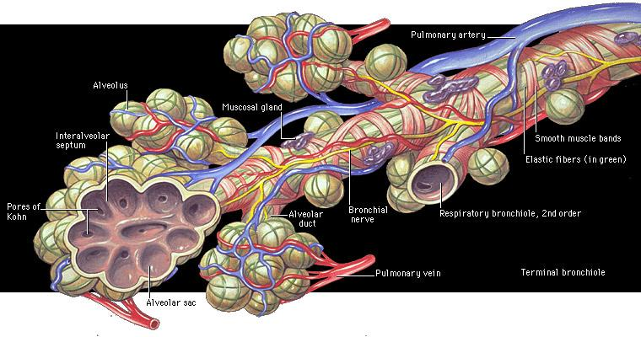

The alveoli are surrounded by pulmonary capillaries, where oxygen and carbon dioxide diffuse from the air into and out of the blood.

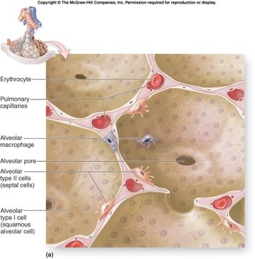

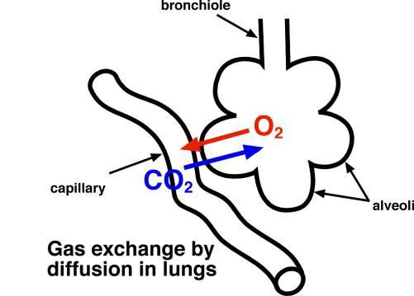

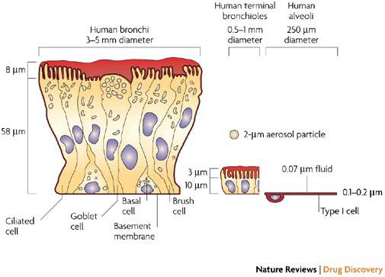

The chest wall is rigid yet somewhat flexible due to the ability of the ribs to move slightly. The diaphragm muscle, between the thoracic and abdominal cavity is the major muscle that produces inhalation during quiet breathing. When the diaphragm contracts it changes from a dome shape to a flatten sheet of muscle that pulls the lung tissue downward, expanding the lung volume, causing a lower pressure inside the lungs, and so draws air in. The external intercostals muscles can move the ribs outward, and the neck muscles can pull the ribs upward, which also expands the lung volume to assist in active inhalation.

Normal, quiet exhalation is a passive movement produced by the elastic recoil of the chest wall, elastin connective tissue fibers of the lungs, and the water surface tension inside the alveoli. Forced exhalation during exercise also requires the contraction of the internal intercostals muscles that pull the ribs together, and abdominal muscles that push the diaphragm upward. All these actions compress the lungs, decrease the volume, increase the alveolar pressure, and pushes the air out of the lungs.

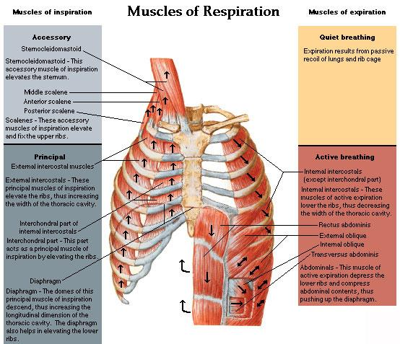

The lungs are only physically connected to the chest by the bronchi, blood vessels, lymph vessels, and nerves that pass through the hilus. There is a pleural space between the chest wall and lung tissue. The pleural space is filled with a very thin layer of serous fluid, produced by the serousal cells, that provides lubrication, so the lung tissue slides along the inner surface of the chest wall when they expand and contract. The serous membrane is continuous along the walls of the pleural space, called the parietal pleura on the chest wall and the visceral pleura on the surface of the lung tissue.

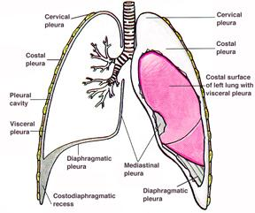

The serousal cells absorbs gas out of the pleural space, which creates a small vacuum (-5 cm H2O) and pulls the pliable lung tissue up against the more rigid chest wall and diaphragm, and keeps it there.

In order to inhale the pressure inside the lungs needs to be less than outside the lungs. So, when the diaphragm moves down and chest wall moves out during inhalation the pressure in the pleural space becomes more negative (-8 cm H2O, see diagram below,c). The lung tissue is pulled along by the vacuum, and so the pressure in the alveoli becomes negative (b), which draws air in through the trachea and increases the tidal volume (a). Once the air fills the lungs the pressure is equal to the air outside, and no more air is drawn in. When the exhalation begins the elasticity and water surface tension pulls the lung tissue inward, and the vacuum in the pleural space draws the relaxed diaphragm and chest wall inward also. Examine the pressure and volume changes during breathing (**see diagram**).

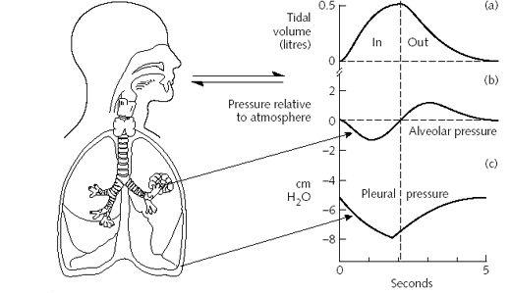

B. Physiology

Lung physiology (function, operation) involves the processes that cause and also effect the movement of air in and out of the lungs. There are two major conditions that effect normal lung function. Conditions that limit the volume (l) of lung expansion (inhalation) or contraction (exhalation) are called **restrictive**. Conditions that limit the air flow rate (l/s) of lung expansion (inhalation) or contraction (exhalation) are called **obstructive**.

**Functional Lung Volumes and Capacities**

(see Pulmonary Function Test [PFT] diagram below)

(l = volume in liters)

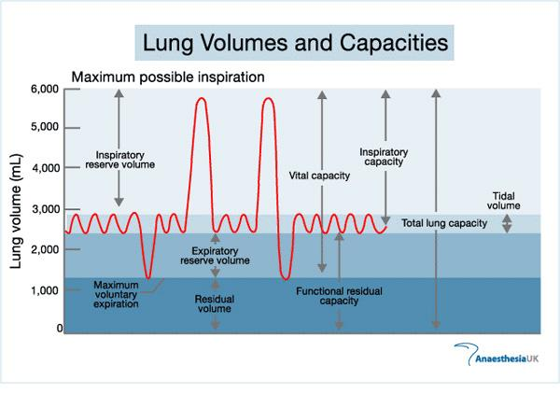

In normal breathing at rest, approximately one-tenth of the total lung capacity is used. Greater amounts are used as needed (i.e., with exercise). The following terms are used to describe lung volumes (see Figure 1):

***Tidal Volume* (TV):** The volume of air breathed in and out without conscious effort

***Inspiratory Reserve Volume* (IRV):** The additional volume of air that can be inhaled with maximum effort after a normal inspiration

***Expiratory Reserve Volume* (ERV):** The additional volume of air that can be forcibly exhaled after normal exhalation

***Residual Volume* (RV):** The volume of air remaining in the lungs after maximum exhalation (the lungs can never be completely emptied)

***Vital Capacity* (VC):** The total volume of air that can be exhaled after a maximum inhalation: VC = TV + IRV + ERV

***Functional Residual Capacity (FRC):*** The volume of air remaining in the lungs at the end of a normal expiration: FRC = ERV + RV

***Total Lung Capacity* (TLC):** = VC + RV

***Minute Ventilation*:** The volume of air breathed in 1 minute: (TV)(breaths/minute)

In this experiment, you will measure lung volumes during normal breathing and with maximum effort. You will correlate lung volumes with a variety of clinical scenarios.

**Functional Lung Volumes and Capacities** are indicators of the effect of problems with lung tissues (epithelia, connective, scar, muscles, surfactant, interstitial). The **Vital Capacity** (**VC**) test is the indicator of **restrictive disease symptoms**. These problems "restrict" the expansion (inhalation) and contraction (exhalation) of the lung tissue or chest wall, and so limit the total volume of air that can be taken in and/or out (i.e. the Vital Capacity = VC). When air is forced out as fast as possible during the VC test, it is called a Forced Vital Capacity (FVC). The FVC results can also be used to determine how fast air flows out of the lungs (a flow rate, l/s), by measuring the volume (l) of air that is exhaled in the first second (s), called the Forced Expiratory Volume in one second (FEV1.0). There are also other ways to measure the flow rate, which will be discussed later.

**Nomograms**

When measuring lung volumes and capacities for diagnostic purposes it is important to know what is considered normal. That way it is known when a measurement is abnormal and may indicate a restrictive lung condition. The following equations are called “**nomograms**” (could be called normalgrams), which give normal values for FVC and FEV1.0. The nomograms were made by measuring thousands of people, who did not have respiratory diseases. It was determined that measurements that were at least 85% of the values predicted by the nomogram equations meant that there was no restrictive lung conditions. So, if you calculated your FVC or FEV1, and **multiply by 0.85**, the value would be the minimum that would show if your actual measured values were normal. In the equations the **height is in centimeters (2.54 x inches) and the age is in years**.

**Males (values corrected to BTPS)**

FVC = (0.0713 × Height) – (0.0265 × Age) - 6.463 = liters

FEV1.0 = (0.0553 × Height) – (0.036 × Age) - 4.182 = liters

**Females (values corrected to BTPS)**

FVC = (0.04315 × Height) – (0.02185 × Age) - 2.83 = liters

FEV1.0 = (0.0347 × Height) – (0.0252 × Age) - 1.929 = liters

**BTPS**

The FVC and FEV1.0 are volumes measured by instruments that are outside the body, in the conditions of temperature, pressure (atmospheric), and humidity (saturation) of the laboratory. These environmental conditions are different from the inside the lungs, called **Body Temperature and Pressure, Saturated (BTPS).** Each of the conditions affects the volume of air. An increase in temperature of a set number of degrees increases the air volume a set amount, which can be calculated (25°C is usual in a room, 37°C is normal in the lungs). An increase in pressure by a set number of mmHg decreases the air volume a set amount, which can be calculated (760 mmHg [1 atm] is normal in the room and in the lungs). An increase in humidity (water in gas form) by a set Relative Humidity (RH,65% is usual in a room, 100 % saturated = maximum level = normal in lungs) increases the air volume a set amount, which can be calculated. Since the value of each of these conditions in the body and the laboratory is known, a **correction factor** (number) can be computed. The FVC and FEV1.0 values you measure are multiplied by the correction factor to determine what the volumes would be inside your lungs (BTPS). **Generally the correction factor is 1.1**. The nomogram equation values (above) are already corrected to BTPS.

FVC measured, or FEV1.0 measured = uncorrected (room conditions)

(FVC measured or FEV1.0 measured) x 1.1 = corrected to BTPS

**Effect of Restrictive Disease Conditions**

There are a number of restrictive diseases that decrease FVC due to **diminished compliance**, which means that it takes more negative pressure to inhale the same volume, compared to normal. When a disease causes deep tissue damage it produces inflammation that leads to **scar tissue** formation (collagen fibers), which requires more force (vacuum pressure) to stretch. These conditions tend to limit how much the lungs can expand, and so decreases the **IRV**. There are a number of these types of conditions that produce **restrictive lung disease**.

a) tuberculosis

b) emphysema

c) chronic asthma

d) chronic bronchitis

e) fibrotic pleuisy

f) lung cancer

There are also a number of other restrictive diseases that decrease FVC due to **pulmonary congestion** (increase in interstitial or intra-alveolar fluid). These conditions **fill the lung tissue and alveolar space with water**, and so limit (restrict) the volume in the chest cavity that can be filled with air. Congestive conditions tend to fill the internal volume of the lungs and so also tend to limit the volume remaining in the lungs at the end of an expiration, the **RV and so FRC**. There are a several of these types of conditions that produce **restrictive lung disease**.

a) pulmonary edema

b) decreased left heart output or failure (congestive heart failure)

c) lung infections

The graphs are shown upside-down compared to the graphs above (expiration is upward).

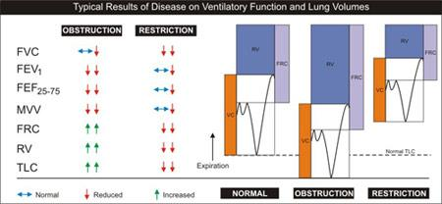

2. **Flow rates (l/s) and Obstructive Pulmonary Conditions**

Air flow rate (l/s, how fast the air moves) is effected by openness of the airways, like the bronchi, and bronchioles. The term openness means how large is the cross-sectional area of the airway through which air can move, which is related to the diameter of the airway (A=Πd2/4),( Π=3.14). The area affects the resistance (friction) to the air flow, as shown in the Ohms law relationship (F=ΔP/R). Ohms law indicates that when the difference in pressure (ΔP) between to places increases (more force pushing the air) the Flow rate increases. Whereas, when the resistance (R) increases (smaller diameter, opening) the flow rate decreases (R=16/d4). This means that resistance (R) is related to the cross-sectional area of the airways [R=9.87/A2], showing that as the area of the airways decrease the R increases a lot.

Any condition that obstructs the airways decreases the openness, decreases the area, increases the resistance, and so decreases the flow rate. So, **obstructive** pulmonary conditions decrease the flow rate of air through the airways. A well-known example is Chronic Obstructive Pulmonary Disease (**COPD**), caused by smoking cigarettes.

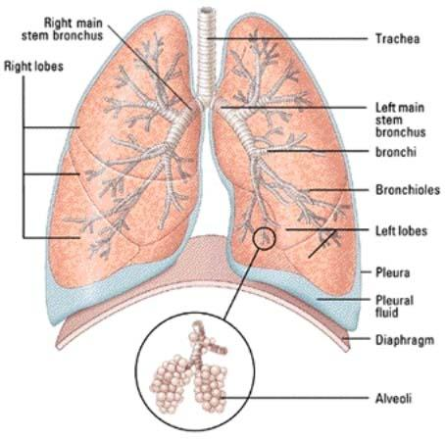

There are a number of ways to measure flow rate that indicate the condition/health of the airways at different levels.

**Definitions**

FEF = Forced Expiratory Flow rate = l/s

PEF = Peak Expiratory Flow rate = max rate = l/s

FIF = Forced Inspiratory Flow rate = l/s

PIF = Peak Inspiratory Flow rate = max rate = l/s

FEV = Forced Expiratory Volume = volume at specified parameters (different times after the start of FVC)

a) FEVx [x = seconds = 0.5, 1.0, 3.0]

The flow (FEF,FIF) at different proportions of FVC also indicates problems at different structural levels in the lungs.

FEF 0-25% of FVC, flow related to upper bronchial tree (bronchi)

FEF 25-50% of FVC, flow related to mid-level bronchioles

FEF 50-75% of FVC, flow related to bronchioles nearest to the alveoli (terminal and respiratory bronchioles)

**Nomograms**

It was determined that measurements that were at least 85% of the values predicted by the nomogram equations meant that there was no obstructive lung conditions. So, if you calculated your FEV1 or FEF25–75%, and **multiply by 0.85**, the value would be the minimum that would show if your actual measured values were normal. **Height in centimeters (2.54 x inches), age in years.**

**Males (values corrected to BTPS)**

FEV1.0 = (0.0553 × Height) – (0.036 × Age) - 4.182 = liters

FEF25–75% = (0.0195 × Height) – (0.043 × Age) + 2.683 = liters

**Females (values corrected to BTPS)**

FEV1.0 = (0.0347 × Height) – (0.0252 × Age) - 1.929 = liters

FEF25–75% = (0.0125 × Height) – (0.034 × Age) + 2.918 = liters

**BTPS**

The FEV1.0 and FEF25–75% values you measure are multiplied by the correction factor to determine what the volumes would be inside your lungs (BTPS). **Generally the correction factor is 1.1**.

FEV1.0 measured ,or FEF25–75% measured = uncorrected (volume in room conditions)

(FEV1.0 measured ,or FEF25–75% measured) **x 1.1** = corrected to BTPS

**The Effect of Obstructive Lung Conditions**

Conditions that directly damage or produce an immune response (allergies) in the lining of the airways causes inflammation. **Inflammation** produces smooth muscle constriction, edema (swelling), and excess mucous secretion. Since the airways are surrounded by stiff cartilage rings, or plates, the inflammatory conditions cause the tissues to expand inward, which **constricts the airways**. The constriction obstructs the airway by decreasing the area, increasing the resistance, and therefore decreasing the air flow rate (FEVx, FEF). **Obstructive diseases** include;

a) acute bronchitis (swelling of the bronchi)

b) pneumonia (fills the airways with fliud)

c) acute asthma (inflammation and swelling of bronchi)

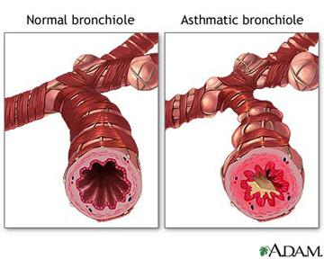

**GENERAL METHODS DESCRIPTION**

There are two methods that are often used to measure flow rates if respiration.

The first method is a modification of the lung volume and capacities measurement technique for the **vital capacity** (VC = maximum voluntary exhalation volume = TV+IRV+ERV). In this method the subject takes a maximum inhalation volume (IC=TV+IRV) and forces out a maximum exhalation (ERV) into the spirometer as fast as possible, which is the Forced Vital Capacity (FVC). The Forced Expiratory Volume in the first second (FEV1.0) is a flow rate (l/s), since it is the volume (liters) per time (second).

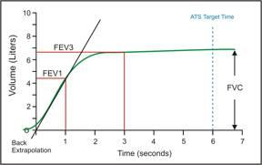

The second method is called the **Flow Volume Loop**, since the measured values are the flow rate (l/s, on the y-vertical axis) and volume (l, on the x-horizontal axis), and the graph ends where it started (sometimes) making a loop.

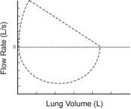

All the flow rate values can be measured on the Flow Volume Loop. The main values that are observed are the PEF, FVC, and FEV1.0. (see figure below)

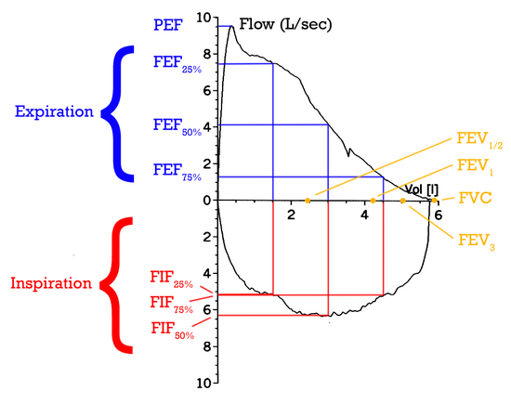

**Respiratory Lab Instrument Information and Operation**

**VOLUMES AND CAPACITY EXPERIMENTS**

**OBJECTIVES**

In this experiment, you will

1. Obtain graphical representation of lung capacities and volumes.
2. Compare lung volumes.

**MATERIALS**

| computer | disposable mouthpiece |
| --- | --- |
| Vernier computer interface | disposable bacterial filter |
| Logger *Pro* | nose clip |
| Vernier Spirometer |  |

**PROCEDURE**

**Important:** Do not attempt this experiment if you are currently suffering from a respiratory ailment such as the cold or flu.

**I. Laptop Computer and LabQuest Unit Setup**

A. LabQuest Unit

1. Plug in charger/transformer into a 110V AC outlet, and connect the power line to the LabQuest Unit (left side).

2. Attach USB cable (small end) to LabQuest Unit (upper end).

3. Attach USB cable (large end) to laptop computer (left side).

4. Plug in the Spirometer transducer into connector #1 of the LabQuest Unit (upper end).

5. **DO NOT** turn the power on to the LabQuest Unit yet.

B. Laptop Computer

1. Plug in charger/transformer into a 110V AC outlet, and connect the power line to the laptop computer (left side, back).

2. Turn on the laptop computer

3. Open the MacIntosh **HD** (or MyComputer) menu.

4. Open the **Applications** Folder

5. In the **Logger Pro 3** folder

a. **Experiments**

1) **Human Physiology**

a) double click on the file: **19 Lung Volumes**

1] A **graph** should appear on the screen.

a] Flow (l/s) vs. Time (s)

2] click on **Page** (upper tool bar)

a] select **Next Page**

b] **Two graphs** should appear on the screen

1} Volume (l) vs. Time (s)

2} Flow (l/s) vs. Time (s)

5. **Turn the power on to the LabQuest** Unit now (button on upper left corner of unit).

C. Spirometer transducer

1. Attach the larger diameter side of a white bacterial filter to the side of the Spirometer head marked “Inlet.” (see Figure 2).

a. Wrap two layers of tape around the narrow tube of the bacterial filter, near where it starts to flare out.

1) The tape will help the disposable cardboard mouthpiece seal more tightly against the bacterial filter tube.

2. Have the subject **stand** with his/her back straight and feet flat on the floor.

3. Hold the Spirometer in one or both hands, **do not** breath through the spirometer, and click  (on the second toolbar, far right, or in the Experiment menu, top toolbar) to set the spirometer reading to 0.00 liters.

a. **Note**: The Spirometer must be held straight up and down (see Figure 2) and not moved during data collection.

4. Collect exhalation and inhalation data.

a. Put on the nose clip and put your mouth against the mouthpiece.

b. **Do not** watch the screen while performing this test, **just concentrate of the breathing routine**.

c. Breath through the mouthpiece for about 30 seconds to get used to the activity.

1) Your inhalation will trigger data collection.

d. Click  to begin data collection when **at the bottom of a normal expiration** (on the second toolbar, far right, or in the Experiment menu, top toolbar).

1) If someone will be starting the data collection other than the person being measured, the subject needs to **signal the operator** when they are at the bottom of a normal expiration. (other wise the operator will not be able to tell)

2) **Take three normal breathes** through the Spirometer mouthpiece.

3) Then **Inhale maximally and then** **Exhale maximally as forcefully and as quickly as possible**.

a) **Important:** *Force ALL possible air in and then out of your lungs.*

4) Without removing your mouth from the mouthpiece, take three normal breathes.

5) Click  to end data collection.

5. If your data does not approximate the figure below, repeat Step 4, **several times to check that you have consistent results**.

a. Delete the present measurement data/graph before performing the next measurement.

1) Click on **Data**, on the top tool bar.

2) Click on **Remove All Data** (bottom of menu), and the previous data/graph will delete.

b. The bottom of the normal breathes after the max inhalation and exhalation rarely come back to the zero volume level where the initial TVs started (see example below).

c. Again, it is **important that maximum effort be expended** when performing tests of air flow.

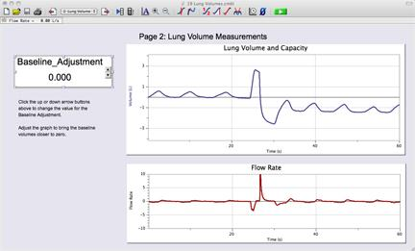

6. If the baseline on your graph has drifted (like the right side of the figure above), use the Baseline Adjustment feature (left of graph) to bring the baseline volumes closer to zero.

a. This is not actually necessary for the measurements that will be performed with this graph.

b. If you want to make the baseline adjustment it helps to modify the function.

1) Double click on the Baseline Adjustment box (a modification menu box will appear).

2) Change the “increment” to 0.005.

3) Click OK

3) This will make smaller changes to the baseline when the up/down arrows are used.

7. To measure **Tidal Volume (TV)** select a representative peak and valley in the TV portion of your graph. (see figure below)

a. Place the cursor on a low peak and click and drag down to the valley that precedes it.

b. Enter the Δ*y* value displayed in the lower left corner of the graph to the nearest 0.1 L as Tidal Volume in Table 1.

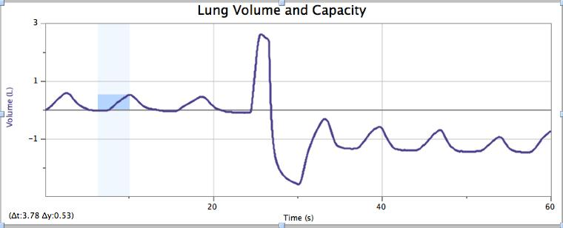

8. To measure the **Inspiratory Reserve Volume (IRV)** move the cursor to the peak that represents your maximum inspiration. (see figure below)

a. Click and drag down the side of the peak until you reach the level of the TV peaks graphed during normal breathing.

b. Enter the Δ*y* value displayed in the lower left corner of the graph to the nearest 0.1 L as Inspiratory Reserve Volume in Table 1.

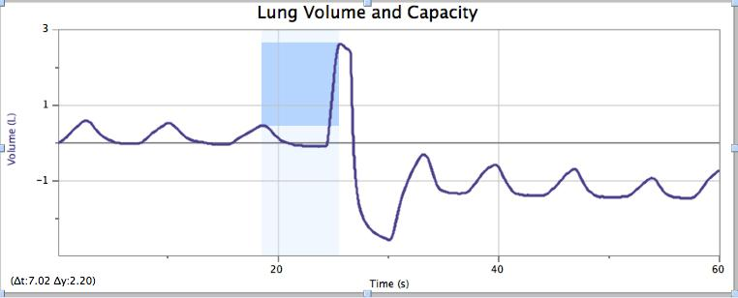

9. To measure the **Expiratory Reserve Volume (ERV)** move the cursor to the lowest valley that represents your maximum expiration. (see figure below)

a. Click and drag up the side of the peak until you reach the bottom level of the TV peaks graphed during normal breathing.

b. Enter the Δ*y* value displayed in the lower left corner of the graph to the nearest 0.1 L as Expiratory Reserve Volume in Table 1.

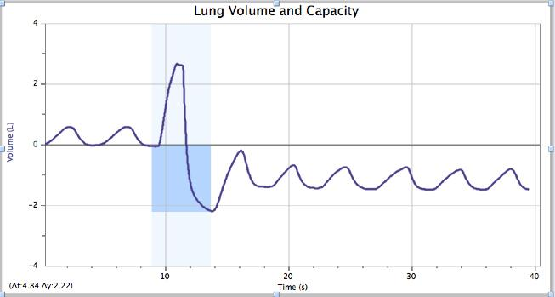

10. To measure the **Forced Vital Capacity (FVC)** move the cursor to the lowest valley that represents your maximum expiration. (see figure below)

a. Click and drag from the lowest valley up the side of the peak until you reach the top level of the peaks graphed during maximum inspiration.

b. Enter the Δ*y* value displayed in the lower left corner of the graph to the nearest 0.1 L as **Vital Capacity (VC)** in Table 1.

c. The Vital Capacity can also be calculated by adding together three functional lung volumes, and then enter the total to the nearest 0.1 L in Table 1.

1) VC = TV + IRV + ERV

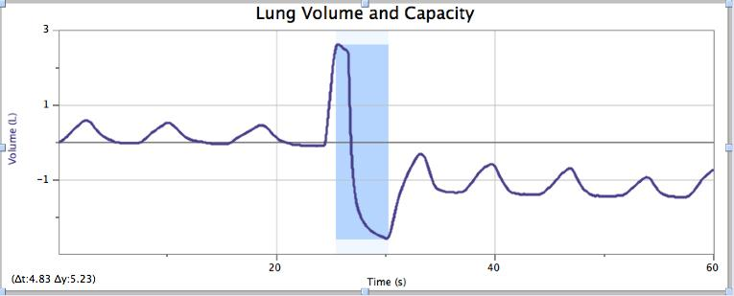

11. Calculate the Total Lung Capacity and enter the total to the nearest 0.1 L in Table 1. (Use the value of 1.5 L for the RV)

1) TLC = VC + RV

12. Share your data with your classmates and complete the Class Average columns in Table (NOT FOR ONLINE LAB STUDENTS)

13. ONLY ONE STUDENT SHOULD USE THE BACTERIAL FILTER (until disinfected)

DISINFECT THE BACTERIAL FILTER (after its use for the day has been completed)

a. remove and discard the disposable cardboard mouthpiece

b. detach the bacterial filter

c. spray isopropyl alcohol into the funnel to saturate the filter

d. sling out the excess alcohol into the sink

e. stand the filter funnel on one of the open ends, so that bottom opening has ventilation

f. allow the filter to dry for 24 hours (do not use if alcohol can be smelled)

**DATA**

| Table 1 | | | | | |
| --- | --- | --- | --- | --- | --- |
| Volume measurement  (L) | | Individual (L) | Class average (Male)  (L) | Class average (Female)  (L) | |
| Tidal Volume (TV) | |  | 0.51 | 0.39 | |
| Inspiratory Reserve (IRV) | |  | 2.15 | 1.73 | |
| Expiratory Reserve (ERV) | |  | 2.13 | 1.60 | |
| Vital Capacity (VC) | |  | 5.06 | 3.80 | |
| Residual Volume (RV) | | ≈1.5 | ≈1.5 | ≈1.5 | |
| Total Lung Capacity (TLC) | |  | 6.11 | 5.3 | |

**FLOW VOLUME LOOP EXPERIMENTS**

**OBJECTIVES**

In this experiment, you will

1. Obtain graphical representation of a flow volume loop.
2. Find the forced expiratory volume at 1 s (FEV1) and the forced vital capacity (FVC).
3. Calculate FEV1/FVC.
4. Find the peak expiratory flow rate (PEF).

**MATERIALS**

| computer | disposable mouthpiece |
| --- | --- |
| Vernier computer interface | disposable bacterial filter |
| Vernier Spirometer | nose clip |
| Logger *Pro* |  |

**PROCEDURE**

**I. Laptop Computer and LabQuest Unit Setup**

A. LabQuest Unit

1. Plug in charger/transformer into a 110V AC outlet, and connect the power line to the LabQuest Unit (left side).

2. Attach USB cable (small end) to LabQuest Unit (upper end).

3. Attach USB cable (large end) to laptop computer (left side).

4. Plug in the Spirometer transducer into connector #1 of the LabQuest Unit (upper end).

5. Turn the power on to the LabQuest Unit (button on upper left corner of unit).

B. Laptop Computer

1. Plug in charger/transformer into a 110V AC outlet, and connect the power line to the laptop computer (left side, back).

2. Turn on the laptop computer

3. Open the MacIntosh **HD** (or MyComputer) menu.

4. Open the **Applications** Folder

5. In the **Logger Pro 3** folder

a. **Experiments**

1) **Human Physiology**

a) double click on the file: **21 Analyze Lung Function**

1] A **graph and table** should appear on the screen.

a] Graph: Flow (l/s) vs. Volume (l)

b] Table: Columns for Time (s), Flow Rate (l/s), and Volume (l)

C. Spirometer transducer

1. Attach the larger diameter side of a white bacterial filter to the side of the Spirometer head marked “Inlet.” (see Figure 2).

a. Wrap two layers of tape around the narrow tube of the bacterial filter, near where it starts to flare out.

1) The tape will help the disposable cardboard mouthpiece seal more tightly against the bacterial filter tube.

2. Have the subject **stand** with his/her back straight and feet flat on the floor.

3. Hold the Spirometer in one or both hands, **do not** breath through the spirometer, and click  (on the second toolbar, far right, or in the Experiment menu, top toolbar) to set the spirometer reading to 0.00 liters.

a. **Note**: The Spirometer must be held straight up and down (see Figure 2) and not moved during data collection.

4. Collect exhalation and inhalation data.

a. Put on the nose clip and put your mouth against the mouthpiece.

b. **Do not** watch the screen while performing this test, **just concentrate of the breathing routine**.

c. Click  to begin data collection when **at the top of a maximum inspiration**.

1) If someone will be starting the data collection other than the person being measured, the subject needs to signal the operator when they are **at the top of a maximum inspiration**. (otherwise the operator will not be able to tell)

2) **Exhale as forcefully and as quickly as possible** through the Spirometer mouthpiece.

a) Your exhalation will trigger data collection.

b) **Important:** *Force ALL of the air out of your lungs.*

c) **Without removing your mouth from the mouthpiece, immediately inhale as deeply as possible**.

3) click  (End Data Collection) to stop data collection

5. If your data does not approximate the figure below, repeat Step 4, **several times to check that you have consistent results**.

a. Delete the present measurement data/graph before performing the next measurement.

1) Click on **Data**, on the top tool bar.

2) Click on **Remove All Data** (bottom of menu), and the previous data/graph will delete.

b. The inhalation (lower) part of the loop rarely comes back to the zero volume level where the inspiration started (loop is not completely closed, see example below).

c. Again, it is **important that maximum effort be expended** when performing tests of air flow.

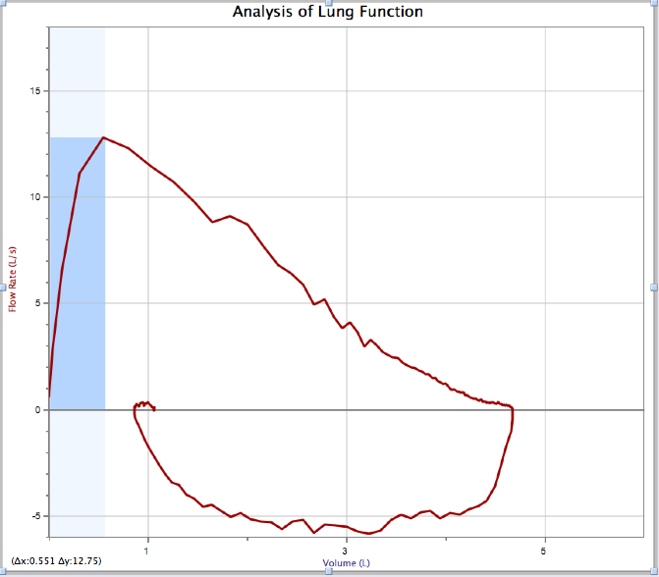

6. Find Forced Expiratory Volume, at one second after the start of exhalation (FEV1) by scrolling down the data table to 1.00 s.

a. This is one type of standard measurement of flow rate, the volume exhaled per one second (l/s).

b. Scroll to the right to see the volume if needed.

c. Record the volume to the nearest 0.01 L in the data table.

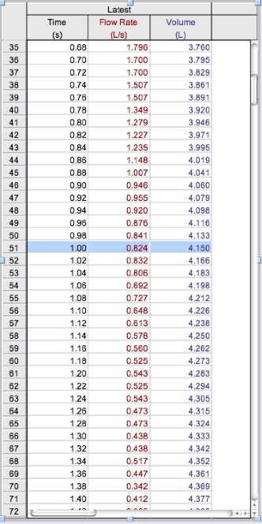

7. Measure the Forced Vital Capacity (FVC)

a. This is the maximum volume of air forced out of the lungs, and so the highest volume measured along the volume (x) axis.

b. There are two ways to make this measurement.

1) Place the cursor at the zero volume point, and then click, hold down the button, and drag the cursor to the rightmost point of the flow volume loop measurement. (see figure below)

a) When the button is let up a dark blue area will show the extent of the measured length along the volume axis.

b) The value of the volume (∆x:#.##) is shown in the lower left corner of the graph.

2) OR, use the Examine function.

a. Click the **Analyze** menu (top toolbar)

1] Click on the **Examine** function

2] Move the examine line (which appears on the graph) to the rightmost point of the flow volume loop, which is the FVC.

3] Record the volume value, from the small statistics-box that is on the graph, to the nearest 0.01 L in the data table.

4] Turn off the Examine function by returning to the Analyze menu, and uncheck the Examine function.

5] Close the Statistics box by clicking the X in the upper left corner of the box.

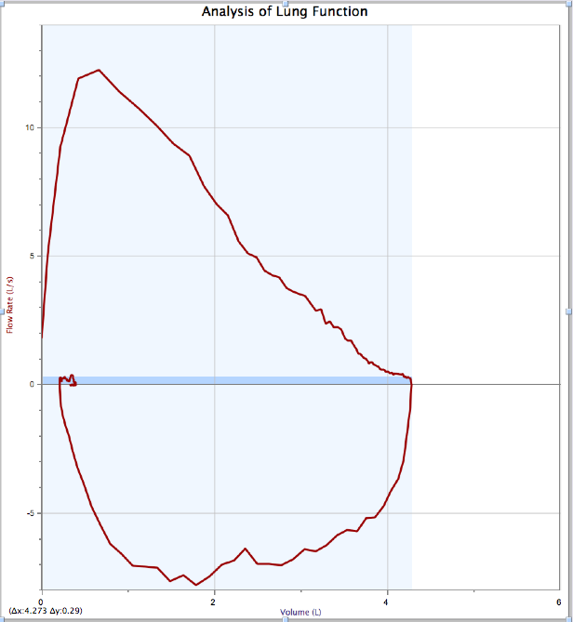

8. Find FEV1/FVC, multiply by 100, and enter the calculated value in the data table.

9. Measure the Peak Expiratory Flow (PEF) rate (l/s)

a. The PEF is the highest (peak) flow rate, the fastest that air volume is moving out of the lungs.

b. There are two ways to make this measurement.

1) Place the cursor at the zero flow rate point, and then click, hold down the button, and drag the cursor to the highest (vertical) point of the flow volume loop measurement. (see figure below)

a) When the button is let up a dark blue area will show the extent of the measured height along the flow rate (l/s) axis.

b) The value of the volume (∆y:#.##) is shown in the lower left corner of the graph.

2) OR, use the Statistics function.

a. Click the Analyze menu (top toolbar)

1] Click on the Statistics function

2] Record the max flow rate value (second line, second value), from the small statistics-box that is on the graph, to the nearest 0.01 l/s in the data table.

3] Close the Statistics box by clicking the X in the upper left corner of the box.

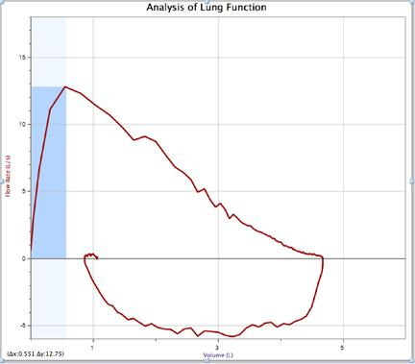

10. Both the FVC and PEF can be measured at the same time.

a. There is a simple way to make this measurement.

1) Place the cursor at the zero flow rate and volume point, and then click, hold down the button, and drag the cursor to the highest (vertical) and rightmost (horizontal) point of the flow volume loop measurement. (see figure below)

a) When the button is let up a dark blue area will show the extent of the measured height along the flow rate (l/s) y-axis, and length along the volume (l) x-axis.

b) The value of the flow rate (∆y:#.##) and volume (∆x:#.##) is shown in the lower left corner of the graph.

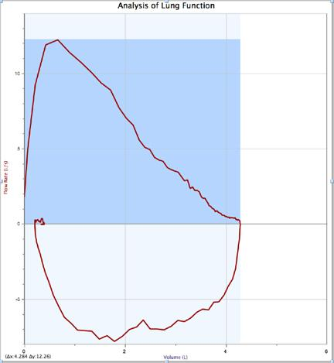

11. ONLY ONE STUDENT SHOULD USE THE BACTERIAL FILTER (until disinfected)

DISINFECT THE BACTERIAL FILTER (after its use for the day has been completed)

a. remove and discard the disposable cardboard mouthpiece

b. detach the bacterial filter

c. spray isopropyl alcohol into the funnel to saturate the filter

d. sling out the excess alcohol into the sink

e. stand the filter funnel on one of the open ends, so that bottom opening has ventilation

f. allow the filter to dry for 24 hours (do not use if alcohol can be smelled)

**DATA**

| FEV1  (L) | FVC  (L) | (FEV1/FVC) x100  (%) | PEF  (L/s) |
| --- | --- | --- | --- |
|  |  |  |  |

B. **Collins Respirometer Data Parameters** (physical changes in volume and time shown)

(NOT FOR ONLINE LAB STUDENTS)

1. physical demonstration of principles

a. functional lung volumes

b. volumes associated with an interval

2. Student participation

a. subject

1) own data for comparison to norms and others in class

b. operator

1) run respirometer to become familiar with physical requirements of measurement

3. Data

a. chart recording of volume changes with time (**see diagram**)

4. Measurements and calculations (**see diagram below**)

a. Collins respirometer

1) FVC = Forced Vital Capacity = from maximum inhalation to maximum exhalation

a) volume expired = V1-V2 (ml)

b) multiply by 1.1 to find volume in lungs at BTPS

c) BTPS = Body Temperature and Pressure, Saturated

2) FEV1.0 = Forced Expiratory Volume in first second of FVC

a) one second = 1.25 inches from start of decline in trace

b) volume = Vt=0 - Vt=1s (ml)

c) multiply by 1.1 to find volume in lungs at BTPS

3) FEV1.0/FVC = proportion of FVC exhaled in first second

5. **Collins Spirometer Operation**

a. Attach graph paper to the drum.

1) Be sure overlap of graph paper will not catch on pen as the drum turns (counter-clock-wise, looking down on the top of the drum).

2) Place paper on rim at bottom of drum.

3) Fold-over 1/4" on end of tape to make a tab, so that it is easy to remove.

4) Tape the graph at the bottom and then top, across the overlap.

b. Place a new cardboard mouth piece in the rubber tube of the valve assembly.

1) Place the nose clip on the subject.

2) Use a piece of tissue between the nose and the clip.

c. Prepare the respirometer bell for the measurment.

1) Open the valve to the bell, so air can flow out.

a) Turn the knob on the valve so that the two red dots are horizontal.

2) Push down on the bell, slowly, to the bottom to force the old air out.

a) If water starts coming over the sides, then the valve is not open.

3) Close the valve by turning the red dots on the knob vertically.

d. Prepare the graph-drum to rotate.

1) Check that the speed knob is at the highest rate.

2) Place the pen against the paper.

e. Breathing Routine and Respiratory Measurement

1) Take two deep breathes.

2) Hold the breath at maximum inhalation on the third.

3) Flip the drum rotation switch to the "on" position.

4) Place mouth securely around the cardboard mouth-piece.

5) Turn the valve knob so the red dots are horizontal (open).

6) Exhale as fast and deeply as possible.

a) Squeeze out as much air as possible.

7) Turn the drum switch off.

f. Repeat the measurement with the following steps.

1) Leave the valve open (red dots are horizontal) and push out the air.

2) Close the valve.

3) Repeat the measurement routine.

g. Shut down the spirometer.

1) Turn the drum switch off.

2) Remove the chart paper.

3) Remove the cardboard mouth-piece.

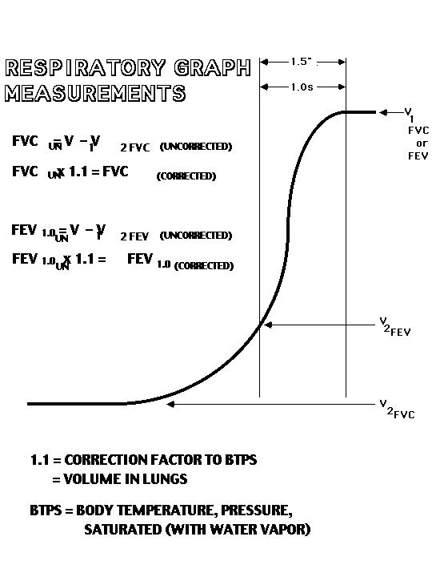

**APPENDIX A**

**Hypothesis: Effect of Asthma on Pulmonary Function Test Results (Diagnostics)**

Based on the definition section of asthma (below) how would lung volumes and flow rates of air be affected by acute and chronic asthma. How would the FVC, FEV1.0, and PEF values for pulmonary lung function tests be affected by acute and chronic asthma, compared to normal values?

Acute asthma should cause a decrease in flow rate of exhaled air, and so should decrease the FEV1.0, and PEF values for pulmonary lung function tests that are measures of flow rate (F=l/s), compared to normal. The air flow rate (F) should decrease because swelling and constriction of the airways, and mucous production decrease the diameter of the airways, increase resistance (R), and so decrease air flow (F=ΔP/R)(assuming ΔP remains constant). The conditions in the airways do not effect the capacity to expand or contract the lungs, so the lung volumes and FVC should not be altered by acute asthma (it just takes longer for the volume to be exchanged).

Chronic asthma should decrease both the flow rate and the lung volumes, and so should decrease FVC, FEV1.0, and PEF. Chronic asthma causes inflammation of both the airways and the rest of the lung tissue (functional and connective), and in addition to the acute effects sclerosis of the parenchymal tissues limit the stretch of the lungs. Limited lung stretch decreases the volume that can be inhaled and so decreases FVC.

**ASTHMA**

By Mayo Clinic staff

<http://www.mayoclinic.com/health/asthma/DS00021>

**Definition**

**Acute Asthma**

Acute asthma occurs when the airways in your lungs (bronchial tubes) become inflamed and constricted. The muscles of the bronchial walls tighten, and your airways produce extra mucus that blocks your airways. Signs and symptoms of asthma range from minor wheezing to life-threatening asthma attacks.

**Video**: An asthma attack (anatomical animation)

<http://www.mayoclinic.com/health/asthma/MM00001>

Transcript for video:

When asthma flares up, the bronchial tubes in the lungs narrow, making it difficult for air to pass through them. The tubes themselves may become inflamed and swollen, and the smooth muscles around the outside of the tubes may tighten. The mucous membrane lining in the tubes begins to produce thick mucus, which builds up and blocks the airways.



**Chronic Asthma**

Chronic asthma produces inflammation in all the lung tissues and so produces disease of the lung parenchyma (functional and connective tissues) leading to scarring or fibrosis. The collagen fibers of the scar tissue prevent the lungs from expanding easily, which limits the volume of air that can be inhaled.

Asthma can't be cured, but its symptoms can be controlled. Management includes avoiding asthma triggers and tracking your symptoms. You may need to regularly take long-term control medications to prevent flare-ups and short-term "rescue" medications to control symptoms once they start. Asthma that isn't under control can cause missed school and work or reduced productivity due to symptoms. Because in most people asthma changes over time, you'll need to work closely with your doctor to track your signs and symptoms and adjust your treatment as needed.

**Symptoms**

Asthma signs and symptoms range from minor to severe, and vary from person to person. You may have mild symptoms such as infrequent wheezing, with occasional asthma attacks. Between episodes you may feel normal and have no trouble breathing. Or, you may have signs and symptoms such as coughing and wheezing all the time or have symptoms primarily at night or only during exercise.

Asthma signs and symptoms include:

* Shortness of breath

* Chest tightness or pain

* Trouble sleeping caused by shortness of breath, coughing or wheezing

* An audible whistling or wheezing sound when exhaling

* Bouts of coughing or wheezing that are worsened by a respiratory virus such as a cold or the flu

**Causes**

It isn't clear why some people get asthma and others don't, but it's probably due to a combination of environmental and genetic (inherited) factors.

Asthma triggers are different from person to person. Exposure to various allergens and irritants can trigger signs and symptoms of asthma, including:

* Airborne allergens, such as pollen, animal dander, mold, cockroaches and dust mites

* Respiratory infections, such as the common cold

* Physical activity (exercise-induced asthma)

* Cold air

* Air pollutants and irritants such as smoke

* Certain medications, including beta blockers, aspirin and other nonsteroidal anti-inflammatory drugs

* Strong emotions and stress

* Sulfites, preservatives added to some perishable foods

* Gastroesophageal reflux disease (GERD), a condition in which stomach acids back up into your throat

* Menstrual cycle in some women

* Allergic reactions to foods such as peanuts or shellfish

**Risk factors**

Asthma is common, affecting millions of adults and children. A growing number of people are diagnosed with the condition each year, but it isn't clear why. A number of factors are thought to increase the chances of developing asthma. These include:

* A family history of asthma

* Frequent respiratory infections as a child

* Exposure to secondhand smoke

* Living in an urban area, especially if there's a lot of air pollution

* Exposure to occupational triggers, such as chemicals used in farming, hairdressing and manufacturing

* Low birth weight

* Being overweight

**Tests and diagnosis**

Diagnosing asthma can be difficult. Signs and symptoms can range from mild to severe and are often similar to those of other conditions, including emphysema, early congestive heart failure or vocal cord problems. In children, it can be hard to differentiate asthma from wheezy bronchitis, pneumonia or reactive airway disease.

In order to rule out other possible conditions, your doctor will do a physical exam and ask you questions about your signs and symptoms and about any other health problems. You may also be given lung (pulmonary) function tests to determine how much air moves in and out as you breathe.

Tests to measure lung function include:

* Spirometry. This test measures the narrowing of your bronchial tubes by checking how much air you can exhale after a deep breath, and how fast you can breathe out.

* Peak flow. A peak flow meter is a simple device that can be used at home to help detect subtle changes before you notice symptoms. If the readings are lower than usual, it's a sign your asthma may be about to flare up. Your doctor will give you instructions on how to track and deal with low readings.

Lung function tests often are done before and after taking a bronchodilator to open your airways. If your lung function improves with use of a bronchodilator, it's likely you have asthma.

**Treatments and drugs**

Treatment for asthma generally involves avoiding the things that trigger your asthma attacks and taking one or more asthma medications. Treatment varies from person to person.

* Most people with persistent asthma use a combination of long-term control medications and quick-relief medications, taken with a hand-held inhaler.

* If your asthma symptoms are triggered by airborne allergens, such as pollen or pet dander, you may also need allergy treatment.

**Long-term control medications**

In most cases, these medications need to be taken every day. Types of long-term control medications include:

* Inhaled corticosteroid medications (such as fluticasone = Flovent Diskus) reduce airway inflammation and are the most commonly used long-term asthma medication.

* Long-acting beta-2 agonists medications (LABAs, such as salmeterol = Serevent Diskus), called long-acting bronchodilators, open the airways and reduce inflammation.

* Leukotriene modifier, inhaled medications (such as montelukast = Singulair) work by opening airways, reducing inflammation and decreasing mucus production.

* Cromolyn and nedocromil (Tilade) inhaled medications reduce asthma signs and symptoms by decreasing allergic reactions.

* Theophylline, a daily pill that opens your airways (bronchodilator) relaxes the muscles around the airways.

**Quick-relief medications**

Also called rescue medications, you use quick-relief medications as needed for rapid, short-term relief of symptoms during an asthma attack.

* Short-acting beta-2 agonists, such as **albuterol**. These inhaled medications, called bronchodilators, ease breathing by temporarily relaxing airway muscles. They act within minutes, and effects last four to six hours.

* Ipratropium (Atrovent) is an inhaled anticholinergic for the immediate relief of your symptoms. Like other bronchodilators, ipratropium relaxes the airways, making it easier to breathe. Ipratropium is mostly used for emphysema and chronic bronchitis.

* Oral and intravenous corticosteroids to treat acute asthma attacks or very severe asthma. Examples include prednisone and methylprednisolone. These medications relieve airway inflammation. They may cause serious side effects when used long term, so they're only used to treat severe asthma symptoms.

**Medications for allergy-induced asthma.**

These decrease your body's sensitivity to a particular allergen or prevent your immune system from reacting to allergens. Allergy treatments for asthma include:

* Immunotherapy. Allergy-desensitization shots (immunotherapy) are generally given once a week for a few months, then once a month for a period of three to five years. Over time, they gradually reduce your immune system reaction to specific allergens.

* Anti-IgE monoclonal antibodies, such as omalizumab (Xolair). This medication reduces your immune system's reaction to allergens. Xolair is delivered by injection every two to four weeks.

**(APPENDIX B)**

**Experimental Design: What Measurements Would Provide the Data to Address the Hypothesis**

Based on the definition section of asthma (above) how would lung volumes and flow rates of air be affected by acute and chronic asthma. How would the FVC, FEV1.0, and PEF values for pulmonary lung function tests be affected by acute and chronic asthma, compared to normal values?

Both acute and chronic asthma effect air flow rates from the lungs, and so pulmonary function tests for flow rate (FEV1.0, and PEF) should be used to measure lung operation. Chronic asthma can also effect lung volumes and capacities, and so pulmonary function tests for volumes (FVC) should be used to measure lung operation. The values obtained for a subject need to be compared with nomogram values for people of the same gender, height, and age to determine if the results are in the normal range for the flow rate and volume measurements.