**Doctor of Pharmacy**

**Pharmacy Skills Laboratory (PHAR321)**

**Lab 2 : The Compounding and Dispensing of Solutions Used in the Oral Cavity**

**Dr. Hani Shtaya**

**Muhammad Musleh/1162595**

**Dana Joza’/1160058**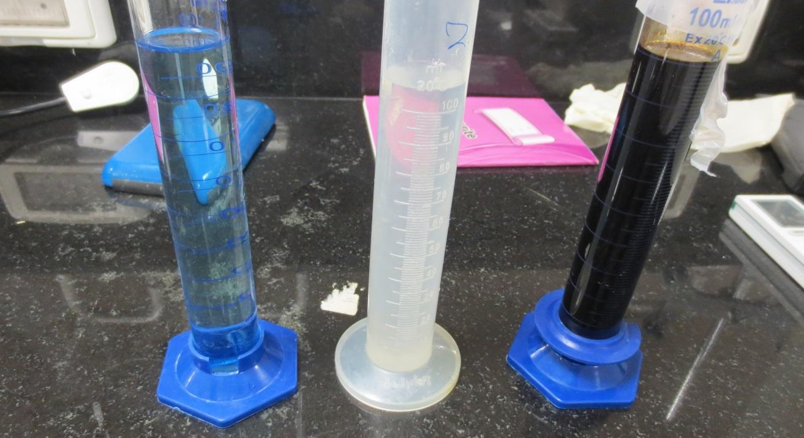

| Doctor of Pharmacy Program | | Pharmacy Skill Laboratory (PHAR321) | |
| --- | --- | --- | --- |
| Student Name | **Dana Joza’** | **Student Number** | **1160058** |
| **Muhammad Musleh** | **1162595** |
| Exp. Name | **Gargles and Mouth Washes** | **Exp. NO.** | **2** |

**Experiment 2.1 : Potassium Chlorate and Phenol Gargle BPC**

**Product Formula:-**

**Table 1 : PF 1**

| NO. | Ingredients | Quantity | Dispensed by | Checked by |
| --- | --- | --- | --- | --- |
| 1 | **Potassium Chlorate** | **3.01g** | **Muhammad** | **Dana** |
| 2 | **Patent Blue V** | **1 mg (1 Drop)** | **Muhammad** | **Dana** |
| 3 | **Liquefied Phenol** | **1.5 ml** | **Dana** | **Muhammad** |
| 4 | **Water qs** | **100ml** | **Muhammad** | **Dana** |

**Pharmaceutical Drug in Pharmacy:-**

**Trade name:**

**Company:**

**Active Pharmaceutical Ingredient: Potassium Chlorate, Liquefied Phenol**

**About Product:-**

**Product name: Potassium Chlorate and Phenol Gargle**

**Product’s components and their roles:**

**Table 1 : Roles of components 1**

| NO. | Ingredients | Role |
| --- | --- | --- |
| 1 | **Potassium Chlorate** | **Has a weak astringent effect to make throat more healthy, sialagogue which increases the saliva to relief the dryness of the mouth.** |
| 2 | **Patent Blue V** | **Colouring agent** |
| 3 | **Liquefied Phenol** | **Bactericide** |
| 4 | **Water** | **Solvent** |

**Counseling:-**

1. **Indication (Why the medicine is given ) :**

Gargles are aqueous solutions in concentrated form in our experiment , Potassium chlorate and Phenol gargle is used as a prophylactic or treats throat infections and as searched can be used in stomatitis and vaginitis as it is used a s a weak astringent in those cases and pharynx and nasopharynx . As this gargle Is generally used as a sialagogue , astringent and bactericide .

1. **Administration (How to use it ) :**

The gargle should be diluted with warm water before it is used and then used by making the gargle contact with the throat for a few seconds and then should be spit out , if the person swallows a bit of it ,it is okay but this gargle should not be swallowed in large quantities , as potassium chlorate if swallowed can cause acute toxicity . The gargle can be diluted as follows: 3 5ml spoonfuls should be added to about 150 ml of warm water . after dilution the gargle should be used , rinse the mouth for a about 20 sec once in morning and once in evening or more frequently if needed , any solution that stays not used from dilution should be discarded after . For about 10 minutes after using the gargle , refrain from eating or drinking .

1. **Adverse Effects :**

If too much swallow can cause acute toxicity , other adverse effects include nausea , vomiting , flatulence , abdominal pain and diarrhea .

1. **Storage Conditions :**

Should be stored in a cool place and kept away from children in a well closed air tight container because it has a nice taste and smell they may drink it . and should be protected from light because potassium chlorate Is sensitive to light and should not be use after expiration and should be discarded (Expiry : 2 weeks).

**Calculations:-**

**Product strength = (API Mass / Total volume) * 100%**

**Potassium Chlorate Strength=( 3.01g /100 ml) *100%**

= 3.01 % w/v

**Experiment 2.2 : Sodium Chloride Mouth-Wash BP**

**Product Formula:-**

**Table 3 : PF 2**

| NO. | Ingredients | Quantity | Dispensed by | Checked by |
| --- | --- | --- | --- | --- |
| 1 | **Sodium Chloride** | **1.56g** | **Dana** | **Muhammad** |
| 2 | **Sodium Bicarbonate** | **1.01g** | **Dana** | **Muhammad** |
| 3 | **Peppermint Emulsion Con.** | **2.5ml** | **Muhammad** | **Dana** |
| 4 | **Chloroform Water, Double Strength** | **50ml** | **Muhammad** | **Dana** |
| 5 | **Water for Preparation** | **100ml** | **Muhammad** | **Dana** |

**Pharmaceutical Drug in Pharmacy:-**

**Trade name:**

**Company:**

**Active Pharmaceutical Ingredient: Sodium Chloride, and Sodium Bicarbonate**

**About Product:-**

**Product name: Sodium Chloride Mouth-Wash**

**Product’s components and their roles:**

**Table 4 : Roles of components 2**

| NO. | Ingredients | Role |
| --- | --- | --- |
| 1 | **Sodium Chloride** | **Deodorant, antimicrobial agent, and makes solution hypertonic** |
| 2 | **Sodium Bicarbonate** | **Deodorant, antacid-pH regulation- expectorant-Dissolve mucus- and mild abrasive** |
| 3 | **Peppermint Emulsion Con.** | **Flavouring agent** |
| 4 | **Chloroform Water, Double Strength** | **Flavouring agent, solvent, and preservative** |
| 5 | **Syrup** | **Co-Solvent** |

**Counseling :-**

1. **Indication (Why the medicine is given ) :**

Sodium Chloride mouth wash . Mouth washes , like Gargles are aqueous and concentrated but with deodorant , antiseptic , local analgesic or astringent characteristics . This mouth wash is to treat and prevent infections of the mouth and throat , and because the sodium chloride makes the environment hypertonic , it kills the bacteria and when you have mouth sore, bleeding gum, inflamed sore gum . Also used for oral hygiene and keeping the buccal cavity clean and fresh as well deodorize and it is an antiseptic .

1. **Administration (How to use it ) :**

The mouthwash should be diluted before using it , as about 20 ml of the mouthwash should be diluted with 20 ml of warm water( an equal volume of water ) . Use the mouthwash every 4 hours .

1. **Adverse Effects :**

Sometimes can cause slight burning on the nasal mucosa also can stain teeth and cause swelling of the mouth . Also can cause muscle hyper tonicity . Also should not be swallowed in large quantities as too much sodium bicarbonate can cause potassium deficiency .

1. **Storage Conditions :**

Should be stored in a cool place and away from children with tight sealed container and the container should be amber as it is extemporaneously prepared ( Expiry : 1 month ).

**Calculations:-**

For Exp 2.2 there were some calculations in the manual as follows:

-Sodium bicarbonate is soluble 1 in 11 parts of water , so to dissolve 1 g of sodium bicarbonate a minimum of 1*11 = 11 ml water should be required .

-Sodium chloride is soluble 1 in 3 parts of water . So to dissolve 1.5 g of sodium chloride , a minimum of 1.5*3=4.5 ml water should be required .

**Product strength = (API Mass / Total volume) * 100%**

**Sodium Chloride Strength=( 1.56 g /100 ml) *100%**

= 1.56 % w/v

**Experiment 2.3 : Dental-Iodine Glycerin 10% (J.P)**

**Product Formula:-**

**Table 5 : PF 3**

| NO. | Ingredients | Quantity | Dispensed by | Checked by |
| --- | --- | --- | --- | --- |
| 1 | **Iodine** | **10.03g** | **Muhammad** | **Dana** |
| 2 | **Potassium Iodide** | **8.04g** | **Muhammad** | **Dana** |
| 3 | **Zinc Sulphate** | **1.04g** | **Dana** | **Muhammad** |
| 4 | **Glycerol** | **35ml** | **Muhammad** | **Dana** |
| 5 | **Water qs** | **100ml** | **Muhammad** | **Dana** |

**Pharmaceutical Drug in Pharmacy:-**

**Trade name:**

**Company:**

**Active Pharmaceutical Ingredient: Iodine**

**About Product:-**

**Product name: Dental-Iodine Glycerin 10%**

**Product’s components and their roles:**

**Table 6 : Roles of components 3**

| NO. | Ingredients | Role |
| --- | --- | --- |
| 1 | **Iodine** | **Antiseptic, and antifungal** |
| 2 | **Potassium Iodide** | **Solubilizer** |
| 3 | **Zinc Sulphate** | **Astringent, and antibacterial** |
| 4 | **Glycerol** | **Sweeting agent, and prolongs the formula in the mouth** |
| 5 | **Water** | **Co-solvent** |

**Counseling :-**

1. **Indication (Why the medicine is given ) :**

Dental Iodine Glycerine 10% is used for gingivitis and oral ulcers also has antiseptic and antifungal effects because of the iodine in it .

1. **Administration (How to use it ) :**

Apply the dental iodine on infected area only using a dropper or cotton swab and if infection is too big the dental iodine can be used like a gargle for 20 sec .

1. **Adverse Effects :**

Allergic reactions ,and because it contains a small quantity of Glycerine, which can be harmful If swallowed in very big quantity ,can cause headache, stomach upset and diarrhea. also causes metallic taste .

1. **Storage Conditions :**

Should be protected from the light in light resistant air tight containers and kept away from children ( Expiry : 1 month ).

**Calculations:-**

In Exp2.3 , the manual used the ingredient based to 1000 mL , but we used 100 mL during the experiment , so the ingredients quantities become like this :

Iodine was 100 g for 1000 mL . dividing by 10 should give us the result for 100 ml so:

100/10= 10 g iodine

Potassium iodide was 80 g for 1000 ml so for 100 ml :

80/140 = 8 g potassium iodide

Zinc sulphate was 10 g for 1000 ml so for 100 ml :

10 /10 = 1 g zinc sulphate

Glycerol was 350 ml for 1000 ml so for 100 ml :

350/10 = 35 ml glycerol

**Product strength = (API Mass / Total volume) * 100%**

**Sodium Chloride Strength=( 10.03 g /100 ml) *100%**

= 10.03 % w/v

**Questions:-**

1. **In preparing the gargle, potassium chlorate is dissolved in warm water, why ?**

To enhance its solubility, 1 g of potassium chlorate dissolves slowly in 16.5 ml water, and in 1.8 ml of boiling water.

1. **What is chloroform water ? Why do we use it ?**

Is water with chloroform dissolve in it, it might either be single strength -2.5 ml chloroform in 1L solution- or double strength -5 ml chloroform in 1L solution- it’s used as flavouring agent because when taken orally it has a pleasant taste, gives a warm sensation to mouth, has carminative and preservative effects.

1. **Iodine is insoluble in water, how was it dissolved in the exercise ?**

Iodine does not dissolve in water because water is a polar molecule, while iodine exists in the diatomic form of I2, and is therefore non-polar, and will not dissolve in water. **(Like Dissolve Like)**

By addition of potassium iodide it would dissolve in water, which give iodide ion when dissolved with water, iodide ion-Lewis base- will react with iodine-Lewis acid- to form the soluble Tri-Iodide ion.

**KI → K+ + I-**

**I2 + I- I3-**

**Main Label:-**

**Pharmacy name**: MID Pharmacy

**Pharmacist name**:  Dana Joza’

**Partner name**: Mohammad Musleh

**Product name:** Potassium Chlorate and Phenol Gargle

**Product strength:**  3.01% g\ml

**Expiration date:** 2 Weeks

**Amount prepared:** 100 ml

**Use:** Throat infections.

**Auxiliary Label:-**

**Main Label:-**

**Pharmacy name**: MID Pharmacy

**Pharmacist name**:  Dana Joza’

**Partner name**: Mohammad Musleh

**Product name:** Sodium Chloride Mouth-Wash

**Product strength:** 1.56% g\ml

**Expiration date:** 1 month

**Amount prepared:** 100 ml

**Use:** Infections of the mouth and throat.

**Auxiliary Label:-**

**Main Label:-**

**Pharmacy name**: MID Pharmacy

**Pharmacist name**:  Dana Joza’

**Partner name**: Mohammad Musleh

**Product name:** Dental-Iodine Glycerin 10%

**Product strength:** 10.03% g\ml

**Expiration date:** 1 month

**Amount prepared:** 100 ml

**Use:** Gingivitis and oral ulcers.

**Auxiliary Label:-**