**Doctor of Pharmacy**

**Pharmacy Skills Laboratory (PHAR321)**

**Lab1 : Oral Solutions**

**Dr. Hani Shtaya**

**Muhammad Musleh/1162595**

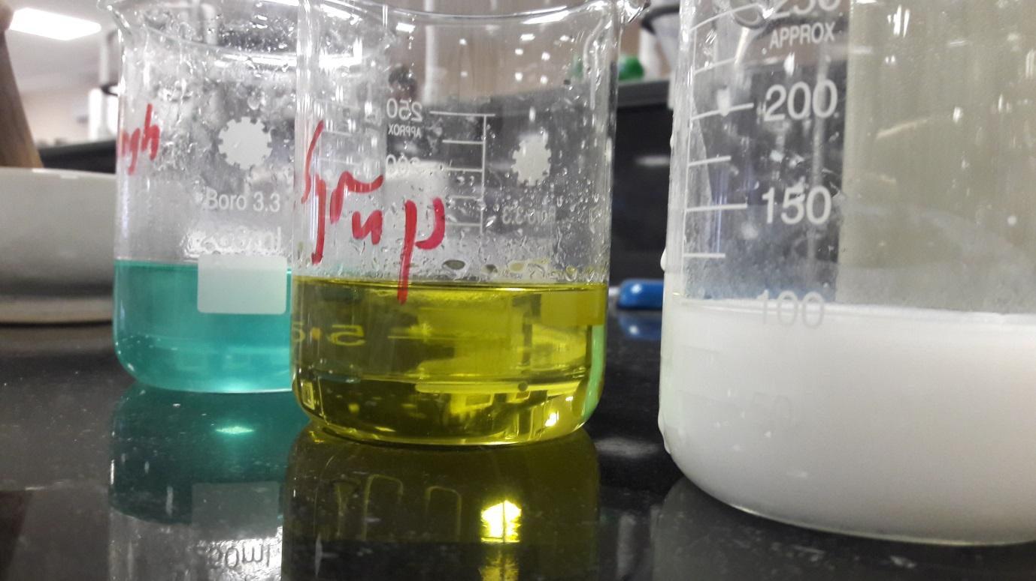**Dana Joza’/1160058**

| Doctor of Pharmacy Program | | Pharmacy Skill Laboratory (PHAR321) | |
| --- | --- | --- | --- |
| Student Name | **Dana Joza’** | **Student Number** | **1160058** |
| **Muhammad Musleh** | **1162595** |
| Exp. Name | **Oral Solutions** | **Exp. NO.** | **1** |

**Experiment 1.1 : Ferrous Sulfate Syrup (Remington)**

**Product Formula:-**

| NO. | Ingredients | Quantity | Dispensed by | Checked by |
| --- | --- | --- | --- | --- |
| 1 | **Ferrous Sulfate** | **4.00g** | **Dana** | **Muhammad** |
| 2 | **Citric acid, Hydrous** | **0.21g** | **Dana** | **Muhammad** |
| 3 | **Peppermint Spirit** | **2 drops** | **Muhammad** | **Dana** |
| 4 | **Syrup qs** | **100ml** | **Muhammad** | **Dana** |

**Table 1 : PF 1**

**Pharmaceutical Drug in Pharmacy:-**

**Trade name: Feosol**

**Company: MID**

**Active Pharmaceutical Ingredient: Ferrous Sulfate (FeSO4)**

**About Product:-**

**Product name: Ferrous Sulfate Syrup –Remington-**

**Product’s components and their roles:**

| NO. | Ingredients | Role |
| --- | --- | --- |
| 1 | **Ferrous Sulfate** | **API: Supplement Iron** |
| 2 | **Citric acid, Hydrous** | **Increase solubility by lower pH** |
| 3 | **Peppermint Spirit** | **Flavouring agent** |
| 4 | **Sucrose** | **Sweetener, Preservative** |
| 5 | **Purified Water** | **Vehicle** |

**Table 1 : Roles of components 1**

**Counseling:-**

1. **Indication (Why the medicine is given ) :**

Ferrous sulfate syrup is used for iron deficiency anemia (a lack of red blood cells caused by having too little iron in the body) , as the iron will induce the production of RBCs .

1. **Administration (How to use it ) :**

600 mg of Ferrous sulphate should be taken daily divided for 3 times a day should be taken at an empty stomach as iron is best absorbed when stomach is empty , so can be taken 1 hour before meals or 2 hours after meals .

1. **Adverse Effects :**

Some of the adverse effects of ferrous sulphate : causes stool to become black . also blackens teeth ( so it is recommended to administer it using a straw to avoid the blackening of teeth ) . also causes constipation and an upset stomach .

1. **Storage Conditions :**

Store in a clod and dry place at 20 -25 Co. keep away from the reach of children , also keep away from direct heat or light or moisture and keep container tightly closed .

**Calculations: -**

Some simple calculations were done to complete the weighs and volumes in the experiments as:

We divided each value by 10 as the volume of syrup used was 100 ml not 1000 ml as written in manual so the weighs and volumes became:

Ferrous sulfate was 40 g so 40/10 = 4 g

Citric acid was 2.1 g becomes 0.21 g

**Product strength = (API Mass / Total volume) * 100%**

**Ferrous Sulfate Strength=( 4000 mg /100 ml) *100%**

= 4000 % w/v

**Main Label:-**

**Pharmacy name**: MID Pharmacy

**Pharmacist name**:  Dana Joza’

**Partner name**: Mohammad Musleh

**Product name:** Ferrous Sulfate Syrup

**Product strength:** 4000% mg\ml

**Expiration date:** 1 month

**Amount prepared:** 100 ml

**Use:** Iron deficiency anemia.

**Auxiliary Label:-**

* Store in cool and dark place;
* Keep away from direct heat and light;
* Away from reach of children;
* Should not be administered with tetracyclines ( ciprofloxacin , norfloxacin and ofloxacin).

**Experiment 1.2 : Cough Syrup**

**Product Formula:-**

| NO. | Ingredients | Quantity | Dispensed by | Checked by |
| --- | --- | --- | --- | --- |
| 1 | **Diphenhydramine HCl** | **0.29g** | **Dana** | **Muhammad** |
| 2 | **Ammonium Chloride** | **2.71g** | **Dana** | **Muhammad** |
| 3 | **Sodium Citrate** | **1.14g** | **Dana** | **Muhammad** |
| 4 | **Menthol** | **0.026g** | **Muhammad** | **Dana** |
| 5 | **Syrup qs** | **100ml** | **Muhammad** | **Dana** |

**Table 3 : PF 2**

**Pharmaceutical Drug in Pharmacy:-**

**Trade name: Koflet**

**Company: MID**

**Active Pharmaceutical Ingredient: Diphenhydramine HCl**

**About Product:-**

**Product name: Cough Syrup.**

**Product’s components and their roles:**

| NO. | Ingredients | Role |
| --- | --- | --- |
| 1 | **Diphenhydramine HCl** | **API: Antihistamine** |
| 2 | **Ammonium Chloride** | **API: Expectorant** |
| 3 | **Sodium Citrate** | **Stabilizer** |
| 4 | **Menthol** | **Flavouring agent** |
| 5 | **Syrup qs** | **Sweetener, Preservative** |

**Table 4 : Roles of components 2**

**Counseling :-**

1. **Indication (Why the medicine is given ) :**

Cough Syrup ( Diphenhydramine HCl) used as an anti-cough , as it relieves symptoms of common cold and fever and allergy , some symptoms include cough , runny nose and sneezing .

1. **Administration (How to use it ) :**

Doses of Cough Syrup based on age are as below :

Children (1-5 ) years : 2.5 ml .

Children ( 6-12 ) years : 5 ml .

Taken every 4-6 hours and should not exceed 6 doses in 24 hours. This medication should not be given to children under the age 1.

1. **Adverse Effects :**

Cough syrup adverse effects : as it is an antihistamine so it causes drowsiness , also causes constipation and upset stomach , blurred vision or dry mouth or throat may occur .

1. **Storage Conditions :**

Store in cold and dark place , away from reach of children and away from direct heat and light.

**Calculations:-**

The manual had the values for 5 ml of syrup but we used 100 ml so each value was multiplied by 20 and values became:

Diphenhydramine HCl was 14 mg becomes 280 mg

Ammonium chloride was 135 mg becomes 2700 mg

Sodium citrate was 57 mg becomes 1140 mg

Menthol was 1 mg becomes 20 mg

**Product strength = (API Mass / Total volume) * 100%**

**Diphenhydramine HCl Strength=( 290 mg /100 ml) *100%**

= 290 % w/v

**Main Label:-**

**Pharmacy name**: MID Pharmacy

**Pharmacist name:** Mohammad Musleh

**Partner name:** Dana Joza’

**Product name:**  Cough syrup

**Product strength**: 290% mg / ml

**Expiration date:** 1 month

**Amount prepared:** 100 ml

**Use:** For coughing (anti-cough)

**Auxiliary Label:-**

* Store in cool and dark place;
* Keep away from direct heat and light ;
* Away from reach of Children .

**Caution: can cause drowsiness**

**Experiment 1.3 : Magnesium Carbonate Mixture BPC**

**Product Formula:-**

| NO. | Ingredients | Quantity | Dispensed by | Checked by |
| --- | --- | --- | --- | --- |
| 1 | **Light Magnesium Carbonate BP** | **5.05g** | **Dana** | **Muhammad** |
| 2 | **Sodium Bicarbonate BP** | **8.07g** | **Dana** | **Muhammad** |
| 3 | **Con.Peppermint Emulsion** | **2.5ml** | **Muhammad** | **Dana** |
| 4 | **Double Strength Chloroform Water BP** | **50ml** | **Muhammad** | **Dana** |
| 5 | **Water qs** | **100ml** | **Muhammad** | **Dana** |

**Table 5 : PF 3**

**Pharmaceutical Drug in Pharmacy:-**

**Trade name: Aromag**

**Company: MID**

**Active Pharmaceutical Ingredient: Light Magnesium Carbonate BP**

**About Product:-**

**Product name: Magnesium Carbonate Mixture BPC**

**Product’s components and their roles:**

| NO. | Ingredients | Role |
| --- | --- | --- |
| 1 | **Light Magnesium Carbonate BP** | **API: Antacid** |
| 2 | **Sodium Bicarbonate BP** | **Antacid** |
| 3 | **Con.Peppermint Emulsion** | **Flavouring agent** |
| 4 | **Double Strength Chloroform Water BP** | **Co-solvent for Sodium Bicarbonate, Preservative** |
| 5 | **Purified Water** | **Dispersion Medium** |

**Table 6 : Roles of components 3**

**Counseling :-**

1. **Indication (Why the medicine is given ) :**

Magnesium carbonate mixture is used as an antacid ,as used to neutralize the stomach acidity ( also can be used for other conditions such as heartburn , acidity in the blood , also used as a topical protectant ..etc. also symptomatic relief of dyspepsia )

1. **Administration (How to use it ) :**

Magnesium carbonate mixture : dose of 10 ml given 3 times a day to adults. It is indicated that you mix 2 spoonful of 5 ml of medication with equal volumes of water . Caution should be taken when given to the elderly and it is not recommended to be used in children .

1. **Adverse Effects :**

Magnesium carbonate mixture adverse effects : may cause discomfort as a result of the release of carbon dioxide in the stomach , other adverse effects include diarrhea , rapid breathing , swelling of feet , twitching and always feeling the urge to urinate .

1. **Storage Conditions :**

Amber bottle and tightly closed , keep away from reach of children , keep away from direct light or heat . shake well before use.

**Calculations:-**

Also in this experiment the volume of water used was 100 ml rather than 1000 ml so each value was divided by 10 so values became:

Light magnesium carbonate was 50 g becomes 5 g

Sodium bicarbonate was 80 g becomes 8 g

**Product strength = (API Mass / Total volume) * 100%**

**Diphenhydramine HCl Strength=( 5050 mg /100 ml) *100%**

= 5050 % w/v

**Main Label:-**

**Pharmacy name:** MID Pharmacy

**Pharmacist name:**Mohammad Musleh

**Partner name:**Dana Joza’

**Product name:** Magnesium Carbonate Mixture BPC

**Product strength: 5050%** mg / ml of light magnesium carbonate BP

**Expiration date**: 1 month

**Amount prepared:** 100 ml

**Use:**Antacid

**Auxiliary Label:-**

* Shake well before use
* Keep away from direct heat and light
* Away from reach of children

**Compounder’s signature: -------------------------------------------------**

**Lab supervisor’s signature: --------------------------------------------------**

**Post Lab Questions:-**

**Q1:-**

Simply, since cooling down at a fast rate causes crystallization, then this problem can be controlled by cooling down at a slower rate, this will minimize and decrease crystallization. You can prevent crystallization from occurring by adding glycerol, as glycerol is co-solvent and increases solubility, this will dilute the mixture and prevent crystallization.

**Q2:-**

2FeSO4(s) --------->  Fe2O3(s) +SO2 (g) +SO3 (g)

Anhydrous ferrous sulfate (White) -------> ferric oxide (Brown)

This is a decomposition reaction.

Amount of Fe

2 Mole of FeSO4 = 1 Mole of Fe2O3

2 Moles of Fe = Moles of Fe2O3

Mole of FeSO4 = Mass/M.W = 4/151.905

= 0.026 mole

Mole of Fe2O3 = 2 * Mole of FeSO4

= 0.052 mole

Moles of Fe = Moles of Fe2O3 /2

= 0.026 mole of Fe

Mass of Fe = 0.026* 159.68

= 4.15 g

**Q3:-**

Types of coughs:

1. Wet cough: also called productive cough, this cough brings up mucus, commonly caused by flu or cold.
2. Dry cough: also called unproductive cough, this cough does not bring up mucus, this type of cough gives you a ticklish feeling at the back of the throat and thus triggering the cough. It is difficult to control and normally occur because of irritation or inflammation in respiratory tract.
3. Whooping cough: caused by a bacterial infection which causes violent coughing fits, makes the people infected use all the oxygen they have so they produce a whoop sound. Whooping coughs lead to paroxysmal coughs which are an uncontrollable violent coughing which is painful and those who experience it have difficulty breathing and often vomit.
4. Croup cough: viral infection usually in children under the age of 5, as upper airways become swollen and irritated.

Cough medicine should not be given to toddlers under the age of 1, also if the patient has high BP they should consult a doctor before using this medication.

**Q4:-**

* Do not give cough and cold medicines to children under the age of one. Check with your health care provider for remedies for specific symptoms.
* If you give cough and cold medicines to older children, follow the label directions exactly.
* Measure doses with the correct measuring cup, spoon, or syringe. Do not use ordinary household spoons and cups.
* After you give each dose, replace the child-resistant closure. Lock the medicine up high, where children can't see it or reach it.
* If any allergic reactions occur , stop the medication.
* Anyone with a medical condition like [heart disease](https://www.webmd.com/heart-disease/default.htm) or [high blood pressure](https://www.webmd.com/hypertension-high-blood-pressure/default.htm) , serious kidney or liver disease, thyroid disease, diabetes, asthma, chronic lung disease or shortness of breath, persistent or chronic cough or glaucoma.  Should check with a doctor before using any cold medicine.
* Don’t overuse the drugs in cough and cold medicines, or double a dose because you missed one you’ll put yourself at risk of an overdose.