**Doctor of Pharmacy**

**Pharmacy Skills Laboratory (PHAR321)**

**Lab 7 : The Compounding and Dispensing of Creams and Ointemnts**

**Dr. Hani Shtaya**

**Muhammad Musleh/1162595**

**Ibrahim**

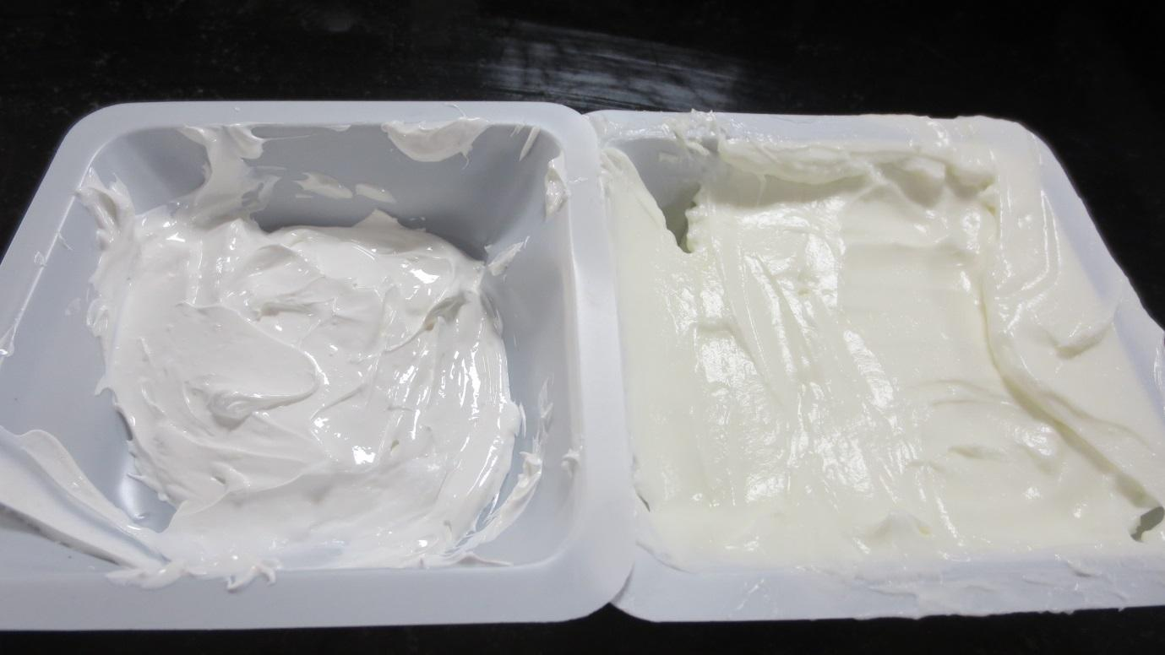

| Doctor of Pharmacy Program | | Pharmacy Skill Laboratory (PHAR321) | |
| --- | --- | --- | --- |
| Student Name |  | **Student Number** | **116** |
| **Muhammad Musleh** | **1162595** |
| Exp. Name | **Creams and Ointments** | **Exp. NO.** | **7** |

**Basic preparation 1.6 : Aqueous Cream 100g BP**

**Product Formula:-**

**Table 1 : PF 1**

| NO. | Ingredients | Quantity | Dispensed by | | | Checked by |
| --- | --- | --- | --- | --- | --- | --- |
| 1 | **Emulsifying wax (Cetostearyl alcohol 9g, Sodium lauryl sulfate 0.9g)** | **40.06g** | | | **Ibrahim** | **Muhammad** |
| 2 | **White soft paraffin** | **60g** | | **Ola** | | **Dana** |
| 3 | **Liquid paraffin** | **24.02g** | | **Kinda** | | **Kholud** |
| 6 | **Purified Water** | **276.4g** | | **Ola** | | **Dana** |

**About Product:-**

**Product name: Aqueous Cream**

**Product’s components and their roles:**

**Counseling:-**

1. **Indication (Why the medicine is given ) :**
2. **Administration (How to use it ) :**

**3- Adverse effects**:

**4-Storage Conditions:**

**5-Precautions and extra Notes :**

**Calculations:-**

**We multiple all the quantity by 4, then divide it to 3 groups**

**Experiment 7.2: Salicylic Acid and Sulphur Cream BP 20g**

**Product Formula:-**

**Table 2 : PF 2**

| NO. | Ingredients | Quantity | Dispensed by | Checked by |
| --- | --- | --- | --- | --- |
| 1 | **Salicylic Acid** | **2g** | **Ibrahim** | **Muhammad** |
| 2 | **Precipitated Sulphur** | **2.01g** | **Muhammad** | **Ibrahim** |
| 3 | **Aqueous Cream BP** | **96.5g** | **Ibrahim** | **Muhammad** |

**Pharmaceutical Drug in Pharmacy:-**

**Trade name: SaliCare**

**Company: AdvaCare**

**Active Pharmaceutical Ingredient: Salicylic Acid**

**About Product:-**

**Product name: Salicylic Acid and Sulphur Cream**

**Product’s components and their roles:**

**Table 3 : Roles of components 2**

| NO. | Ingredients | Role |
| --- | --- | --- |
| 1 | **Salicylic Acid** | **Ketolytic** |
| 2 | **Precipitated Sulphur** | **Anti-fungus** |
| 3 | **Aqueous Cream BP** | **Base** |

**Counseling :-**

1. **Indication (Why the medicine is given) :**
2. **Administration (How to use it ) :**
3. **Adverse Effects :**
4. **Storage Conditions :**

**Calculations:-**

**Product strength = (API Mass / Total volume) * 100%**

**Strength of Salicylic Acid = ( 2g /100 ml) *100%**

= 2 % w/v

**Experiment 7.3 : Zinc Cream BP**

**Product Formula:-**

**Table 5 : PF 3**

| NO. | Ingredients | Quantity | Dispensed by | Checked by |
| --- | --- | --- | --- | --- |
| 1 | **Zinc Oxide** | **16.15g** | **Ibrahim** | **Muhammad** |
| 2 | **Calcium Hydroxide** | **0.0236g** | **Ibrahim** | **Muhammad** |
| 3 | **Oleic Acid** | **0.25ml(5 Drops)** | **Ibrahim** | **Muhammad** |
| 4 | **Arachis Oil** | **16ml** | **Ibrahim** | **Muhammad** |
| 5 | **Wool Fat** | **3.9g** | **Muhammad** | **Ibrahim** |
| 6 | **Purified Water Qs** | **50g** | **Muhammad** | **Ibrahim** |

**Pharmaceutical Drug in Pharmacy:-**

**Trade name: Zinc Cream White-Zincstic-**

# Company: Sanofi

**Active Pharmaceutical Ingredient: Zinc Oxide**

**About Product:-**

**Product name: Zinc Cream**

**Product’s components and their roles:**

**Table 6 : Roles of components 3**

| NO. | Ingredients | Role |
| --- | --- | --- |
| 1 | **Zinc Oxide** | **Astringent for mild irritation** |
| 2 | **Calcium Hydroxide** | **Emulsifying Agent** |
| 3 | **Oleic Acid** | **Oily Phase** |
| 4 | **Arachis Oil** | **Oily Phase** |
| 5 | **Wool Fat** | **Natural Emulsifying Agent** |
| 6 | **Purified Water** | **Vehicle + Watery Phase** |

**Counseling:-**

1. **Indication (Why the medicine is given):**
2. **Administration (How to use it ) :**
3. **Adverse Effects :**

**4- Storage Conditions:**

**5- Precaution and Exra Notes ;**

**Calculations:-**

**Product strength = (API Mass / Total volume) * 100%**

**Strength of Zinc Oxide = ( 16.15g /100 ml) *100%**

= 16.15 % w/v

**Second part**

**Experiment 7.4 : Salicylic Acid and Sulfur ointment BPC**

**Product Formula:-**

**Table 7 : PF 4**

| NO. | Ingredients | Quantity | Dispensed by | Checked by |
| --- | --- | --- | --- | --- |
| 1 | **Salicylic Acid** | **3.01g** | **Ibrahim** | **Muhammad** |
| 2 | **Precipitated Sulfur** | **3.03g** | **Muhammad** | **Ibrahim** |
| 3 | **Oily Cream BP** | **94g** | **Ibrahim** | **Muhammad** |

**Pharmaceutical Drug in Pharmacy:-**

**Trade name:** SULFUR OINTMENT

# Company: De La Cruz

**Active Pharmaceutical Ingredient:**

**About Product:-**

**Product name:** Salicylic Acid and Sulfur ointment

**Product’s components and their roles:**

**Table 8 : Roles of components 4**

| NO. | Ingredients | Role |
| --- | --- | --- |
| 1 | **Salicylic Acid** |  |
| 2 | **Precipitated Sulfur** |  |
| 3 | **Oily Cream BP** |  |

**Counseling:-**

1. **Indication (Why the medicine is given):**
2. **Administration (How to use it ) :**
3. **Adverse Effects :**

**4- Storage Conditions:**

**5- Precaution and Exra Notes ;**

**Calculations:-**

**Product strength = (API Mass / Total volume) * 100%**

**Strength of = (g /100 ml) *100%**

= % w/v

**Experiment 7.5 : Zinc ointment BP**

**Product Formula:-**

**Table 8 : PF 5**

| NO. | Ingredients | Quantity | Dispensed by | Checked by |
| --- | --- | --- | --- | --- |
| 1 | **Zinc Oxide** | **15.14** | **Muhammad** | **Ibrahim** |
| 2 | **Simple ointment** | **85g** | **Muhammad** | **Ibrahim** |

**Simple Ointment**

**Table 9 : Roles of components 5**

| NO. | Ingredients | Quantity | Dispensed by | Checked by |
| --- | --- | --- | --- | --- |
| 1 | **Cetostearyl alcohol BP** | **10.20** | **Kholud** | **Kinda** |
| 2 | **Hard paraffin** | **10.02** | **Kinda** | **Kholud** |
| 3 | **Wool fat-Lanolin-** | **10.07** | **Muhammad** | **Ibrahim** |
| 4 | **White soft paraffin BP** | **170.2** | **Ibrahim** | **Muhammad** |

**Pharmaceutical Drug in Pharmacy:-**

**Trade name:** Zinc Ointment

# Company: SPAR

**Active Pharmaceutical Ingredient:**

**About Product:-**

**Product name:** Zinc ointment

**Product’s components and their roles:**

**Table 10 : Roles of components 5**

| NO. | Ingredients | Role |
| --- | --- | --- |
| 1 | **Zinc Oxide** |  |
| 2 | **Simple ointment** |  |

**Counseling:-**

1. **Indication (Why the medicine is given):**
2. **Administration (How to use it ) :**
3. **Adverse Effects :**

**4- Storage Conditions:**

**5- Precaution and Exra Notes ;**

**Calculations:-**

**Product strength = (API Mass / Total volume) * 100%**

**Strength of = (g /100 ml) *100%**

= % w/v

**Exp 7.2**

**Main Label:-**

**Pharmacy name**: MID Pharmacy

**Pharmacist name**:

**Partner name**: Mohammad Musleh

**Product name**:Salicylic Acid and Sulphur Cream

**Product strength**: 2 % w/v

**Expiration date:** One month

**Amount prepared:** 100ml

**Use:** Acne

**Auxiliary Label:-**

**Exp 7.3**

**Main Label:-**

**Pharmacy name**: MID Pharmacy

**Pharmacist name**:

**Partner name**: Mohammad Musleh

**Product name:** Zinc Cream

**Product strength:**16.15 % w/v

**Amount prepared**: 50g

**Use:**

**Auxiliary Label:-**

**Exp 7.4**

**Main Label:-**

**Pharmacy name**: MID Pharmacy

**Pharmacist name**:

**Partner name**: Mohammad Musleh

**Product name:**

**Product strength:**

**Amount prepared**:

**Use:**

**Auxiliary Label:-**

**Exp 7.5**

**Main Label:-**

**Pharmacy name**: MID Pharmacy

**Pharmacist name**:

**Partner name**: Mohammad Musleh

**Product name:**

**Product strength:**

**Amount prepared**:

**Use:**

**Auxiliary Label:-**

**Questions:-**

1. Why are salicylic acid and sulphur cream applied only on the affected area? Give contraindication(s) of using this drug ?
2. What is the concentration of salicylic acid used for callus?
3. What is the formula for Cold cream ? What are the aqueous phase, oily phase and emulsifying agent in the preparation?
4. What questions should be asked to the patient to insure that the symptoms are not fungal infection?
5. What is spermaceti and why is it usually incorporated in cosmetic preparation?