**Doctor of Pharmacy**

**Pharmacy Skills Laboratory (PHAR321)**

**Lab 5 : The Compounding and Dispensing of Suspensions and Elixirs**

**Dr. Hani Shtaya**

**Muhammad Musleh/1162595**

**Ahlam Awawdeh/1160951**

**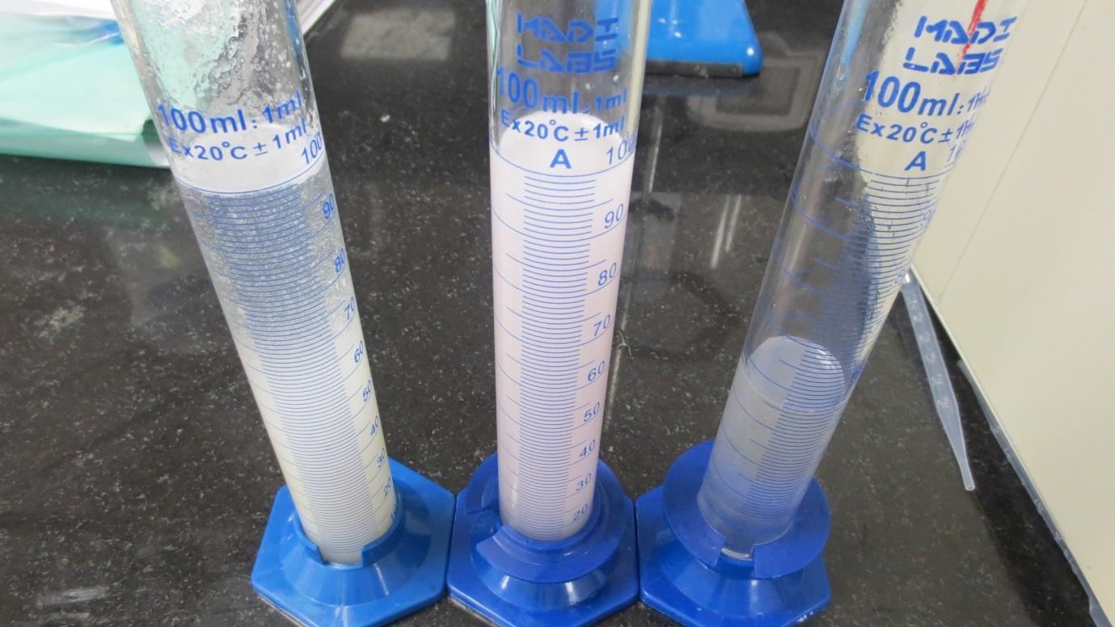**

| Doctor of Pharmacy Program | | Pharmacy Skill Laboratory (PHAR321) | |
| --- | --- | --- | --- |
| Student Name | **Ahlam Awawdeh** | **Student Number** | **1160951** |
| **Muhammad Musleh** | **1162595** |
| Exp. Name | **Suspensions and Elixirs** | **Exp. NO.** | **5** |

**Experiment 5.1 : Chloramphenicol Suspension**

**Product Formula:-**

**Table 1 : PF 1**

| NO. | Ingredients | Quantity | Dispensed by | | | Checked by |
| --- | --- | --- | --- | --- | --- | --- |
| 1 | **Chloramphenicol Palmitate** | **4g** | | | **Ahlam** | **Muhammad** |
| 2 | **Glycerine** | **20.18g** | | **Muhammad** | | **Ahlam** |
| 3 | **Xanthan Gum** | **0.2g** | | **Muhammad** | | **Ahlam** |
| 4 | **Flavouring Agent** | **2 drops** | | **Muhammad** | | **Ahlam** |
| 5 | **Simple Syrup** | **50.05g** | | **Ahlam** | | **Muhammad** |
| 6 | **Water** | **To 100ml** | | **Muhammad** | | **Ahlam** |

**Pharmaceutical Drug in Pharmacy:-**

**Trade name: Paraxin**

**Company: Abbott**

**Active Pharmaceutical Ingredient: Chloramphenicol Palmitate**

**About Product:-**

**Product name: Chloramphenicol Suspension**

**Product’s components and their roles:**

**Table 1 : Roles of components 1**

| NO. | Ingredients | Role |
| --- | --- | --- |
| 1 | **Chloramphenicol Palmitate** | **Antibiotic** |
| 2 | **Glycerine** | **Wetting agent** |
| 3 | **Xanthan Gum** | **Suspending agent** |
| 4 | **Flavouring Agent** | **Flavouring agent** |
| 5 | **Simple Syrup** | **Sweetening agent** |
| 6 | **Water** | **Vehicle** |

**Counseling:-**

1. **Indication (Why the medicine is given ) :**

Chloromphenicol is indicated only for treatment of serious infection in which less toxic antibacterial are ineffective or contraindicated.

Mechanism of actionof it**:** Chloramphenicol is lipid-soluble, allowing it to diffuse through the bacterial cell membrane. It then reversibly binds to the L16 protein of the 50S subunit of bacterial ribosome's, where transfer of amino acids to growing peptide chains is prevented, thus inhibiting peptide bond formation and subsequent protein synthesis.

1. **Administration (How to use it ) :**

Chloramphenicol is best taken with a full glass of water (240ml) on an empty stomach (either 1 hour before or 2 hours after meals)**,** while dosing will be different for different patients, the amount of medicine that you take depends on the strength of the medicine. Also, the number of doses you take each day, the time allowed between doses, and the length of time you take the medicine depend on the medical problem for which you are using the medicine.

Adults and teenagers—Dose is based on body weight. The usual dose is 12.5 milligrams (mg) per kilogram (kg)

Children—

Infants up to 2 weeks of age: Dose is based on body weight. The usual dose is 6.25

mg per kg of body weight every six hours.

Infants of two weeks and older the dose is also based on weight, the usual dose is

12.5 mg per kg of body weight every six hours.

In severe infection dose can be increased to 100mg/kg/day and the adult prescribing

Limit is up to maximum 4g per day.

If you miss a dose of this medicine, take it as soon as possible. if it is almost time for

for next dose skip the missed dose and go back to your regular schedule. Don’t

double dosing

**3- Adverse effects**:

Gray syndrome in babies, Anemia, dark colored urine, sore throat and fever,

Confusion and delirium, difficulty in breathing,

Gray syndrome is a syndrome due to a toxicity of chloromphenicol in newborn

Babies, especially premature babies because of lack of necessary enzymes

To metabolize this drug, and the symptoms of this syndrome is (hypotension

Vomiting, gray color of skin or blue color of skin and lips, hypothermia and

Cardiovascular collapse)

**4-Storage Conditions:**

It should be stored in refrigerator, in a tight container away from children

Prevent freezing.

**5-Precautions:**

Should be used in pregnant and breast feeding only when it very necessary

And when the benefits out weight the risk because it can be absorbed

From the placenta and milk to the fetus or baby, also should be used with

Caution in patients with liver or kidney problems.

**6-Expiry date:** Two weeks

**Calculations:-**

**Product strength = (API Mass / Total volume) \* 100%**

**Chloramphenicol Palmitate Strength=( 4g /100 ml) \*100%**

= 4% w/v

**Experiment 5.2: Aromatic Elixir USP**

**Product Formula:-**

**Table 3 : PF 2**

| NO. | Ingredients | Quantity | Dispensed by | Checked by |
| --- | --- | --- | --- | --- |
| 1 | **Rose Oil-Diluted-** | **6ml** | **Muhammad** | **Ahlam** |
| 2 | **Peppermint Oil** | **1 drop** | **Muhammad** | **Ahlam** |
| 3 | **Simple Syrup** | **37.5ml** | **Ahlam** | **Muhammad** |
| 4 | **Talc** | **3.02g** | **Muhammad** | **Ahlam** |
| 5 | **Alcohol-95% ethyl alc.-** | **25ml** | **Muhammad** | **Ahlam** |
| 6 | **Purified water** | **Qs ad 100ml** | **Ahlam** | **Muhammad** |

**Pharmaceutical Drug in Pharmacy:-**

**Trade name: Donnatal Elixir**

**Company: AVKARE**

**Active Pharmaceutical Ingredient: Rose Oil-Diluted-**

**About Product:-**

**Product name: Aromatic Elixir**

**Product’s components and their roles:**

**Table 4 : Roles of components 2**

| NO. | Ingredients | Role |
| --- | --- | --- |
| 1 | **Rose Oil-Diluted-** | **Flavouring agent** |
| 2 | **Peppermint Oil** | **Flavouring agent** |
| 3 | **Simple Syrup** | **Sweeting agent** |
| 4 | **Talc** | **Absorb excess amount of oil** |
| 5 | **Alcohol-95% ethyl alc.-** | **Solvent** |
| 6 | **Purified water** | **Vehicle** |

**Counseling :-**

1. **Indication (Why the medicine is given) :**

Aromatic elixir is a sweetened aromatic solution of alcohol and water, serving as a vehicle for medicines.

1. **Administration (How to use it ) :**

Since aromatic elixir is only a vehicle for numerous drugs; its administration depends on the drug added to it. It’s designed for drugs intended for oral administration. Medications delivered using aromatic elixir as a vehicle should be shaken before use.

1. **Adverse Effects :**

Aromatic elixir contains alcohol, so it’s best to avoid alcoholic beverages while taking medications delivered using this vehicle. It also contains simple syrup, which is prepared from sucrose, so diabetics should be cautious while taking medications in this vehicle.

1. **Storage Conditions :**

Aromatic elixir should be stored at room temperature, away from direct heat and light. It’s stored in a closed amber bottle. It should be kept out of the reach of children. Its expiration date is in 1 month after preparation.

**Calculations:-**

**Product strength = (API Mass / Total volume) \* 100%**

**Rose Oil-Diluted-Strength=( 6ml /100 ml) \*100%**

= 6% w/v

**Experiment 5.3 : Paracetamol Elixir**

**Product Formula:-**

**Table 5 : PF 3**

| NO. | Ingredients | Quantity | Dispensed by | Checked by |
| --- | --- | --- | --- | --- |
| 1 | **Paracetamol-Acetaminophen-** | **1.2g** | **Muhammad** | **Ahlam** |
| 2 | **Ethyl alcohol** | **6ml** | **Ahlam** | **Muhammad** |
| 3 | **Propylene glycol** | **5ml** | **Muhammad** | **Ahlam** |
| 4 | **Water** | **5ml** | **Muhammad** | **Ahlam** |
| 5 | **Glycerin** | **50ml** | **Muhammad** | **Ahlam** |

**Pharmaceutical Drug in Pharmacy:-**

**Trade name: Paracetamol Elixir**

**Company: Guardian**

**Active Pharmaceutical Ingredient: Paracetamol-Acetaminophen-**

**About Product:-**

**Product name: Paracetamol Elixir**

**Product’s components and their roles:**

**Table 6 : Roles of components 3**

| NO. | Ingredients | Role |
| --- | --- | --- |
| 1 | **Paracetamol-Acetaminophen-** | **Antipyretic and analgesic** |
| 2 | **Ethyl alcohol** | **To dissolve Paracetamol** |
| 3 | **Propylene glycol** | **Co-solvent** |
| 4 | **Water** | **Vehicle** |
| 5 | **Glycerin** | **Co-solvent and sweetening agent** |

**Counseling:-**

1. **Indication (Why the medicine is given):**

Used for the treatment of mild to moderate pain, It can also be used to relieve the symptoms of influenza, feverishness and feverish colds.

**Mechanism of action: Paracetamol** is termed a simple analgesic and an antipyretic. Despite enduring assertions that it acts by inhibition of cyclooxygenase (COX)-mediated production of prostaglandins, unlike non-steroidal anti-inflammatory drugs (NSAIDs), **paracetamol** has been demonstrated not to reduce tissue inflammation.

1. **Administration (How to use it ) :**

Dose calculated depending on patient weight not age, but there are also doses for group of ages:

From 3 months to two years the dose is between 2.5 to 5 ml 4 times daily

From 2 years to 6 years between 5 to 10 ml, 4 times daily.

Do not give it more than 4 times in 24 hours period and leave at least 4 hours between each dose.

1. **Adverse Effects :**

Rash, swelling and allergic reactions, nausea, low fever and fast heart beat.

It mustn’t used when theres hypersensitivity to paracetamol and the overdose of this drug can be reversed by methionin or IV N Acetyl cystine.

Also, it causes drug-drug interaction:

The absorption of paracetamol may increase with metoclopramide or domperidone and the absorption may reduce with cholystyremine.

The anticoagulant effect of warfarin maybe increased regulated use of paracetamol, which increase risk of bleeding.

1. **Storage Conditions:**

Stored at room temperature, away from heat and light, away from children and in Close container.

1. **Expiry date:** One month

**Calculations:-**

**Product strength = (API Mass / Total volume) \* 100%**

**Paracetamol-Acetaminophen-Strength= ( 1.2g /100 ml) \*100%**

= 1.2% w/v

**Questions:-**

1. **Why are suspensions used when an emergency formulation is required?**

Because suspension do not undergo disintegration so they are absorbed much faster than solid dosage forms and they exert the needed effect in a short than solid dosage forms and they exert the needed effect in a short period of time which is appropriate in emergencies.

1. **What ate the precautions considered when prescribing an elixir medication to a patient?**

Elixirs are contraindicated in neonates as they can affect their liver function, cause gastric irritation in addition to neurological depression some kinds of alcohol can cause serious problems; benzyl alcohol can cause gasping syndrome which is characterized by a deterioration of organ functions and death, and propylene glycol can cause seizures in preterm infants, they also can’t be used if the patient cannot consume alcohol, for example if they have allergies, or if they’re taking other CNS depressing medicines, as well as in patients with impaired liver function. Elixirs are not to be used during pregnancy and lactation unless strictly necessary, as well as in elderly with heart problem as they’re more sensitive to tachycardia and hypertension.

1. **Why should aromatic elixirs be stored in a tightly closed and light resistant container?**

Because elixirs have a high content of volatile alcohols and oils.

1. **What is the mechanism of action of chloramphenicol? Discuss its side effects?**

Chloramphenicol is lipid soluble and it can pass through the plasma membranes of bacteria and reversibly bind to the 50S subunit of the ribosome thus inhibiting protein synthesis. Its side effects are quite serious for example it can cause bone marrow depression which might in itself have other effect on health like increasing the risk of infections and delayed healing, in addition to aplastic anemia and gray baby syndrome.

1. **What are the daily recommended doses of paracetamol to each age group?**

3-6 months old: 2.5 ml, 6months-2 years: 5ml, 2-4 years: 7.5ml, 4-6 years: 10ml all are taken 4 times a day.

1. **Does the paracetamol elixir require a preservative? Use calculations to prove your answer?**

Alcohols are self-preserving when they make up more than 10%-12% of the preparation, to calculate the percentage of alcohol in this preparation:   
- 90 ml ethanol → 100 ml water  
 ? → 5 ml   
(90\*5)/100 = 4.5 ml ethanol   
- percentage of ethanol = (alcohol content/ overall volume of preparation) \* 100%  
 = 4.5/100  
 = 4.5%

Thus its concentration is not sufficient for it to self-preserve.

**Main Label:-**

**Pharmacy name**: MID Pharmacy

**Pharmacist name**: Ahlam Awawdeh

**Partner name**: Mohammad Musleh

**Product name: Chloramphenicol suspension**

**Product strength: 4 % w/v**

**Expiration date:** Two weeks

**Amount prepared:** **100 ml**

**Use:**  **treatment of serious infections**

**Auxiliary Label:-**

| Auxiliary Label: \* Shake well before use. \* oral use only C:\Users\husni\AppData\Local\Microsoft\Windows\Temporary Internet Files\Content.IE5\A35AGBSV\France_road_sign_A14.svg[1].png  \* Save in tight container in refrigerator |
| --- |

**Main Label:-**

**Pharmacy name**: MID Pharmacy

**Pharmacist name**: Ahlam Awawdeh

**Partner name**: Mohammad Musleh

**Product name:** Aromatic Elixir

**Product strength:**  6% v/v

**Expiration date:** One month

**Amount prepared:** 100ml

**Use:** Vehicle for medicine.

**Auxiliary Label:-**

* Shake well before use.
* Store at room temperature.
* Keep away from direct heat or light.
* Store in a closed container.

**Main Label:-**

**Pharmacy name**: MID Pharmacy

**Pharmacist name**: Ahlam Awawdeh

**Partner name**: Mohammad Musleh

**Product name:** paracetamol elixir

**Product strength:** 1.2% w/v

**Expiration date:** One month

**Amount prepared:** 50 ml

**Use:** For the treatment of mild to moderate pain, anti-pyretic and post immunization pyrexia.

**Auxiliary Label:-**

| Auxiliary Label: \* Shake well before use. \* oral use only  \* Save at room temperature \* Do not overfill the spoon. |
| --- |

**Do we use ointments or creams for wounds?**

Creams contain 50% water and 50% oil which make it more spreadable on skin while ointments contain about 80% oil and 20%water so there absorption is not very good and they stay on skin longer time.

Antibiotic ointments (such as Neosporin) help wounds heal by keeping out infection and by keeping the wound clean and moist, Most cuts and scrapes heal without antibiotic ointment. But it can make healing go faster and help reduce scarring.

Several factors are taken into consideration when selecting a topical product. Skin absorbs a cream more quickly, whereas an ointment will remain on the skin longer and take a longer time to absorb. Your physician may prescribe a cream if he or she wants your skin to absorb the medication quickly, or an ointment may be prescribed if slower absorption through the skin is desired, for example, when your skin is wet we use a cream as there's more water.

**The difference between paracetamol elixir and syrup:-**

The main difference is that elixir contain alcohol and water but syrup don’t have alcohol as that amount of elixir, also syrup contain much sugar that make it thick and sweet while elixir contain less amount of sugar making syrup more suitable for children, elixirs are more stable and easier to make but less suitable for children (there's limits on the percentage of alcohol in it)