**Doctor of Pharmacy**

**Pharmacy Skills Laboratory (PHAR321)**

**Lab 3 : The Compounding and Dispensing of Solutions Instilled Into Body Cavities**

**Dr. Hani Shtaya**

**Muhammad Musleh/1162595**

**Dana Joza’/1160058**

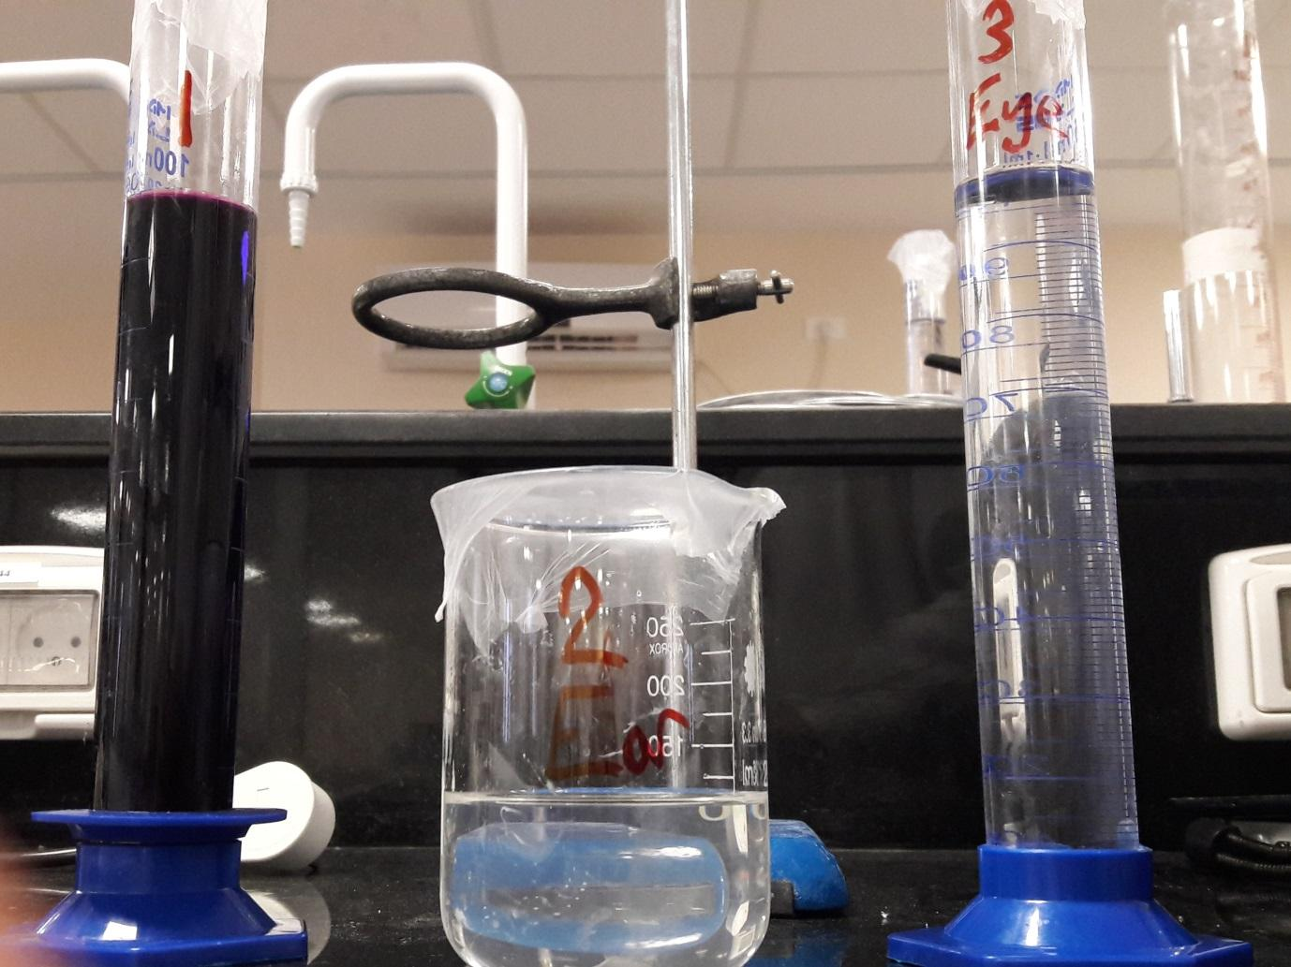

| Doctor of Pharmacy Program | | Pharmacy Skill Laboratory (PHAR321) | |
| --- | --- | --- | --- |
| Student Name | **Dana Joza’** | **Student Number** | **1160058** |
| **Muhammad Musleh** | **1162595** |
| Exp. Name | **Body Cavities** | **Exp. NO.** | **3** |

**Experiment 3.1 : 0.1% Potassium Permanganate Solution**

**Product Formula:-**

**Table 1 : PF 1**

| NO. | Ingredients | Quantity | Dispensed by | Checked by |
| --- | --- | --- | --- | --- |
| 1 | **Potassium Permanganate** | **0.13g** | **Dana** | **Muhammad** |
| 2 | **Water** | **100ml** | **Muhammad** | **Dana** |

**Pharmaceutical Drug in Pharmacy:-**

**Trade name: Permasol**

**Company: ICM Pharma**

**Active Pharmaceutical Ingredient: Potassium Permanganate**

**About Product:-**

**Product name: 0.1% Potassium Permanganate Solution**

**Product’s components and their roles:**

**Table 1 : Roles of components 1**

| NO. | Ingredients | Role |
| --- | --- | --- |
| 1 | **Potassium Permanganate** | **Antiseptic, disinfectant, kill fungi, and parasites** |
| 2 | **Water** | **Vehicle** |

**Counseling:-**

1. **Indication (Why the medicine is given ) :**

Used for cleansing wounds and deodorizing suppurating eczematous (red patches with pus-skin rash-) reactions and wounds.

When applied to your skin, potassium permanganate kills germs by releasing oxygen when it meets compounds in your skin. It also acts as an astringent, which is a drying agent.

Some of the conditions that potassium permanganate can help treat include:

1. **Infected eczema**: If you have [eczema with blisters](https://www.healthline.com/health/infected-eczema), potassium permanganate can help to dry them out.
2. **Open and blistering wounds**: Potassium permanganate is used as a wet dressing for wounds on your skin’s surface that are blistered or oozing pus.
3. **Athlete’s foot and impetigo**: Potassium permanganate can help to treat both bacterial and fungal skin infections such as [athlete’s foot](https://www.healthline.com/health/athletes-foot) and [impetigo](https://www.healthline.com/health/impetigo).
4. **Administration (How to use it ) :**

Before applying potassium permanganate to your skin, it’s important to dilute it with water. [Most medical uses](http://apps.who.int/medicinedocs/en/d/Jh2918e/25.2.html#Jh2918e.25.2) require a dilution of 1 part to 10 when using a 0.1% potassium permanganate solution.

To achieve an appropriate dilution using potassium permanganate 0.1% solution, combine 1 part potassium permanganate with 10 parts hot water. Undiluted potassium permanganate has a striking purple colour, but a diluted solution should be pink. Potassium permanganate **must**be diluted since undiluted solution may cause burns. Even with dilution it may irritate the skin, and with repeated use may still cause burns.

Potassium permanganate also comes in 400-milligram (mg) tablets. To utilize the tablets in a bath soak, dissolve 1 tablet in 4 liters of hot water before pouring into the bath. The bath soak may be repeated twice daily for two days.

Here are some guidelines on how to use potassium permanganate for specific conditions:

1. **Infected eczema.**Use or create a dilution of 1 part in 10,000. Add it to a basin or bath tub and soak the affected part of your body.
2. **Superficial wounds.**Apply a dilution of 1 part in 10,000 to a bandage and apply it over your wound. Change the bandage two to three times a day.
3. **Athlete’s foot.** For severe infections, soak your foot in a 1 part in 10,000 dilution of potassium permanganate every eight hours. Depending on how severe your infection is, your doctor might prescribe a stronger solution.
4. **Impetigo.** Gently rub a dilution of 1 part in 10,000 on the affected skin to removed loose bits of skin.

Depending on your condition, your doctor might instruct you to create a stronger solution with a dilution of 1 part in 7,000. To achieve this, mix 1 part potassium permanganate with 7 parts hot water. This will create a slightly darker pink liquid.

1. **Adverse Effects :**

skin irritation, redness, or burns.

Potassium permanganate is generally safe, but it may leave a brown stain on your skin and nails, which should fade after a day or two. It might also leave a stain in your bathtub that’s hard to remove, which is why many people prefer to use it in a smaller basin.

1. **Storage Conditions :** 
   1. Store in a cool place (because of the reactivity of medicament).
   2. All medicines must be stored out of the reach and sight of children.

**Calculations:-**

**Product strength = (API Mass / Total volume) * 100%**

**Potassium permanganate Strength=( 0.13g /100 ml) *100%**

= 0.13 % w/v

**Experiment 3.2 : Sodium Bicarbonate Ear-Drops**

**Product Formula:-**

**Table 3 : PF 2**

| NO. | Ingredients | Quantity | Dispensed by | | Checked by |
| --- | --- | --- | --- | --- | --- |
| 1 | **Sodium Bicarbonate** | **5.07g** | **Dana** | **Muhammad** | |
| 2 | **Glycerol** | **30ml** | **Muhammad** | **Dana** | |
| 3 | **Purified Water** | **75ml** | **Dana** | **Muhammad** | |

**Pharmaceutical Drug in Pharmacy:-**

**Trade name: Sodium Bicarbonate Ear Drops**

**Company: Sai-Meds**

**Active Pharmaceutical Ingredient: Sodium Bicarbonate**

**About Product:-**

**Product name: Sodium Bicarbonate Ear-Drops**

**Product’s components and their roles:**

**Table 4 : Roles of components 2**

| NO. | Ingredients | Role |
| --- | --- | --- |
| 1 | **Sodium Bicarbonate** | **Soften the hardened ear wax** |
| 2 | **Glycerol** | **Maintain the viscosity, and dissolve wax-Like dissolve like-** |
| 3 | **Purified Water** | **Solvent** |

**Counseling :-**

1. **Indication (Why the medicine is given ) :**

To soften dry and hardened earwax. This reduces the need for wax to be physically removed, but also makes ear irrigation easier.

1. **Administration (How to use it ) :**
2. Wash your hands thoroughly before and after every administration.
3. Lie down your head a little, such that affected ear is should face upwards.
4. Gently pull earlobe-or press- to straighten the canal of affected ear.
5. Release 3 to 4 drops into your ear to fill up the ear canal. Do not touch the inside of your ear with the dropper.
6. Repeat the process in the other ear, if required.

If your symptoms have not improved after five days, make an appointment to see your doctor for further advice.

1. **Adverse Effects :**
2. Sodium Bicarbonate can cause dryness in your ear canal, but this is rarely troublesome.
3. It is unlikely that you will experience any other major side effects, but do speak with your doctor of pharmacist if there is anything that concerns you.
4. Allergic reactions may demand medical assistance.
5. **Storage Conditions :**
6. Store bottle upright in carton with leaflet.
7. Store in cool-below 25 °C, Do not freeze- and dry place.
8. Store away from direct heat and light.
9. Discard the drops 28 days after first opening.
10. All medicines must be stored out of the reach and sight of children.

**Calculations:-**

**Product strength = (API Mass / Total volume) * 100%**

**Sodium Bicarbonate Strength=( 5.07g /100 ml) *100%**

= 5.07 % w/v

**Experiment 3.3 : Chloramphenicol Eye Drops (Martindale) 0.5%** *w/v*

**Product Formula:-**

**Table 5 : PF 3**

| NO. | Ingredients | Quantity | Dispensed by | Checked by |
| --- | --- | --- | --- | --- |
| 1 | **Chloramphenicol** | **0.52** | **Muhammad** | **Dana** |
| 2 | **Boric Acid** | **1.53** | **Muhammad** | **Dana** |
| 3 | **Borax** | **0.34** | **Muhammad** | **Dana** |
| 4 | **Phenyl mercuric Nitrate** | **-** | **-** | **-** |
| 5 | **Water for Injection** | **100 ml** | **Dana** | **Muhammad** |

**Pharmaceutical Drug in Pharmacy:-**

**Trade name:** **Chloramphenicol 0.5% w/v Antibiotic Eye Drops**

**Company: Martindale/ Farmigea**

**Active Pharmaceutical Ingredient: Chloramphenicol**

**About Product:-**

**Product name: Chloramphenicol Eye Drops (Martindale) 0.5%**

**Product’s components and their roles:**

**Table 6 : Roles of components 3**

| NO. | Ingredients | Role |
| --- | --- | --- |
| 1 | **Boric Acid and Borax** | **Adjust Isotonicity** |
| 2 | **Phenyl mercuric Nitrate** | **Preservative-Not used-** |
| 3 | **Water for Injection** | **Vehicle** |

**Counseling :-**

1. **Indication (Why the medicine is given ) :**

Chloramphenicol eye drops and ointment are wide spectrum antibiotic used for the treatment of acute bacterial infection of the external eye. Eye infections are a common cause of conjunctivitis**.**

1. **Administration (How to use it ) :**

Adults (including the elderly) and children aged 2 years and over:

1. Put two drops into the affected eye(s) every 2 hours for the first 48 hours and 4 hourly thereafter.
2. To be used during waking hours only
3. The course of treatment should be 5 days.
4. **Adverse Effects :**
5. Can cause stinging, irritation, itching, or burning in eye- This happens straight after using the eye drops and only lasts for a short time.
6. Do not drive until your eyes feel comfortable again and your vision is clear.
7. Dermatitis- The skin around eye becomes red and irritated- you must tell your doctor to recommend another antibiotic for you
8. Serious allergic reaction- Anaphylaxis-
9. **Storage Conditions :**
10. Store upright at 2 to 8°C in a dry place away from strong sunlight and do not freeze (for example keep in a fridge).
11. 24 months Unopened
12. Although the shelf life once opened is 28 days, patients should be advised to discard the medicine after a 5 day course of treatment.
13. All medicines must be stored out of the reach and sight of children.

Question Asked :

Why should we leave the eye drop outside in room temperature after getting it out of the fridge ?

We should do that so that the eye drops don’t sting .

**Calculations:-**

**Product strength = (API Mass / Total volume) * 100%**

**Chloramphenicol Strength=( 0.52g /100 ml) *100%**

= 0.52 % w/v

**Questions:-**

1. **What is/are the pharmaceutical and medical use(s) of KMnO4 solution. What is the mechanism of its action ?**

KMnO4 is medically used as fungicide and antiseptic and kills parasites , it is also used to treat many skin conditions such as eczema , acne , and other fungal infections caused in hands and legs and can be used in the case of athlete’s foot .also can be used on people who have oozing blisters and wounds that have pus in them ( remember not to forget that the solution should be diluted for use), it is also used in fish diseases and parasites as it cures the bacterial gill infections and skin ulcers .

MOA: KMnO4 is a strong oxidizing agent , it readily takes or accepts electrons from other substances and by this mechanism it gets its disinfectant effect .

1. **What are the signs of using KMnO4 internally(Internal toxicity of KMnO4) ?**

Some of the signs and symptoms of using it internally and ingesting it , are related to GI (such as dysphagia, odynophagia, nausea, and vomiting, which are a result of gastrointestinal edema, burns, and ulcerations), respiratory and circulatory as :

Potassium permanganate is a nephrotoxin and hepatotoxin, so it can damage the liver and kidneys , as well as a corrosive agent in the gastrointestinal tract. and burns and ulcers in the mouth and esophaegus can occur .It also causes upper airway obstruction as aspiration can cause acute tracheobrochitis (a lower respiratory tract infection (windpipe and bronchi) )and bronchopneumonia(a type of pneumonia that also causes inflammation in the bronchi). Fatty changes in the heart have been also been seen when using it . also causes bleeding tendency and methemoglobinemia( blood disorder in which an abnormal amount of methemoglobin is produced. ).Most of the deaths from severe KMnO4 poisoning are due to cardiovascular depression and collapse, upper airway obstruction, hemorrhagic shock owing to massive gastrointestinal bleeding **.**

1. **Why was not any preservative used in the douche preparation ?**

Because the KMnO4 itself acts as a preservative .it is an oxidizing agent and is widely used as an oxidant in chemical production and for instance it serves as an oxidant for making saccharin, vitamin C, isoniazid and benzoic acid; used as a preservative, disinfectant, deodorant and disinfectant in medicine and is even used in the treatment of water .

1. **Why is glycerol included in NaHCO3 Eardrops?**

Glycerol is a viscous liquid maintains the viscosity of the liquid so it will thicken the drop . it can also add moisture and lubrication which can help with softening of the ear wax . in addition , glycerine attracts water which can be helpful if there is any water in the ear canal .

1. **What is the equation of how NaHCO3 solution works ?**

It is an acid – base reaction

NaHCO3 (base) + wax (acid) ------->Na+ + CO2 + H2O + softened wax

1. **Can the ear wax softener be used for a long time, why ?**

No , because ( even though it is rare ) it can cause dryness in the ear canal and can irritate the skin of t ear drum and ear canal as the skin is delicate there and may cause infections and burning and swelling around the ear .

1. **Eye drops should be isotonic. How is Chloramphenicol E/D made isotonic ?**

An isotonic solutions refers to two solutions having the same osmotic pressure across a semipermeable membrane. This state allows for the free movement of water across the membrane without changing the concentration of solutes on either side. Eye drops are isotonic which means equal concentrations of the medication in the cells and thus will prevent too much water from entering which will cause swelling of the eye and will also prevent water from getting out which will cause dryness of the eyes . in the chloramphenicol eye drops , borax and boric acid are added with it , those ingredients adjust isotonicity and that’s how chloramphenicol is made isotonic .

1. **(Ear drops can be used in eye but eye drops cannot be used in ear) Is this true; explain your answer.**

No it is false , as eye drops can be used in the ear while ear drops cannot be used in the eye . because eye drops are sterile , not like ear drops . as the solutions that are used as drops contain many microorganisms which can cause infections which can lead to blindness , so it is dangerous to use non-sterile solution in the eye .

1. **If your doctor has prescribed you two types of drops(Containing different active ingredients), what is the proper counselling to take them ? What if the two drops have the same active ingredient ?**

In the case of the two drops having different APIs , the patient should be told to take the two drops one at a time and not at the same time as there may be a risk of drug –drug interactions ( also this depends on the APIs id they interact or not but to be safer they should take them at different times ) , so there should be about 15 minutes between one type of drop and the other type.

In the case of the two drops having the same API , it will be okay to take them at the same time ,. As in this case there is no fear of drug-drug interactions .

Definitions of storage conditions ( asked By Dr. Hani) :

* **Cold**: Any temperature not exceeding 8°C and usually between 2°C to 8°C. A refrigerator is a cold place in which the temperature is maintained thermostatically between 2°C to 8°C.
* **Cool**: Any temperature between 8°C and 25°C. An article, for which storage in a cool place is directed may alternately, be stored in a refrigerator unless otherwise specified in the individual monograph.
* **Room Temperature**: The temperature prevailing in a working area.

**Main Label:-**

**Pharmacy name**: MID Pharmacy

**Pharmacist name**:  Dana Joza’

**Partner name**: Mohammad Musleh

**Product name:** Potassium Permanganate Solution

**Product strength:**  0.13% g\ml

**Expiration date:** Freshly prepared, 1 week.

**Amount prepared:** 100 ml

**Use:** Throat infections.

**Auxiliary Label:-**

* For external use only .
* Do NOT swallow .
* For vaginal use only.
* Avoid contact with organic substances
* Store in a cool place
* Away from children

**Main Label:-**

**Pharmacy name**: MID Pharmacy

**Pharmacist name**:  Dana Joza’

**Partner name**: Mohammad Musleh

**Product name:** Sodium Bicarbonate Ear-Drops

**Product strength:** 5.07 % g\ml

**Expiration date:** 1 month

**Amount prepared:** 100 ml

**Use:** Dissolve hardens wax in ear

**Auxiliary Label:-**

* For external use only (For ear use only .​)
* Not to be taken orally
* Not for injection
* Not to be diluted with water before use.​
* Keep away from children

**Main Label:-**

**Pharmacy name**: MID Pharmacy

**Pharmacist name**:  Dana Joza’

**Partner name**: Mohammad Musleh

**Product name:** Chloramphenicol Eye Drops (Martindale) 0.5%

**Product strength:** 0.52 % g\ml

**Expiration date:** 5 days after opened.

**Amount prepared:** 100 ml

**Use:** Eye infection

**Auxiliary Label:-**

* Keep away from children.​
* Throw away the bottle of chloramphenicol after you have finished the five-day course of treatment, even if there is some left.
* Keep in a fridge (2°C to 8°C)
* Protect from light.​
* WARNING : Contamination of the dropper or eye solution can lead to a serious eye infection.