

**Second Semester 2020/2021**

**Natural Products & Phyto-pharmacy   
  
Common Herbal Medication**

**Instructor Lina Adwan  
  
Homework 1 (case study)  
  
Group 6**

**Student names and I.D   
Aseel Ghanem / 1182520  
Hadeel Kahala / 1180663  
Cileen Joudeh / 1182991**

**Rajaee Afagane / 1182596**

**Muhammad Musleh / 1162595**

**Ginseng**

**We discussed the Case and concluded the following:-**  
  
 **1-** We have to stop Ginseng, because it interacts with Warfarin by inhibiting Cytochrome P450 enzymes.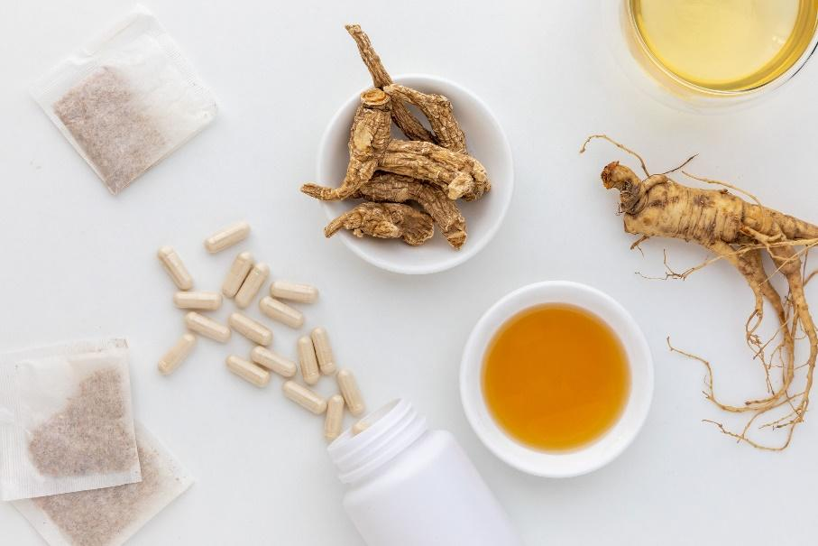

**2-** Ginseng is often used to improve mental concentration, treat anemia, diabetes, blood pressure (As Diuretic), and Adaptogenic agent.

.